BASH-Assignment 2

COIT 11241

Eric Steyn 12053766

[Year]

Question 1

This was the one option I tried, it did not really work well

Install aptitude

sudo apt-get install aptitude

but could not get it working properly.

The second one I tried was. It’s a bit fragmented but it seemed to have worked.

$ ls /usr/share/applications | awk -F '.desktop' ' { print $1}'

$ls /usr/share/applications | awk -F '.desktop' ' { print $1}' - > ~/Desktop/newapplications.txt

$ diff -c ~/Desktop/applications.txt ~/Desktop/newapplications.txt

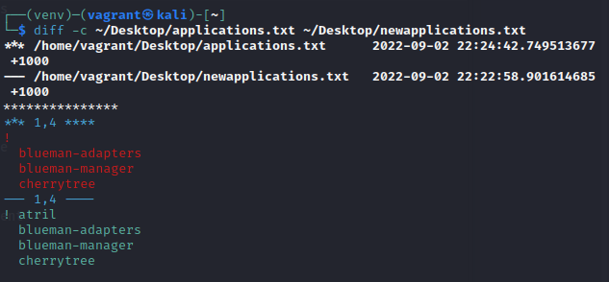

Where AWK is seemingly filtering everything that ends with a .desktop. F is just printing the expressions that is true. And the print seems to be only printing the actual name and dropping the .desktop and the prequel before dash.

Question 2

The command for services is

Service service --status-all | awk '{print $4}' - > ~/Desktop/newservices.txt

$ diff -c ~/Desktop/serives.txt ~/Desktop/newservices.txt

I added the pipe awk ‘{print $4} to only print the necessary data

Added the - > ~/Desktop/services.txt to save to desktop

next use the diff command

$ diff -c ~ /Desktop/serives.txt ~/Desktop/newservices.txt

I used the -c syntax to show the differences between the two files

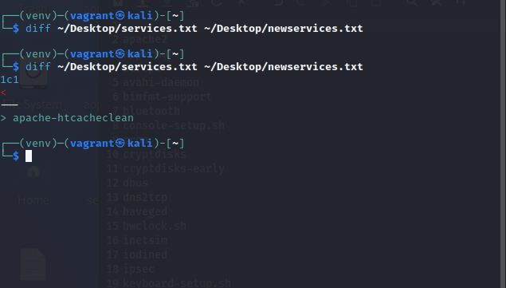

Question 3

Find all the open ports/services

cat /etc/services

cat /etc/services | awk '{print $2}' filtering for the second column only.

Option1

cat /etc/services | grep -Eo '[0-9]{5,6}' filtering for numbers only, where the same instance can re-occur on the same line 5 times but no more than 6

cat /etc/services | grep -Eo '[0-9]{5,6}'

cat /etc/services | grep -o '[[:digit:]]*'

cat /etc/services | grep -o '[[:digit:]]*'

Option 2 (This is the one I used)

cat /etc/services | grep -o '[[:digit:]]*' |awk '$1 <1023' - > ~/Desktop/newports.txt

$ diff -c ~/Desktop/ports.txt ~/Desktop/newports.txt

( filters even more down. So all ports below 1023)

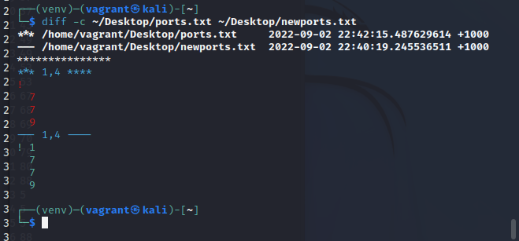

Question 4

1. Address from Bing Maps, it’s a street close to me,
2. I substituted the details in the url as follows <http://dev.virtualearth.net/REST/v1/Locations?countryRegion=Australia&adminDistrict=QLD&locality=Runcorn&postalCode=4113&addressLine=Beechel&key=AklX82YXHHg_1qruaAqch-j7YEWp4Tm8xeHTYyMAtzrG5E7g_yBKhaZ9ZP8zAQ2I>
3. I entered the url into a browser and I got the following {"authenticationResultCode":"ValidCredentials","brandLogoUri":"http:\/\/dev.virtualearth.net\/Branding\/logo_powered_by.png","copyright":"Copyright © 2022 Microsoft and its suppliers. All rights reserved. This API cannot be accessed and the content and any results may not be used, reproduced or transmitted in any manner without express written permission from Microsoft Corporation.","resourceSets":[{"estimatedTotal":1,"resources":[{"__type":"Location:http:\/\/schemas.microsoft.com\/search\/local\/ws\/rest\/v1","bbox":[-27.613307718269578,153.06257437052867,-27.605582283128225,153.07419822894335],"name":"Beechal St, Runcorn, Queensland 4113, Australia","point":{"type":"Point","coordinates":[-27.609445,153.0683863]},"address":{"addressLine":"Beechal St","adminDistrict":"Queensland","countryRegion":"Australia","formattedAddress":"Beechal St, Runcorn, Queensland 4113, Australia","locality":"Brisbane","postalCode":"4113"},"confidence":"Low","entityType":"RoadBlock","geocodePoints":[{"type":"Point","coordinates":[-27.609445,153.0683863],"calculationMethod":"Interpolation","usageTypes":["Display"]}],"matchCodes":["Good"]}]}],"statusCode":200,"statusDescription":"OK","traceId":"310eaa003f264a8fbdbff58705d03de9|PUS0004C79|0.0.0.1|Ref A: 05C442F1DE4546C3B9A2B2C8436824AE Ref B: SEL20EDGE0317 Ref C: 2022-09-01T11:54:08Z"}
4. I used the co-ordinates in this message and substituted the longitude and latitude points in the url which will give us a map print out. <http://dev.virtualearth.net/REST/v1/Imagery/Map/Road/-27.609445,153.0683863/15?mapSize=500,500&key=AklX82YXHHg_1qruaAqch-j7YEWp4Tm8xeHTYyMAtzrG5E7g_yBKhaZ9ZP8zAQ2I>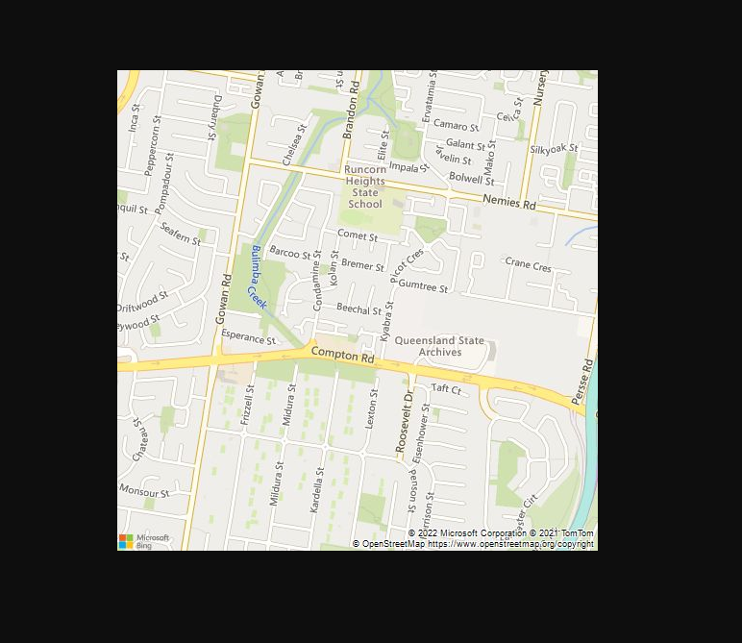
5. I would like to think you can use this to map out all your customers on a map or bring up a map on a website.

CURL <http://dev.virtualearth.net/REST/v1/Locations?countryRegion=Australia&adminDistrict=QLD&locality=Runcorn&postalCode=4113&addressLine=Beechel&key=AklX82YXHHg_1qruaAqch-j7YEWp4Tm8xeHTYyMAtzrG5E7g_yBKhaZ9ZP8zAQ2I>

curl "http://dev.virtualearth.net/REST/v1/Imagery/Map/Road/$coordinates/15?mapSize=500,500&key=AklX82YXHHg_1qruaAqch-j7YEWp4Tm8xeHTYyMAtzrG5E7g_yBKhaZ9ZP8zAQ2I"

To only get the coordinates

curl "http://dev.virtualearth.net/REST/v1/Locations?countryRegion=Australia&adminDistrict=QLD&locality=Runcorn&postalCode=4113&addressLine=Beechel&key=AklX82YXHHg_1qruaAqch-j7YEWp4Tm8xeHTYyMAtzrG5E7g_yBKhaZ9ZP8zAQ2I" | grep -E -o ".{0,25}calculationMethod{0,19}" |cut -f1 -d"]"

Save it to a variable

coordinates=' curl "http://dev.virtualearth.net/REST/v1/Locations?countryRegion=Australia&adminDistrict=QLD&locality=Runcorn&postalCode=4113&addressLine=Beechel&key=AklX82YXHHg_1qruaAqch-j7YEWp4Tm8xeHTYyMAtzrG5E7g_yBKhaZ9ZP8zAQ2I" | grep -E -o ".{0,25}calculationMethod{0,19}" |cut -f1 -d"]" '

Question 5

Option1

if [/arping ] ; then for i in {1..50} ;arping -c 1 172.16.1.$i | grep reply ;    done ; fi

Option 2

#!/bin/bash

for num in {1..255}; do

echo -n “192.168.0.$num “

arping -c 1 192.168.0.$num | grep “1 response”

if [ $? != 0 ]; then

echo “”

fi

done

Option 3 (This is the one I decided to go with)

This was the closest answer although I could not stop the output from comping up in the terminal. When it saved though it did not save that information so seem to be doing the right thing in file but not in terminal. I ran out out of time to troubleshoot.

$ for num in {1..50}; do arping -c 1 172.16.1.$num | grep -o -E '([[:xdigit:]]{1,2}:){5}[[:xdigit:]]{1,2}'->~/Desktop/newmacs.txt ; done

$ diff -c ~/Desktop/macs.txt ~/Desktop/newmacs.txt