DEPARTMENT OF INFORMATION TECHNOLOGY
COURSE CODE: DJS23ICPC602 DATE:
COURSE NAME: Cryptography and Network Security Laboratory CLASS: T. Y. BTech
EXPERIMENT NO. 1
CO/LO: Design secure system using appropriate security mechanism
AIM / OBJECTIVE:
- Implementation of Ceaser Cipher on alphanumeric data.
- Implementation of Ceaser Cipher on gray scale image.

THEORY / CONCEPT / ALGORITHM:
- The Caesar Cipher is one of the simplest and oldest methods of encrypting messages, named after Julius Caesar, who reportedly used it to protect his military communications. This technique involves shifting the letters of the alphabet by a fixed number of places. For example, with a shift of three, the letter ‘A’ becomes ‘D’, ‘B’ becomes ‘E’, and so on. Despite its simplicity, the Caesar Cipher formed the groundwork for modern cryptographic techniques.
- To cipher a given text, we need an integer value, known as a shift which indicates the number of positions each letter of the text has been moved down. The encryption can be represented using modular arithmetic by first transforming the letters into numbers, according to the scheme, A = 0, B = 1,…, Z = 25. Encryption and decryption of a letter by a shift n can be described mathematically as.
En​(x)=(x+n) mod 26 (Encryption Phase with shift n)
Dn​(x)=(x−n) mod 26 (Decryption Phase with shift n)

SOURCE CODE:

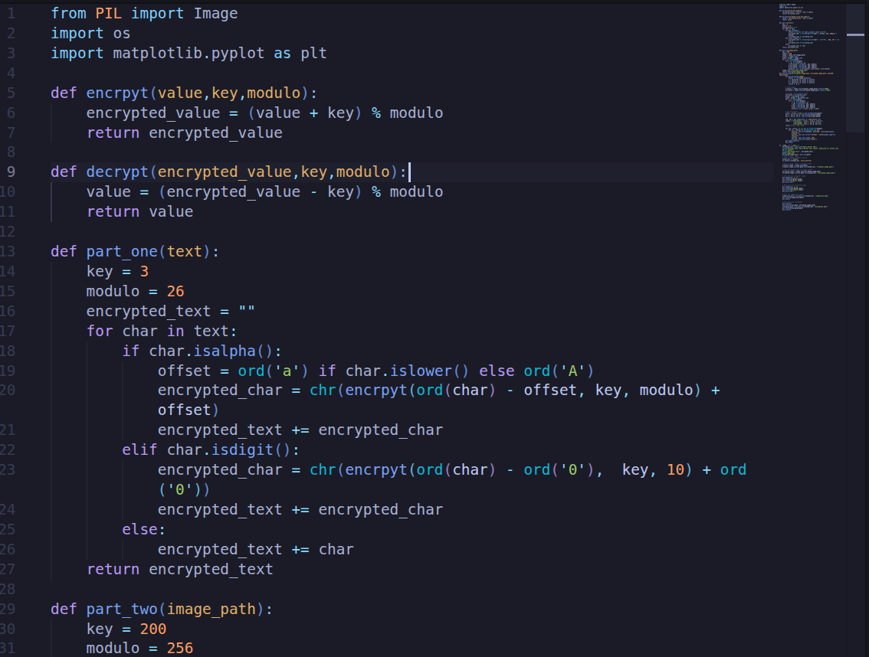

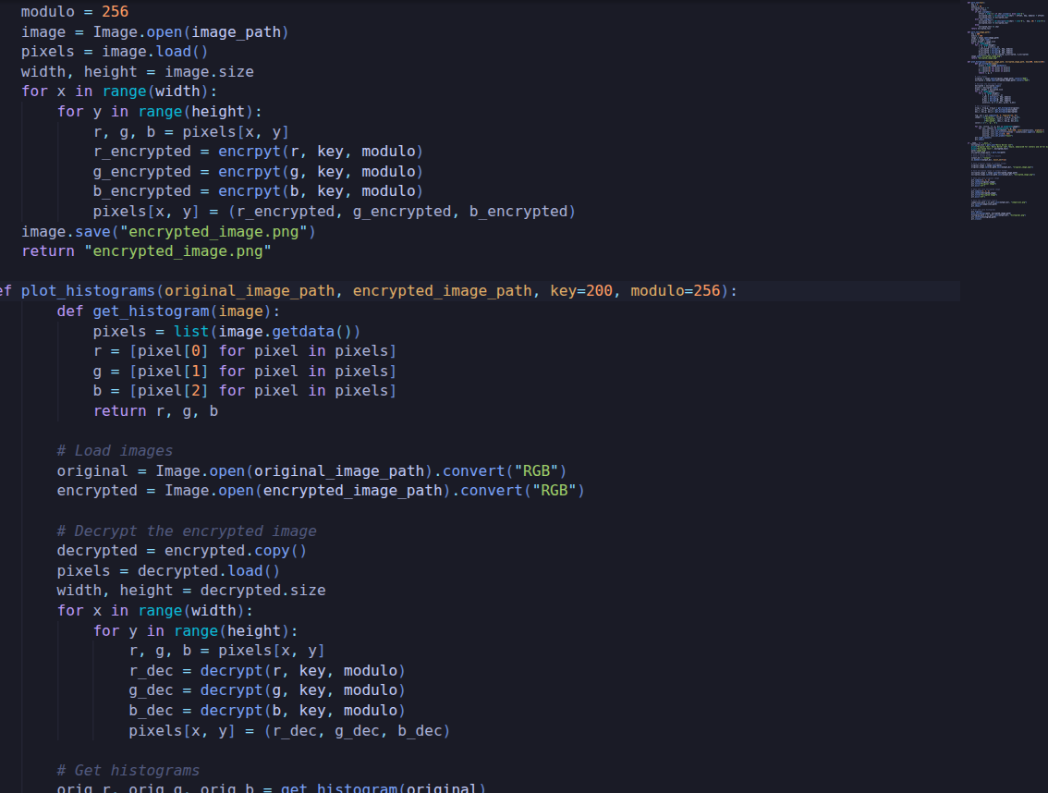

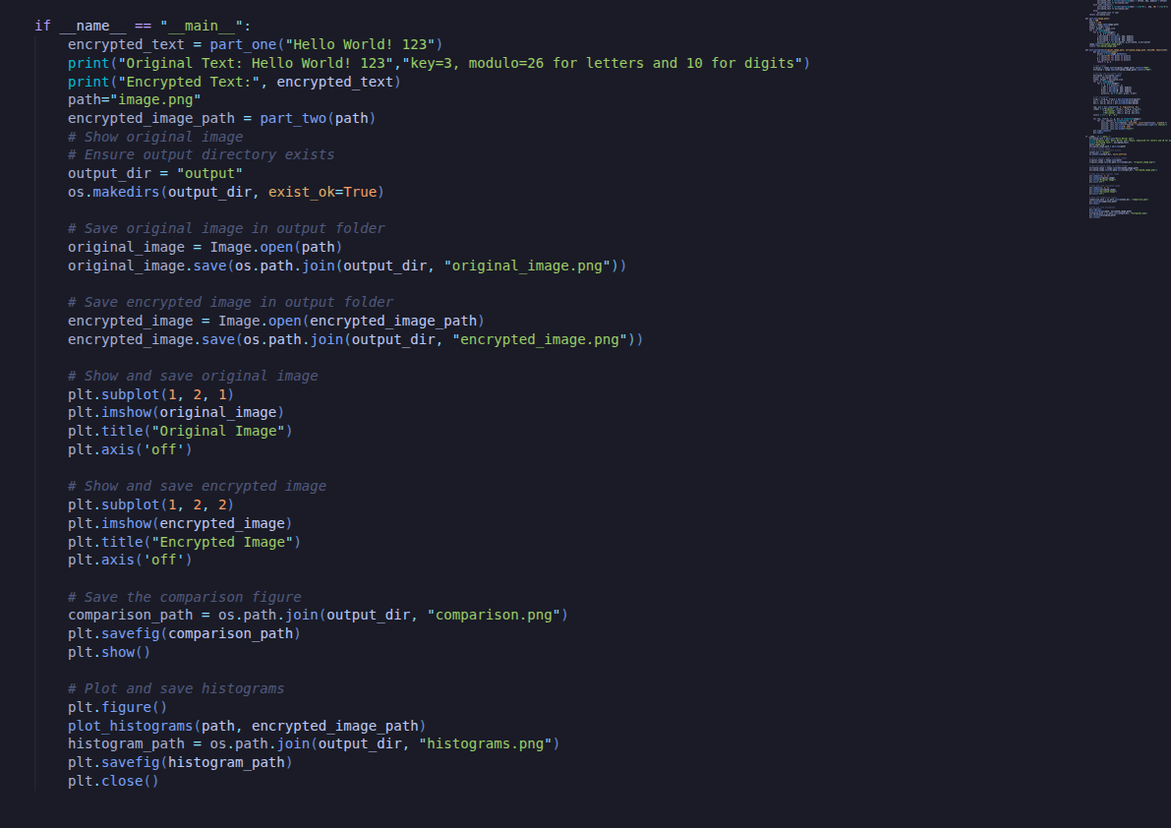

Image Encryption
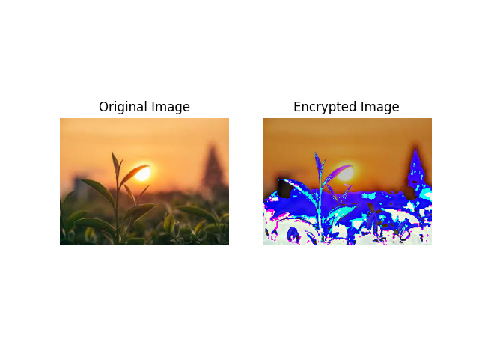
Text Encryption

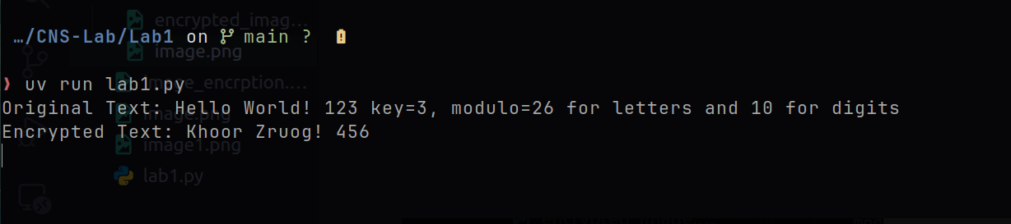

Histogram
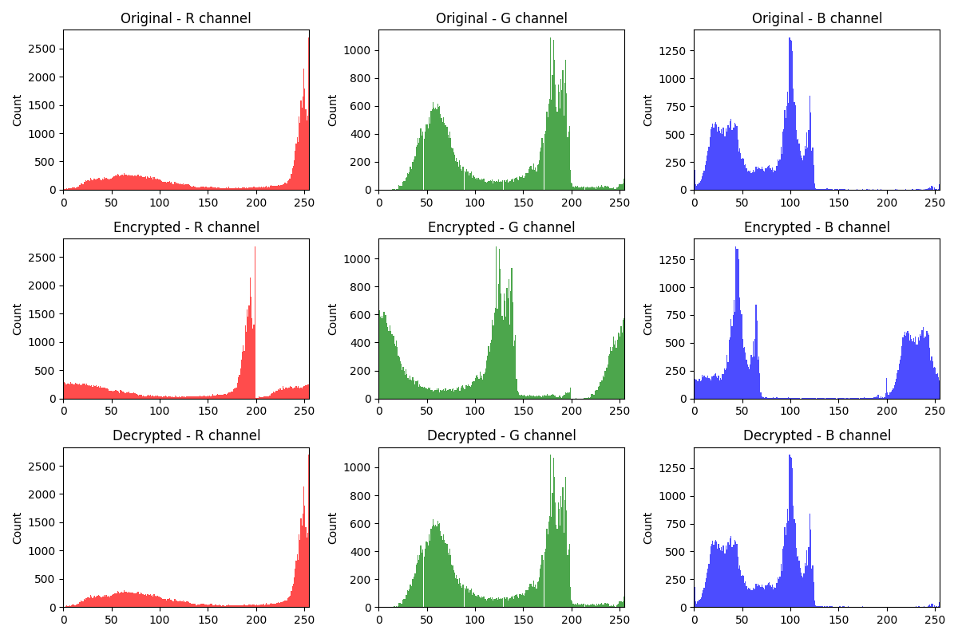

QUESTIONS:
- Perform a frequency analysis of the encrypted alphanumeric data and compare it to the frequency of the original data.
- Generate histograms of the pixel values for the original, encrypted, and decrypted images.
- Show encryption and decryption with the help of an example
- Cryptanalysis of Caesar Cipher
CONCLUSION: conclude based on the questions asked.
REFERENCES:

