Chapter 2 - First Steps in Programming
- An integer is any whole number without a decimal point. 2.0 would be described as an integer because it is a whole number, but as far as your computer is concerned, it isn’t because it is written with a decimal point. It is floating point.
- printf("My salary is %d.\n", salary);
The first argument is a control string, or format string. ‘%d’ is called conversion specifier.
- The expression 12 % 5 produces 2.
- int cookies = 45;
int children = 7;
cookies/children = 6; // 是整形
Division and Modulus with Integers
With division operator (/), the result will always be negative if the operands have different signs. Thus, the expression –45 / 7 produces the same result as the expression 45 / –7, which is –6. If the operands in a division are of the same sign, either positive or negative, the result is always positive. Thus, 45 / 7 produces the same result as –45 / –7, which is 6.
With the modulus operator (%), the sign of the result is always the same as the sign of the left operand whether the operands have different signs or not. Thus, 45 % –7 results in the value 3, whereas –45 % 7 results in the value –3; the expression -45 % -7 also evaluates to -3.
- int expenditure = 75;
printf("Your balance has changed by %d.", -expenditure); // -75, minus sign.
The expression -expenditure does not change the value stored in expenditure — it’s still 75. The value of the expression is –75.
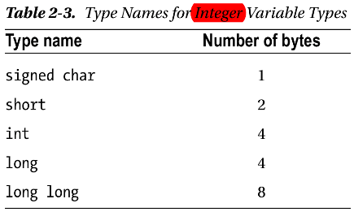
short shoe_size;
int house_number;
long long star_count;
The type names short, long, and long long can be written as short int, long int, and long long int. And they can optionally have the keyword signed in front. It’s easy to find out what the limits are for your compiler because they are defined in the limits.h header file.
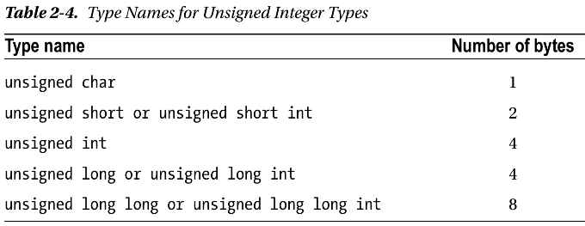
- Variables of different types that occupy the same number of bytes are still different. Type long and type int may occupy the same amount of memory but they are still different types.
- If you just write the integer value 100, for example, this will be of type int, by default from compiler. If you want to make sure it is type long, you must append an uppercase or lowercase letter L to the numeric value. So, 100 as a long value is written as 100L.
long Big_Number = 1287600L;
long long really_big_number = 123456789LL;
unsigned int count = 100U;
unsigned long value = 999999999UL;
unsigned long long metersPerLightYear = 9460730472580800ULL;
unsigned long long metersPerLightYear = 0xFABABULL; // Hex format
Working with Floating-Point Numbers
Floating-point numbers hold values that are written with a decimal point, such as 100.0. Floating-point numbers are often expressed as a decimal value multiplied by some power of 10, where the power of 10 is called the exponent. For examples below:
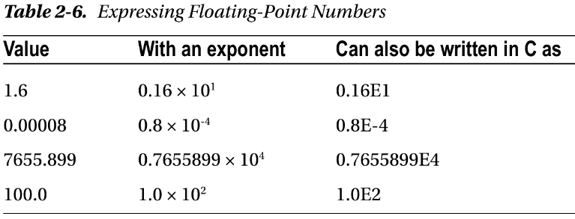
For very large or very small numbers, the exponent form is very useful. I am sure you would rather write 0.5E-15 than 0.0000000000000005, wouldn’t you?
Floating-Point Number Representation
Figure 2-2 shows how a floating-point number is stored in a four-byte word in memory on an Intel PC.
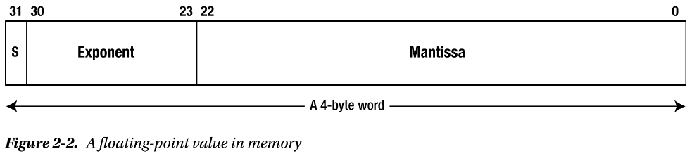
This is a single-precision floating-point value, which occupies four bytes of memory. The value consists of three parts:
- A sign bit that is 0 for a positive value and 1 for a negative value;
- An 8-bit exponent;
- A 23-bit mantissa;
The mantissa contains the digits in the number and occupies 23 bits. It is assumed to be a binary value of the form 1.bbb...b, with 23 bits to the right of the binary point. Thus, the value of the mantissa is always greater than or equal to 1, and less than 2. I’m sure you are wondering how you get a 24-bit value into 23-bits, but it’s quite simple. The leftmost bit is always 1, so it does not need to be stored. Adopting this approach provides an extra binary digit of precision.
The exponent is an unsigned eight-bit value, so the exponent value can be from 0 to 255. The actual value of the floating-point number is the mantissa multiplied by 2 to the power of the exponent. You need negative exponent values to allow small fractional numbers to be represented. To accommodate this, the actual exponent for a floating-point value has 127 added to it. This allows for values from –127 to 128 to be represented as an eight-bit unsigned value. Thus, an exponent of –6 will be stored as 121 and an exponent of 6 will be stored as 133. 也就是说, 实际的exponent是这个8-Bit的unsigned int的值减去127. However, there are a few complications.
- A floating- point value of zero is represented by a word with all bits in the mantissa and exponent as 0, so the actual exponent value of –127 cannot be used for other values.
- Another complication arises because it is desirable to be able to detect division by zero. Two more special values are reserved that represent +infinity and -infinity, the values that result from dividing a positive number or a negative number by zero. Dividing a positive number by zero will generate a result with a zero sign bit, all the exponent bits 1 and all the mantissa bits 0. This value is special and represents +infinity. Dividing a negative number by zero results in the negation of that value, so –1 × 2¹²⁸ is a special value too.

The last complication arises because it is desirable to be able to represent the result dividing zero by zero. This is referred to as ‘Not a Number’ (NaN). The value reserved for this has all exponent bits 1 and the leading digit in the mantissa as 1 or 0 depending on whether the NaN is a quiet NaN, which allows execution to continue, or it is a signaling NaN, which causes an exception in the code that can terminate execution. When NaN has a leading 0 in the mantissa, at least one of the other mantissa bits is 1 to distinguish it from infinity.

