Docker

* Why we need it? The compatibility matrix (compatibility between different components) issue is called the matrix from hell. When a new developer wants to setup environment, she has to run a lot of commands: right version of os, other components. She may use different development tests and production environment. To change the components individually without affecting other components. With docker we can run the components in a separate container with their own dependencies and its own libraries all on the same VM and the OS but within separate environments(containers).
* Initialize the docker once
* And developer run with a simple docker command. They just need docker.

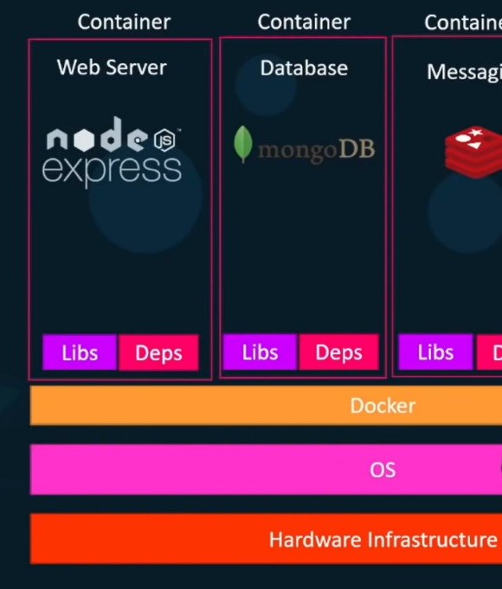

## Containers

* Completely isolated environments, they can have their own processes or services, their own network interfaces, their own mounts, just like virtual machines, except they all share the same OS kernel.
* They are not new like docker: Aleksy, LSD, CFS
* Docker utilizes the Aleksey containers. Setting up the containers is hard, they are low level, but docker provides high level tool, with several functionalities making it easy.

## How docker works?

* Like Ubuntu, Fedora, CenOs: An os Kenel(here linux) and a set of software(different user interfaces, compilers, file managers, developer tools).

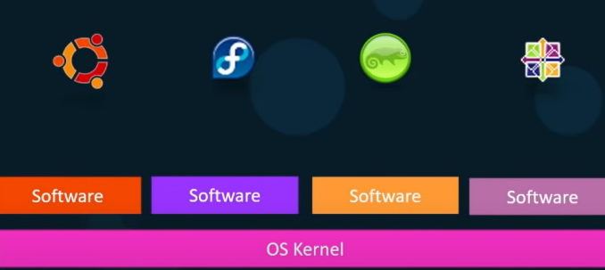

* **Containers share the same kernel:** Ubuntu Os, Docker installed on it. Docker can run different Oss as long as the kernel (here Linux) is the same (Debian, Suse, or centos). Docker can run a containers based on another distribution like Fedora, or Suse. Each docker has only the additional software. Docker uses the os below which works with the OSs above. We can not run windows container on Ubuntu.

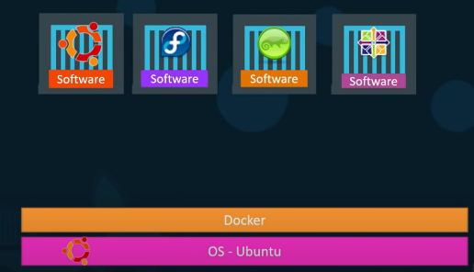

* We can run a linux container on a linux virtual machine on windows.
* Docker is not meant to virtualize and run different operating systems on the same hardware like hypervisors.
* The main purpose of Docker is to package and containerize applications and to ship them and run them anytime anywhere as many time as we want.
* Less security: shared os

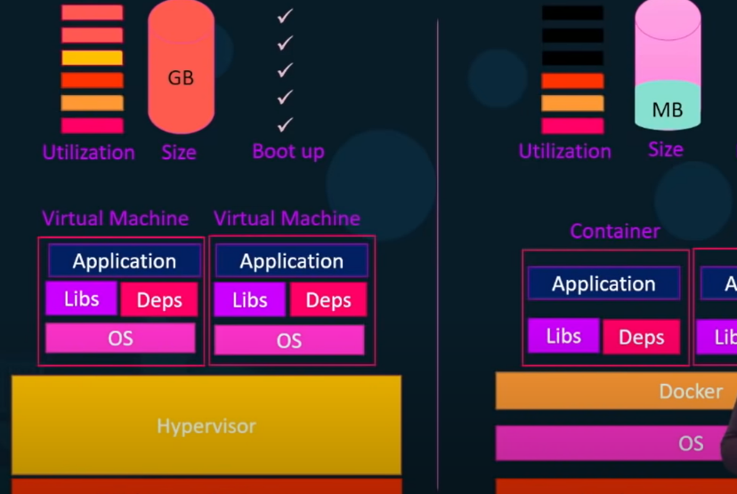

* When we have a large environment with thousands of containers, we use virtual docker hosts: virtualizations and containers. In this case we have thousands of containers for each virtual os.

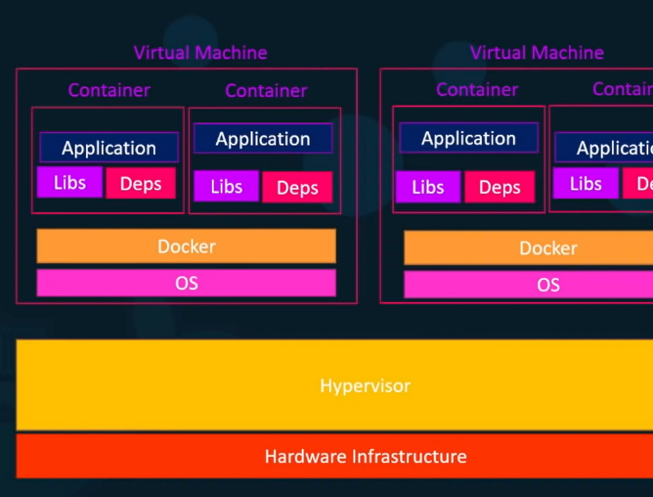

* Companies provide images of os, databases, tools. Install docker => the image that we need. Run the docker with the name of image. Doker hub repo.

docker run ansible

docker run mongodb

docker run nodejs

* We can have multiple instances of webservices. And configure the load balance in the front.
* An image is a package or template that is used to create one or more containers. Containers are running instances of images that are isolated and have their own environment and set of processes.
* Devops: The docker.file is used to create the image for an app (developer). Then we deploy it (operations).

Linux

Docs.docker.com => get docker, community.