Instalation

Windows:

* <https://www.postgresql.org/download/windows/>
* Uncheck the stack builder
* User-pass to login in local machine
* PGAdmin // database management platform. Web based. Manage, inspect postgres database. Can connect to local or remote databases( Amazon web services …) . Can view/change just about anything in PG.

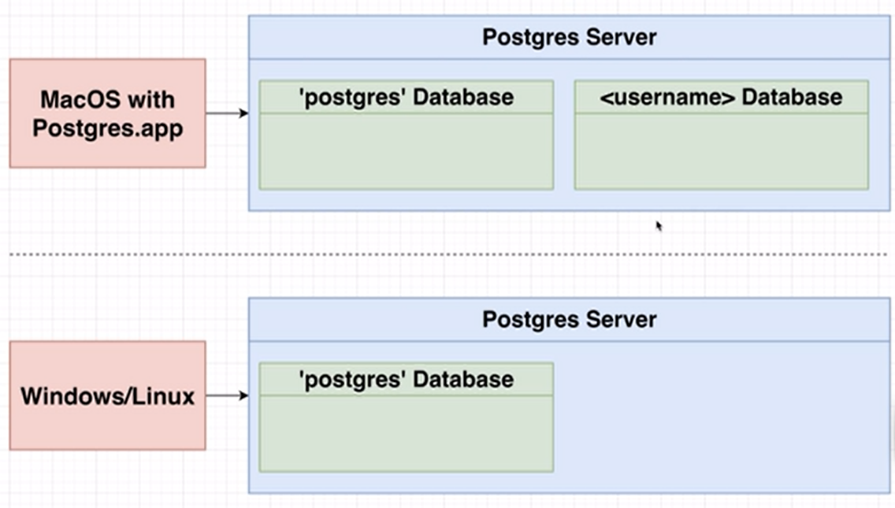

* What will be set up on our machine?
  + PGAdmin
  + Postgres Server // a piece of software. We can have multiple databases.

Parts

Postgres Keywords

* SELECT **GREATEST**(20,10,30);// select the greatest value from a list of values. It is for Postgres
  + Shipping is the maximum of (weight*$2) or $30

SELECT name, wight, GREATEST(30, 2*weight) FROM proudcts;

* **SELECT LEAST()** //

SELECT name, price, LEAST(400, 0.5*price) FROM proudcts;

* **CASE WHEN…THEN … ELSE END** // print a value for each row (create a new column) based on a condition. The comparison in WHEN can be anything that can be done in WHERE. It's not used very often since we do usually print with programming languages.
  + Print each product and its price. Also print a description of the price.

SELECT

name,

price,

CASE

WHEN price>600 THEN 'high'

WHEN price<300 THEN 'medium'

ELSE 'cheap'

END

FROM products;

* SELECT (2.0**::**INTEGER); // To define the type.
  + It is a CAST operation(cast to a date type).
  + SELECT now()::timestamp(0); Is equivalent to:
  + SELECT CAST (now() AS timestamp(0));
  + They both result in casting now() to timestamp in the following format: YYYY-MM-DD HH:MM:SS

Data types

* **SERIAL**