测试用例1：
read x;
y := x @ 2; { Invalid symbol @ }
write y $ { Invalid symbol $ }
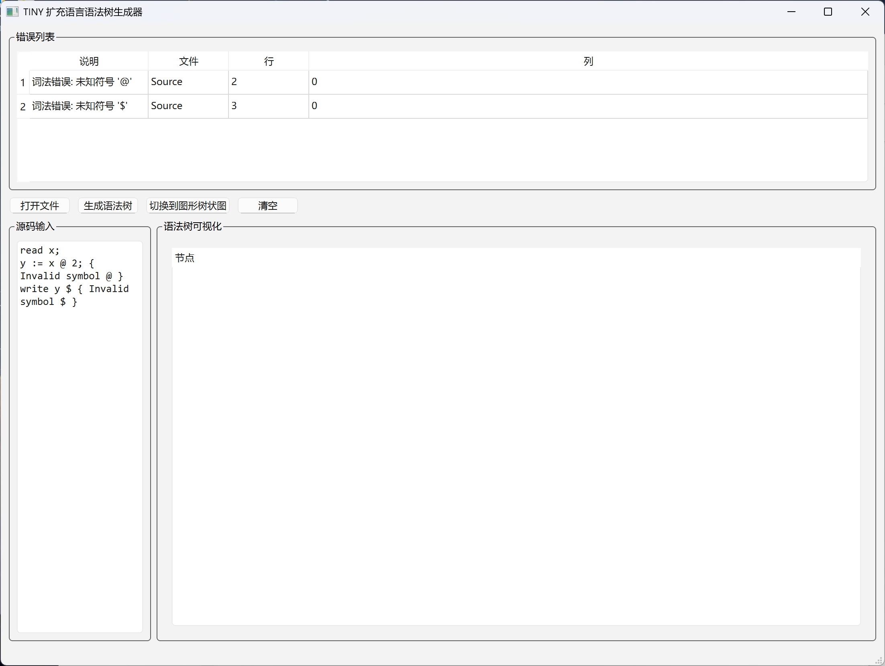

测试用例2：
{ Test all expanded features }
read x;
read y;
if x < y then
write y
else
write x
end;
z := (x + y) * (x - y) / 2 % 3 ^ 2;
while (z > 0)
write z;
--z
endwhile;
for (i := 0; i < 10; ++i)
write i
endfor
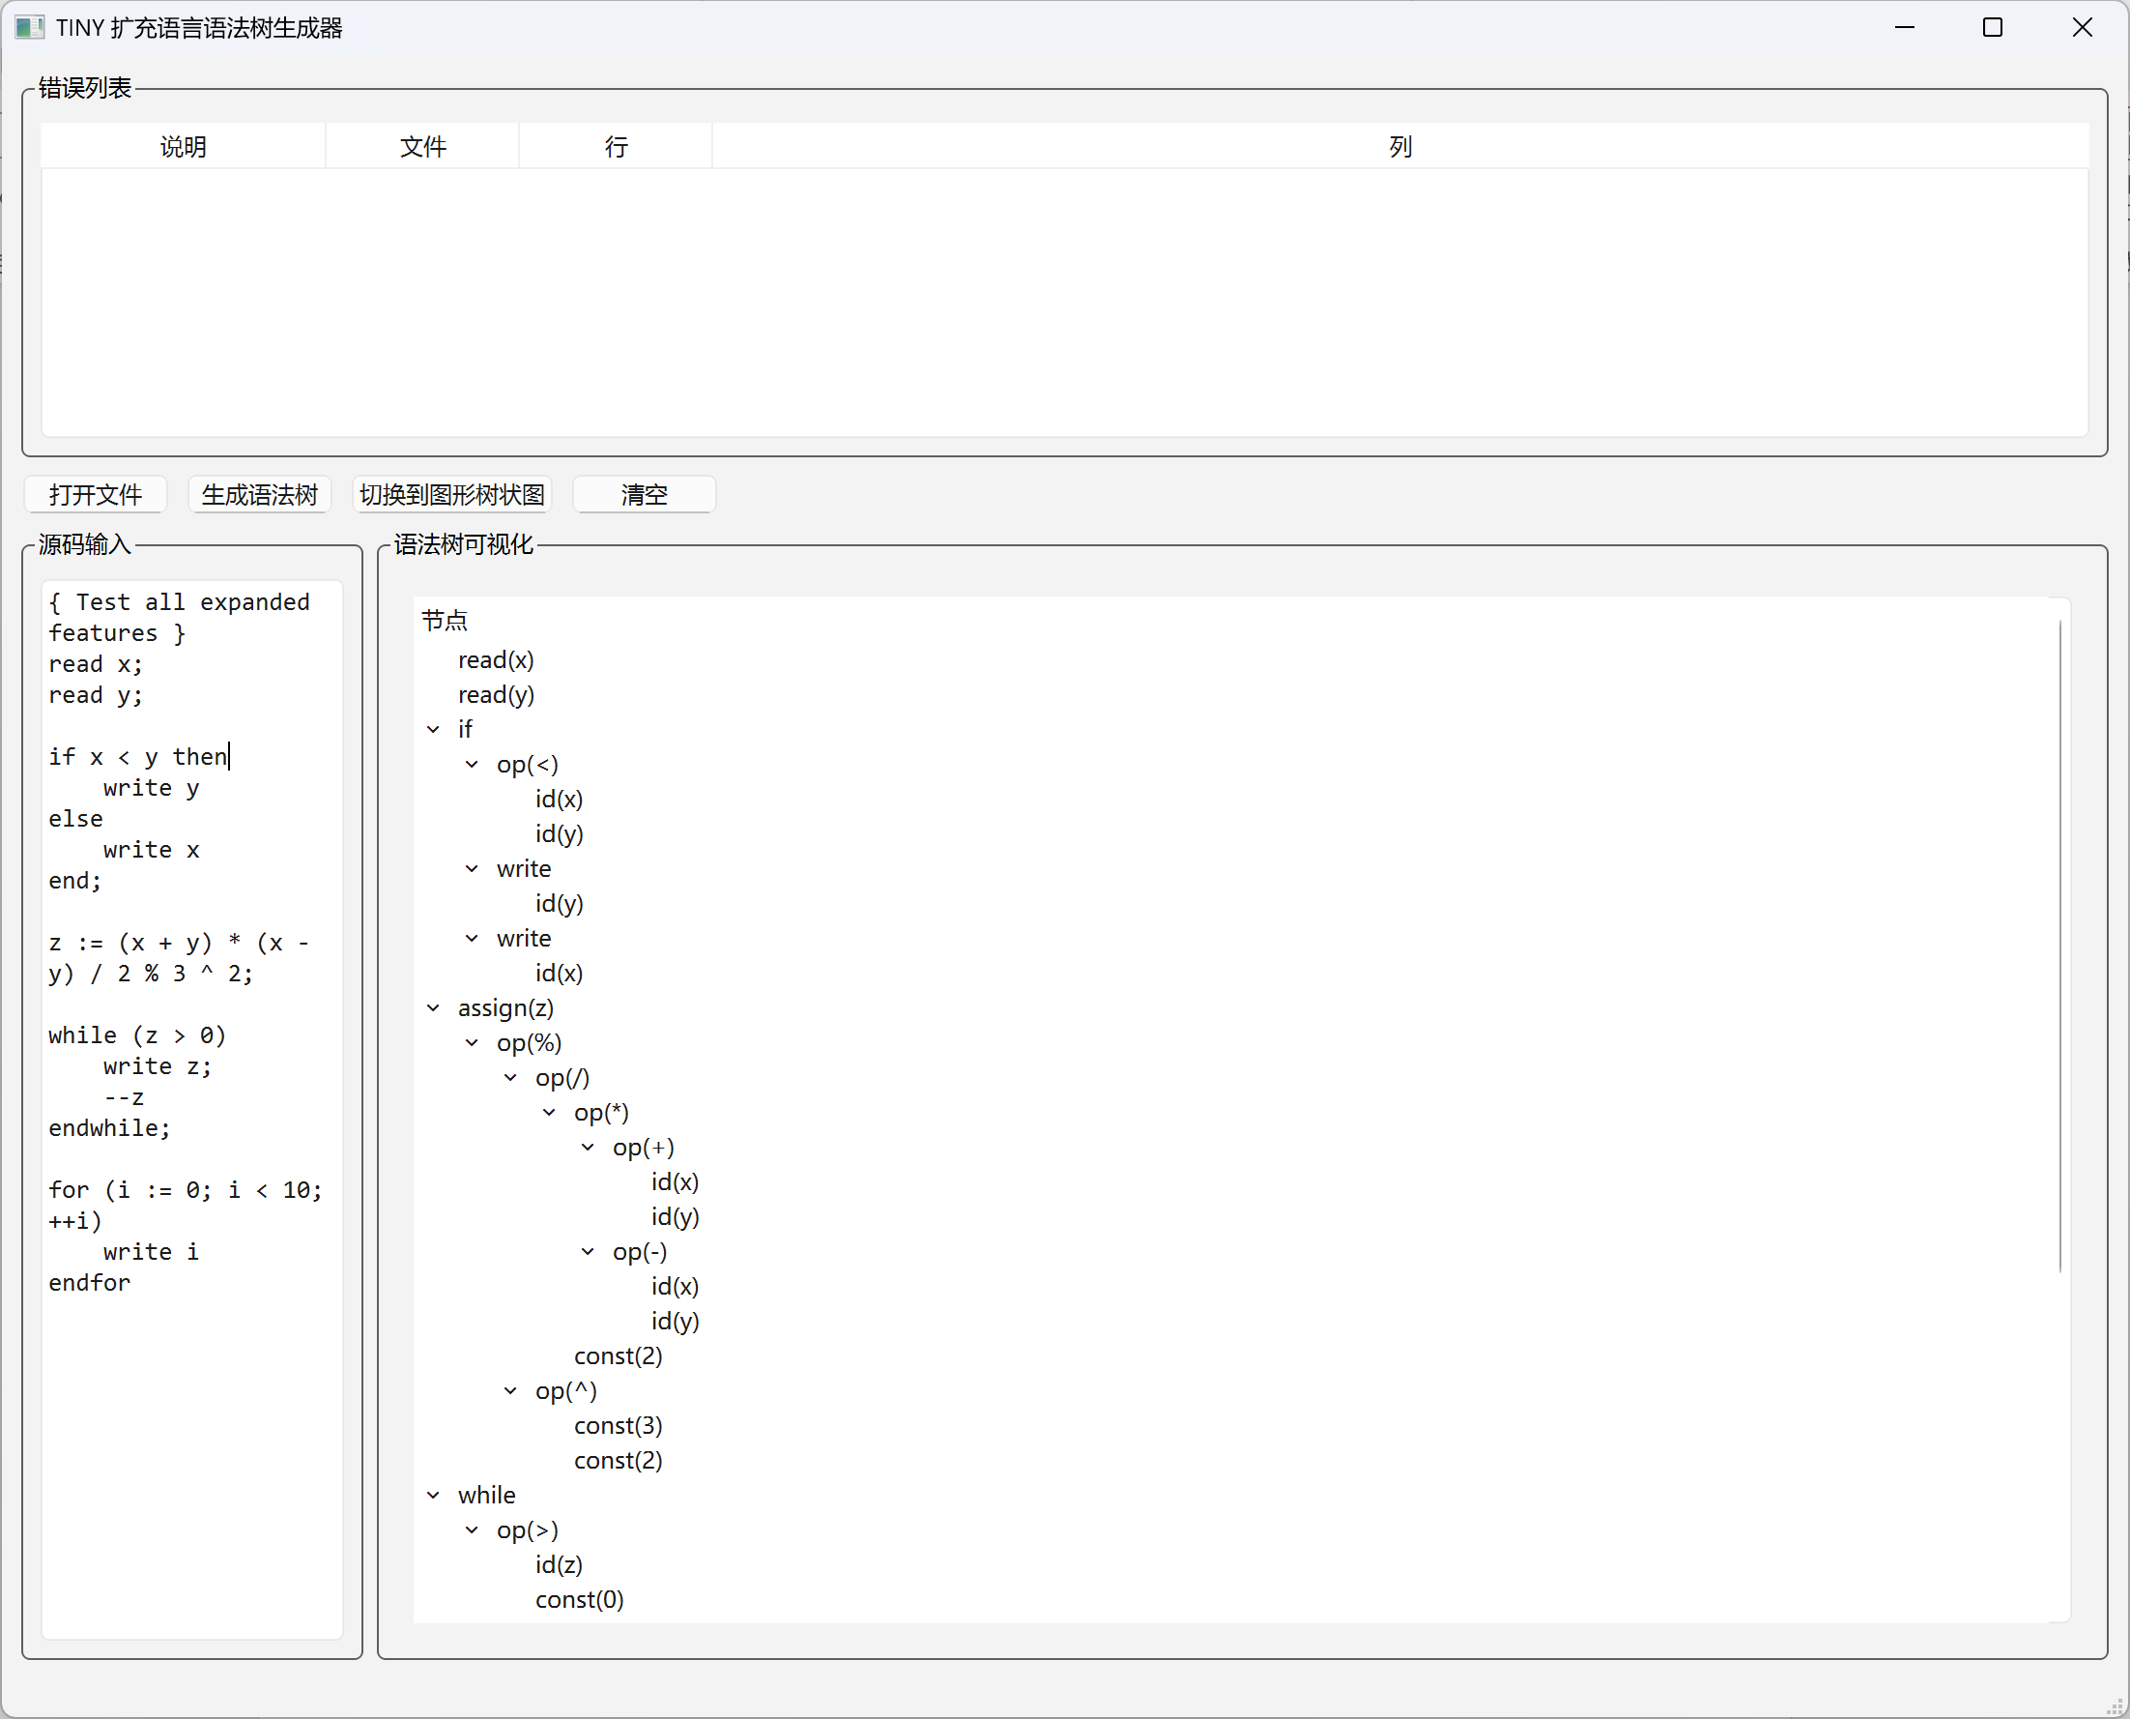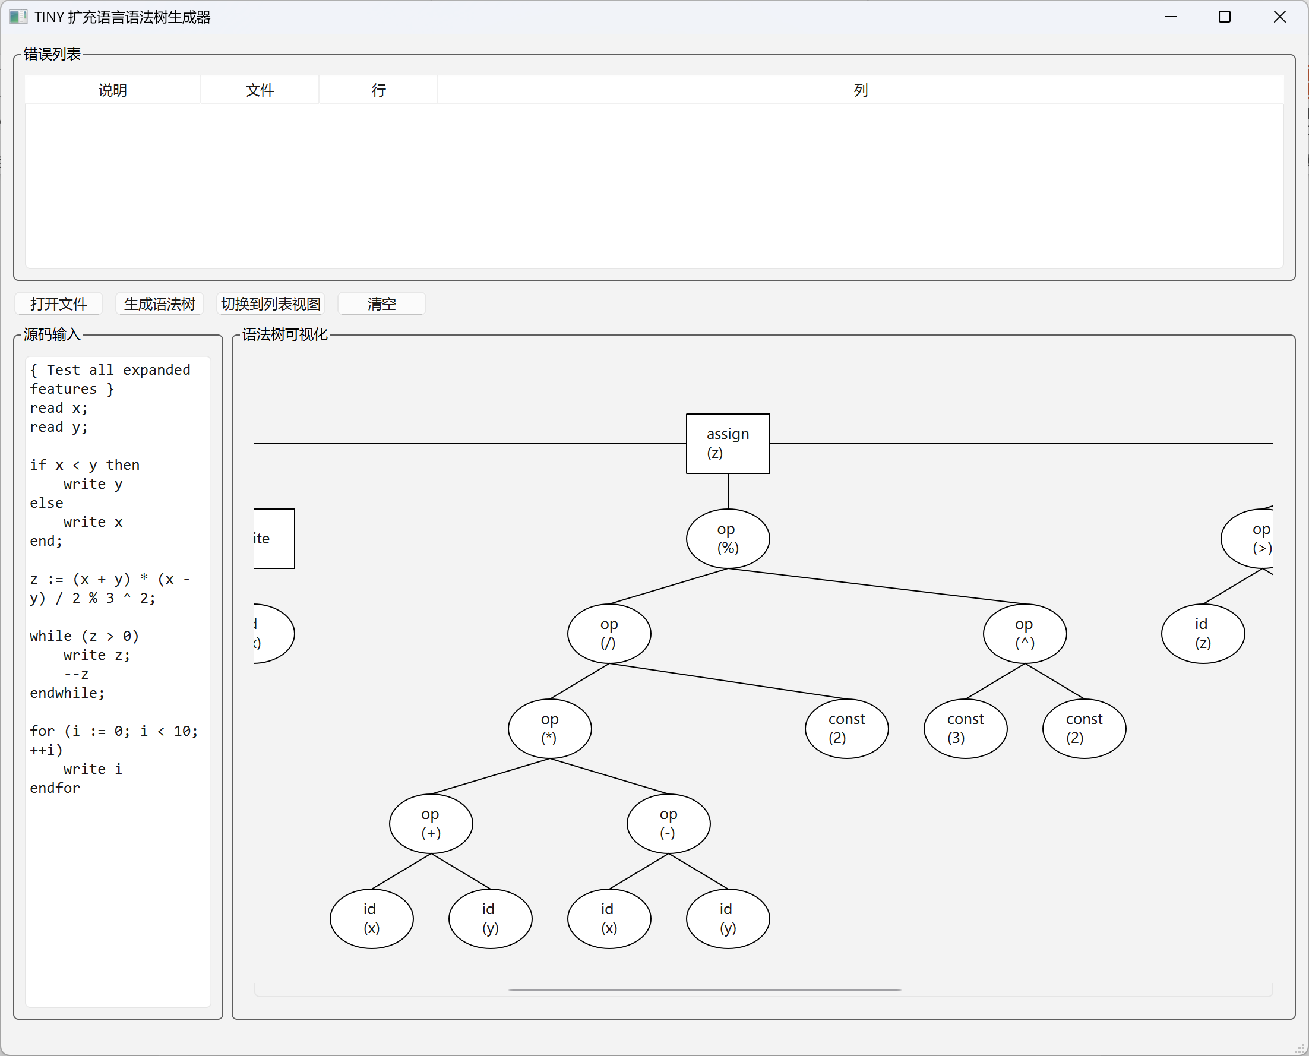

测试用例3：
{ Incorrect for loop }
for (i := 0 i < 10 ++i) { Missing semicolons }
write i
endfor
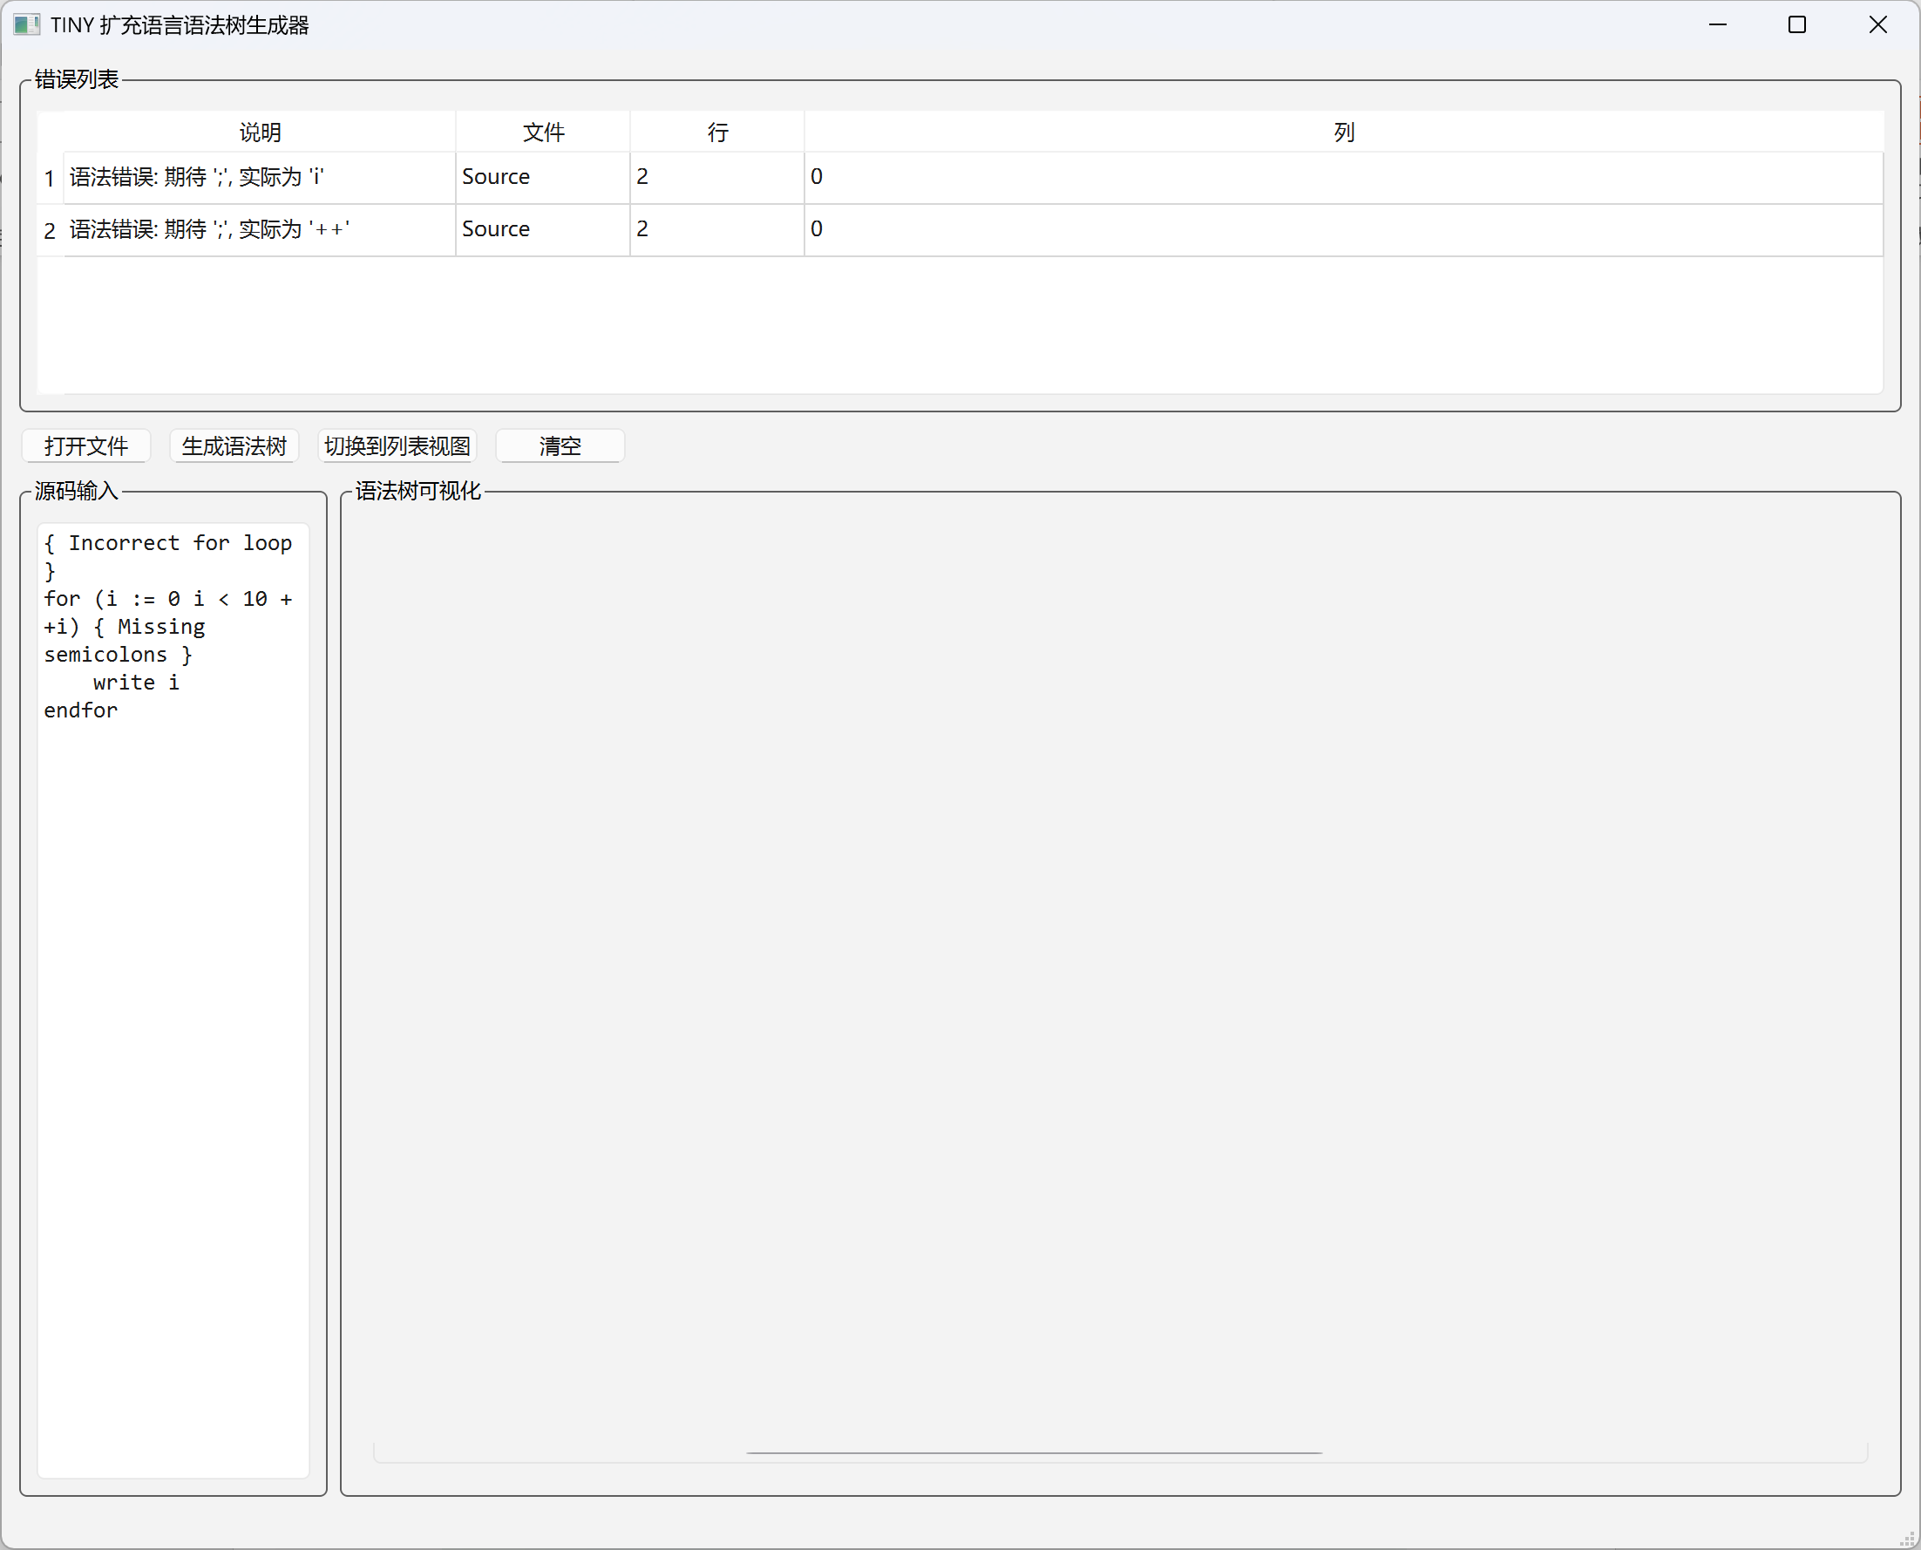

测试用例4：
{ Factorial with while loop }
read n;
fact := 1;
i := n;
while (i > 1)
fact := fact * i;
--i
endwhile;
write fact
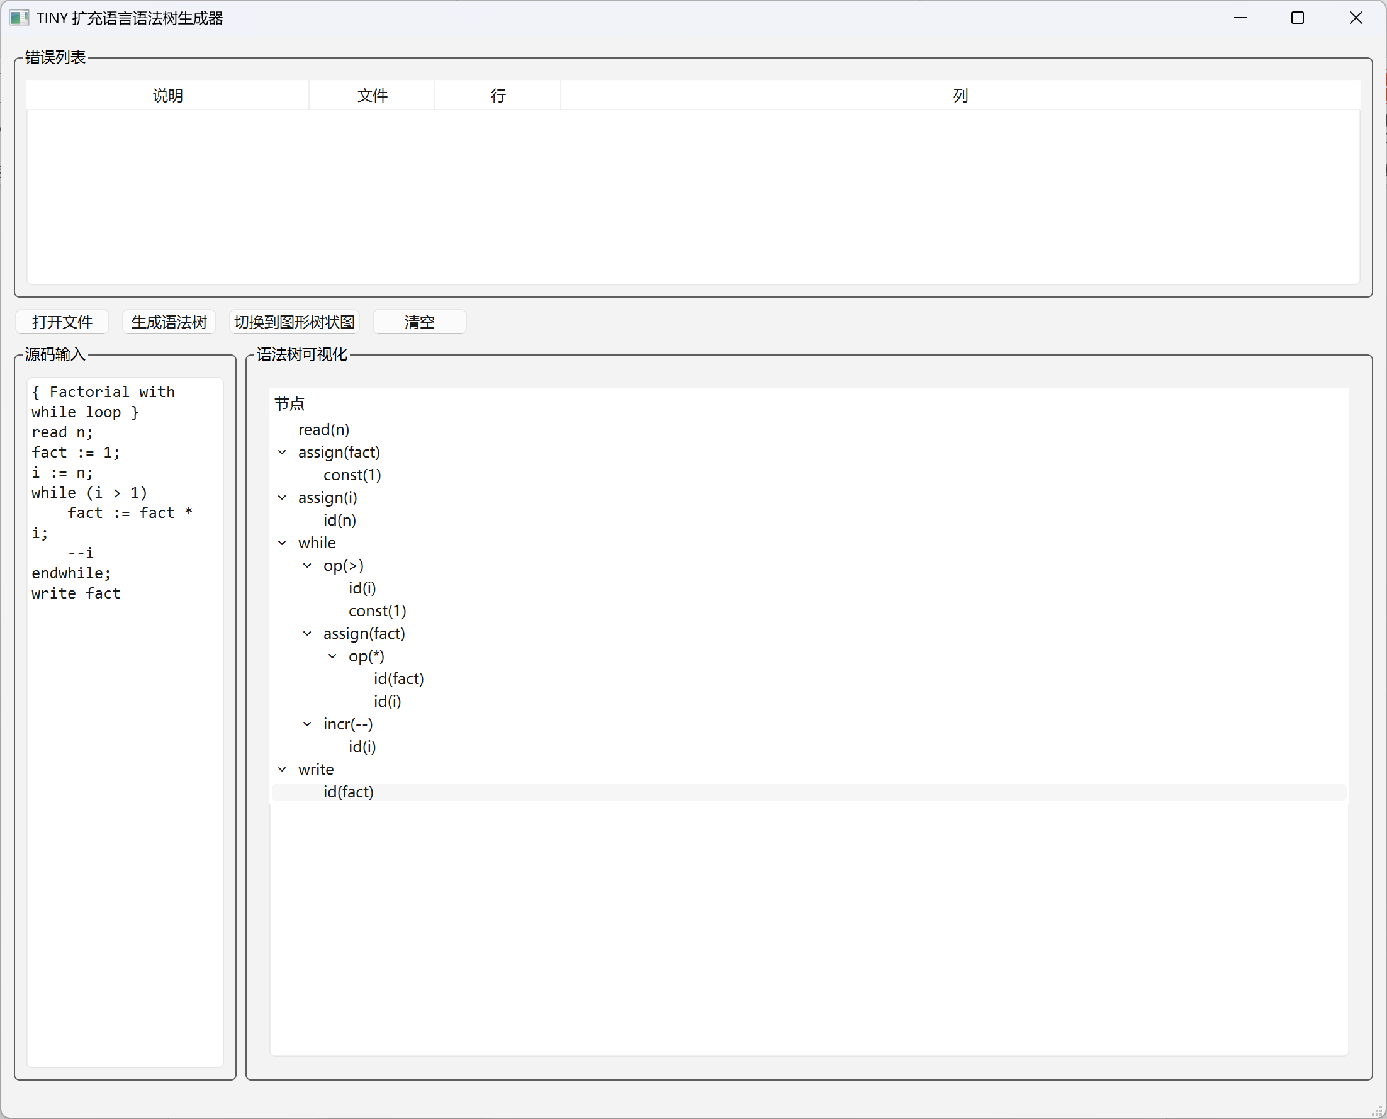
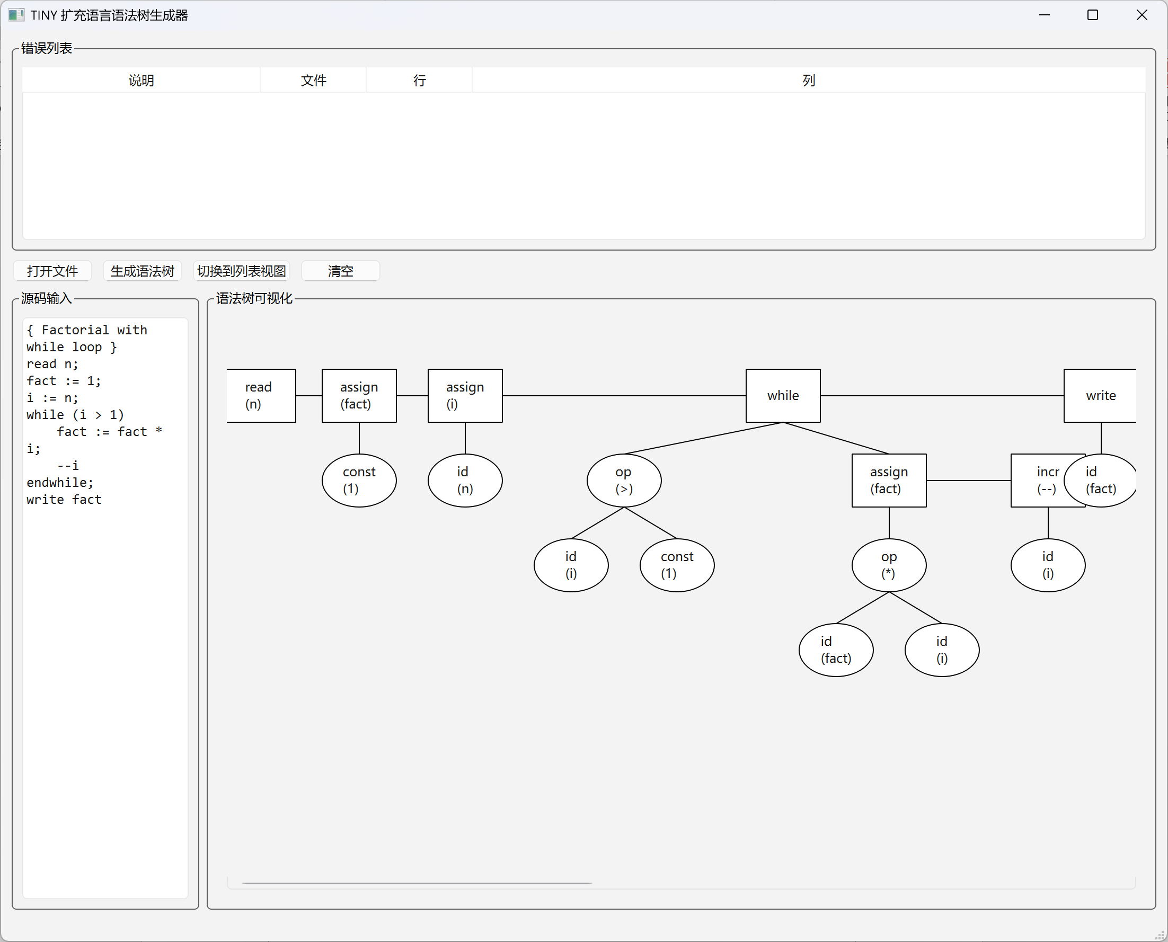

测试用例5：
read x;
if x > 0 { Missing then }
write x
{ Missing end }
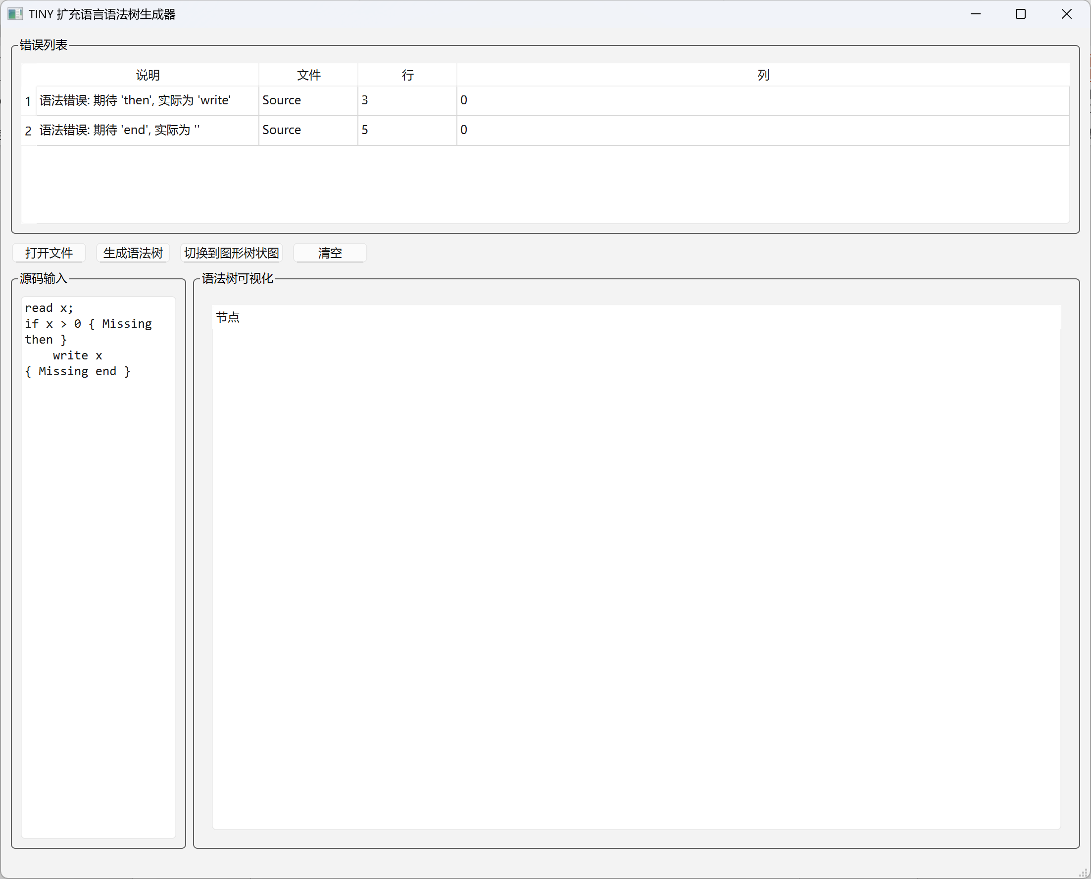

测试用例6：
{ Test regular expression features }
re1 ::= a | b & c?;
re2 ::= (a | #) & d;
re3 ::= a & b & c
