**ANNAMALAI** **UNIVERSITY**

**FACULTY OF ENGINEERING AND TECHNOLOGY**

**Department of Computer Science & Engineering**

**MOBILE APP DEVELOPMENT**

**ASSIGNMENT -1**

Routine



**Submitted to**

**Dr. K. T. Meena Abarna**

Designer

Documentation

Designer

Documentation

SANJEEVIKUMAR (LE06)

SABARIVASAN S (LE08)

Programmer

PRADEEP G (LE19)

MOHAMED AKRAM M N (LE11)

Programmer

DEEPATH KUMAR S (LE10)

BARATHRAJ B (LE05)

Your handy task manager for organizing & prioritizing your to-do list with ease.

**Project ROUTINE:**

**Crafting a Productive To-Do Application with User-Centric Features**

**Overview:**

This documentation will provide an in-depth exploration of the development process, from conceptualization to implementation. It will delve into the core features of "ROUTINE," including the ability to add tasks, set due dates, assign priorities, and mark tasks as completed. Throughout this journey, we will emphasize a user-centric approach, ensuring that every feature aligns with the needs and preferences of our target audience.

**Teck Stack:**

* **Development Environment:**
  + Android Studio: The primary integrated development environment (IDE) for Android app development.
* **Programming Language:**
  + Java: The core programming language used for developing the Android app.
* **Database Management:**
  + Room Persistence Library: A part of the Android Architecture Components, Room is used for local data persistence, making it easier to work with SQLite databases in Android.
* **User Interface (UI) Design:**
  + Android XML Layouts: For defining the app's user interface elements.
* **Version Control:**
  + Git: To manage version control and track changes in the project.
* **Documentation:**
  + Microsoft Word: For creating detailed documentation and reports for the assignment.
* **Testing:**
  + Android Emulator: For testing the app on different virtual Android devices.
* **Operating System:**
  + Windows and Linux

**System Requirement:**

* **Operating System:**
  + Android OS: The app is designed to run on Android devices, so it requires an Android operating system.
* **Minimum Android Version:**
  + Android 7.0 (Nougat): The app is compatible with Android devices running version 7.0 and above.
* **Device Screen Size:**
  + A minimum screen size of 4.5 inches is recommended for a comfortable user experience.
* **Storage Space:**
  + The app requires a minimum of 20MB of free storage space on the device for installation.
* **RAM (Memory):**
  + A device with at least 1GB of RAM is recommended for smooth app performance.
* **Internet Connectivity:**
  + The app can function without internet connection.
* **Permissions:**
  + The app requires permissions for accessing device storage to save data and reminders.

**Source code:**

The source code of the project is available on github ([*https://github.com/Dark-WizZ/Routine*](https://github.com/Dark-WizZ/Routine)).

MainActivity.java:

package com.darkwizz.routine;

import android.os.Bundle;

import com.darkwizz.routine.adaptor.OnTodoClickListener;

import com.darkwizz.routine.adaptor.RecyclerViewAdaptor;

import com.darkwizz.routine.model.SharedViewModel;

import com.darkwizz.routine.model.Task;

import com.darkwizz.routine.model.TaskViewModel;

import com.google.android.material.bottomsheet.BottomSheetBehavior;

import com.google.android.material.floatingactionbutton.FloatingActionButton;

import androidx.appcompat.app.AppCompatActivity;

import androidx.appcompat.widget.Toolbar;

import androidx.constraintlayout.widget.ConstraintLayout;

import androidx.lifecycle.ViewModelProvider;

import androidx.recyclerview.widget.LinearLayoutManager;

import androidx.recyclerview.widget.RecyclerView;

import android.view.Menu;

import android.view.MenuItem;

public class MainActivity extends AppCompatActivity implements OnTodoClickListener {

    private TaskViewModel taskViewModel;

    private static final String TAG = "ITEM";

    private RecyclerView recyclerView;

    private RecyclerViewAdaptor recyclerViewAdaptor;

    private int counter;

    BottomSheetFragment bottomSheetFragment;

    private SharedViewModel sharedViewModel;

    @Override

    protected void onCreate(Bundle savedInstanceState) {

        super.onCreate(savedInstanceState);

        setContentView(R.layout.activity_main);

        Toolbar toolbar = findViewById(R.id.toolbar);

        setSupportActionBar(toolbar);

        counter=0;

        bottomSheetFragment = new BottomSheetFragment();

        ConstraintLayout constraintLayout = findViewById(R.id.bottomSheet);

        BottomSheetBehavior<ConstraintLayout> bottomSheetBehavior = BottomSheetBehavior.from(constraintLayout);

        bottomSheetBehavior.setPeekHeight(BottomSheetBehavior.STATE_HIDDEN);

        recyclerView = findViewById(R.id.recycler_view);

        recyclerView.setHasFixedSize(true);

        recyclerView.setLayoutManager(new LinearLayoutManager(this));

        taskViewModel = new ViewModelProvider.AndroidViewModelFactory(

                MainActivity.this.getApplication())

                .create(TaskViewModel.class);

        sharedViewModel = new ViewModelProvider(this)

                .get(SharedViewModel.class);

        taskViewModel.getAllTasks().observe(this, tasks -> {

            recyclerViewAdaptor = new RecyclerViewAdaptor(tasks, this);

            recyclerView.setAdapter(recyclerViewAdaptor);

        });

        FloatingActionButton fab = findViewById(R.id.fab);

        fab.setOnClickListener(view -> {

//            Task task = new Task("Task" + counter++, Priority.MEDIUM, Calendar.getInstance().getTime(),

//                    Calendar.getInstance().getTime(),false);

//            TaskViewModel.insert(task);

            showBottomSheetDialog();

        });

    }

    private void showBottomSheetDialog() {

        bottomSheetFragment.show(getSupportFragmentManager(), bottomSheetFragment.getTag());

    }

    @Override

    public boolean onCreateOptionsMenu(Menu menu) {

        // Inflate the menu; this adds items to the action bar if it is present.

        getMenuInflater().inflate(R.menu.menu_main, menu);

        return true;

    }

    @Override

    public boolean onOptionsItemSelected(MenuItem item) {

        // Handle action bar item clicks here. The action bar will

        // automatically handle clicks on the Home/Up button, so long

        // as you specify a parent activity in AndroidManifest.xml.

        int id = item.getItemId();

        //noinspection SimplifiableIfStatement

        if (id == R.id.action_settings) {

            return true;

        }

        return super.onOptionsItemSelected(item);

    }

    @Override

    public void onTodoClick(Task task) {

        sharedViewModel.selectItem(task);

        sharedViewModel.setIsEdit(true);

        showBottomSheetDialog();

    }

    @Override

    public void onTodoRadioButtonClick(Task task) {

        TaskViewModel.delete(task);

        recyclerViewAdaptor.notifyDataSetChanged();

    }

}

BottomSheetFragment.java:

package com.darkwizz.routine;

import android.os.Bundle;

import android.text.TextUtils;

import android.view.LayoutInflater;

import android.view.View;

import android.view.ViewGroup;

import android.widget.CalendarView;

import android.widget.EditText;

import android.widget.ImageButton;

import android.widget.RadioButton;

import android.widget.RadioGroup;

import com.darkwizz.routine.model.Priority;

import com.darkwizz.routine.model.SharedViewModel;

import com.darkwizz.routine.model.Task;

import com.darkwizz.routine.model.TaskViewModel;

import com.darkwizz.routine.util.Utils;

import com.google.android.material.bottomsheet.BottomSheetDialogFragment;

import com.google.android.material.chip.Chip;

import com.google.android.material.snackbar.Snackbar;

import androidx.annotation.NonNull;

import androidx.constraintlayout.widget.Group;

import androidx.lifecycle.ViewModelProvider;

import java.util.Calendar;

import java.util.Date;

public class BottomSheetFragment extends BottomSheetDialogFragment implements View.OnClickListener{

    private EditText enterTodo;

    private ImageButton calendarButton;

    private ImageButton priorityButton;

    private RadioGroup priorityRadioGroup;

    private RadioButton selectedRadioButton;

    private int selectedButtonId;

    private ImageButton saveButton;

    private CalendarView calendarView;

    private Group calendarGroup;

    private Date dueDate;

    Calendar calendar = Calendar.getInstance();

    private SharedViewModel sharedViewModel;

    private boolean isEdit;

    private Priority priority;

    public BottomSheetFragment(){

    }

    @Override

    public View onCreateView(

            LayoutInflater inflater, ViewGroup container,

            Bundle savedInstanceState

    ) {

        // Inflate the layout for this fragment

        View view = inflater.inflate(R.layout.bottom_sheet, container, false);

        calendarGroup = view.findViewById(R.id.calendar_group);

        calendarView = view.findViewById(R.id.calendar_view);

        calendarButton = view.findViewById(R.id.today_calendar_button);

        enterTodo = view.findViewById(R.id.enter_todo_et);

        saveButton = view.findViewById(R.id.save_todo_button);

        priorityButton = view.findViewById(R.id.priority_todo_button);

        priorityRadioGroup = view.findViewById(R.id.radioGroup_priority);

        Chip todayChip = view.findViewById(R.id.today_chip);

        todayChip.setOnClickListener(this);

        Chip tommorowChip = view.findViewById(R.id.tomorrow_chip);

        tommorowChip.setOnClickListener(this);

        Chip nextWeekChip = view.findViewById(R.id.next_week_chip);

        nextWeekChip.setOnClickListener(this);

        return view;

    }

    @Override

    public void onResume() {

        super.onResume();

        if(sharedViewModel.getSelectedItem().getValue() != null){

            isEdit = sharedViewModel.getIsEdit();

            Task task = sharedViewModel.getSelectedItem().getValue();

            enterTodo.setText(task.getTask());

        }

    }

    public void onViewCreated(@NonNull View view, Bundle savedInstanceState) {

        super.onViewCreated(view, savedInstanceState);

        sharedViewModel = new ViewModelProvider(requireActivity())

                .get(SharedViewModel.class);

        calendarButton.setOnClickListener(view1 -> {

            calendarGroup.setVisibility(

                    calendarGroup.getVisibility() == View.GONE ? View.VISIBLE : View.GONE

            );

            Utils.hideSoftKeyboard(view1);

        });

        calendarView.setOnDateChangeListener((calendarView, year, month, dayOfMonth) ->{

            calendar.clear();

            calendar.set(year, month, dayOfMonth);

            dueDate = calendar.getTime();

        });

        priorityButton.setOnClickListener(view1 -> {

            Utils.hideSoftKeyboard(view1);

            priorityRadioGroup.setVisibility(

                    priorityRadioGroup.getVisibility() == View.GONE ? View.VISIBLE : View.GONE

            );

            priorityRadioGroup.setOnCheckedChangeListener((radioGroup, checkedId) -> {

                if (priorityRadioGroup.getVisibility() == View.VISIBLE){

                    selectedButtonId = checkedId;

                    selectedRadioButton = view.findViewById(selectedButtonId);

                    if(selectedRadioButton.getId() == R.id.radioButton_high){

                        priority = Priority.HIGH;

                    }else if(selectedRadioButton.getId() == R.id.radioButton_med){

                        priority = Priority.MEDIUM;

                    }else if(selectedRadioButton.getId() == R.id.radioButton_low){

                        priority = Priority.LOW;

                    }else{

                        priority = Priority.LOW;

                    }

                }else{

                    priority = Priority.LOW;

                }

            });

        });

        saveButton.setOnClickListener(view1 -> {

            String task = enterTodo.getText().toString().trim();

            if(!TextUtils.isEmpty(task) && dueDate != null && priority != null){

                Task myTask = new Task(task, priority,

                        dueDate, Calendar.getInstance().getTime(),

                        false);

                if(isEdit){

                    Task updateTask = sharedViewModel.getSelectedItem().getValue();

                    updateTask.setTask(task);

                    updateTask.setDateCreated(Calendar.getInstance().getTime());

                    updateTask.setPriority(priority   );

                    updateTask.setDueDate(dueDate);

                    TaskViewModel.update(updateTask);

                    sharedViewModel.setIsEdit(false);

                }else {

                    TaskViewModel.insert(myTask);

                }

                enterTodo.setText("");

                if (this.isVisible()){

                    this.dismiss();

                }

            }else{

                Snackbar.make(saveButton, R.string.empty_field, Snackbar.LENGTH_LONG)

                        .show();

            }

        });

    }

    @Override

    public void onClick(View view) {

        int id = view.getId();

        if (id == R.id.today_chip){

            calendar.add(Calendar.DAY_OF_YEAR,0);

            dueDate = calendar.getTime();

        }else if(id==R.id.tomorrow_chip){

            calendar.add(Calendar.DAY_OF_YEAR,1);

            dueDate = calendar.getTime();

        }else if(id==R.id.next_week_chip){

            calendar.add(Calendar.DAY_OF_YEAR,7);

            dueDate = calendar.getTime();

        }

    }

}

activity_main.xml:

<?xml version="1.0" encoding="utf-8"?>

<androidx.coordinatorlayout.widget.CoordinatorLayout xmlns:android="http://schemas.android.com/apk/res/android"

    xmlns:app="http://schemas.android.com/apk/res-auto"

    xmlns:tools="http://schemas.android.com/tools"

    android:layout_width="match_parent"

    android:layout_height="match_parent"

    tools:context=".MainActivity">

    <com.google.android.material.appbar.AppBarLayout

        android:layout_width="match_parent"

        android:layout_height="wrap_content"

        android:theme="@style/Theme.Todoister.AppBarOverlay">

        <androidx.appcompat.widget.Toolbar

            android:id="@+id/toolbar"

            android:layout_width="match_parent"

            android:layout_height="?attr/actionBarSize"

            android:background="?attr/colorPrimary"

            app:popupTheme="@style/Theme.Todoister.PopupOverlay" />

    </com.google.android.material.appbar.AppBarLayout>

    <com.google.android.material.floatingactionbutton.FloatingActionButton

        android:id="@+id/fab"

        android:layout_width="wrap_content"

        android:layout_height="wrap_content"

        android:layout_gravity="bottom|end"

        android:layout_margin="@dimen/fab_margin"

        app:srcCompat="@android:drawable/ic_input_add"

        tools:ignore="ContentDescription" />

    <androidx.recyclerview.widget.RecyclerView

        android:id="@+id/recycler_view"

        android:layout_width="match_parent"

        android:layout_height="match_parent"

        android:layout_marginTop="@dimen/dimen_60"

        android:padding="@dimen/recycler_padding"

        android:visibility="visible">

    </androidx.recyclerview.widget.RecyclerView>

    <include layout="@layout/bottom_sheet"/>

</androidx.coordinatorlayout.widget.CoordinatorLayout>

bottom_sheet.xml:

<?xml version="1.0" encoding="utf-8"?>

<androidx.constraintlayout.widget.ConstraintLayout xmlns:android="http://schemas.android.com/apk/res/android"

    xmlns:app="http://schemas.android.com/apk/res-auto"

    android:id="@+id/bottomSheet"

    style="@style/Animation.Design.BottomSheetDialog"

    android:layout_width="match_parent"

    android:layout_height="match_parent"

    android:background="#fff"

    app:behavior_hideable="false"

    app:behavior_peekHeight="@dimen/dimen_32"

    app:layout_behavior="com.google.android.material.bottomsheet.BottomSheetBehavior">

    <EditText

        android:id="@+id/enter_todo_et"

        android:layout_width="0dp"

        android:layout_height="wrap_content"

        android:layout_margin="@dimen/dimen_16"

        android:hint="@string/enter_todo_hint"

        android:inputType="textPersonName"

        android:padding="@dimen/dimen_16"

        app:layout_constraintEnd_toEndOf="parent"

        app:layout_constraintStart_toStartOf="parent"

        app:layout_constraintTop_toTopOf="parent" />

    <ImageButton

        android:id="@+id/priority_todo_button"

        android:layout_width="77dp"

        android:layout_height="46dp"

        android:layout_marginStart="24dp"

        android:layout_marginTop="16dp"

        android:background="@android:color/transparent"

        app:layout_constraintStart_toEndOf="@+id/today_calendar_button"

        app:layout_constraintTop_toBottomOf="@+id/enter_todo_et"

        app:srcCompat="@drawable/ic_baseline_outlined_flag_24"

        android:contentDescription="@string/image_description" />

    <ImageButton

        android:id="@+id/save_todo_button"

        android:layout_width="70dp"

        android:layout_height="72dp"

        android:layout_marginTop="16dp"

        android:background="@android:color/transparent"

        android:scaleX="0.4"

        android:scaleY="0.4"

        android:contentDescription="TODO"

        app:layout_constraintEnd_toEndOf="parent"

        app:layout_constraintHorizontal_bias="0.843"

        app:layout_constraintStart_toEndOf="@+id/priority_todo_button"

        app:layout_constraintTop_toBottomOf="@+id/enter_todo_et"

        app:srcCompat="@drawable/ic_baseline_arrow_circle_up_24" />

    <ImageButton

        android:id="@+id/today_calendar_button"

        android:layout_width="74dp"

        android:layout_height="48dp"

        android:layout_marginStart="16dp"

        android:contentDescription="@string/image_description"

        android:layout_marginTop="16dp"

        android:background="@android:color/transparent"

        app:layout_constraintStart_toStartOf="parent"

        app:layout_constraintTop_toBottomOf="@+id/enter_todo_et"

        app:srcCompat="@drawable/ic_baseline_calendar_today_24" />

    <com.google.android.material.chip.Chip

        android:id="@+id/tomorrow_chip"

        android:layout_width="269dp"

        android:layout_height="41dp"

        android:text="@string/tomorrow"

        app:chipIcon="@drawable/ic_baseline_wb_sunny_24"

        app:layout_constraintEnd_toEndOf="@+id/next_week_chip"

        app:layout_constraintHorizontal_bias="1.0"

        app:layout_constraintStart_toStartOf="@+id/next_week_chip"

        app:layout_constraintTop_toBottomOf="@+id/today_chip" />

    <com.google.android.material.chip.Chip

        android:id="@+id/next_week_chip"

        android:layout_width="272dp"

        android:layout_height="41dp"

        android:background="@android:color/transparent"

        android:text="@string/next_week"

        app:chipIcon="@drawable/ic_baseline_next_week_24"

        app:layout_constraintEnd_toEndOf="parent"

        app:layout_constraintStart_toStartOf="parent"

        app:layout_constraintTop_toBottomOf="@+id/tomorrow_chip" />

    <com.google.android.material.chip.Chip

        android:id="@+id/today_chip"

        android:layout_width="267dp"

        android:layout_height="41dp"

        android:layout_marginTop="2dp"

        android:text="@string/today"

        app:chipIcon="@drawable/ic_baseline_today_24"

        app:layout_constraintEnd_toEndOf="@+id/tomorrow_chip"

        app:layout_constraintStart_toStartOf="@+id/tomorrow_chip"

        app:layout_constraintTop_toBottomOf="@+id/textView" />

    <TextView

        android:id="@+id/textView"

        android:layout_width="244dp"

        android:layout_height="33dp"

        android:layout_marginTop="48dp"

        android:gravity="center_horizontal"

        android:text="@string/due_date_text"

        android:textSize="18sp"

        android:textStyle="bold"

        app:layout_constraintEnd_toEndOf="parent"

        app:layout_constraintHorizontal_bias="0.497"

        app:layout_constraintStart_toStartOf="parent"

        app:layout_constraintTop_toBottomOf="@+id/priority_todo_button" />

    <CalendarView

        android:id="@+id/calendar_view"

        android:layout_width="318dp"

        android:layout_height="296dp"

        app:layout_constraintBottom_toBottomOf="parent"

        app:layout_constraintEnd_toEndOf="parent"

        app:layout_constraintHorizontal_bias="0.494"

        app:layout_constraintStart_toStartOf="parent"

        app:layout_constraintTop_toBottomOf="@+id/next_week_chip"

        app:layout_constraintVertical_bias="0.16000003" />

    <RadioGroup

        android:id="@+id/radioGroup_priority"

        android:layout_width="0dp"

        android:layout_height="51dp"

        android:layout_marginTop="8dp"

        android:orientation="horizontal"

        android:padding="@dimen/dimen_10"

        android:visibility="gone"

        app:layout_constraintEnd_toEndOf="parent"

        app:layout_constraintStart_toStartOf="parent"

        app:layout_constraintTop_toBottomOf="@+id/priority_todo_button">

        <RadioButton

            android:id="@+id/radioButton_high"

            android:layout_width="wrap_content"

            android:layout_height="wrap_content"

            android:layout_weight="1"

            android:background="#C91517"

            android:text="@string/radio_high" />

        <RadioButton

            android:id="@+id/radioButton_med"

            android:layout_width="wrap_content"

            android:layout_height="wrap_content"

            android:layout_weight="1"

            android:background="#FFB300"

            android:text="@string/radio_med" />

    </RadioGroup>

    <androidx.constraintlayout.widget.Group

        android:id="@+id/calendar_group"

        android:layout_width="280dp"

        android:layout_height="0dp"

        android:visibility="gone"

        app:constraint_referenced_ids="calendar_view,next_week_chip,tomorrow_chip,today_chip,textView"

        app:layout_constraintEnd_toEndOf="parent"

        app:layout_constraintStart_toStartOf="parent" />

</androidx.constraintlayout.widget.ConstraintLayout>

**Demo:**

Creating a task: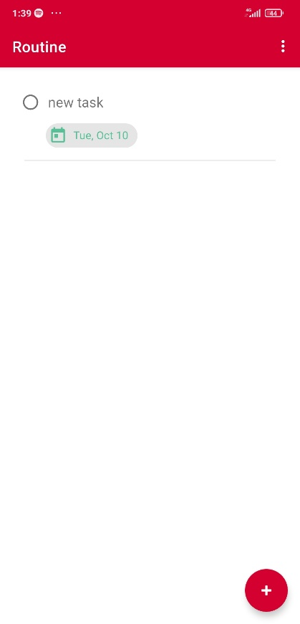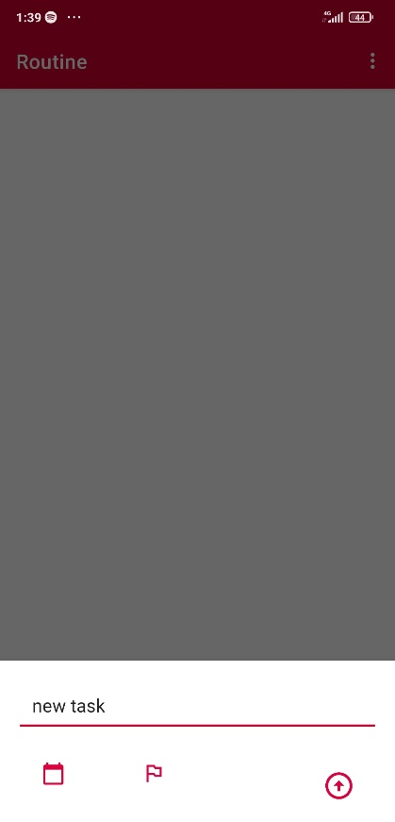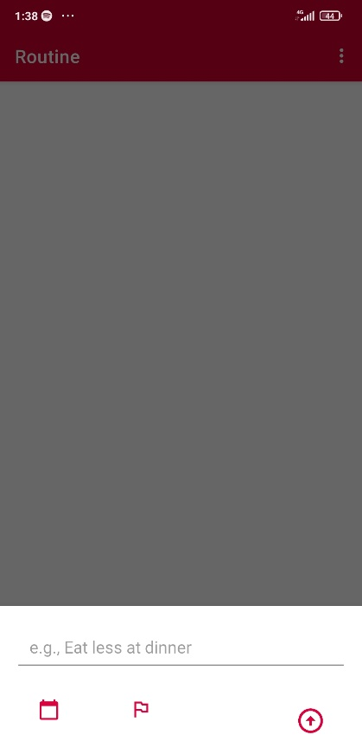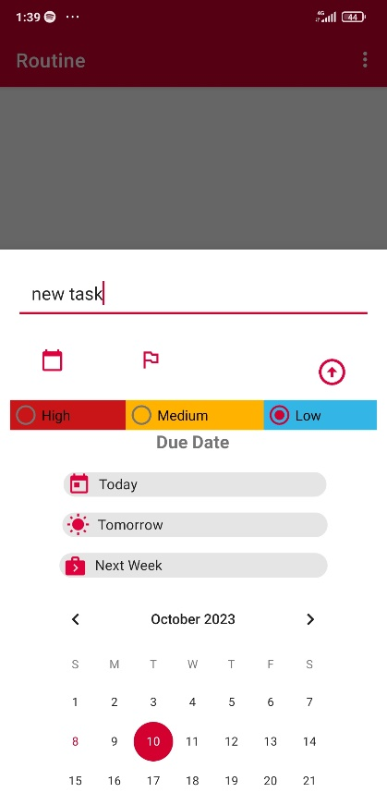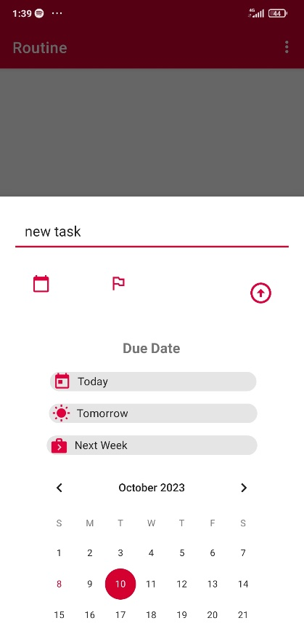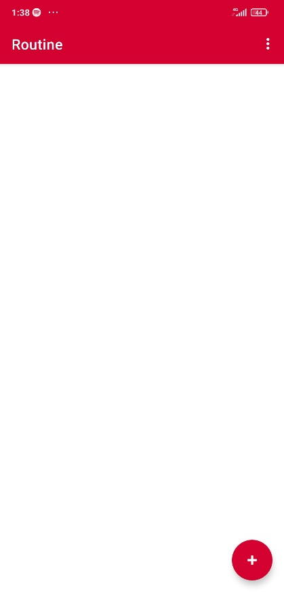

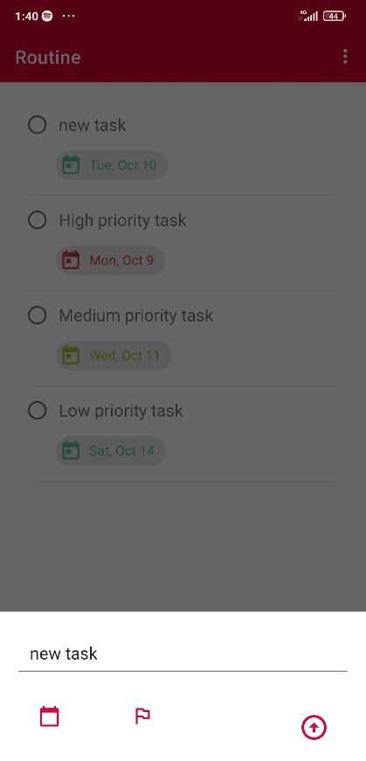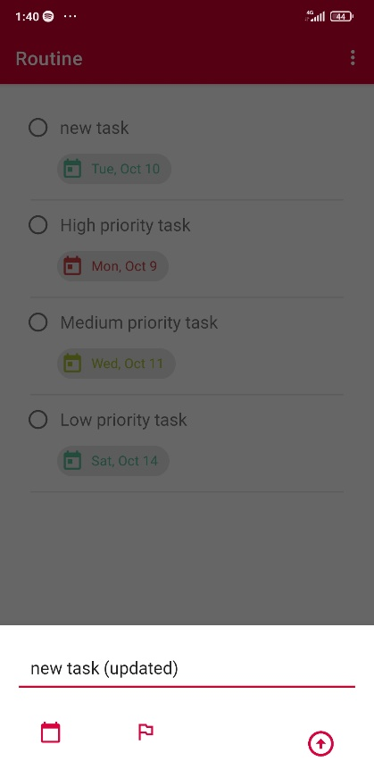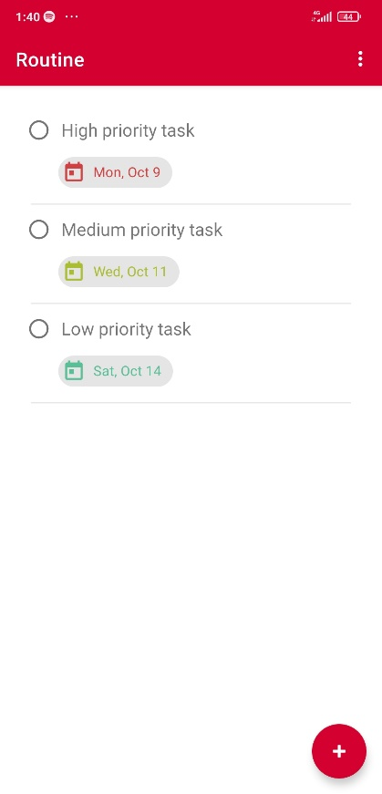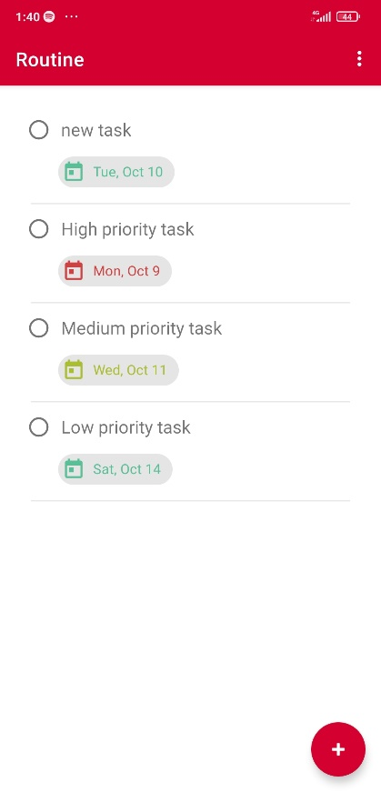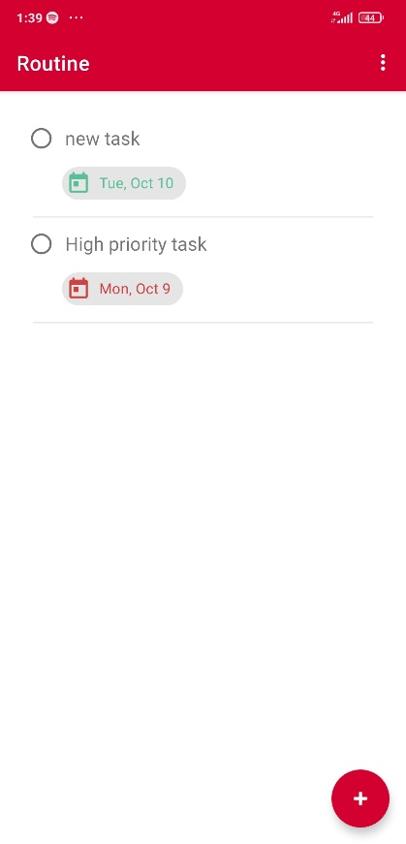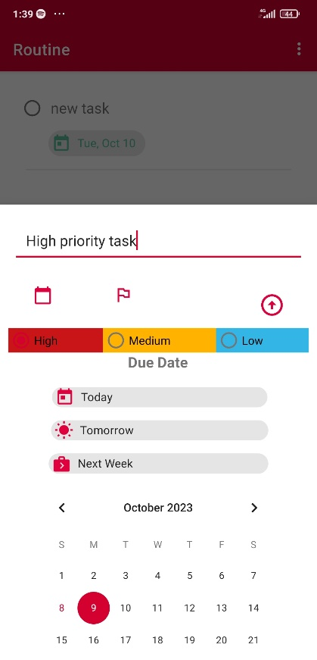Prioritizing task:

Updating task:

**End Note:**

In the journey of creating "ROUTINE," the to-do app for efficient task management, we learned valuable lessons in software development, user-centric design, and project management. This assignment allowed me to explore the intricacies of Android app development using Java and Room Persistence Library, fostering a deeper understanding of mobile application architecture.

As we crafted each feature and meticulously designed the user interface, I gained insights into the importance of simplicity and user-friendliness in app design. The emphasis on user-centric features such as task prioritization and due date management reflects a commitment to delivering a product that genuinely enhances productivity and organization.

We want to express our gratitude to my instructor for this assignment, which provided an opportunity to apply theoretical knowledge to real-world development. The process of creating "ROUTINE" has been both challenging and rewarding, and I look forward to further honing my skills as a developer.

Lastly, we want to acknowledge the support and encouragement of our friends and fellow students who provided valuable feedback and insights throughout this project.

Thank you