**Vpc –virtual private Cloud:**

**Amazon Virtual Private Cloud (Amazon VPC) enables you to launch AWS resources into a virtual network that you've defined. This virtual network closely resembles a traditional network that you'd operate in your own data center, with the benefits of using the scalable infrastructure of AWS**.

**Amazon VPC concepts**

**Vpc is the networking layer for amazon EC2**

**The following are the key concepts for VPCs**:

**virtual private cloud (VPC)** –A virtual network dedicated to your AWS account.

**subnets** ---- A range of ip address in your Vpc.

**Route table** ------ A set of rules called routes that are used to determine where network

Traffic is directed.

**Internet gateway** ------ A gateway that you attach to your VPC to enable communication

Between resources in your VPC and the internet.

**Vpc endpoint** --- Enables you to privately connect your Vpc to supported Aws services

And Vpc endpoint services powered by Vpc connection

**CIDR Block** ----- Classless Inter-d=Domain Routing. An internet

Protocol address allocation and route aggregation methodology.

**Internet gateway** – A type of internet gateway that allows an EC2 instance in

Subnets to access the internet but prevents resources on the internet form

Initiating communication with the instance.

**Nat gateway** – A managed AWS service that allows EC2 instances in private

Subnets to connect to the internet other VPCs or on premises network.

**NAT instance** --- An EC2 instance in a public subnet that allows instances in private subnets to connect to the internet, other VPCs, or on-premises networks.

**DHCP options sets** ---- Configuration information (such as domain name and domain name server) passed to EC2 instances when they are launched into VPC subnets.

**Prefix lists** ------------ A collection of CIDR blocks that can be used to configure VPC security groups, VPC route tables, and AWS Transit Gateway route tables and can be shared with other AWS accounts using Resource Access Manager (RAM).

**Network ACLs** --------- An optional layer of security for your VPC that acts as a firewall for controlling traffic in and out of your subnets.

**1 How do I create a vpc ?**

**: go to the amazon vpc console**

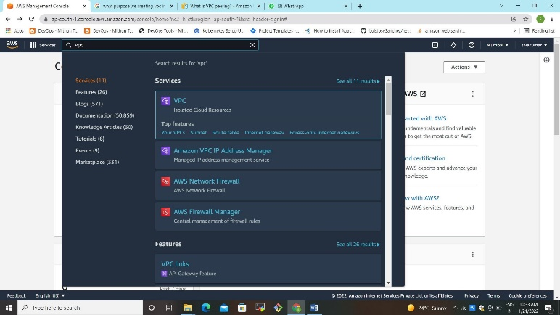

**Click the VPC it will display the VPC Dasboard**

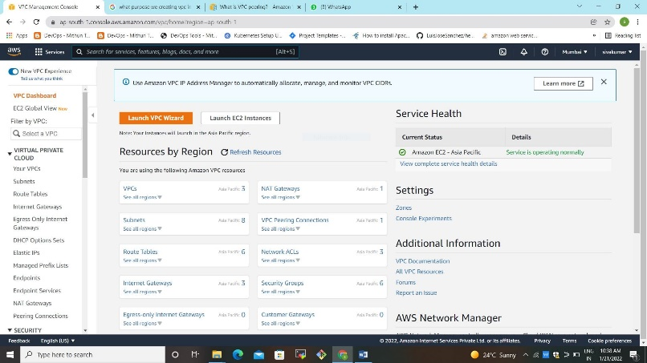

1. **Go to VPCs here we create our own vpc**
2. **Vpc prerequisite:**
3. **1 Creating VPC**
4. **2 Creating CIDR--------10.0.0.0/16 ----go to the Actions -------- Edit DNS host name ---- Enable the check box**
5. **3 Creating subnets ----inside public subnets ------private subnets ---data subnets**
6. **4 Creating Nat Gateway**
7. **5 creating the internet gateway------attach to Vpc**
8. **6 creating Route Table**
9. **public subnets -----private Subnets**
10. **attaching subnets associations**
11. **adding Routes - public –ADD --IGW**
12. **private-----ADD - NAT-GW**
13. **DATA Subnets ------NAT-GW**

CIDR RANGES

dev-private-subnet-1-zone-1-10.0.0.0/19

dev-private-subnet-2-zone-2-10.0.32.0/19

dev-private-subnet-3-zone-3-10.0.64.0/19

dev-public-subnet-1-zone-1-10.0.96.0/22

dev-public-subnet-2-zone-2-10.0.100.0/22

dev-public-subnet-3-zone-3-10.0.104.0/22

**Creating New Vpc 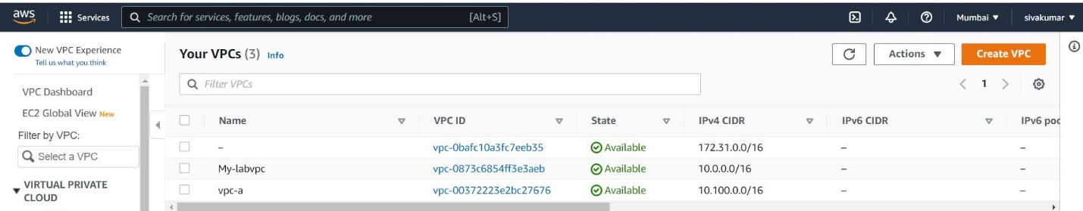step1 Here we giving the Name and CiDR Ranges and save it**

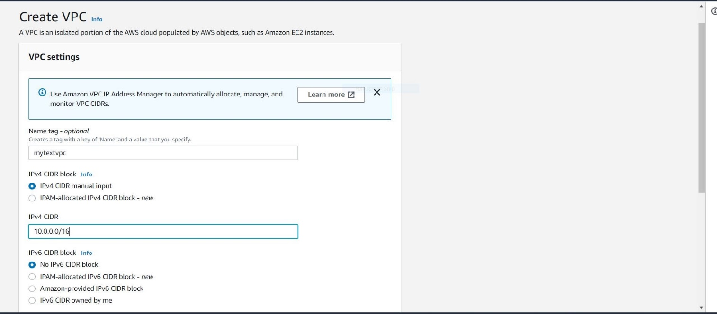

**2 steps Here we Enable the DNS Hostname go to the Actions click**

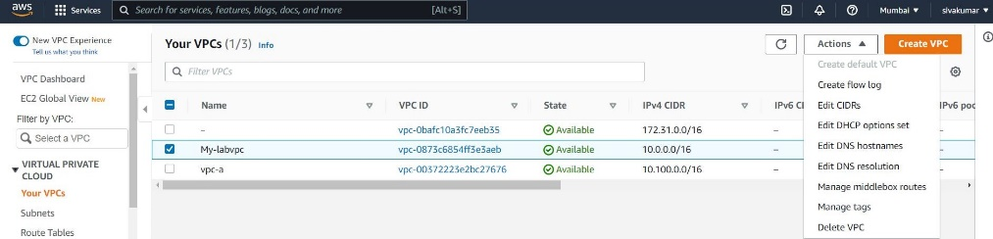

**click the edit DNS hostnames click the enable check box and save it**

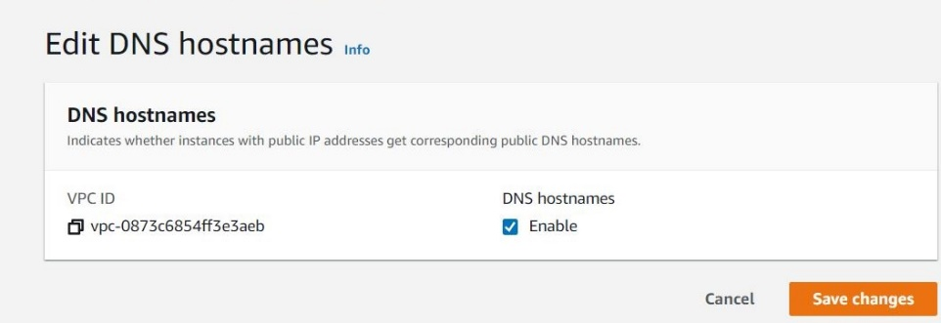

**Step3 creating the subnets**

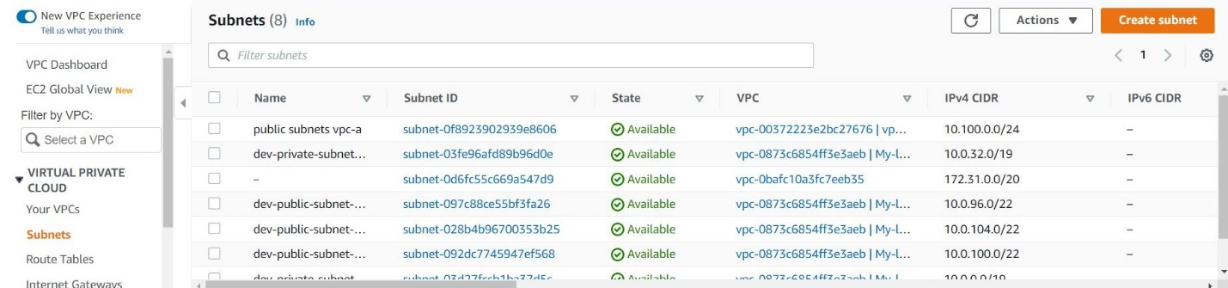

Here we giving what we have created Vpc select that one and created private subnets giving the CIDR ranges they have selecting the Availability zone we created 3 Availability ZonesLike same process

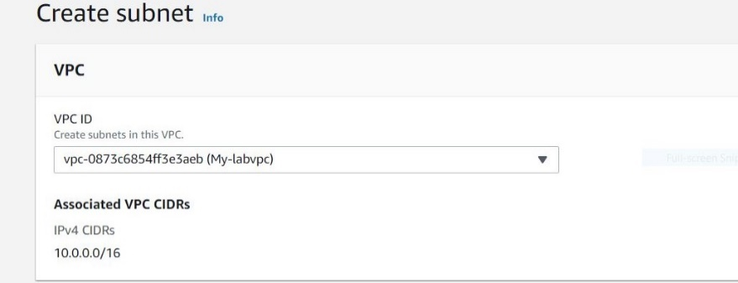

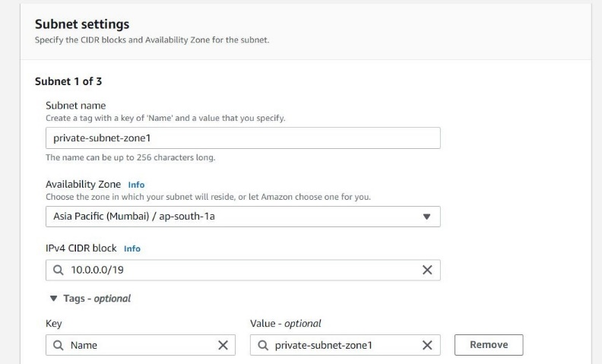

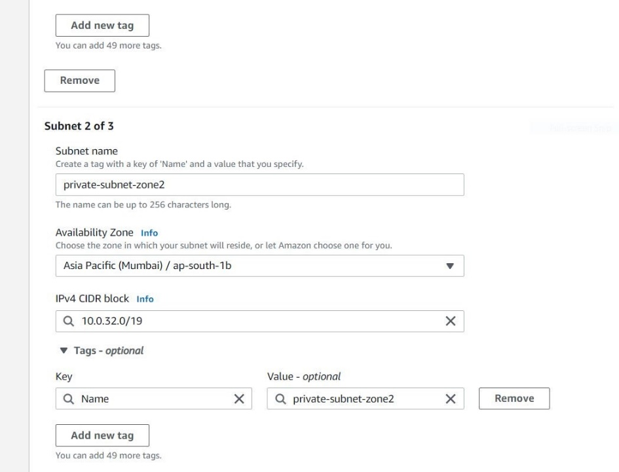

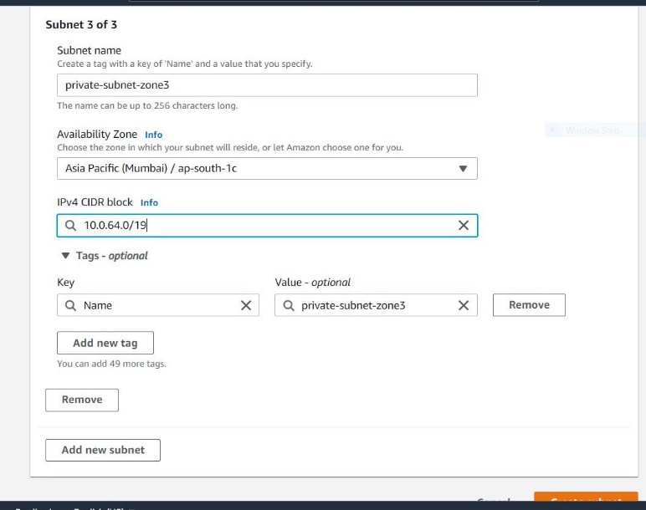

**Save it**

Here we giving what we have created Vpc select that one and created public subnets giving the CIDR ranges they have selecting the Availability zone we created 3 Availability Zones Like same process

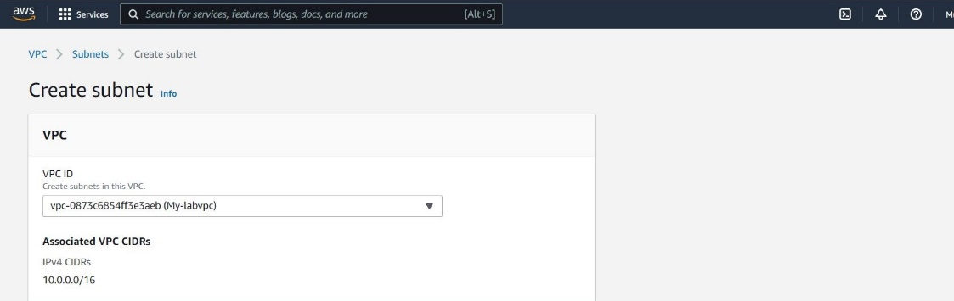

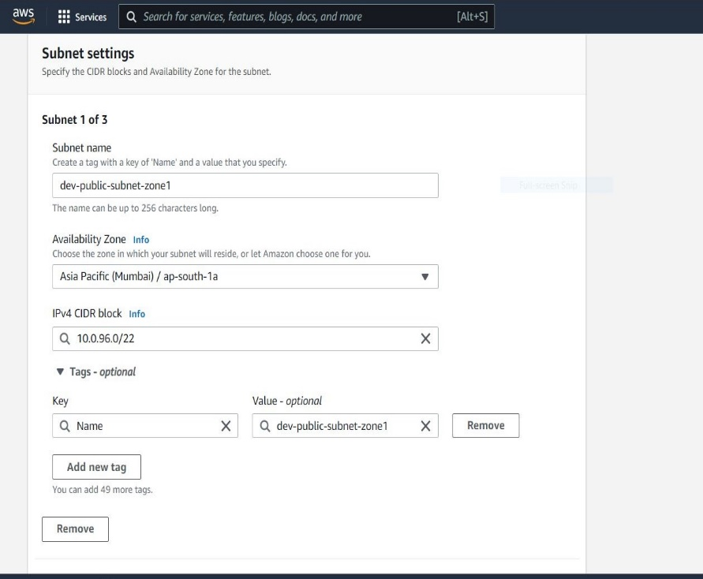

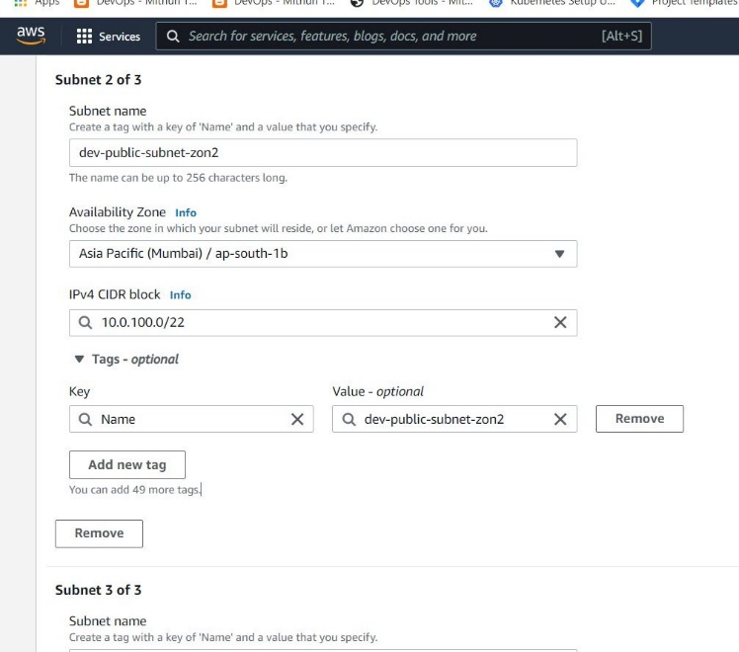

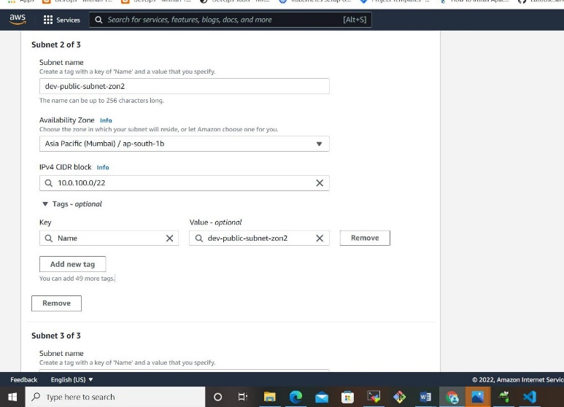

**Save it**

**Step 3 create the internet gateway to attach vpc**

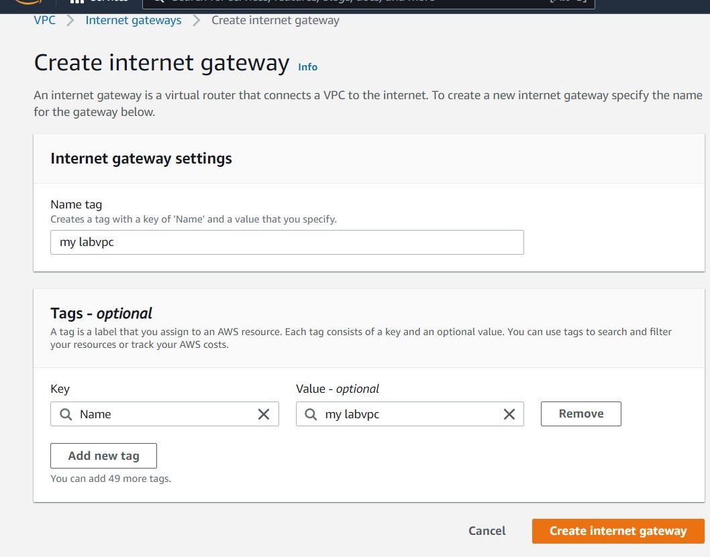

**Here we attach the internet gateway to Vpc by throw Action**

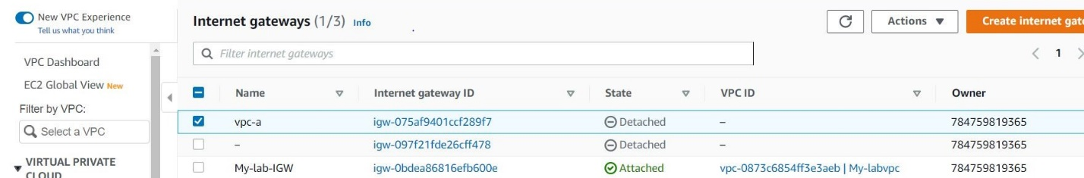

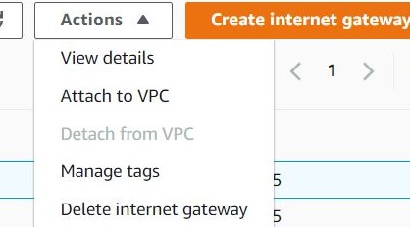**click the attach to Vpc and select your VPCs and save it**

**4 Step Create Nat Gateways and give name and select the subnet –public**

**And allocate one elastic ip and save it** 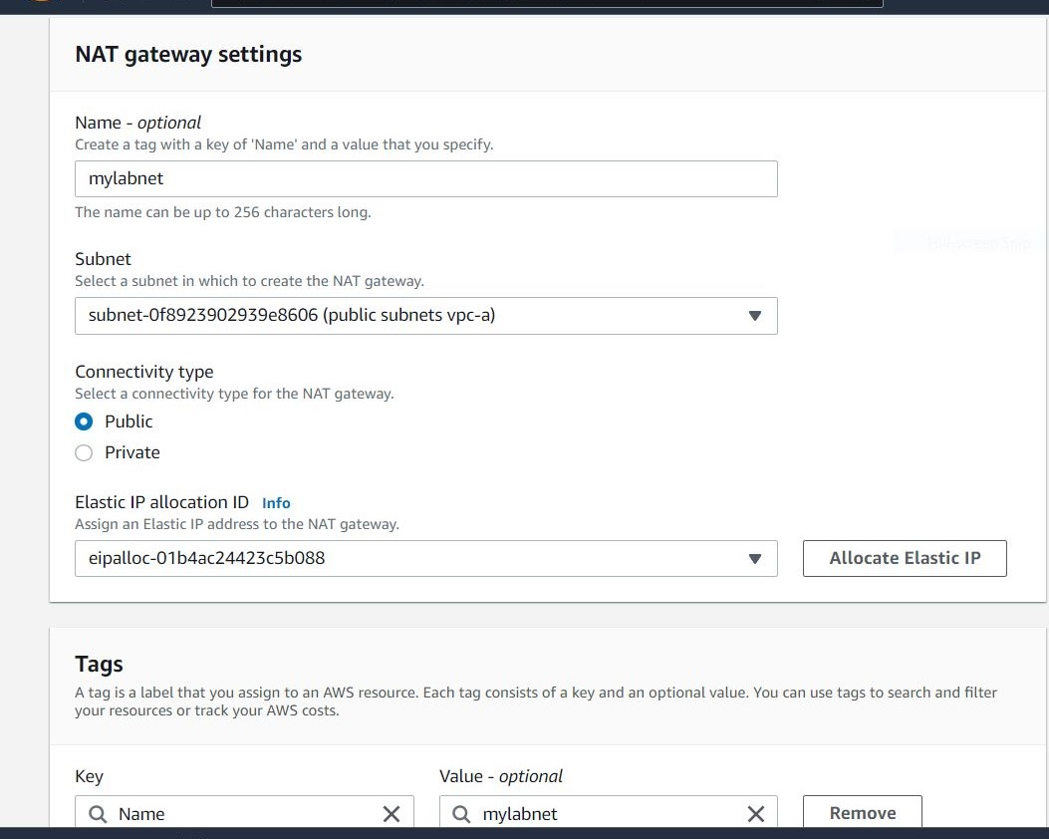

**Step5 create the Route tables**

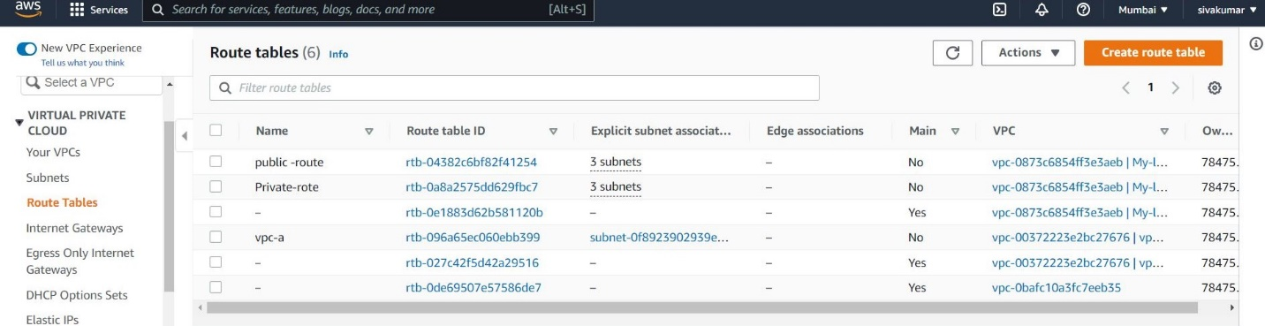

**Here we create one public route , private route , select the your Vpc and save it**

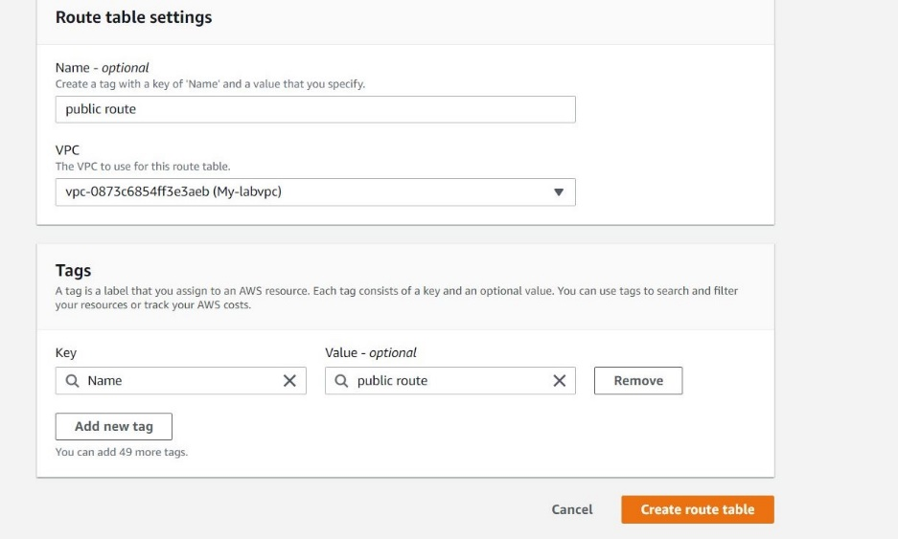

**Now ceate the private route again go the route table and create route table**

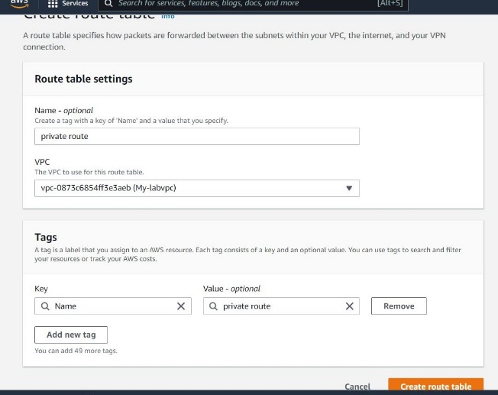

**Once it done go your public route click the check box go to under here**

**We can see the Routes go the edit routes go to the and ADD --IGW**

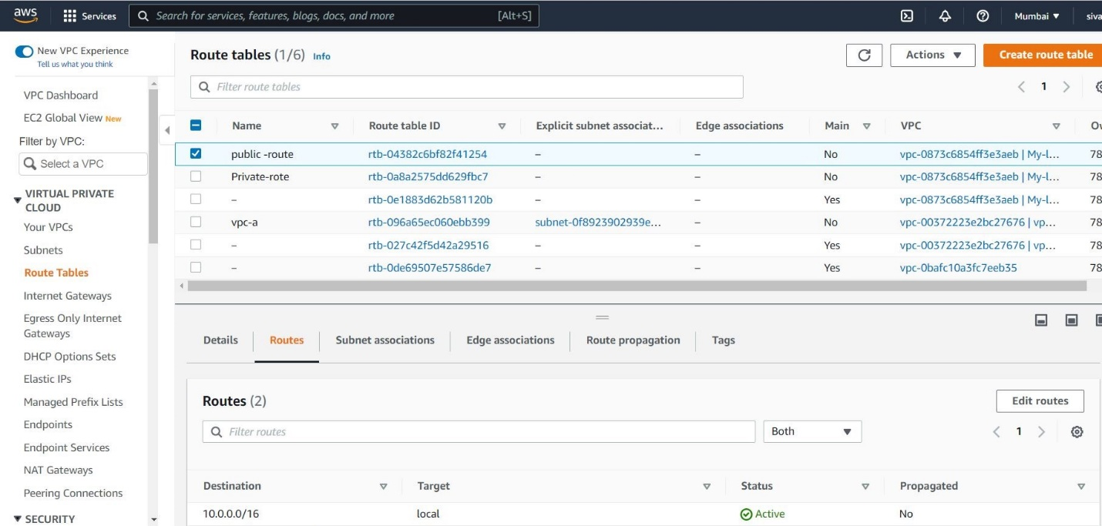

**Click routes edit here it showing one Add route**

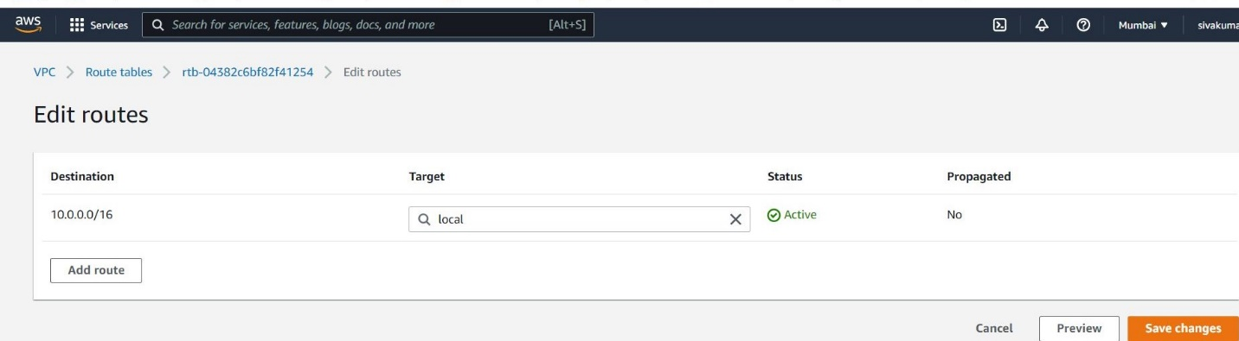

**Here we selecting the internet gateway and save it**

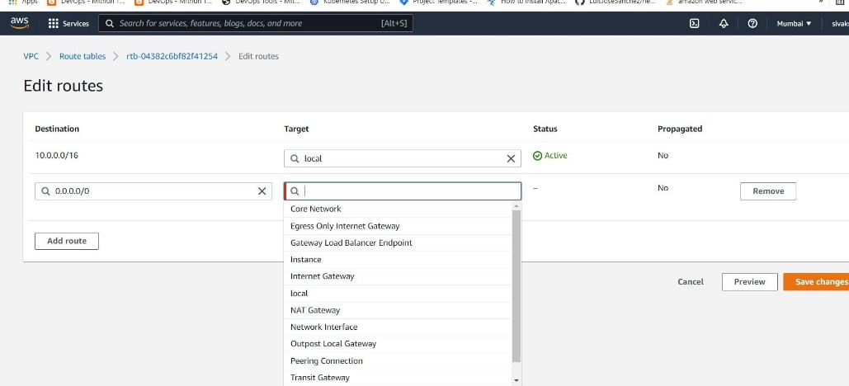

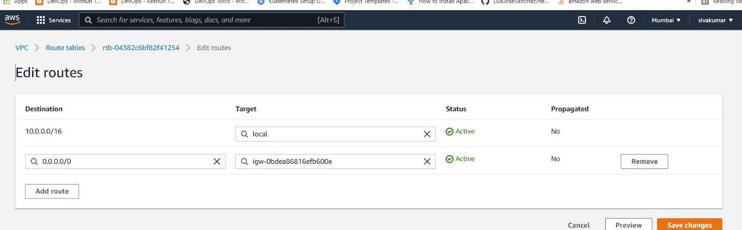

**Go to routes table select the private routes click the check box go to under here**

**We can see the Routes go the edit routes go to the and ADD –NAT-Gateway**

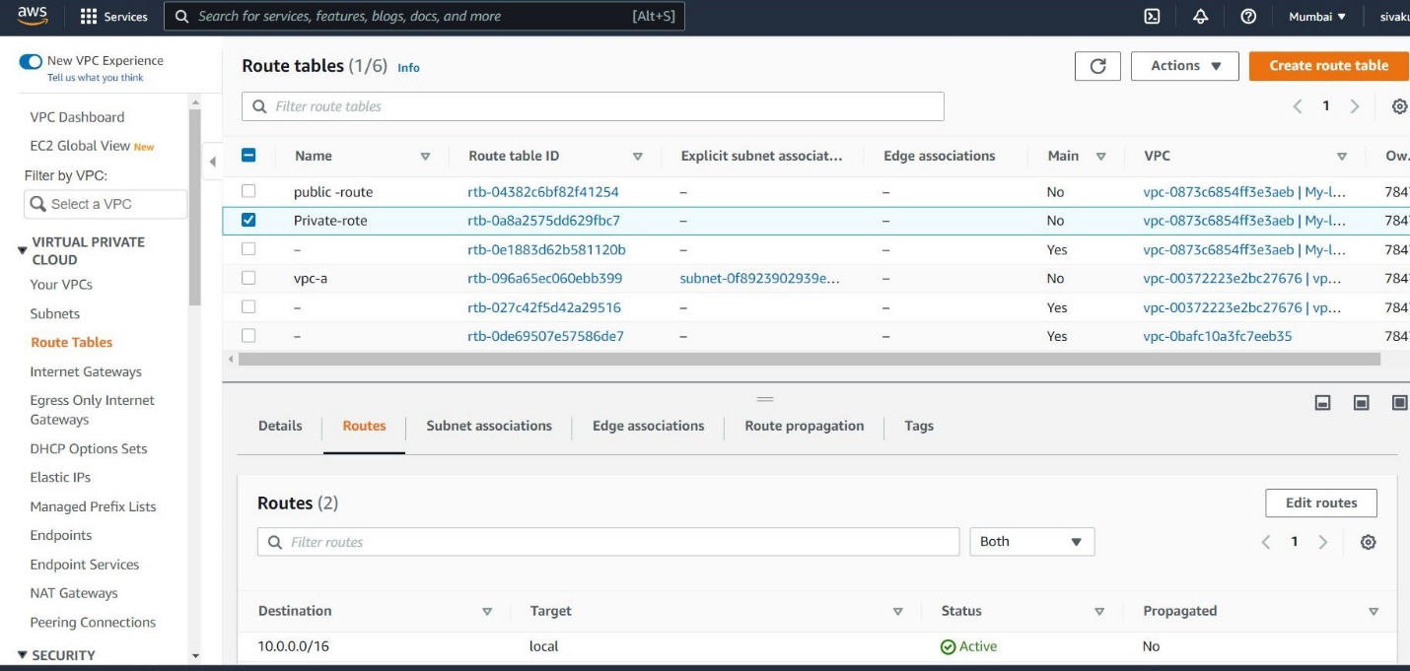

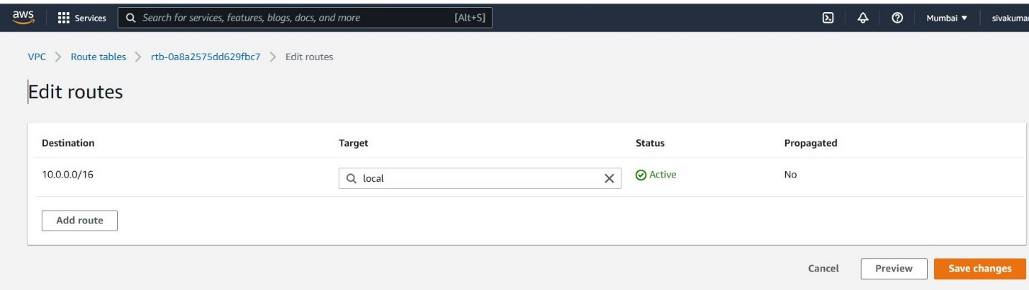**Here we selecting the Nat gateway and save it**



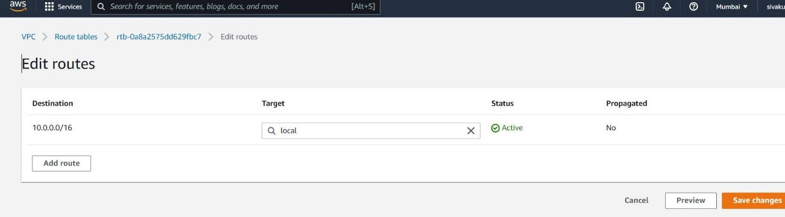

**Now go to Route Tables select the public –route and select the subnet association**

**Go to the Edit subnet association**

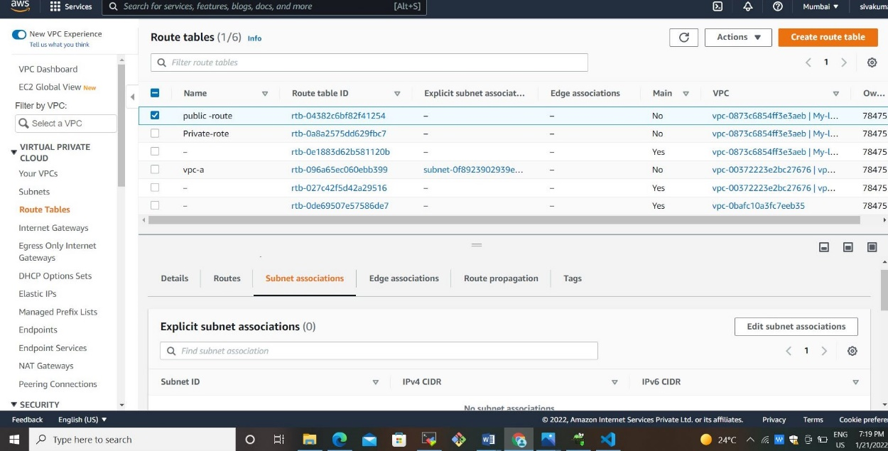

**Here we type the public it will show all public –subnet select and save it**

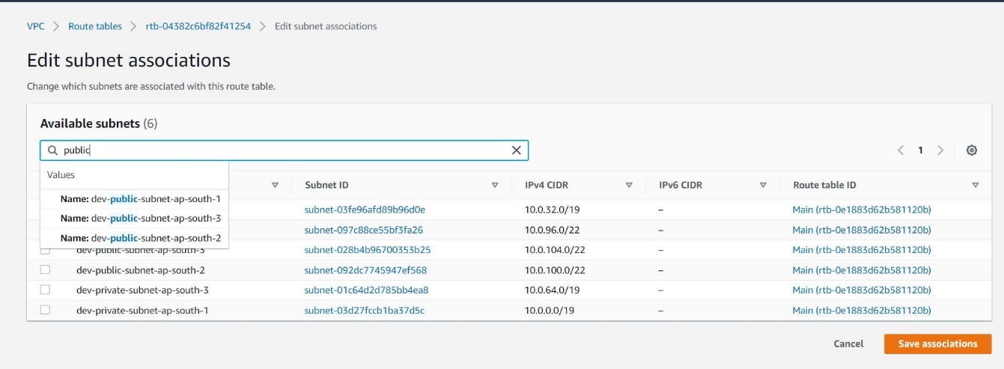

**Again go the route select the private - subnet and select the subnet association**

**Go to the Edit subnet association**

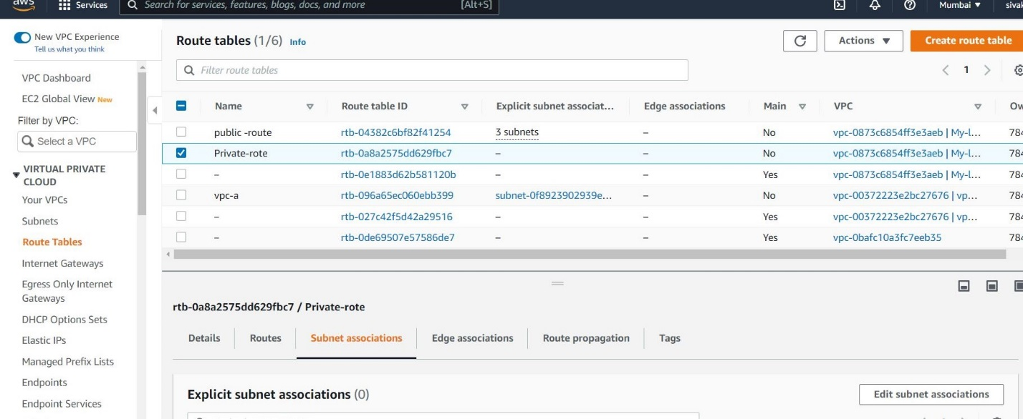

**Here we type the public it will show all private –subnet select and save it**

