**Creating 2 ec2 machine with our VPC**

**1 public ec2 machine – t2 micro**

**2 private ec2 machine –t2 micro**

**They have number of OS in our AWS service but I want to select my environment purpose I will take**

**The Amazon OS images.**

**Here we can see the Launch instance in that Launch instance click on it will display the number of OS images.**

**Here we see the below options we choosing the 7 steps we need flow way then instructions then only OS is install otherwise it wise it not install**

**1. Choose AMI**

**2. Choose Instance Type**

**3. Configure Instance**

**4. Add Storage**

**5. Add Tags**

**6. Configure Security Group**

**7. Review**

**In Aws they provide some OS they making charges & some of OS Free If you want, to select free tier OS please click the check box and it will display free OS**

**Quick Start**

My AMIs

AWS Marketplace

Community AMIs

Free tier only

LAB ------------- ec2 machine with our VPC creating two machine one is public and another machine

Private.

Click the Launch instance

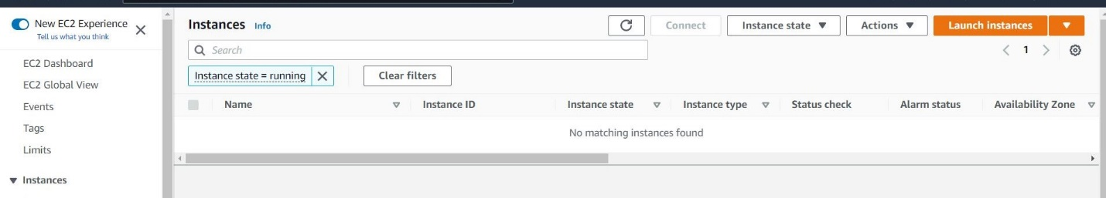

Select the free tier only and select the OS

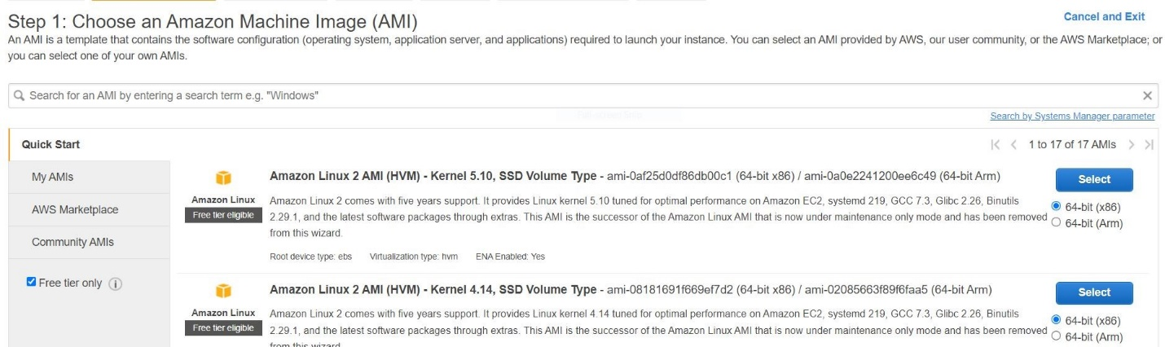

Here we can select the number type machine you have suppose 4 CPUS Memory 32 (GB) we can select but they making Charges so that wise I selecting my lab purpose t2. micro have 1 CPU 1 Memory (GB) click and Next configure instance details.

My environment t2.micro

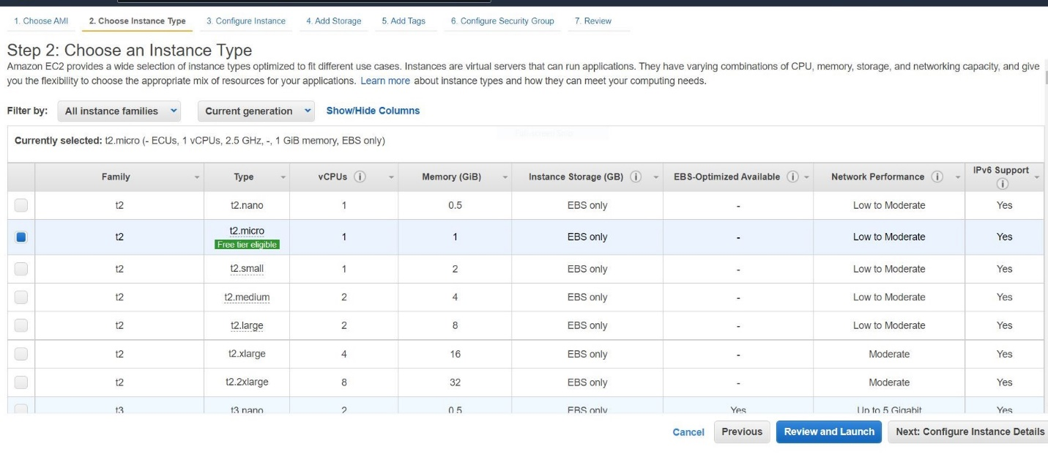

Here Please focused Here it showing the default VPC it’s if you want go with your VPC and click the subnets and select the private subnets and click the Auto-assign- public Ip change enable option click ADD storage

Again the same process we want to do private ec2 machine

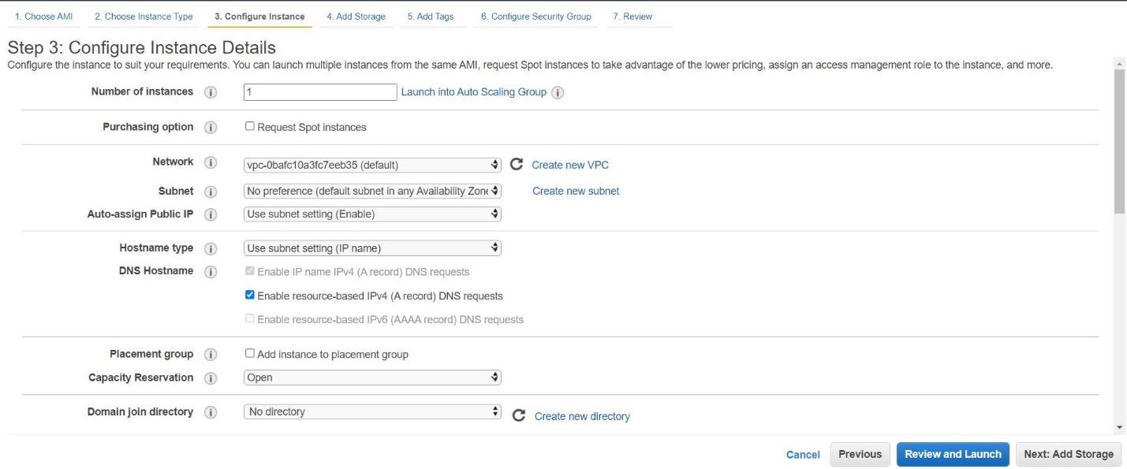

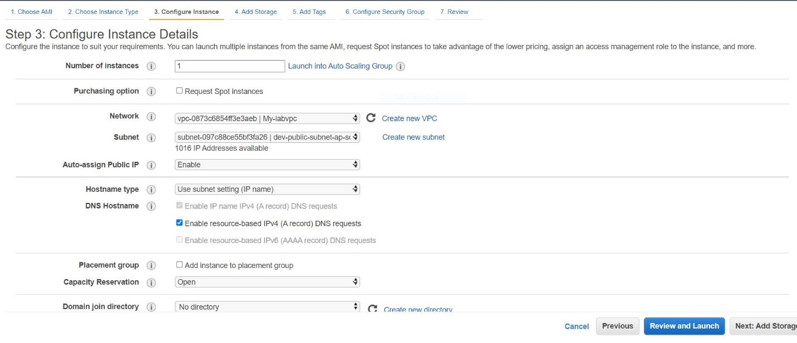

Here we change hard disk size suppose here showing the 8 GB if you want give 20 GB

Go to the size change what you want

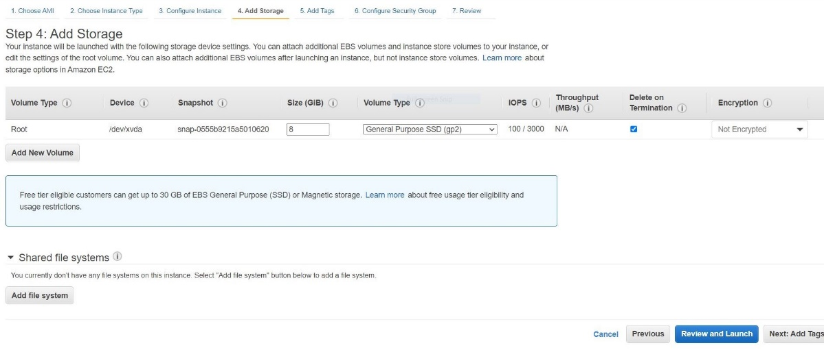

Here we giving the Tag name

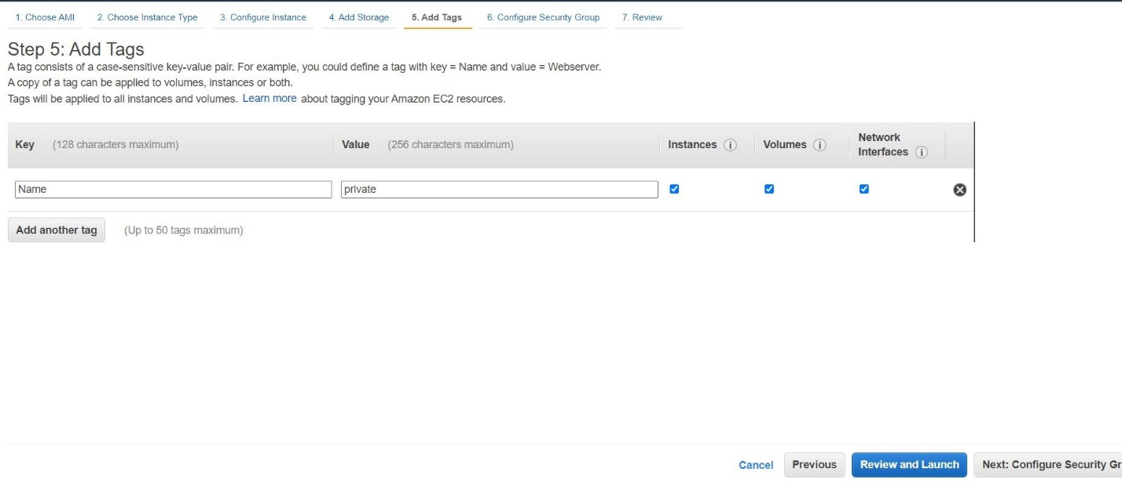

We giving the the default security group

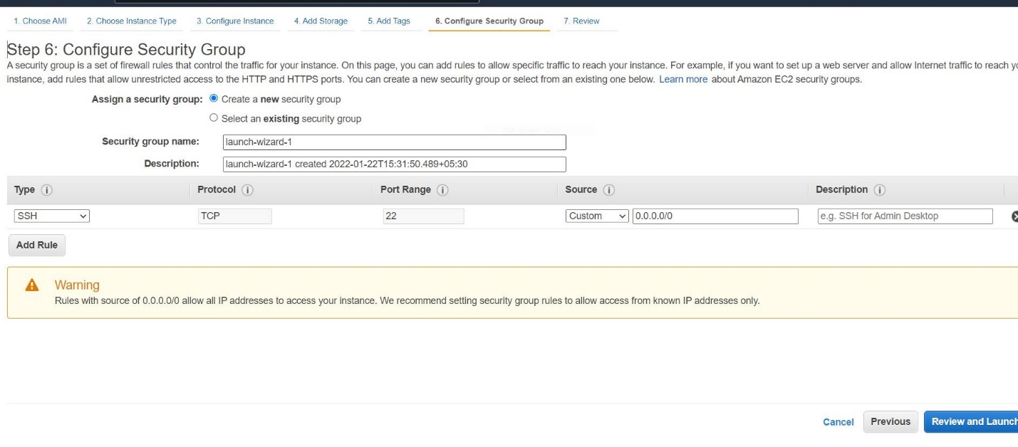

Review and launch

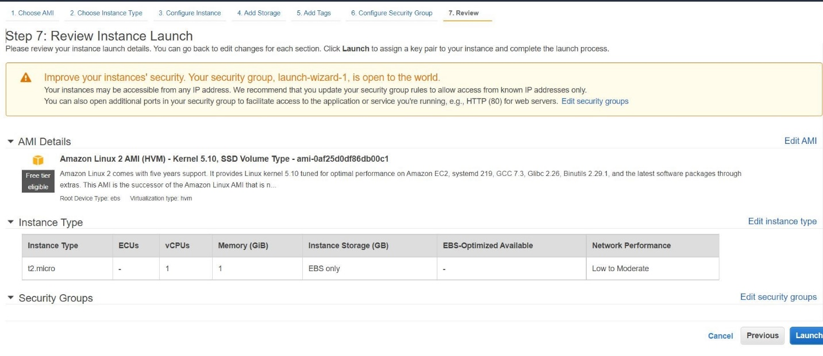

If you are new launching ec2 –machine, you can choose an existing key pair click on that it will display

2 create a new key pair

3 proceed without a key pair

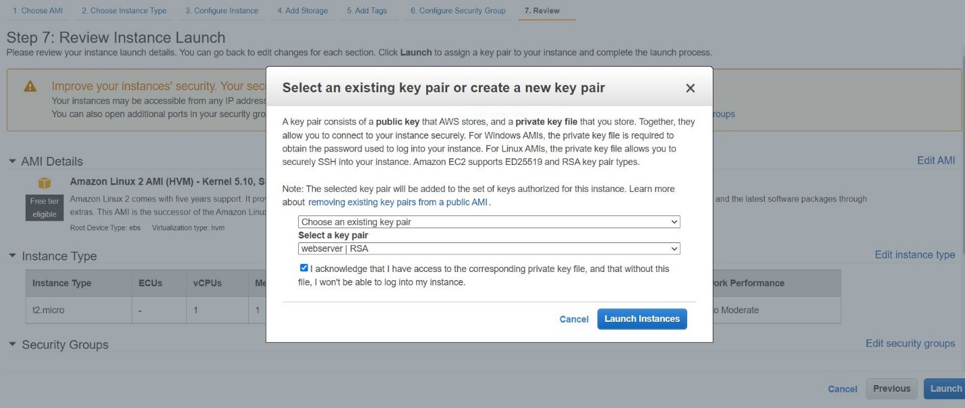

Select a key pair here we enter the name click check box download the process and save it after the

Click the Launch instance