# **1. Subsets**

Given an integer array set of **unique** elements, return *all possible subsets (the power set)*.

Return the solution in **any order**.

**Example 1:**

**Input:** set = [1,2,3]

**Output:** [[],[1],[2],[1,2],[3],[1,3],[2,3],[1,2,3]]

**Example 2:**

**Input:** set = [0]

**Output:** [[],[0]]

def truthtable(n):  
 if n < 1:  
 return [[]]  
 subtable = truthtable(n-1)  
 return [ row + [v] for row in subtable for v in [0,1] ]  
  
def printPowerSet(set):  
 tt = truthtable(len(set))  
 print('[',end='')  
 for subtt in tt:  
 print('[',end='')   
 for idx in range(0,len(subtt)):  
 if subtt[idx]==1:  
 print(f'{ set[idx]} ',end ="")  
 if(tt[len(tt)-1]==subtt):  
 print("]",end='')  
 else:  
 print("]",end='')  
 print(']')  
 print(tt)  
set = [[1,2,3],2,3]  
  
printPowerSet(set)

Function truthtable(n) is used as an utility function to generate truth table for n variables which is going to be used for printing the power set later on.

printPowerSet(set) is our main function, we are taking all sub-truth tables of n varibles which is the length of our initial set.

The idea behind this program is that we print the element from **set** at position **idx** where **subtt[idx] is 1**.

**subtt** – **sub truthtable**(example : for 3 variables x y z – a sub truth table will be 0 0 0 or 1 1 1)

and lastly some prints with **[ ]** to make it more visually appealing

## **2. XNOR**

Create a program that would ask for two boolean values (true or false, 0 or 1) and would output the result for the XNOR operation performed on them.

You're allowed to use only `and`, `or` and `not` operations.

def xnor(x,y):  
 if ((x and y)or(not x and not y))==True:  
 return 1  
 return 0  
  
def main():  
 print(xnor(0,0))  
 print(xnor(0,1))  
 print(xnor(1,0))  
 print(xnor(1,1))  
  
if __name__ == '__main__':  
 main()

Logic behind our program:

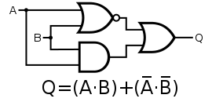

### **3. Regular Expression Matching**

Given an input string **string** and a pattern **pattern**, implement regular expression matching with support for **’ . ’** and **’ * ’** where:

* **‘ - ‘** Matches any single character.​​​​
* **‘ * ‘** Matches zero or more of the preceding element.

The matching should cover the **entire** input string (not partial).

**Example 1:**

**Input:** string = "aa", pattern = "a"

**Output:** false

**Explanation:** "a" does not match the entire string "aa".

**Example 2:**

**Input:** string = "aa", pattern = "a*"

**Output:** true

**Explanation:** '*' means zero or more of the preceding element, 'a'. Therefore, by repeating 'a' once, it becomes "aa".

**Example 3:**

**Input:** string = "ab", pattern = ".*"

**Output:** true

**Explanation:** ".*" means "zero or more (*) of any character (.)".

**Example 4:**

**Input:** string = "aab", pattern = "c*a*b"

**Output:** true

**Explanation:** c can be repeated 0 times, a can be repeated 1 time. Therefore, it matches "aab".

**Example 5:**

**Input:** string = "mississippi", pattern = "mis*is*p*."

**Output:** false

def match(expression, pattern):  
 exp = expression  
 pat = pattern  
 print(exp,pat)  
 if not exp and not pat:  
 return True  
 elif exp and not pat:  
 return False  
 elif not exp and pat:  
 return False  
  
 if len(pat) >= 3 and pat[0] == '.' and pat[1] == '*' and pat[2].isalpha():  
 pat = pat[2:]  
 while exp[0] != pat[0]:  
 exp = exp[1:]  
 if exp and pat:  
 p = pat[1:]  
 pat = p  
 return match(exp, pat)  
 elif len(pat) == 2 and pat[0] == '.' and pat[1] == '*':  
 return True  
 elif len(pat) >= 2 and pat[1] == '*':  
 t = pat[0]  
 pat = pat[2:]  
 if t == '.':  
 ch = exp[0]  
 while len(exp)>0 and exp[0] == ch:  
 exp = exp[1:]  
 return match(exp,pat)  
 if t == exp[0]:  
 while len(exp) > 0 and exp[0] == t:  
 exp = exp[1:]  
 return match(exp, pat)  
 return match(exp, pat)  
  
 elif pat[0] == '.':  
 pat = pat[1:]  
 exp = exp[1:]  
 return match(exp, pat)  
 elif pat[0].isalpha():  
 if exp[0] == pat[0]:  
 while exp != "" and pat != "" and exp[0] == pat[0]:  
 if len(pat) > 1 and (pat[1] == '*' or pat[1] == '.'):  
 break  
 exp = exp[1:]  
 pat = pat[1:]  
 return match(exp, pat)  
 else:  
 return False  
  
  
  
  
  
expression = str(input())  
pattern = str(input())  
print(match(expression, pattern))

Logic behind our program is that we follow each step of the condition based on priority and recursively till the moment when either expression or pattern becomes an empty string or both do (or in some particular cases we return True/False based on the regulations)

In the following screenshots there is output on how my program is working for each example given:

Example 1:

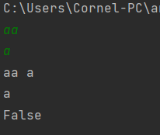

Example 2:

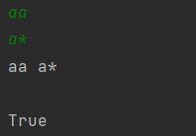

Example 3:

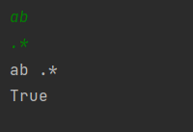

Example 4:

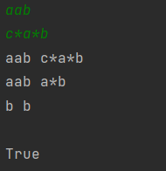

Example 5:

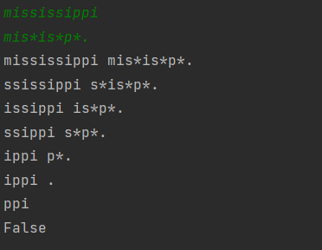

#### **4. Truth table solver**

You have to write a program that computes the truth table for various expressions. The set of expressions are limited to:

- `and` operation

- `or` operation

- `not` operation

- supports parenthesis

An example of your program input is `(!x + y) * z + (!z * y * k)` and it should print out:

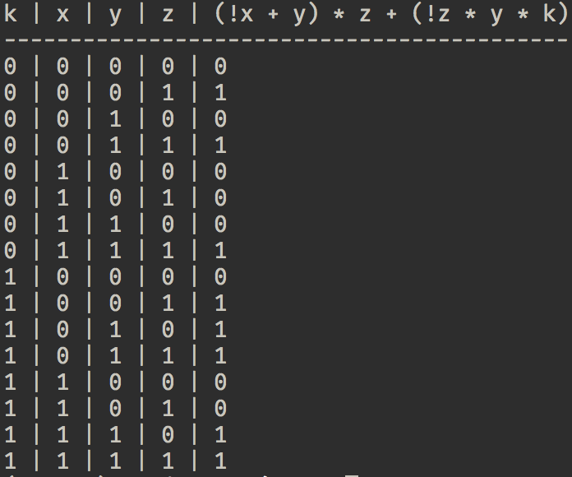

Here are some examples of input that your program should support

```

x + y

!x * y

(!x + y) * x + y * !k

```

**Note:**

I strongly recommend to use the python **`eval`** function. Inventing math operations and their execution priority is **not** the aim of this exercise.

expression = input()  
dictionary ={}  
vars = []  
for i in range(0,len(expression)):  
 if expression[i].isalpha():  
 if expression[i] not in dictionary:  
 dictionary[expression[i]] = 0  
 vars.append(expression[i])  
for var in vars:  
 print(f'{var}|',end="")  
print(expression)  
expression=expression.replace('*','or')  
expression=expression.replace('+','and')  
expression=expression.replace('!','not ')  
arr = [0]*(len(dictionary))  
  
for i in range(0,2**len(dictionary)):  
 for j in range(0,len(dictionary)):  
 val = (i & (1<<j))  
 if(val > 0):  
 val = 1  
 arr[j] = val  
 k=0  
 for key in dictionary:  
 dictionary[key] = arr[k]  
 k+=1  
 for elem in arr:  
 print(elem,end="|")  
 print(eval(expression,None,dictionary))

we show the function eval to take the values of variables from the dictionary which is constantly changed in the inner scope of the for (in range (0,len(dict))

values of the variables are changed by left bit shift operator

##### **5. Leibniz harmonic triangle**

Write a program that prints the harmonic triangle for the depth `n`, where `n` is an input value.

**Tip:**

If you're using Python you might look into **`fractions`** module.

def leibniz(size):  
 result = [[0 for rows in range(size + 1)] for cols in range(size + 1)]  
 i = 0  
 while (i <= size):  
 j = 0  
 while (j <= i):  
 if (j == i or j == 0):  
 result[i][j] = 1  
 else:  
 result[i][j] = result[i - 1][j - 1] + result[i - 1][j]  
 j += 1  
 i += 1  
 i = 1  
 while (i <= size):  
 j = i  
 while (j < size):  
 print("\t", end="")  
 j += 1  
 j = 1  
 while (j <= i):  
 if (i == 1 and j == 1):  
 print("1".center(8),end='')  
 else:  
 r = str('1/' + str(result[i - 1][j - 1] * i)).center(8)  
 print(r,end='')  
 j += 1  
 print()  
 i += 1  
   
def main():  
 leibniz(10)  
if __name__ == '__main__':  
 main()

#

#  
#  
#

#

#

#

#

#

1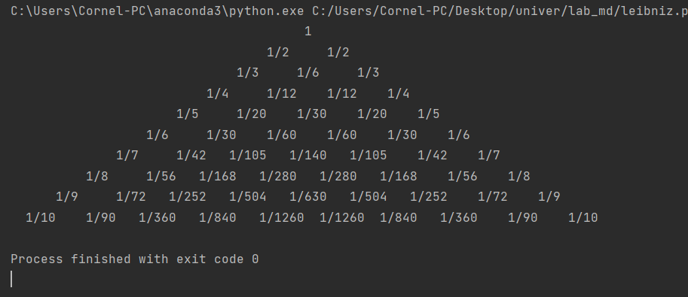

L+R

\ /

C * ( current row)