**Relationship between computer Hardware and computer Software**

* Hardware represents the physical and tangible components of a computer i.e. the components that can be seen and touched.  
  Examples of Hardware are following:
* **Input devices --**keyboard, mouse etc.
* **Output devices --**printer, monitor etc.
* **Secondary storage devices --**Hard disk, CD, DVD etc.
* **Internal components --**CPU, motherboard, RAM etc

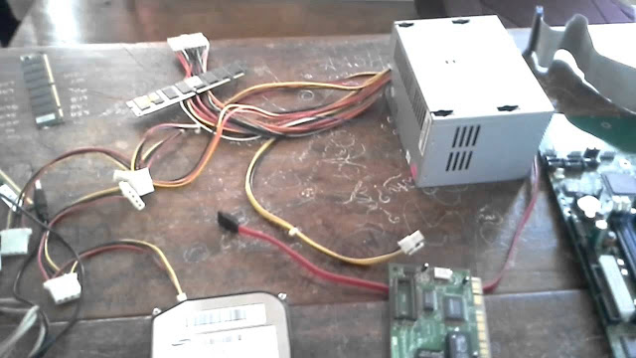

Relationship between Hardware and Software

Hardware and software are mutually dependent on each other. Both of them must work together to make a computer produce a useful output.

Software cannot be utilized without supporting hardware.

Hardware without set of programs to operate upon cannot be utilized and is useless.

To get a particular job done on the computer, relevant software should be loaded into the hardware

Hardware is a one-time expense.

Software development is very expensive and is a continuing expense.

Different software applications can be loaded on hardware to run different jobs.

Software acts as an interface between the user and the hardware.

If hardware is the 'heart' of a computer system, then software is its 'soul'. Both are complimentary to each other.

**Features of Windows Operating System**

**Overview**

The Windows operating system is the most famous and common operating system. It is developed by Microsoft and was first released in the year 1985. Basically, windows provide a Graphical User Interface, multitasking, support for many peripheral devices, file explorer, command prompt, task manager, an AI-powered bot called Cortana, etc. Windows have Microsoft Office which became the most common and popular office suite. Windows provide several editions to the users but the common ones are windows Home and Professional.

* **Scope**
* This article deals with the features of Windows Operating System.
* Various features will be elaborated in depth along with their illustrations.
* **What are the Features of Windows Operating System?**
* The various features of Windows operating system include-
* **Start Menu**- As the name suggests, this is the part where the user starts his actions, after turning on the computer. The start menu contains a list of all the applications, pinned applications, and recently used applications. We can search various files and applications using the search bar. There is also an option of switching the user and turning off/restart/sleep mode options. So start basically is a place where user can begin their work by choosing the desired place to start their task.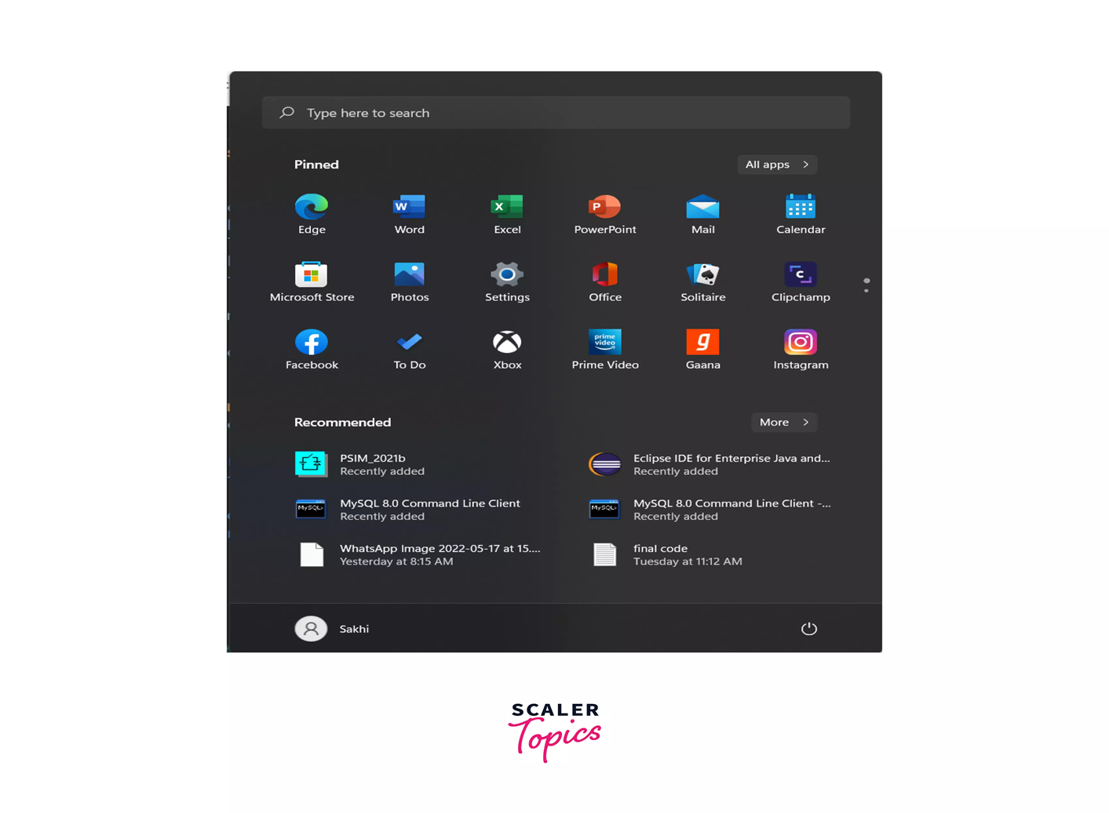
* **File Explorer**- In real life, we keep all our documents in one place and segregate them according to their use and need. In windows, the same work is done by the file explorer. It saves all our files in one place, according to the location that we provide. All the locations are displayed here along with the removable disks and pen drives that we insert. We can also manage various files and perform operations on them like- inserting, creating shortcuts, renaming, deleting, grouping files, etc. It makes searching for files easier using the search function. We can also find the recent files that we have used in file explorer.

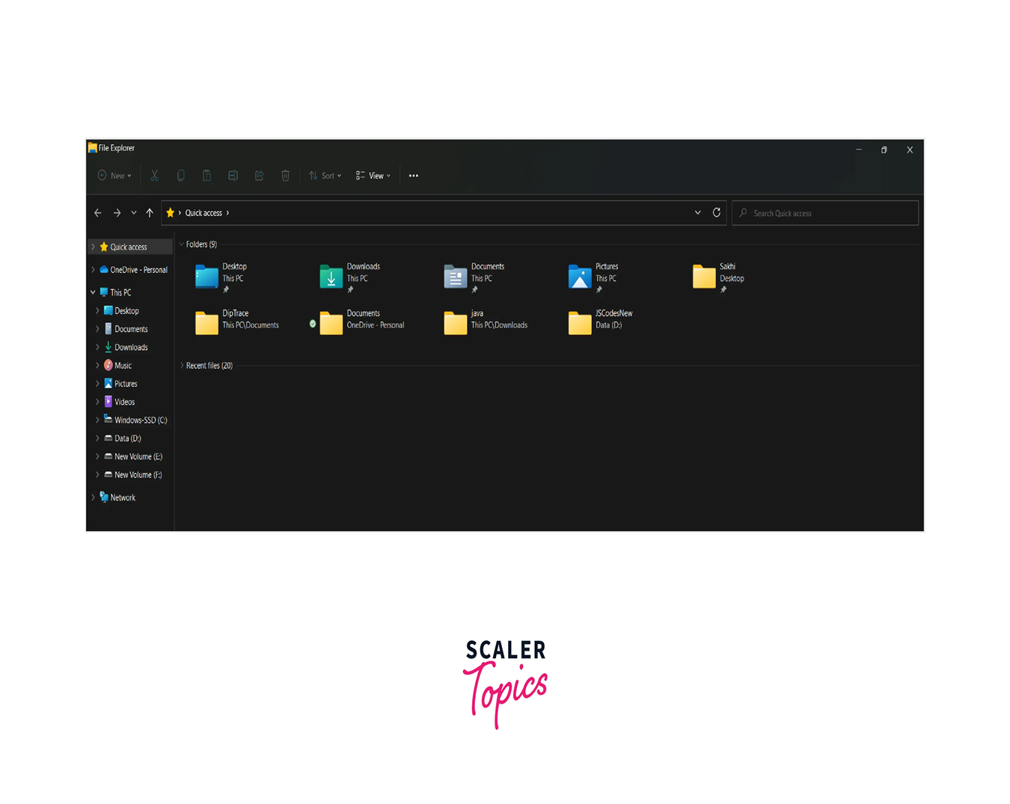

* **Control Panel**- As the name suggests, it controls and configures the resources and apps on our computer. There are a lot of functions that can be performed according to the user's needs. Right from system administration to set the time, everything can be done here. If we want to interface our computer with hardware, the settings can be changed here and various network-related settings can be changed too. In this way, the user can use and change system settings according to his discretion.

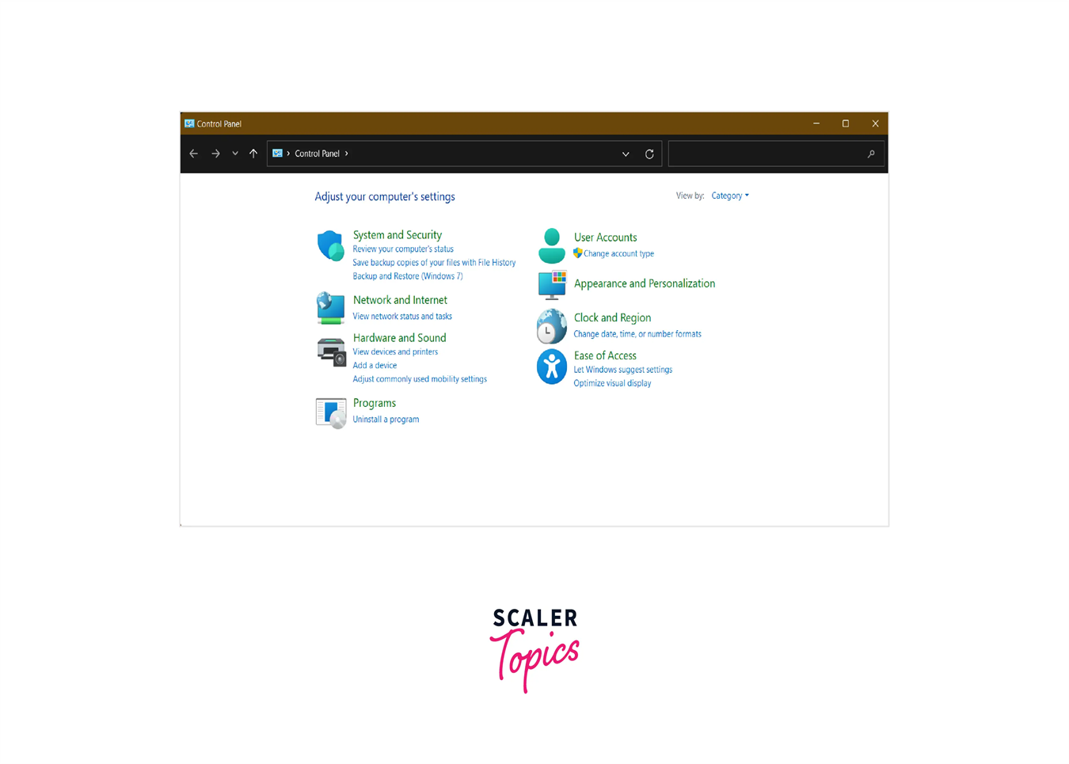

**Cortana**- In windows, we have been provided with a voice assistant who helps us with things that we are unable to do and are stuck at. It is an important feature of the windows operating system which is an AI-operated voice assistant that acts according to our commands and helps us to perform actions like opening a document, playing music, etc. Its concept resembles that of Google Assistant, Siri, etc.

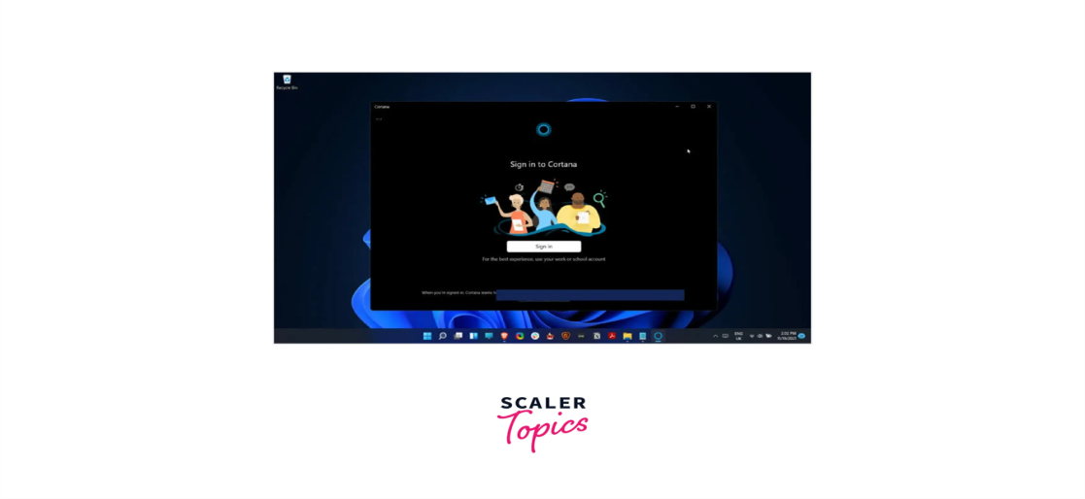

* **Browser (Edge)**- The default browser of windows is Microsoft Edge. We can search for information and surf the internet using the browser. Windows come in with a pre-installed browser. Earlier the default browser was Internet Explorer but later it was changed to Edge. It renders results of search faster and has security features like malware protection, phishing protection, and detection of insecure websites.
* **MS Paint**- This is a feature from the 1st version of Windows itself. As the name suggests, it is used to paint, i.e., create drawings, paintings, colourings, etc. A blank canvas along with various inks, pens, and shapes. Now an improvised version of MS Paint that is known as Paint-3D comes with more and improved features.

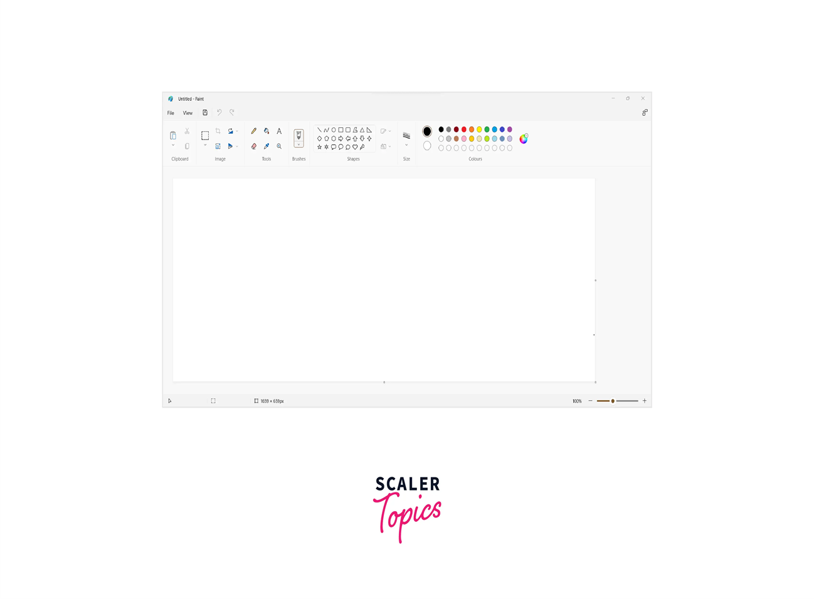

* **Task Manager**- The task manager is used to manage all the currently running tasks. We can force stop tasks that are currently running and also get information that which tasks are running in the background. The 'End Task' option enables the user to force stop the background and foreground running application. We also get information on how much CPU, RAM, and memory is used by various system resources.

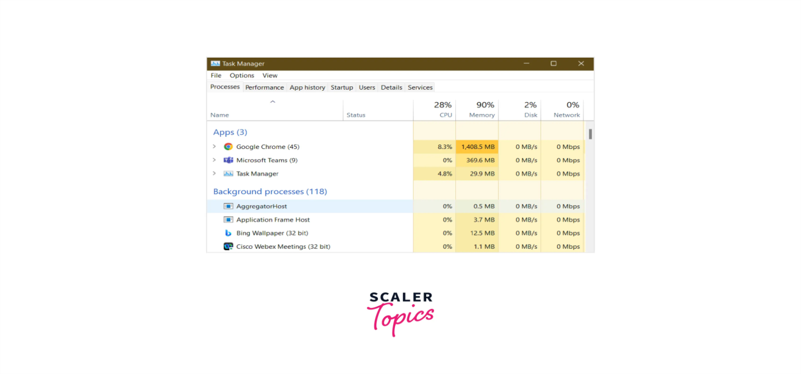

* **Task bar**- The task bar is one of the features of windows operating system. The element of the graphical user interface which shows the tasks or applications that are open right now. It also contains pinned applications which is done by the user, date and time. We can customise the taskbar. The taskbar varies according to the operating system but it is usually a small strip located at the bottom of the screen.

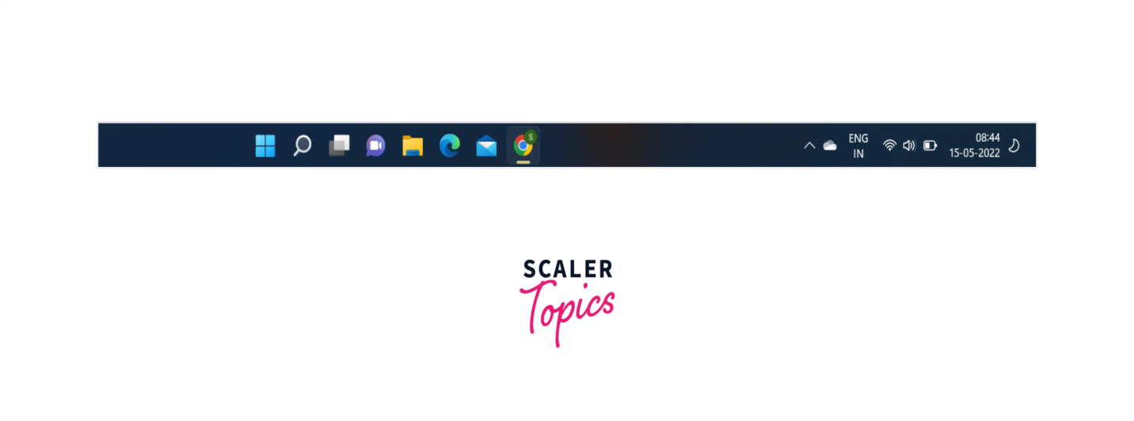

* **Advantages of Windows Operating System**
* **Backing of majority of equipment**- The majority of the clients use windows and that amounts to almost 95%, the drivers for windows are made by a majority of merchants.
* **Programming and gaming support**- Windows is a big platform that supports a majority of applications and games which are both paid and unpaid. Most gaming laptops are windows based because of their performance so programmers prefer the windows operating system because of this feature.
* **Clean and lucid GUI**- The Graphical User Interface provided by Windows is clean and can be understood well by a new user too. Windows UI is better than MAC and Linux.
* **Microsoft Office**- Windows users are provided with Microsoft Office which contains a lot of applications like- Powerpoint, excel, word, OneNote, teams etc. This has built-in support for Windows and works smoothly on windows.
* **Disadvantages Of Windows Operating System**
* **Many of the Windows products are paid**- Many of the essential features of windows os are paid which include applications like photoshop, games and various other applications.
* **Malicious virus**- The majority of the virus is made for windows as it has a huge number of clients. For our security purpose, we have to be cautious and install antivirus software.
* **Costly**- With respect to Windows, Linux is open sourced so it can be used by anyone, but the cost of Windows is high.
* **Technical support**- Most users do not get good technical support from the Windows team. If there is an organisation that uses windows, they get technical support from the windows team.
* **Rebooting a system**- When the system slows down, the system has to be rebooted. This happens when many programs run at the same time which slows down the system. This leads to a slower speed so rebooting has to be done.
* **Prone to hacking**- Since windows are widely used, hackers tend to hack windows OS more than other OS. There is no feature in Windows OS that prevents this.
* **High system requirements**- There are a lot of requirements that need to be fulfilled before installing Windows. The requirements specify the required specifications of processor, hard disk space, OS, display and graphic card.