

NAME : Manan Verma SEMESTER:4th
SECTION: 24_AIT_KRG-G1 UID:24BAI70008
SUBJECT CODE: 24CSH-298
FACULTY’S NAME: Mr Shalabh Bhatia

Lab Experiment 5

AIM
To understand and apply conditional logic in SQL by using the modulus operator (MOD / %) to analyze numerical data and classify employee salaries as odd or even, thereby improving data analysis and decision-making skills in SQL.

Objective of the Session
- To write and execute SQL queries that use the MOD (%) operator to check employee salaries and display odd and even salary values separately from an employee table.

Software Requirements
Database Management System:
Oracle Database Express Edition (Oracle XE)
PostgreSQL Database
Database Administration Tool / Client Tool:
Oracle SQL Developer (for Oracle XE)
pgAdmin (for PostgreSQL)

Experiment Question :
Write SQL queries to classify employee salaries as odd or even using the MOD (%) operator.The structure of the table is as follows:

Practical/Experiment steps:
- Open Oracle SQL Developer / pgAdmin.
- Create an Employee table with employee details.
- Insert sample employee salary records.
- Execute SQL queries using the MOD (%) operator.
- Display employees having even salaries.
- Display employees having odd salaries.
- Verify the output.

CODE:
-- Create Table
CREATE TABLE Employee (
emp_id INT,
emp_name VARCHAR(50),
salary INT
);

-- Insert Sample Data
INSERT INTO Employee VALUES (1, ‘Manan’, 25000);
INSERT INTO Employee VALUES (2, ‘Rohan’, 30001);
INSERT INTO Employee VALUES (3, 'Prakharl', 40000);
INSERT INTO Employee VALUES (4, 'Shanaya', 35005);

-- Display Employees with Even Salaries
SELECT *
FROM Employee
WHERE MOD(salary,2) = 0;

-- Display Employees with Odd Salaries
SELECT *
FROM Employee
WHERE MOD(salary,2) = 1;

OUTPUT:

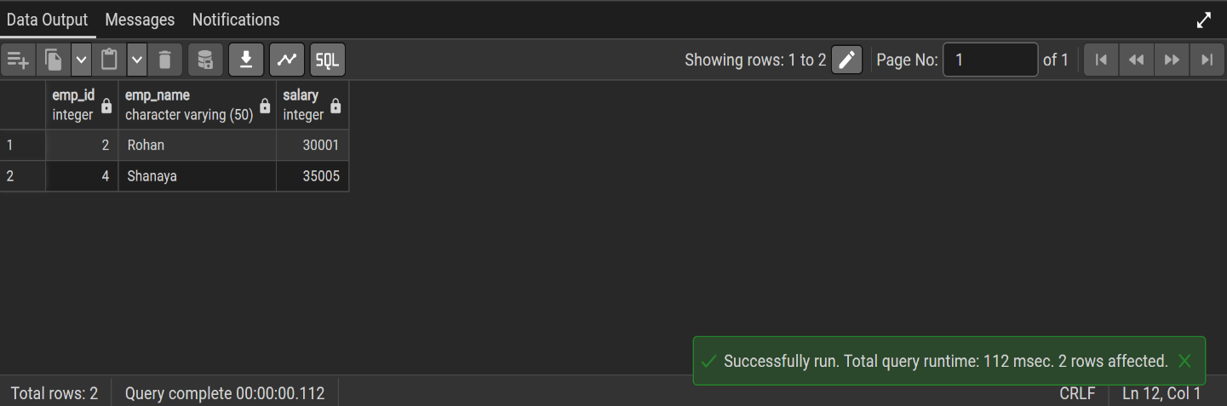

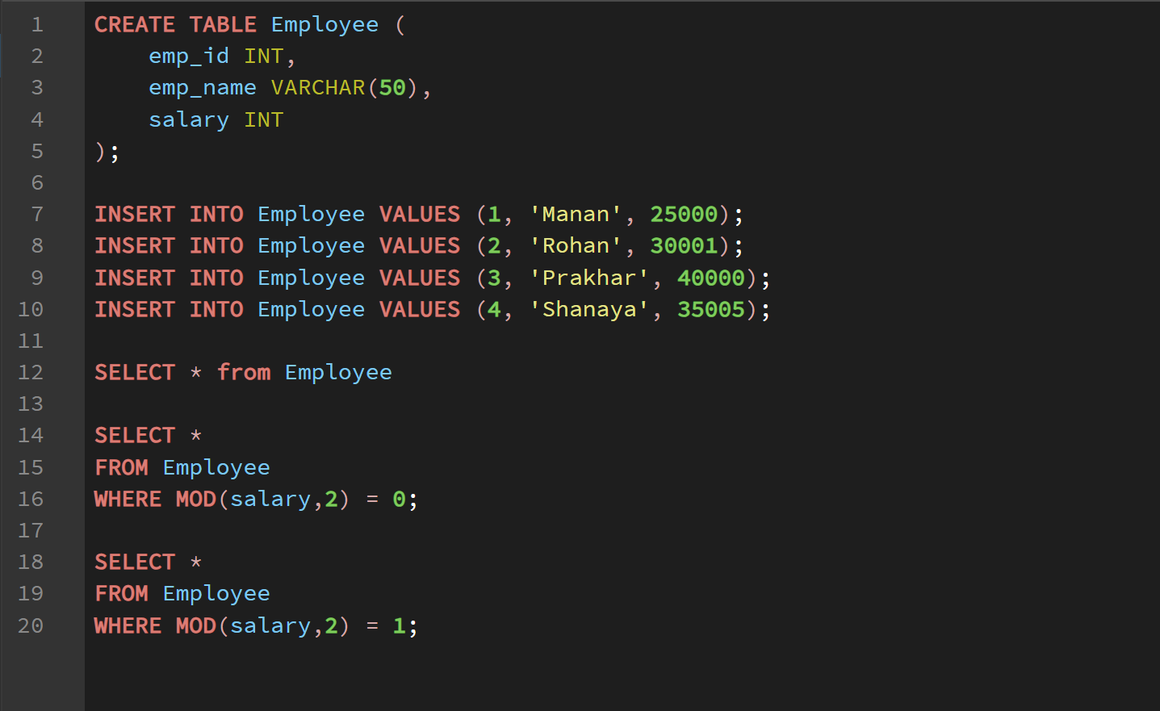

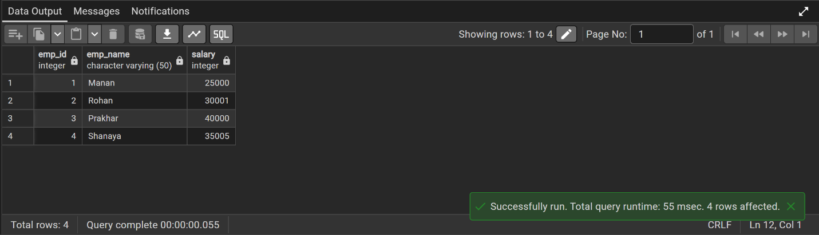Learning Outcome
- Understand the use of the MOD (%) operator in SQL.
- Apply conditional logic to analyze numerical data in a table.
- Write SQL queries to filter records based on conditions.
- Differentiate and display odd and even salary values from a database.

