

NAME : Manan Verma SEMESTER:4th
SECTION:24_AIT_KRG-G1 UID:24BAI70008
SUBJECT CODE:24CSH-298
FACULTY’S NAME: Mr Shalabh Bhatia

Lab Experiment 6

AIM

To understand the concept and working of cursors in PL/SQL and implement implicit and explicit cursors to process multiple rows and apply business logic.

Objective of the Session
- To learn how implicit cursors work in PL/SQL for single-row operations
- To implement explicit cursors for handling multiple records
- To use cursor attributes like %FOUND, %NOTFOUND, %ROWCOUNT, %ISOPEN
- To process records row-by-row and apply business logic

Software Requirements
Database Management System:
Oracle Database Express Edition (Oracle XE)
PostgreSQL Database
Database Administration Tool / Client Tool:
Oracle SQL Developer (for Oracle XE)
pgAdmin (for PostgreSQL)

Experiment Question :
Write PL/SQL programs to:
- Use implicit cursors for single-row operations
- Use explicit cursors to fetch and process multiple employee records
- Use cursor attributes to control execution
- Apply business logic (e.g., salary increment based on condition)

Practical/Experiment steps:
1. Create an EMPLOYEE table
- Insert sample data
3.Write PL/SQL block using implicit cursor
4. Write PL/SQL block using explicit cursor
5. Use cursor attributes for control
6. Display results using DBMS_OUTPUT

CODE:
CREATE TABLE employee (
emp_id INT PRIMARY KEY,
emp_name TEXT,
salary NUMERIC
);

INSERT INTO employee VALUES
(1, 'Manan', 25000),
(2, 'Rahul', 35000),
(3, 'Amit', 20000);

DO $$
DECLARE
v_id INT;
v_name TEXT;
v_salary NUMERIC;

emp_cursor CURSOR FOR
SELECT emp_id, emp_name, salary FROM employee;

BEGIN
-- Implicit-like update
UPDATE employee
SET salary = salary + 1000
WHERE emp_id = 1;

IF FOUND THEN
RAISE NOTICE 'Row Updated';
RAISE NOTICE 'Rows Affected: %', FOUND;
END IF;

OPEN emp_cursor;

LOOP
FETCH emp_cursor INTO v_id, v_name, v_salary;
EXIT WHEN NOT FOUND;

IF v_salary < 30000 THEN
UPDATE employee
SET salary = salary + 5000
WHERE emp_id = v_id;
END IF;

RAISE NOTICE 'ID: %, Name: %, Salary: %',
v_id, v_name, v_salary;

END LOOP;

CLOSE emp_cursor;

RAISE NOTICE 'Processing Completed';

END $$;

OUTPUT:

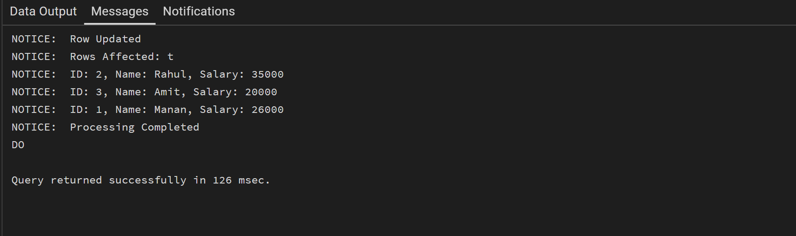

Learning Outcome
1.Understand how cursors help in processing multiple rows
- Differentiate between implicit and explicit cursors
- Use cursor attributes effectively
- Implement row-by-row processing logic
- Apply cursor-based solutions in real-world scenarios

