

NAME :Manan Verma SEMESTER:4th
SECTION:24_AIT_KRG-G1 UID:24BAI70008
SUBJECT CODE:24CSH-298
FACULTY’S NAME: Mr Shalabh Bhatia

Lab Experiment 8

AIM

To design and implement a PL/pgSQL stored procedure that calculates the number of employees based on gender using input, output, and INOUT parameters.

Objective of the Session
- To understand the creation and usage of database tables.
- To learn how to insert and manage records in a relational database.
- To implement stored procedures using PL/pgSQL.
- To use different types of parameters: IN, OUT, and INOUT.
- To perform aggregation operations using COUNT(*).
- To execute procedures and display results using anonymous blocks.

Software Requirements
Database Management System:
Oracle Database Express Edition (Oracle XE)
PostgreSQL Database
Database Administration Tool / Client Tool:
Oracle SQL Developer (for Oracle XE)
pgAdmin (for PostgreSQL)

Experiment Question :
Create a PL/pgSQL stored procedure to count employees based on gender using IN, OUT, and INOUT parameters, and execute it using an anonymous block to display the result.

Practical/Experiment steps:
- Create the Table
Define the EMPLOYEES table with attributes: emp_id, emp_name, gender, and salary.
- Insert Data
Add sample employee records into the table using INSERT statements.
- Create Stored Procedure
- Define procedure get_employee_count_by_gender.
- Use:
  - IN parameter → gender input
  - OUT parameter → employee count
  - INOUT parameter → status message
- Write SQL query using COUNT(*) to calculate total employees by gender.
- Assign 'SUCCESS' to status.
- Execute Procedure Using Anonymous Block
- Declare variables (GEN, COUNT_OF_EMPLOYEES, STATUS)
- Call the procedure using CALL.
- Display output using RAISE NOTICE.
- Verify Output
Check if:
- Correct count is returned
- Status changes from 'PENDING' to 'SUCCESS'
CODE:
CREATE TABLE EMPLOYEES(
emp_id INT PRIMARY KEY,

emp_name VARCHAR(20),

gender VARCHAR(20),

salary NUMERIC(10, 2)

);

INSERT INTO employees (emp_id, emp_name, gender, salary) VALUES

(101, 'Simran', 'Female', 30000),

(102, 'Simon', 'Female', 55000),

(103, 'Riya', 'Female', 45000),

(104, 'Arjun', 'Male', 59000),

(105, 'Anjali', 'Female', 66000);

CREATE OR REPLACE PROCEDURE get_employee_count_by_gender (IN IN_GENDER VARCHAR(20), OUT OUT_COUNT INT, INOUT STATUS VARCHAR(20))

AS

$$

BEGIN

CREATE OR REPLACE PROCEDURE get_employee_count_by_gender (IN IN_GENDER VARCHAR(20), OUT OUT_COUNT INT, INOUT STATUS VARCHAR(20))

AS

$$

BEGIN

SELECT COUNT(*) INTO OUT_COUNT FROM employees WHERE gender = IN_GENDER;

STATUS:='SUCCESS';

END;

$$ LANGUAGE PLPGSQL;

DO

$$

DECLARE

GEN VARCHAR(20):='Female';

COUNT_OF_EMPLOYEES INT;

STATUS VARCHAR:='PENDING';

BEGIN

CALL get_employee_count_by_gender(GEN, COUNT_OF_EMPLOYEES, STATUS);

RAISE NOTICE 'COUNT OF % EMPLOYEES IS % AND STATUS IS %', GEN, COUNT_OF_EMPLOYEES, STATUS;

END;

$$

OUTPUT:
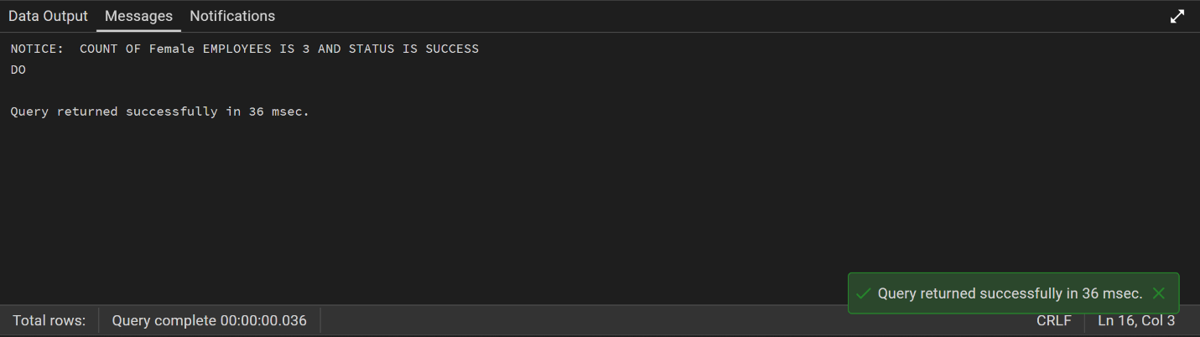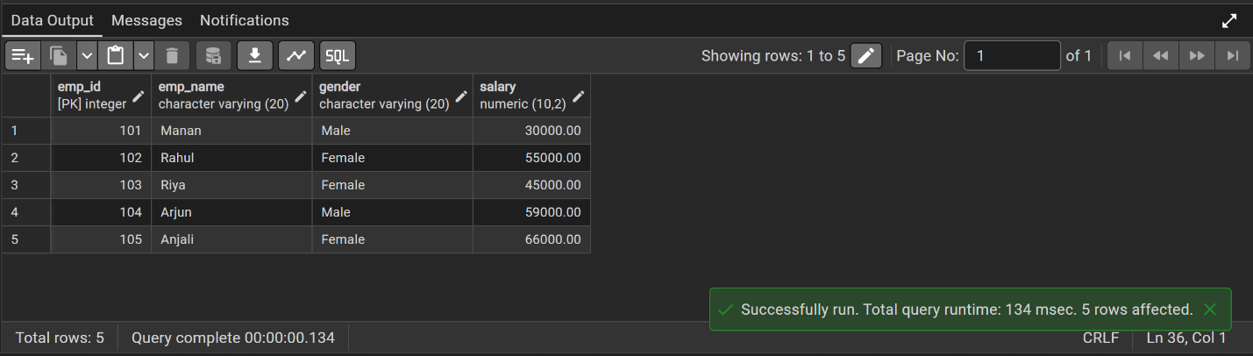

Learning Outcome

After completing this experiment, the student is able to:
Understand how to create and use stored procedures in PL/pgSQL.
Differentiate between IN, OUT, and INOUT parameters.
Perform aggregation using COUNT() function.
Execute procedures using anonymous blocks.
Display results using RAISE NOTICE.

