

NAME: Manan Verma SEMESTER: 4th
SECTION: 24_AIT_KRG-G1 UID: 24BAI70008
SUBJECT CODE: 24CSH-298
FACULTY’S NAME: Mr .SHALABH BHATIA

Topic : Experiment 1

AIM:
To design and implement a Library Management System database using appropriate tables, primary keys, foreign keys, and constraints, and to perform DML operations along with DCL commands such as role creation, privilege granting, and revoking to ensure database security.

Software Requirements
- Database Management System:
  - PostgreSQL
- Database Administration Tool:
  - pgAdmin

Objective :
To gain practical experience in implementing Data Definition Language (DDL), Data Manipulation Language (DML), and Data Control Language (DCL) operations in a real database environment. This will also include implementing role-based privileges to secure data.

Problem Statement
- A Library wants to develop a Library Management System database to manage information about books, members, and book issue records efficiently. The database should be designed using appropriate tables, primary keys, foreign keys, and constraints to ensure data integrity.

- The system must support basic database operations such as inserting records, updating existing data, and deleting obsolete entries. To ensure database security.

- To ensure database security, a database role named Librarian must be created. This role should be password protected and granted SELECT, INSERT, and DELETE permissions on the required tables. The system administrator (pgAdmin) should also have the ability to revoke these permissions when required using role-based access control.
CODE:

CREATE TABLE BOOKS (
BOOK_ID INT PRIMARY KEY,
BOOK_NAME VARCHAR(50) NOT NULL,
AUTHOR_NAME VARCHAR(30) NOT NULL,
BOOK_COUNT INT CHECK (BOOK_COUNT > 0) NOT NULL
);

INSERT INTO BOOKS VALUES
(1, 'Lost Between Lines', 'Riya Kapoor', 4),
(2, 'Whispers of Silence', 'Aman Joshi', 6),
(3, 'Fragments of Yesterday', 'Kunal Shah', 2),
(4, 'Pages Beyond Reality', 'Mehul Jain', 5),
(5, 'Nightfall Diaries', 'Sneha Patel', 1);

SELECT * FROM BOOKS;

CREATE TABLE LIBRARY_VISITORS (
USER_ID INT PRIMARY KEY,
NAME VARCHAR(30) NOT NULL,
AGE INT CHECK (AGE >= 17) NOT NULL,
EMAIL VARCHAR(40) UNIQUE NOT NULL
);

INSERT INTO LIBRARY_VISITORS VALUES
(601, 'Rohit Verma', 20, 'rohit.verma@gmail.com'),
(602, 'Priya Malhotra', 22, 'priya.m@gmail.com'),
(603, 'Sahil Gupta', 19, 'sahil.gupta@gmail.com');

SELECT * FROM LIBRARY_VISITORS;

CREATE TABLE BOOK_ISSUE (
BOOK_ISSUE_ID INT PRIMARY KEY,
USER_ID INT REFERENCES LIBRARY_VISITORS(USER_ID),
BOOK_ID INT REFERENCES BOOKS(BOOK_ID),
ISSUE_DATE DATE
);

INSERT INTO BOOK_ISSUE VALUES
(201, 601, 2, '2026-01-11'),
(202, 602, 4, '2026-01-12');

SELECT * FROM BOOK_ISSUE;

CREATE ROLE LIBRARIAN
WITH LOGIN PASSWORD '123654';

SELECT CURRENT_USER;

GRANT SELECT, INSERT, UPDATE, DELETE
ON BOOKS, LIBRARY_VISITORS, BOOK_ISSUE
TO LIBRARIAN;

REVOKE UPDATE, DELETE
ON BOOKS
FROM LIBRARIAN;

SELECT * FROM BOOKS;
SELECT * FROM LIBRARY_VISITORS;
SELECT * FROM BOOK_ISSUE;

OUTPUT:

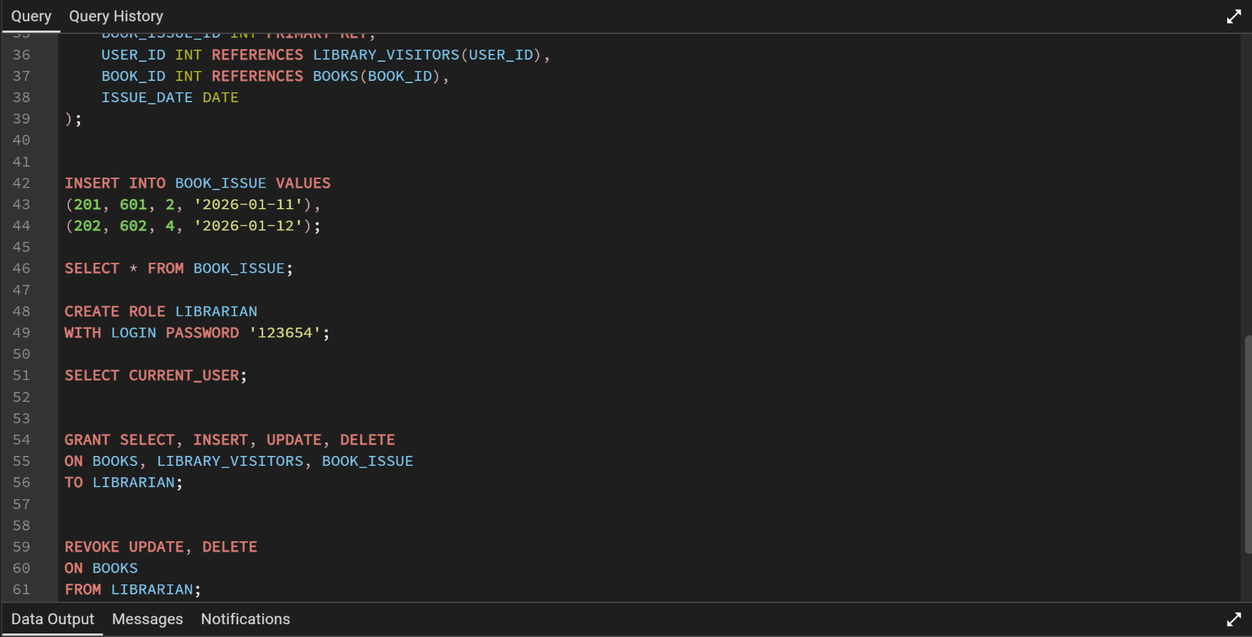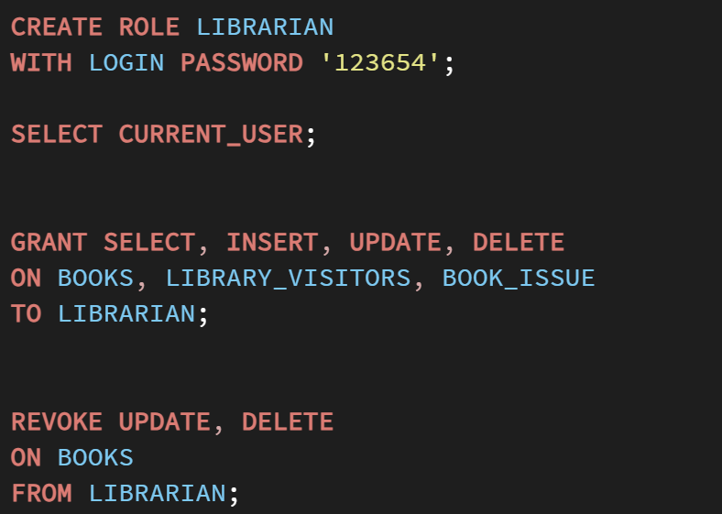
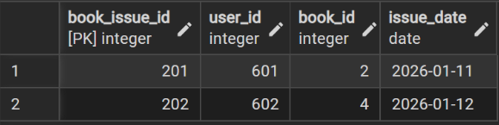

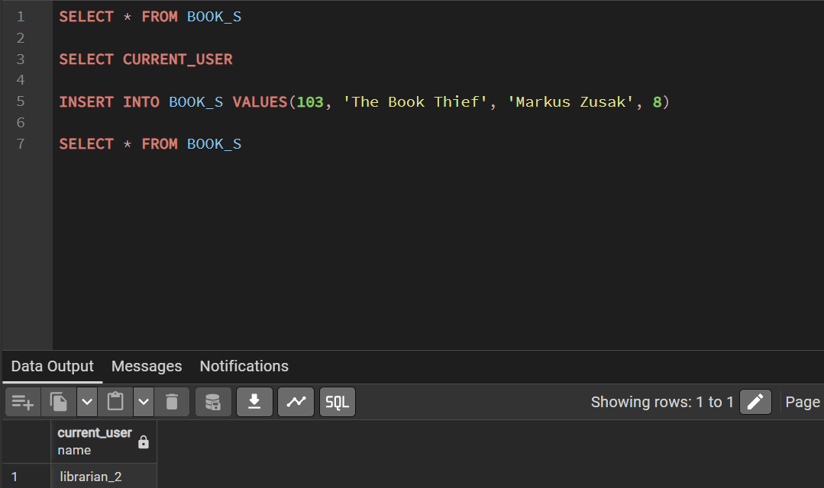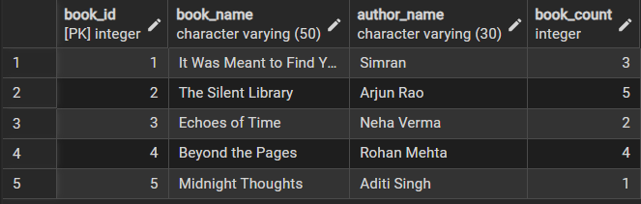

Learning Outcomes:
After completing this experiment, students will be able to:
● Create database tables using DDL commands with appropriate constraints.
● Insert and retrieve records using DML operations.
● Establish relationships between tables using PRIMARY KEY and FOREIGN KEY.
● Implement role-based access control using GRANT and REVOKE commands

