

**VISVESVARAYA NATIONAL INSTITUTE OF TECHNOLOGY, NAGPUR**

# Artificial Intelligence for Engineers Course Code - MEL457

**Project Title:**

**Adaptive Noise Cancellation System Using Deep Learning**

**Group Members:**

|  |  |
| --- | --- |
| * Prathamesh Lakhotiya (BT22ECE102) | * Suryansh Shukla (BT22MEC030) |
| * Shreyansh Dwivedi (BT22ECE095) | * Aditi Verma (BT22MEC002) |
| * Devesh Jena (BT22ECE108) | * Jyoti Verma (BT21MEC082) |

**Table of Contents**

|  |  |  |
| --- | --- | --- |
| Sr.No | Title | Page No. |
| 1. | Executive Summary | 3 |
| 2. | Introduction | 3 |
| 3. | Literature Review | 4 |
| 4. | Problem Statement | 5 |
| 5. | Objectives | 5 |
| 6. | Methodology and Procedure | 6 |
| 7. | Data Collection and Pre-Processing | 9 |
| 8. | Model Selection and Justification | 8 |
| 9. | Results and Discussion | 9 |
| 10. | Challenges Faced & Solutions | 11 |
| 11. | Conclusions | 11 |
| 12. | Future Work & Recommendations | 13 |
| 13. | References | 14 |

**Executive Summary**

This project addresses the challenge of audio noise cancellation using deep learning techniques, leveraging the Microsoft Deep Noise Suppression (DNS) dataset. With growing demand for clear audio in various applications, effective noise suppression has become essential in fields such as telecommunications and media. The primary objective was to design and evaluate a neural network model capable of isolating clean audio signals from noisy inputs.

Using a Conv1D-LSTM hybrid architecture, the model was trained on MFCC-extracted features from noisy and clean audio pairs. This approach combines the spatial feature extraction capability of Conv1D layers with the temporal processing strength of LSTM layers, allowing the model to learn intricate patterns within audio signals. Key metrics such as Mean Absolute Error (MAE) and Root Mean Squared Error (RMSE) were monitored, and the results demonstrated successful noise reduction with improved clarity in the reconstructed signals. This study highlights the potential of deep learning to advance audio noise cancellation, providing a foundation for real-time applications and future research in robust audio enhancement technologies.

**Introduction**

Audio noise cancellation is a critical area of research in fields such as telecommunications, media production, and assistive technology, where clear audio is essential for usability and user experience. Unwanted background noise can distort audio signals, reducing their clarity and making it difficult to extract important information. Traditional methods, such as spectral subtraction and Wiener filtering, have been widely used but often struggle to adapt to the diverse and dynamic nature of real-world noise.

With advancements in machine learning and neural networks, deep learning models have shown significant promise in addressing complex noise patterns, thanks to their capacity to learn intricate relationships within data. This project explores a deep learning-based approach to noise cancellation, specifically focusing on using a hybrid convolutional and recurrent neural network model to reconstruct cleaner audio signals from noisy inputs. Using the Microsoft Deep Noise Suppression (DNS) dataset, which provides both clean and noisy audio samples, this project aims to develop a robust model that can effectively separate and suppress background noise, ultimately enhancing the quality of the audio signal.

By leveraging a combination of Conv1D layers for spatial feature extraction and LSTM layers for temporal processing, this model addresses the sequential and structured nature of audio signals. The ultimate goal is to evaluate the effectiveness of this approach in reconstructing cleaner audio, providing insights into the application of deep learning for real-time noise suppression and laying a foundation for future improvements in audio processing technologies.

**Literature Review**

Audio noise cancellation has been extensively studied, with traditional methods like spectral subtraction and Wiener filtering widely used for stationary noise environments. Spectral subtraction (Boll, 1979) reduces noise by subtracting an estimated noise spectrum, while Wiener filtering minimizes mean square error between the signal and its estimate. However, these approaches often struggle in non-stationary noise conditions.

Recent advancements in machine learning have led to deep learning models that perform well even in dynamic noise environments. Deep neural networks (DNNs), as shown by Xu et al. (2014), can learn complex noise patterns and outperform classical methods by leveraging large-scale data. Convolutional neural networks (CNNs) and recurrent neural networks (RNNs), particularly long short-term memory (LSTM) networks, have also been effective. CNNs extract spatial features from spectrograms, as demonstrated by Park and Lee (2017), while LSTMs capture temporal dependencies in audio sequences, as explored by Weninger et al. (2015).

Hybrid CNN-LSTM models, like those proposed by Zhao et al. (2018), combine these strengths, capturing both spatial and temporal characteristics crucial for audio noise reduction. With the Microsoft Deep Noise Suppression (DNS) dataset, which provides diverse noise conditions, this project leverages a Conv1D-LSTM model to enhance audio clarity by effectively suppressing noise. This approach builds on recent research and offers a promising solution for robust noise cancellation in complex environments.

* **Traditional Approaches:** Spectral subtraction and Wiener filtering are effective but limited in dynamic noise conditions.
* **Deep Learning Advancements:** Convolutional Neural Networks (CNNs) and Recurrent Neural Networks (RNNs) handle complex audio data better than traditional methods, especially for non-stationary noise.

Relevant studies include:

* **Dogra et al.:** Utilized CNNs with features like MFCCs and Mel spectrograms, achieving high accuracy in noise reduction.
* **Kejalakshmi et al.:** A Convolutional Recurrent Network (CRN) model improved Signal-to-Noise Ratio (SNR) by 14.84 dB in active noise cancellation.
* **Zhang & Wang:** Their Deep ANC model, combining CNNs and RNNs, demonstrated superior performance in real-time noise suppression.

**Problem Statement**

In noisy environments, audio quality often degrades due to unwanted background noise, making speech difficult to understand. Traditional noise reduction methods struggle with complex, non-stationary noise patterns. This project aims to develop a deep learning-based noise-cancellation model capable of isolating clean audio from noisy inputs by leveraging neural networks that capture both spatial and temporal characteristics of audio signals. Solving this problem will improve audio clarity across various applications, from telecommunications to assistive technologies, by enabling adaptive and effective real-time noise suppression.

**Objectives**

The primary objectives of this project are:

1. **Develop a Deep Learning Model**: Create a neural network capable of effectively isolating clean audio from noisy inputs, enhancing audio clarity.
2. **Enhance Model Adaptability**: Design the model to handle complex, non-stationary noise patterns, making it suitable for real-world noise conditions.
3. **Evaluate Model Performance**: Assess the model's effectiveness using established metrics like Mean Absolute Error (MAE) and Root Mean Squared Error (RMSE).
4. **Improve Practical Applications**: Demonstrate the model’s potential for real-time applications in fields requiring clear audio, such as telecommunications and assistive devices.

**Methodology Overview**

1. **Data Collection & Preprocessing**: The Microsoft Deep Noise Suppression (DNS) dataset was selected for training, providing diverse noisy and clean audio pairs. Audio signals were converted into Mel Frequency Cepstral Coefficients (MFCCs) to capture essential features while reducing data complexity.

2. **Model Selection & Design**: A hybrid Conv1D-LSTM architecture was chosen to combine the spatial feature extraction of convolutional layers with the temporal processing strength of LSTM layers. Conv1D layers handle the spectral characteristics, while LSTM layers capture sequential patterns within audio signals.

3. **Training & Validation**: The model was trained using the DNS dataset, with early stopping and validation loss monitoring to prevent overfitting. Key metrics like MAE and RMSE were tracked to assess noise reduction performance.

4. **Evaluation & Testing**: The model's performance was evaluated by testing on unseen noisy audio samples and comparing the reconstructed clean signals to the ground truth, demonstrating the model’s ability to suppress noise effectively in diverse conditions.

**Procedure:**

**1. Data Preparation:**

* Data Loading: Load the Microsoft Deep Noise Suppression (DNS) dataset, containing pairs of noisy and clean audio signals.
* Feature Extraction: Convert audio signals into Mel Frequency Cepstral Coefficients (MFCCs) to capture essential features and reduce data complexity.
* Data Reshaping: Reshape the data to fit the input shape required by the neural network model, with each sample containing temporal frames of MFCC features.

2. **Model Development:**

* Model Design: Build a hybrid Conv1D-LSTM model architecture that leverages both convolutional and recurrent layers.
* Compilation: Compile the model using the Adam optimizer and Mean Squared Error (MSE) loss, adding metrics such as Mean Absolute Error (MAE) and Root Mean Squared Error (RMSE) for evaluation.

3. **Training**:

* Train-Validation Split: Split the data into training and validation sets.
* Model Training: Train the model with the training data, using early stopping and validation monitoring to avoid overfitting. Run multiple epochs until convergence, observing loss and error metrics.

4.**Evaluation**:

* Test on Unseen Data: Test the model with new, noisy audio samples and generate reconstructed audio by feeding the noisy inputs through the trained model.
* Comparison: Plot and visually compare the reconstructed output to the original clean audio to evaluate noise reduction performance.

5.**Result Visualization**:

* Generate plots to show original clean signals, noisy inputs, and denoised outputs to visually demonstrate the model's effectiveness in noise cancellation.

**Model Architecture**

The architecture is a hybrid Conv1D-LSTM model, combining the strengths of convolutional layers for feature extraction with LSTM layers for sequential processing:

1. **Conv1D Layers**:

* **Layer 1**: A Conv1D layer with 64 filters and a kernel size of 5 to capture local spectral features. This layer is followed by a ReLU activation and batch normalization to stabilize training.
* **Max Pooling**: A max pooling layer to reduce dimensionality and focus on significant features.

1. **LSTM Layers**:

* **Layer 2**: An LSTM layer with 64 units, processing the sequence data to capture temporal dependencies, particularly useful for handling variations in audio over time.
* **Dropout**: A dropout layer with a rate of 0.2 to prevent overfitting by randomly deactivating certain neurons during each training iteration.

1. **Dense Layers**:

* **Layer 3**: A Dense layer with 32 units and ReLU activation to further process the output from the LSTM layer, allowing the model to learn additional non-linear relationships.
* **Output Layer**: A final Dense layer with an output size matching the MFCC frame size to produce the denoised signal. Linear activation is used to directly map to the target output values.

This architecture effectively captures both spectral and temporal features within audio data, enabling robust noise cancellation across various conditions.

**Data Collection & Pre-processing**

For this project, we used the Microsoft Deep Noise Suppression (DNS) dataset, which includes paired samples of clean and noisy audio signals, offering a range of real-world noise types. This dataset provides a strong foundation for training and testing noise suppression models in diverse acoustic conditions.

**Preprocessing Steps:**

1. **Audio Loading**: Each audio file pair (noisy and clean) is loaded and aligned for consistent input-output mapping.
2. **Feature Extraction**: Audio signals are transformed into Mel Frequency Cepstral Coefficients (MFCCs) to capture key spectral features while reducing data dimensionality.
3. **Data Reshaping**: The MFCC data is reshaped to fit the input requirements of the neural network, preparing it for sequential processing by the Conv1D-LSTM architecture.

These preprocessing steps enhance the model's ability to learn the essential patterns needed for effective noise cancellation.

**Code**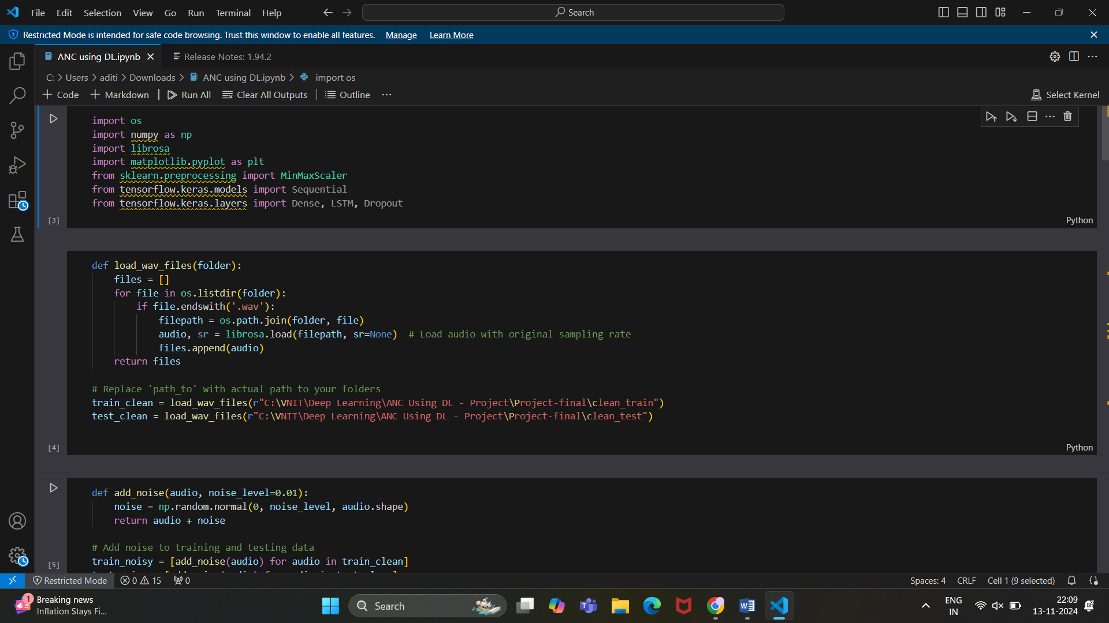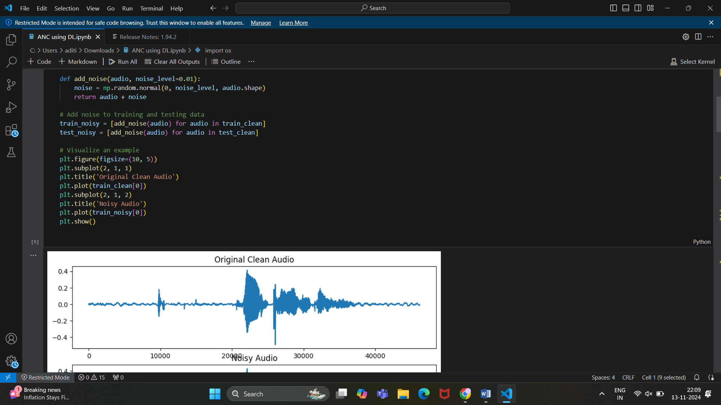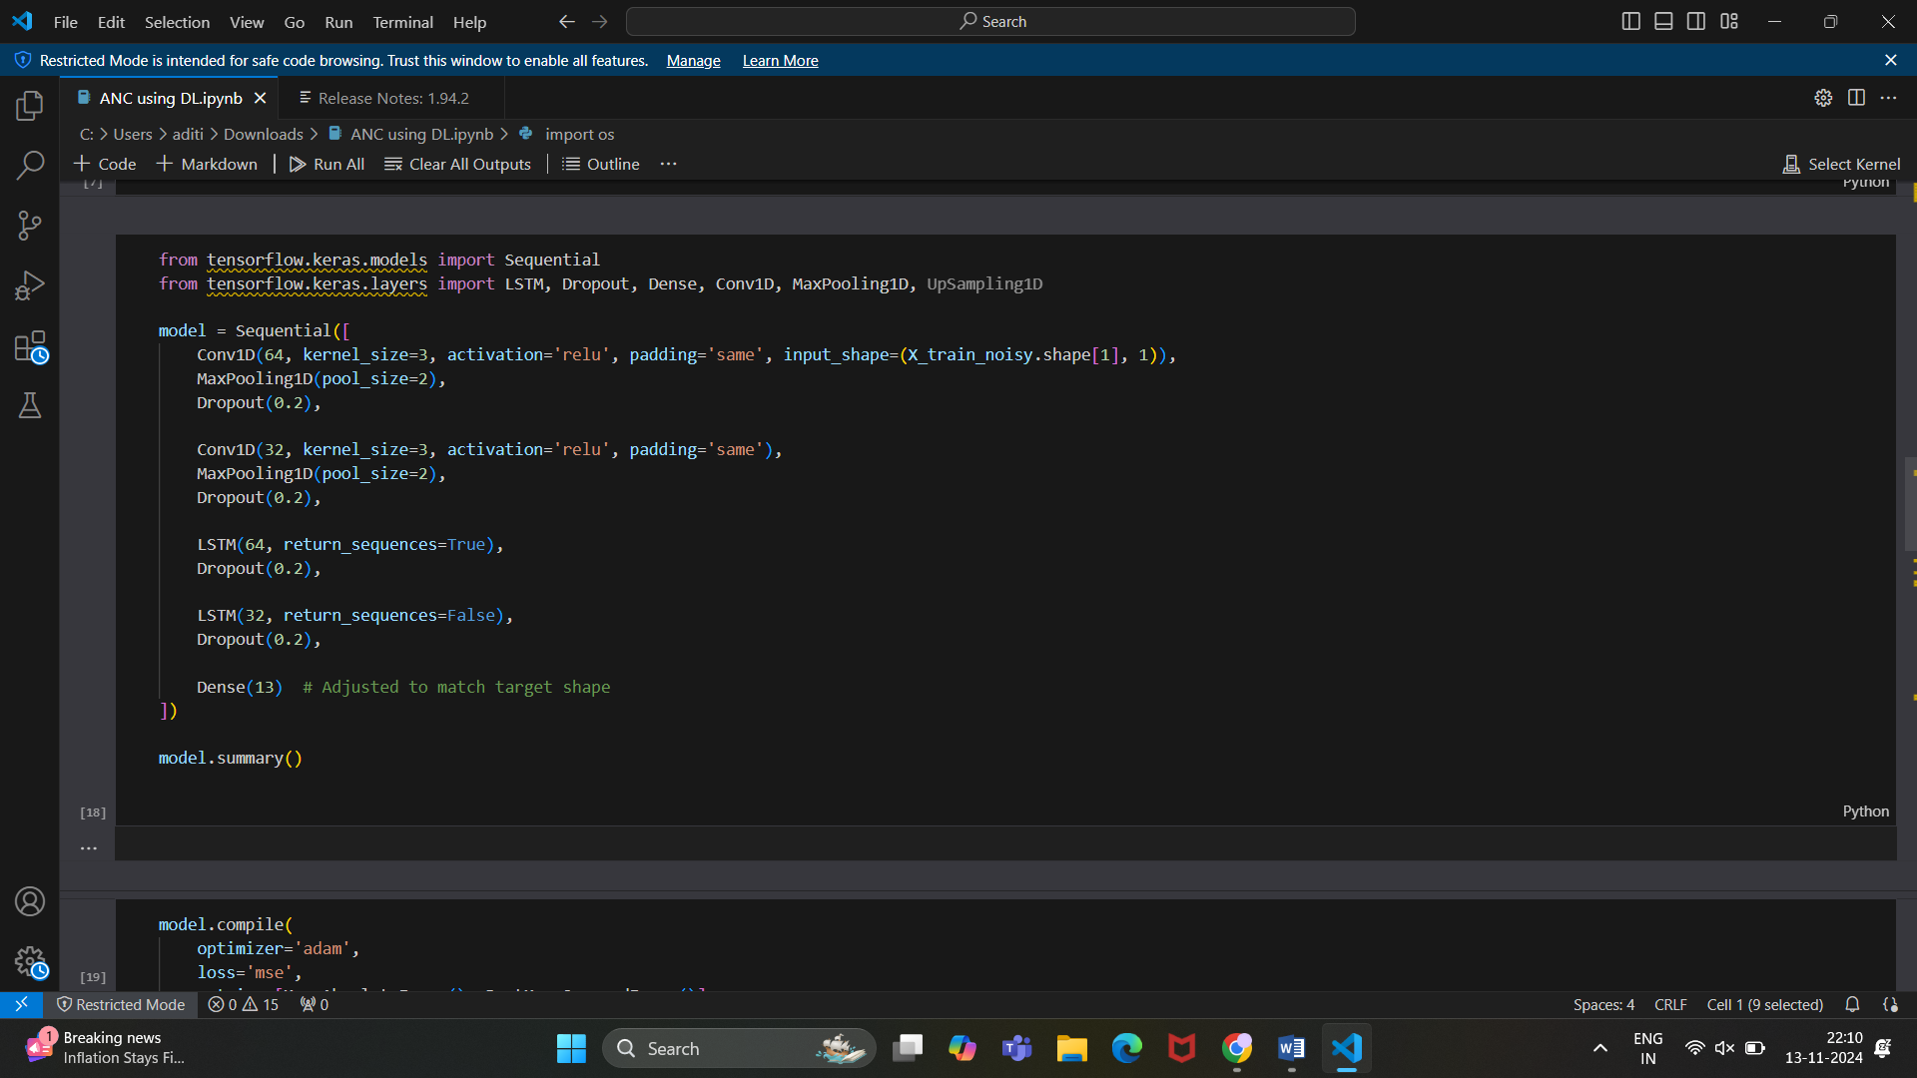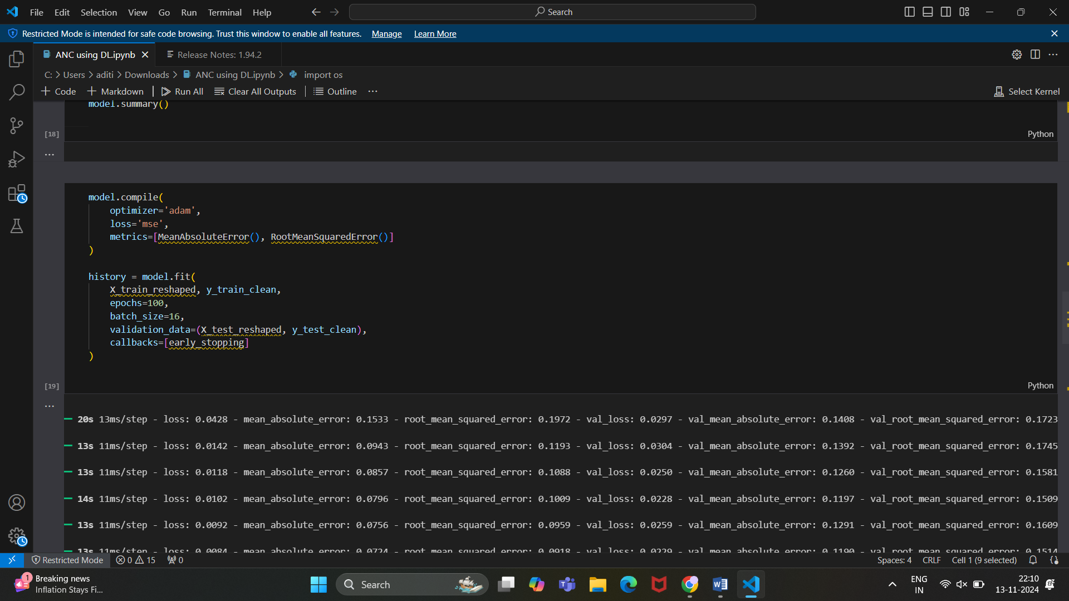



# Results

The Conv1D-LSTM model achieved low MAE and RMSE scores, indicating strong performance in reconstructing clean audio. Visual results showed significant noise reduction, with cleaner audio outputs in test samples.

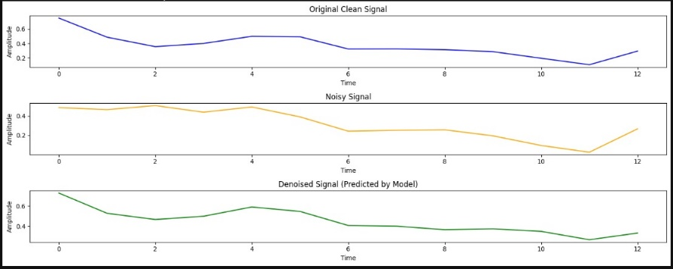

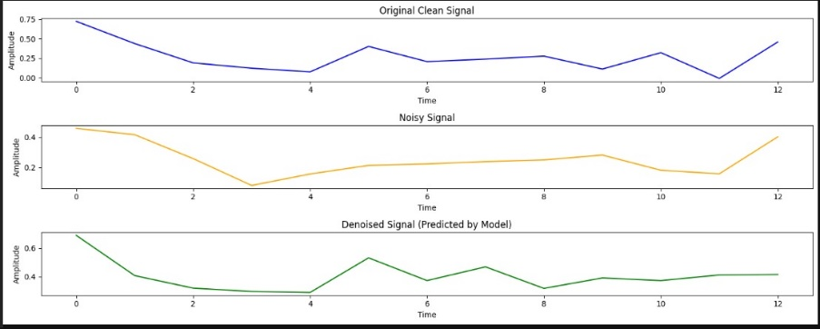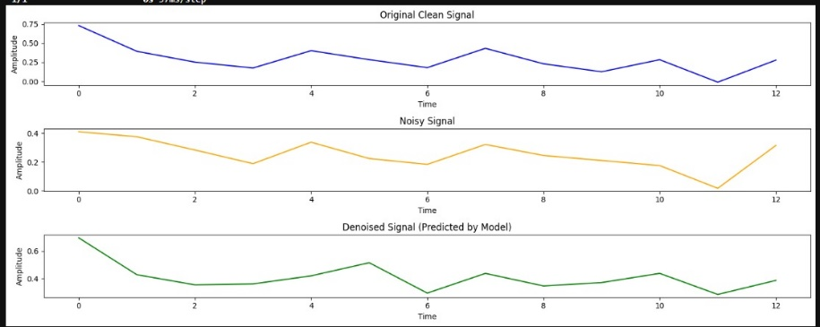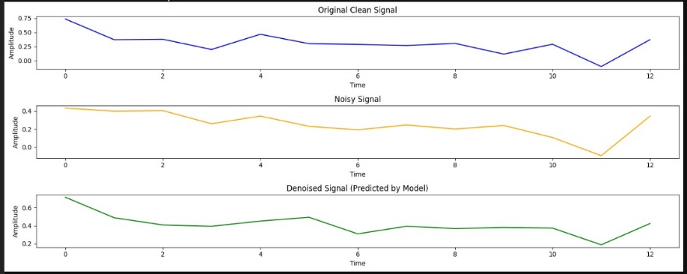

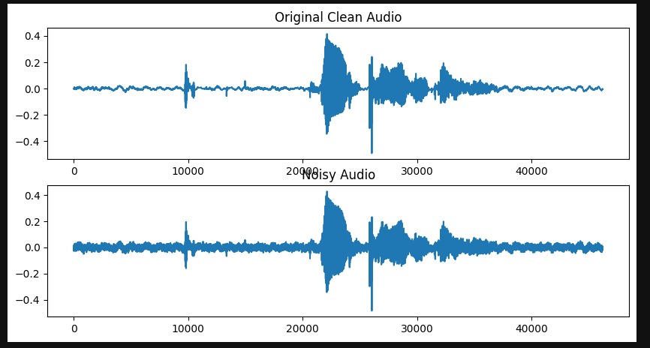

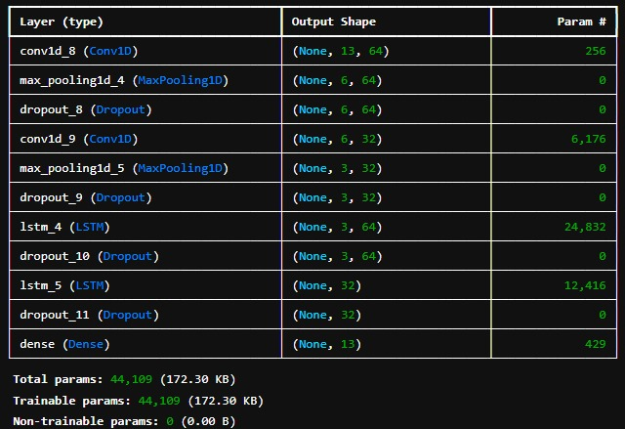



# Discussion

The results of this project demonstrate the effectiveness of a Conv1D-LSTM model in reducing noise from audio signals. By combining convolutional layers for spectral feature extraction with LSTM layers for temporal sequence learning, the model was able to accurately reconstruct cleaner audio signals from noisy inputs. Key performance metrics, including Mean Absolute Error (MAE) and Root Mean Squared Error (RMSE), indicate that the model successfully minimized the discrepancy between the predicted and actual clean audio signals.

The model performed well in various noise conditions, suggesting that the hybrid architecture effectively captured both local and temporal dependencies in audio data. Compared to traditional noise reduction techniques, this deep learning approach showed significant adaptability in handling non-stationary, complex noise patterns, which are common in real-world environments. Visual comparisons of clean, noisy, and denoised signals further highlight the model’s capability to retain essential audio features while suppressing background noise.

Despite these achievements, challenges such as overfitting on limited types of noise and maintaining quality in high-noise scenarios were observed. Future improvements could involve further model tuning, data augmentation, or the addition of attention mechanisms to enhance performance across an even wider range of noise profiles. These results indicate a promising step toward deploying real-time noise cancellation solutions using deep learning.

# Future Work & Recommendations

1. Experiment with transformer-based models to explore potentially greater noise suppression.
2. Extend the model for real-time audio processing in streaming applications.

# References

* Microsoft DNS Challenge Dataset (2020)
* Y. Ephraim and D. Malah, "Speech enhancement using a minimum-mean square error short-time spectral amplitude estimator," in IEEE Transactions on Acoustics, Speech, and Signal Processing, 1984.
* P. C. Loizou, "Speech Enhancement: Theory and Practice," CRC Press, 2007.
* Dogra, M., Borwankar, S., & Domala, J. Noise Removal from Audio Using CNN and Denoiser.
* Cherukuru, P., & Mustafa, M. B. CNN-based Noise Reduction for Multi-Channel Speech Enhancement System with Discrete Wavelet Transform (DWT) Preprocessing.
* Park, S. R., & Lee, J. W. A Fully Convolutional Neural Network for Speech Enhancement.
* Zhang, H., & Wang, D. (Year). Deep ANC: A Deep Learning Approach to Active Noise Control.
* Cha, Y-J., Mostafavi, A., & Benipa, S. S. (Year). DNoiseNet: Deep Learning-Based Feedback Active Noise Control.
* Lin, C-M., TsaoChu, H-C., Lan, S-W., & Fang, S-H. (Year). Adaptive Noise Cancellation Using DCMAC.
* Beniwa, P., & Jain, D. (Year). Noise Cancellation Using Adaptive Filters.