Thanksgiving and Christmas Stores

Group 4: Brandon Forster and Patrick Delva

User Manual

# Setting up your Workstation

1. Download XAMPP from <https://www.apachefriends.org/index.html>
2. Install and run XAMPP.
   1. This database requires Apache, MySQL, and PHP to be installed.
   2. Ensure that Apache, MySQL, and PHP are checked and installed in the installer.
   3. 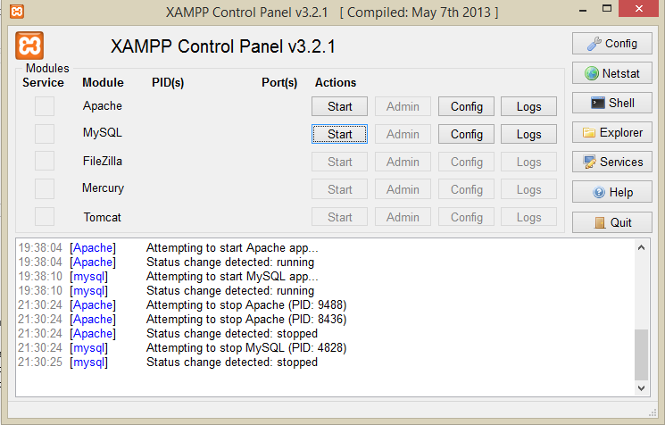All other components are optional and not required for this database application.

Figure : XAMP with Apache and MySQL not running

1. 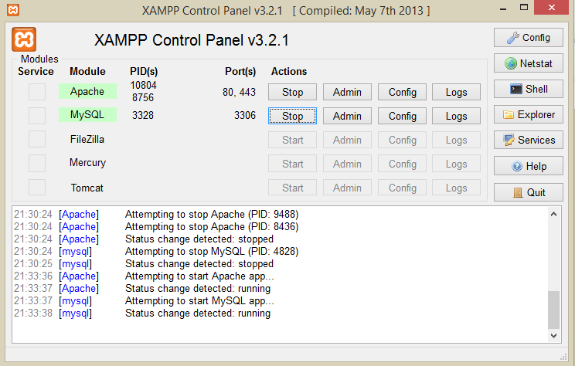Press the start button next to Apache and MySQL. This will launch the servers.

Figure : XAMP with Apache and MySQL running

1. Next, press the “Admin” button next to the MySQL server button.
2. This should open your browser to <http://localhost/phpmyadmin/>
3. Open the “Import” tab on the Database Management tool
4. 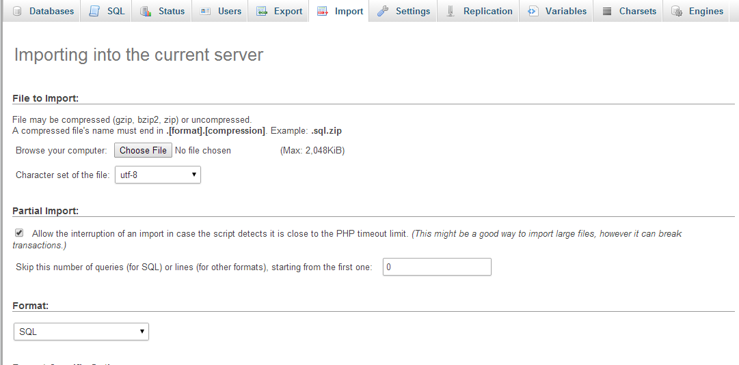On the Import tab, click the “Choose File” button.

Figure : The Import Tab

1. A system file chooser dialog will open. Navigate to the directory containing the database files, and select “church.sql”
2. Navigate your browser to <http://127.0.0.1/registrationform.php>
3. Your workstation is now ready for operation.

# Using the Application

1. Begin on Registration Form.
2. Fill out the form using user provided data.
3. If you’ve missed a required field, the application will not allow you to advance until the required field is filled in with data.
4. If you select “Clothes and Toys,” the application will direct you to the Clothes and Toys form to fill out.
5. Fill this form out, and again, if you’ve missed a required field the application will not allow you to advance until every required field is filled in with data.
6. After filling in the form for Food or Clothes, the app will direct you to a new, blank registration form.
7. Return to Step 1, repeating for every user.

# Outputting Data