

**(Q1) Write a Program to find length of a given String:**

#include <stdio.h>

void main()

{

char s[100];

printf("Enter any string to find it's length: ");

fflush(stdin);

scanf("%s", s);

int sz= 0;

for(int i= 0; s[i]!='\0'; i++)

sz++;

printf("Length of string is: %d", sz);

}

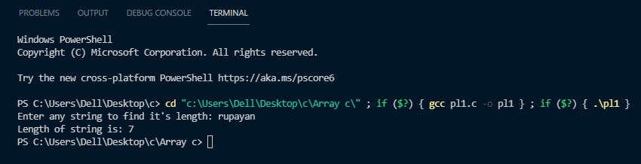

**(Q2) Write a Program to reverse a given string:**

#include <stdio.h>

void main()

{

char s[100];

printf("Enter any string to find it's reverse: ");

fflush(stdin);

scanf("%s", s);

int sz= 0;

for(int i= 0; s[i]!='\0'; i++)

sz++;

char revs[100]; int j= 0;

for(int i= sz-1; i>=0; i--)

revs[j++]= s[i];

revs[j]= '\0';

printf("Reversed string is: %s", revs);

}

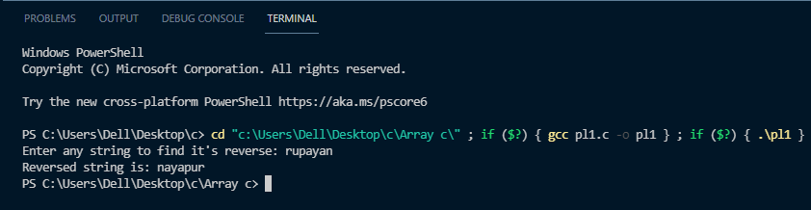

**(Q3) Write a Program to decide a string is palindrome or not:**

#include <stdio.h>

void main()

{

char s[100];

printf("Enter any string to check palindrome: ");

fflush(stdin);

scanf("%s", s);

int sz= 0;

for(int i= 0; s[i]!='\0'; i++)

sz++;

char revs[100]; int j= 0;

for(int i= sz-1; i>=0; i--)

revs[j++]= s[i];

revs[j]= '\0';

int flag= 1;

for(int i= 0; i<sz; i++)

if(s[i]!=revs[i])

flag= 0;

if(flag)

printf("String is palindrome");

else

printf("String is not palindrome");

}

