

**GSWO3AIME20**

**Low Cost Gas Sensor based on tungsten**

**trioxide (**𝐖𝐎𝟑**) nanoparticles**

# MAIN FEATURES



* Low cost
* Low power consumption
* Small size
* Long lifespan
* 2 integrated gas sensors
* Integrated temperature sensor
* Integrated heater
* Especially designed to detect CH3CH2OH and NH3with high reliability
* 10-Lead TO-5 metal can package
* Passive sensor

# GENERAL DESCRIPTION

The GSW03AIME20 is a fully integrated, pin-compatible, gas sensor with a detection system based

on WO3 nanoparticles. The sensor is composed of two identical interdigitated combs hosting the nanoparticles tubes. By settling down on the nanoparticles, the gas molecules of the environment change the combs resistivity, depending on their nature and concentration. The operating

temperature can be selected with the integrated heater resistor made of a N-doped poly-silicon layer. An additional aluminium resistor acts as a temperature sensor to retrieve the operating

temperature of the measurement.

**FUNCTIONNAL DIAGRAM**

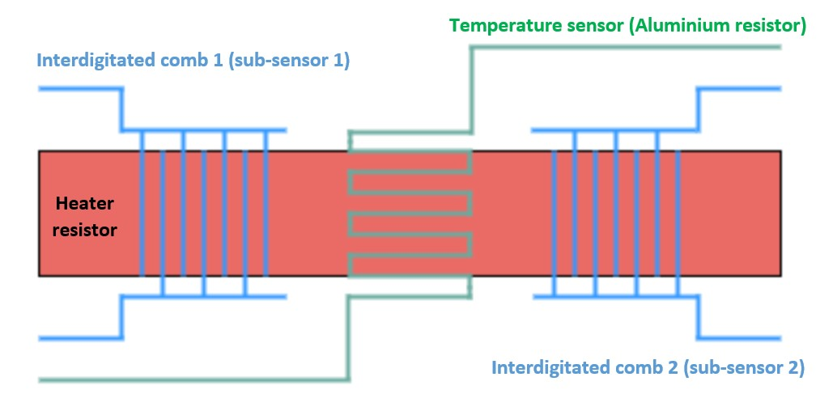

1

# GSWO3AIME20

|  |  |
| --- | --- |
| Pin number | Description |
| 1 | NC |
| 2 | Temperature sensor (Al resistor) |
| 3 | Gas sensor 1 |
| 4 | Heater resistor (N-poly resistor) |
| 5 | Gas sensor 1 |
| 6 | NC |
| 7 | Temperature sensor (Al resistor) |
| 8 | Gas sensor 2 |
| 9 | Heater resistor (N-poly resistor) |
| 10 | Gas sensor 2 |

## PIN CONFIGURATION

**SPECIFICATIONS**

Table 1.

|  |  |  |  |  |  |
| --- | --- | --- | --- | --- | --- |
| **PARAMETER** | **TEST CONDITION** | **MIN** | **TYP** | **MAX** | **UNIT** |
| **Temperature sensor** |  |  |  |  |  |
| Input impedance (𝑅𝐴𝑙) | T = 25°C | 60 | 71 | 80 | Ω |
| Operating voltage | T = 25°C | - | 5 | 10 | V |
| **Heater resistor** |  |  |  |  |  |
| Input impedance (𝑅ℎ) | T = 25°C | 60 | 80 | 105 | Ω |
| Operating voltage | T = 25°C | - | 7,5 | 15 | V |
| **Gas sensor** |  |  |  |  |  |
| Input impedance (𝑅𝑔𝑎𝑠_𝑇=25°𝐶) | T = 25°C | - | 10 | - | GΩ |
| Input impedance (𝑅𝑔𝑎𝑠_𝑇=250°𝐶) | T = 250°C | 2 | 20 | 250 | MΩ |
| Operating voltage | T = 25°C | - | 20 | 20 | V |
| 𝐶𝐻3𝐶𝐻2𝑂𝐻 *detection* |  |  |  |  |  |
| Impedance variation : ΔR/𝑅𝑔𝑎𝑠_𝑇=250°𝐶 | T = 250°C | 20 | 34 | 54 | % |
| Response time τ | T = 250°C | 10 | 20 | 30 | s |
| Sensitivity | T = 250°C | - | 54 | - | kΩ/ppm |
| 𝑁𝐻3 *detection* |  |  |  |  |  |
| Impedance variation : ΔR/𝑅𝑔𝑎𝑠_𝑇=250°𝐶 | T = 250°C | 45 | 82 | 140 | % |
| Response time τ | T = 250°C | 4 | - | 25 | s |
| Sensitivity | T = 250°C | - | 143,3 | - | kΩ/ppm |

# GSWO3AIME20

## ABSOLUTE MAXIMUM RATINGS

Table 2.

|  |  |
| --- | --- |
| **Parameter** | **Rating** |
| Temperature sensor  Operating voltage    Heater resistor  Operating voltage    Gas sensor  Operating voltage  Operating temperature | Nominal range of use : 0V to 5V  Range of non-deterioration : 5V to 10V    Nominal range of use : 0V to 7,5V  Range of non-deterioration : 7,5V to 15V    Range of non-deterioration : 0V to 20V Until 350°C |

## RECOMMENDED OPERATING CONDITIONS

Table 3.

|  |  |  |
| --- | --- | --- |
|  | TYP | Unit |
| External temperature | 20 ± 5 | °C |
| Humidity | 60 ± 5 | % |
| Air quality | 80 / 20 | % (N2 / O2) |

## TYPICAL PERFORMANCE CHARACTERISTICS

### 1. Temperature sensor

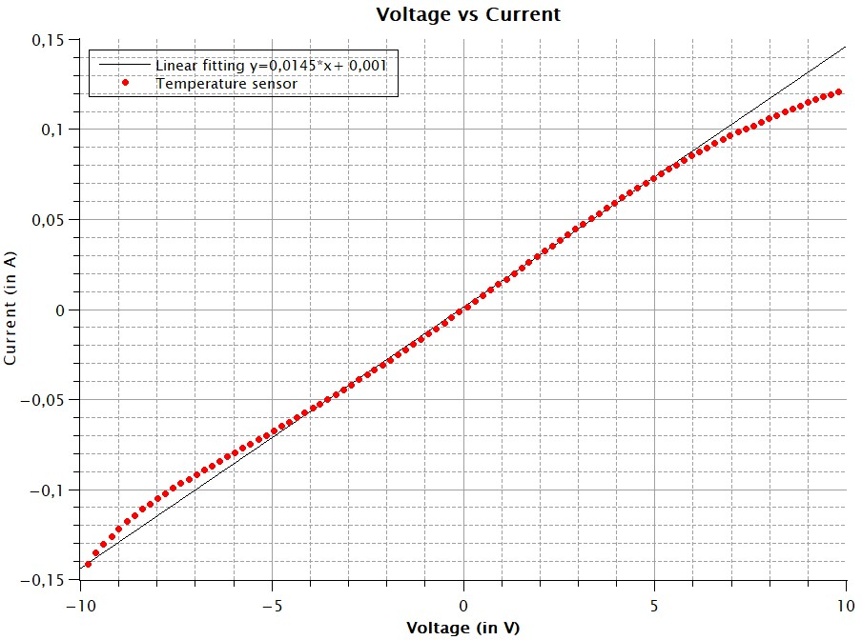

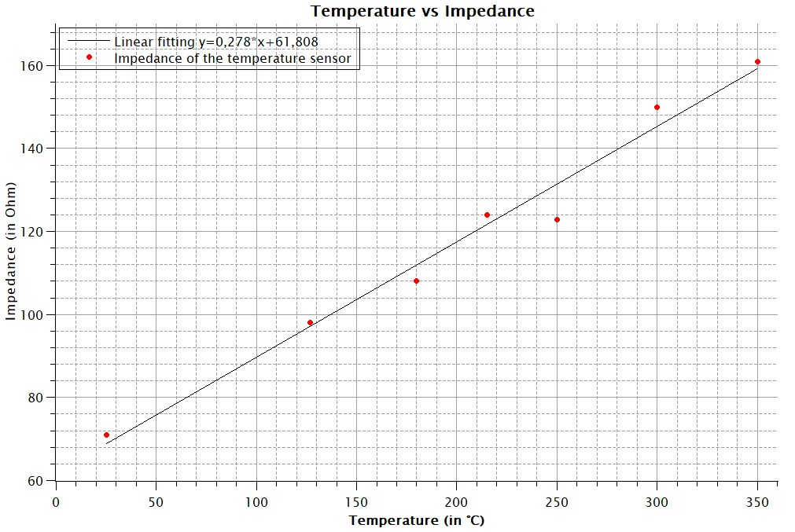

### 2. Heater resistor

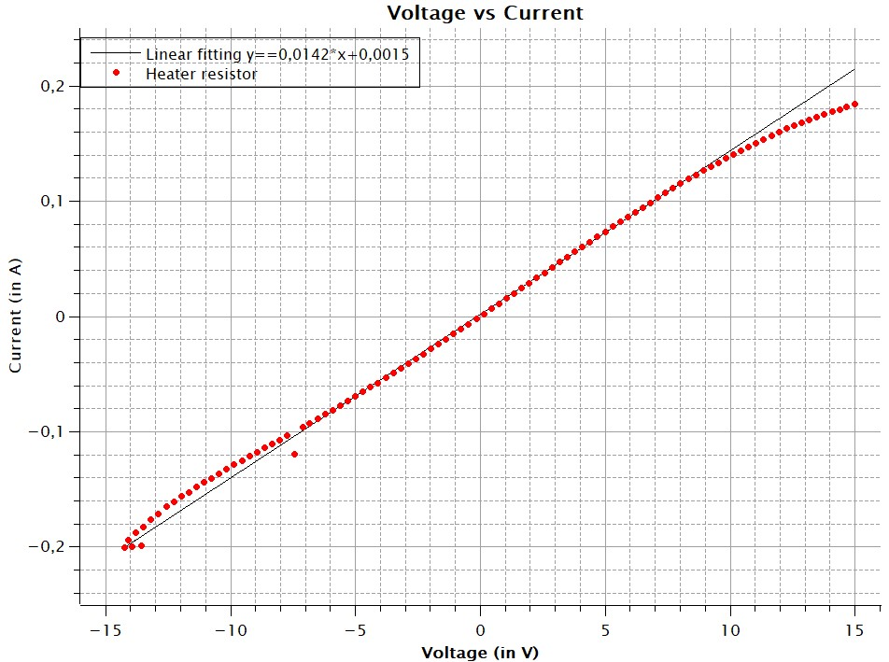

### 3. Gas sensor

For the gas sensor characterization, the following protocol has been used :

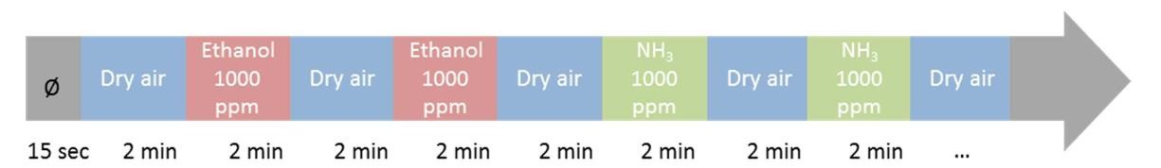

The gas composition is respectively :

* 80% N2 and 20% O2 for “dry air”
* CH3CH2OH at about 0,1% in dry air for “ethanol”
* NH3 at about 0,1% in dry air for “NH3”

The measurements have been operated with a 20V polarization voltage across the gas sensor and by a temperature of 250°C.

#### 3.1. Gas sensor - 𝐶𝐻3𝐶𝐻2𝑂𝐻 detection

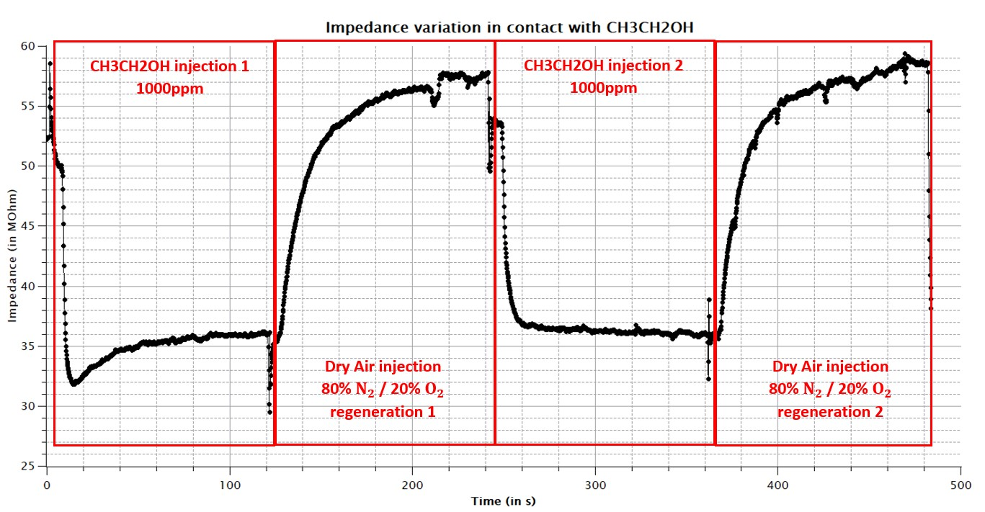

#### 3.2. Gas sensor - 𝑁𝐻3detection

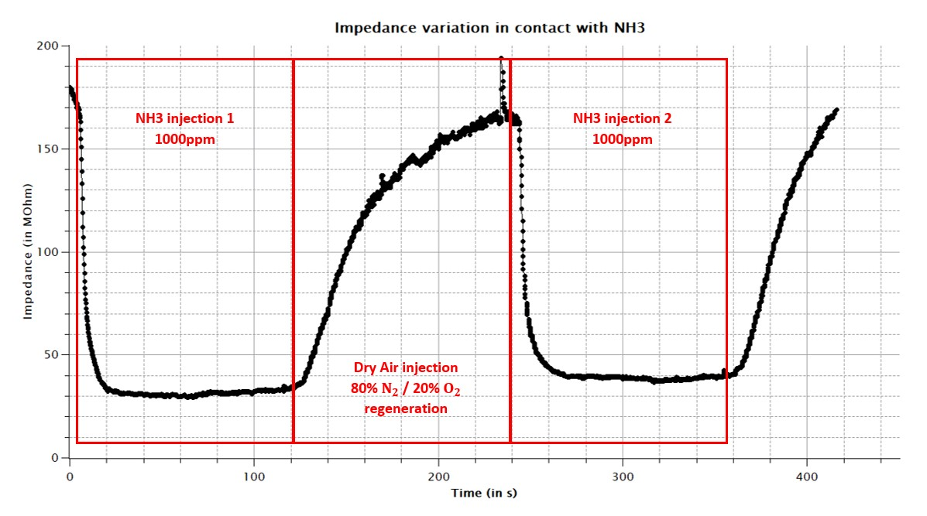

**APPLICATION INFORMATION**

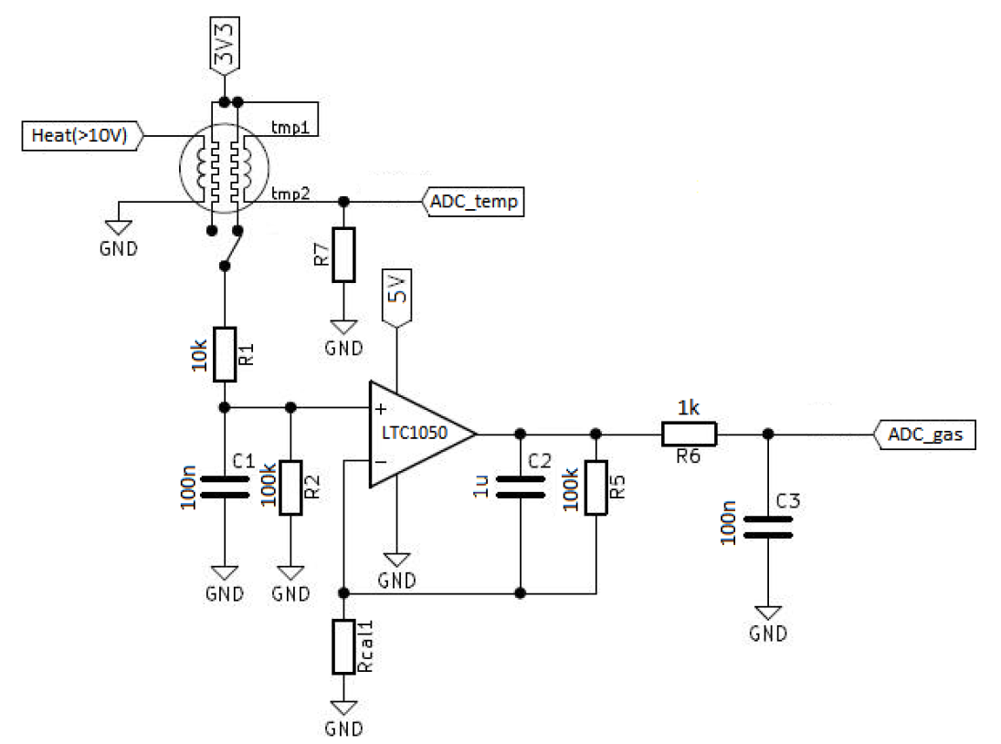

## PACKAGE MATERIAL INFORMATION

