MODULE 6 — IN-VEHICLE INFOTAINMENT SYSTEMS
Conceptual Architecture of an IVI System
Integrating Media, Navigation, and Projection — Annotated Component Interfaces and Data Flow
Project Option 1
Automotive IVI Project — Module 6

NAME : SOURJENDU MISRA
ENROLLMENT NO : 12023002001191
SECTION : C
ROLL NO : 25
CAMPUS : NEWTOWN

1. Objective
This project designs a conceptual architecture for an In-Vehicle Infotainment (IVI) system that integrates three core subsystems — media playback, navigation, and phone projection (Android Auto / Apple CarPlay) — on a single Android Automotive-based head unit. The diagram annotates the interfaces between components and traces, step by step, how user input and system events propagate as data through the application, framework, hardware-abstraction (HAL), and hardware layers.

2. Scope & Assumptions
- Target platform: Android Automotive OS (AAOS) head unit, following the four-layer stack (Application/HMI, Framework/Middleware, HAL, Hardware) common to every IVI subsystem covered in this module.
- Media source modeled: Bluetooth-streamed audio (A2DP/AVRCP) from a paired phone — representative of the wider Media subsystem, since USB and Tuner sources converge on the same Audio HAL path.
- Navigation is provided by a native app using GNSS positioning and the FusedLocationProviderClient API.
- Projection covers Android Auto / Apple CarPlay, rendered through a projection session over USB or Wi-Fi.
- A fourth column, Telephony/Bluetooth, is included because the incoming-call scenario is needed to demonstrate cross-subsystem interaction (audio-focus arbitration) between otherwise independent subsystems.

3. System Overview
Every IVI subsystem — tuner, media, navigation, Bluetooth, or projection — is built from the same four layers, and every app-to-platform call travels over AIDL/HIDL through Binder IPC. Although Media, Navigation, and Projection are functionally independent, they converge on two shared resources: the Car Launcher / Display Compositor (one physical screen and cluster) and the Car Media Service (one physical speaker path). Because only one subsystem can own the screen focus or the speaker output at a time, the architecture must explicitly model an arbitration point for each shared resource rather than treating the three subsystems as fully isolated stacks. Figure 1 makes both the per-subsystem paths and these shared arbitration points explicit.

4. Conceptual Architecture Diagram
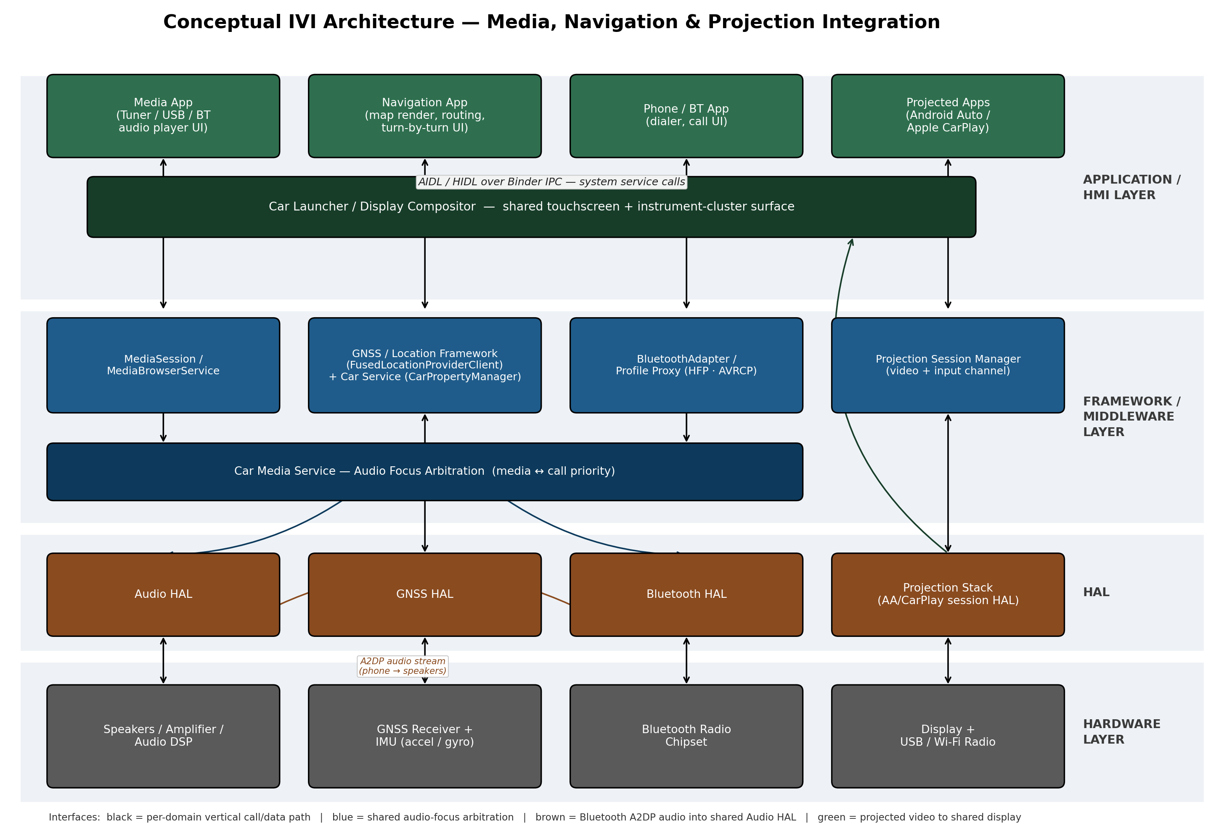
Figure 1. Conceptual layered architecture for IVI Media, Navigation, and Projection integration, annotated with component interfaces and shared arbitration paths.

5. Component Descriptions
Layer | Component | Responsibility
Application / HMI | Media App | Presents playback controls; browses BT / USB / tuner sources
Application / HMI | Navigation App | Renders map, computes routes, issues turn-by-turn voice prompts
Application / HMI | Phone / BT App | Handles call UI, contact lookup, caller ID display
Application / HMI | Projected Apps (Android Auto / CarPlay) | Car-safe UI rendered and streamed by the connected phone
Application / HMI (shared) | Car Launcher / Display Compositor | Composes the touchscreen + cluster surface shared by every app
Framework / Middleware | MediaSession / MediaBrowserService | Publishes playback state and a browsable content tree
Framework / Middleware | GNSS / Location Framework (FusedLocationProviderClient) | Streams position fixes to the Navigation App
Framework / Middleware | Car Service (CarPropertyManager) | Exposes vehicle signals (speed, gear) for nav / ADAS context
Framework / Middleware | BluetoothAdapter / Profile Proxy | Manages HFP (calls) and AVRCP (media transport) profiles
Framework / Middleware | Projection Session Manager | Negotiates the video / input channel with the phone
Framework / Middleware (shared) | Car Media Service | Arbitrates audio focus among media, nav prompts, and calls
HAL | Audio HAL | Final common path for all audio output (media, call, TTS)
HAL | GNSS HAL | Delivers raw satellite / IMU data to the location framework
HAL | Bluetooth HAL | Radio-level pairing and streaming control
HAL | Projection Stack (AA / CarPlay session HAL) | Vendor implementation of the projection transport
Hardware | Speakers / Amplifier / Audio DSP | Physical audio output
Hardware | GNSS Receiver + IMU | Satellite signal capture and dead-reckoning sensors
Hardware | Bluetooth Radio Chipset | RF transceiver for phone pairing
Hardware | Display + USB / Wi-Fi Radio | Physical screen and projection transport medium

6. Interface & Protocol Annotations
Table 2 annotates every arrow in Figure 1 with the concrete mechanism it represents.
Interface | Between | Mechanism | Purpose
App ↔ Framework | Every app ↔ system services | AIDL / HIDL over Binder IPC | Standard Android IPC carrying all app-to-platform calls
Media control | Media App ↔ MediaSession | MediaSession / MediaBrowser API | Transport control, metadata, content browsing
Audio arbitration | MediaSession, BT stack ↔ Car Media Service | AudioManager focus API (requestAudioFocus / onAudioFocusChange) | Ensures only one authoritative audio source at a time
Location | Navigation App ↔ Location Framework | FusedLocationProviderClient.requestLocationUpdates() | Streams position fixes for map matching and routing
Vehicle signals | Navigation / ADAS ↔ Car Service | CarPropertyManager (e.g. PERF_VEHICLE_SPEED) | Supplies speed / gear context for guidance
Bluetooth profiles | Phone/BT App ↔ BluetoothAdapter | HFP (calls), A2DP (audio stream), AVRCP (transport/metadata) | Standardized contracts so any phone/head-unit pair interoperates
Projection session | Projected App ↔ Projection Session Manager | USB or Wi-Fi/BT handshake + video/touch channel | Streams rendered UI frames; returns touch/voice events
Shared display | All apps ↔ Display Compositor | Car App Library templates (List/Grid/Navigation/Message) | Guarantees driver-distraction-safe, consistent rendering

7. Annotated Data-Flow Sequence
To demonstrate the data flow implied by Figure 1, consider a single continuous scenario that exercises all three integrated subsystems: the driver is navigating, streaming music from their phone, and receives an incoming call. Figure 2 traces this as a numbered sequence across the same components.
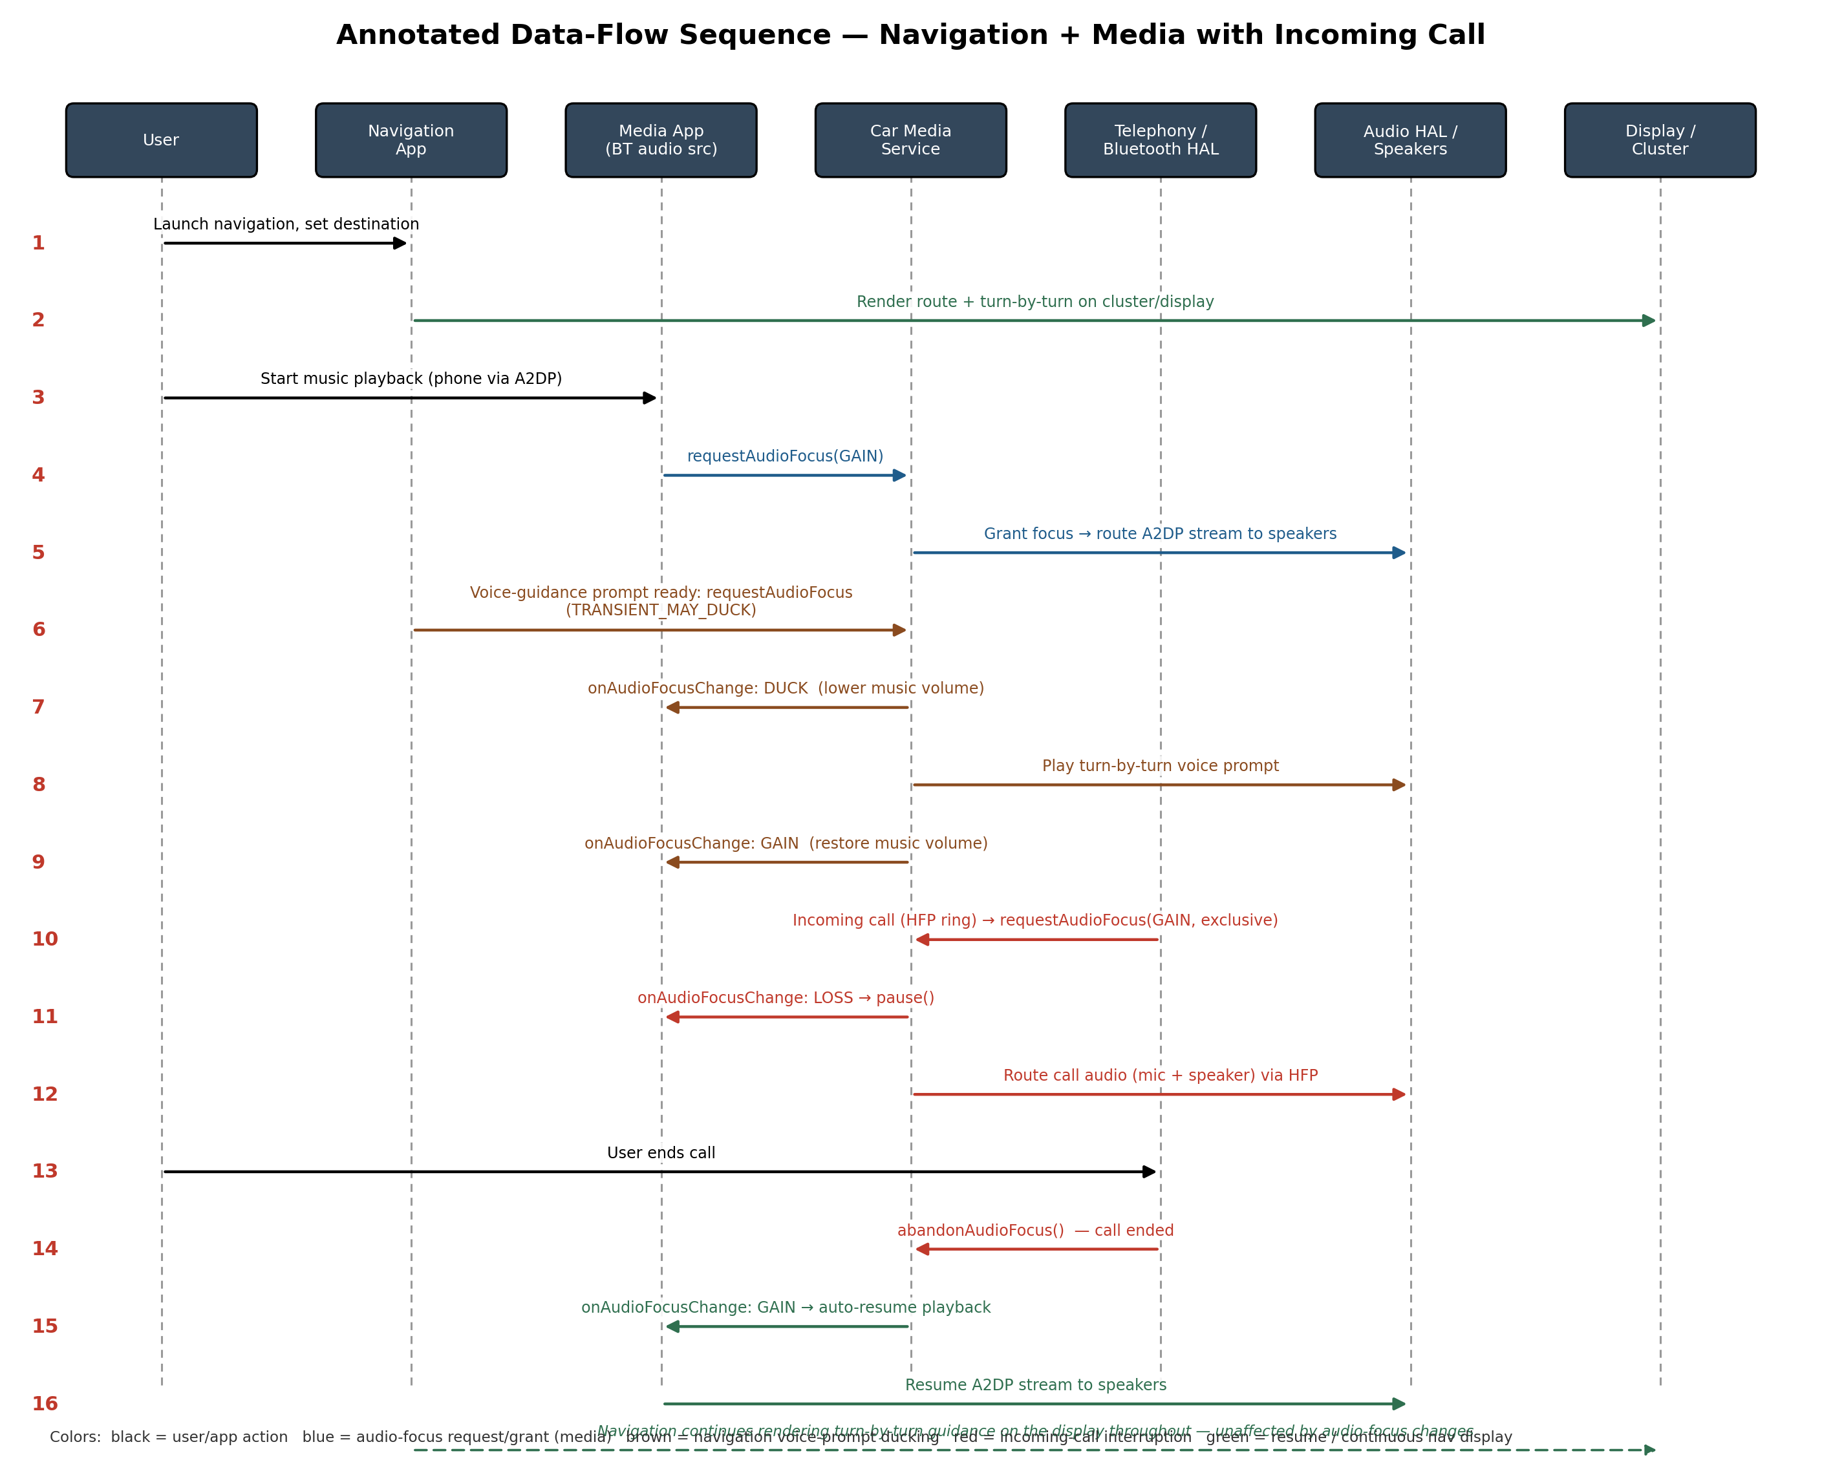
Figure 2. Annotated data-flow sequence — navigation guidance, Bluetooth media playback, voice-prompt ducking, and an incoming-call interruption with automatic media resume.

8. Data-Flow Walkthrough
- User launches the Navigation App and sets a destination.
- Navigation App begins rendering the route and turn-by-turn guidance on the shared display / instrument cluster.
- User starts music playback; the Media App streams audio from the phone over Bluetooth A2DP.
- Media App calls requestAudioFocus(GAIN) on the Car Media Service.
- Car Media Service grants focus; the A2DP stream is routed through the Audio HAL to the speakers.
- When a turn-by-turn voice prompt is ready, the Navigation App requests AUDIOFOCUS_GAIN_TRANSIENT_MAY_DUCK.
- Car Media Service signals the Media App to duck (lower) its volume.
- The voice prompt plays through the Audio HAL.
- Focus returns to the Media App, which restores its volume.
- An incoming call arrives via Bluetooth HFP; the Telephony/BT stack requests exclusive AUDIOFOCUS_GAIN.
- Car Media Service signals AUDIOFOCUS_LOSS to the Media App, which pauses playback.
- Call audio (microphone and speaker) is routed via HFP through the Audio HAL.
- The user ends the call.
- The Telephony/BT stack calls abandonAudioFocus().
- Car Media Service returns AUDIOFOCUS_GAIN to the Media App, which automatically resumes playback.
- The A2DP stream resumes to the Audio HAL and speakers — throughout all of this, the Navigation App continues to render guidance on the display, since visual turn-by-turn is unaffected by audio-focus changes.

9. Design Considerations

9.1 Audio Focus Arbitration
The Car Media Service is the single cross-cutting component in this architecture: it is the only component with an incoming arrow from three independent subsystems (Media, Navigation voice prompts, and Telephony). Any future subsystem that produces audio — a voice assistant, a reversing-sensor chime — must integrate at this same point rather than talking to the Audio HAL directly, or focus conflicts will resurface.

9.2 Driver-Distraction Constraints on the Shared Display
Because Navigation, Media, and Projected apps all render through one Display Compositor, none of them may draw an arbitrary layout. The Car App Library's templates (List, Grid, Navigation, Message) enforce glance-time limits (≤ 2 seconds per interaction), large touch targets, and text-to-speech fallback for long strings, so that three independently-developed apps still produce one driving-safe surface.

9.3 Security & Sandboxing
Each app in the Application/HMI layer runs in its own SELinux-confined sandbox. Reading or writing safety-adjacent vehicle properties through CarPropertyManager (e.g. speed, gear) requires a signature/privileged permission, so a compromised or malicious Media or Projected app cannot escalate into the vehicle-control domain — it can only reach the Audio HAL and Display Compositor shown in Figure 1.

9.4 Extension to Automated Vehicles
As the vehicle takes on more of the driving task, this same architecture extends rather than changes shape: the Navigation App additionally feeds lane-level guidance to ADAS, the Car Media Service gates richer passenger-entertainment content once the driver's attention is no longer required, and the Projection Session Manager can mirror to rear-seat displays — all through the interfaces already annotated in Figure 1.

10. Conclusion
Modeling Media, Navigation, and Projection as three parallel stacks that converge on two shared, arbitrated resources — audio output and display — captures both their independence and their real interactions. The annotated interfaces (Binder IPC, MediaSession, AudioManager focus, CarPropertyManager, and the Bluetooth/projection profiles) and the traced data-flow sequence together show not just what each component does, but exactly how a user action such as an incoming call ripples across subsystems that were designed independently.

11. References
- Module 6 — In-Vehicle Infotainment (IVI): NAVI, Bluetooth & Projection (course slide deck).
- Module 6 — In-Vehicle Infotainment: Tuner & Media (course slide deck).
- Module 6 — Android for Infotainment Systems (course slide deck).
- Module 6 — Automotive Infotainment System (course slide deck).
- Module 6 — Android for Infotainment Systems in Automated Vehicles (course slide deck).

