Table of Contents
Welcome 2
Installation 2
Install Quipu in a blank system. 2
Update Quipu to a new version. 2
Basic data management 3
Taxes 4
Bank accounts 5
Create a bank account 6
Create bank movements manually 9
Import CSV files with bank activities 11
Products and services 12
Create products and categories. 12
Import CSV files with product listings. 13
Sales and Customer management 15
Creating and managing customers 15
Importing customer from CSV files 18
Analyzing customers profitability 19
Creating orders 20
The order life cycle 23
Invoicing 24
Creating a private area in frontend for your customers 24
Purchases and supplier management 28
Creating suppliers 28
Importing suppliers from CSV files 29
Creating purchase orders 30
The purchase order life cycle 31

Welcome
Thank you very much for using Quipu! And welcome to the user documentation. In the following pages we will explain you how use Quipu for Joomla as your enterprise resource management.

Installation

Install Quipu in a blank system.
When you purchase your subscription, you will receive an email with a link to the Quipu component extension. All you have to do is download it and use your Joomla! Extension installer to install it.
Once your are done, you will see a new menu item in your extensions menu with access to Quipu's main functionalities.

Update Quipu to a new version.
Quipu uses Joomla's extension updater to deploy every new version in the 1.0.X series, so whenever a new version is released all you have to do is go to Extensions Manager → update, check the Quipu extension and click the “Update button”.
Please note that if you are using Joomla 3, there is a bug in versions prior to 3.0.4 that prevents updates to install from certain update servers, and ours is among them. So you will have to download the extension from our support forum and install it manually as if it was a clean install. The new version will update the old one without any data loss.

Basic data management
The first thing to do when you install Quipu is create the basic configuration for your setup. Once created, you will always be able to change it through the Configuration section.
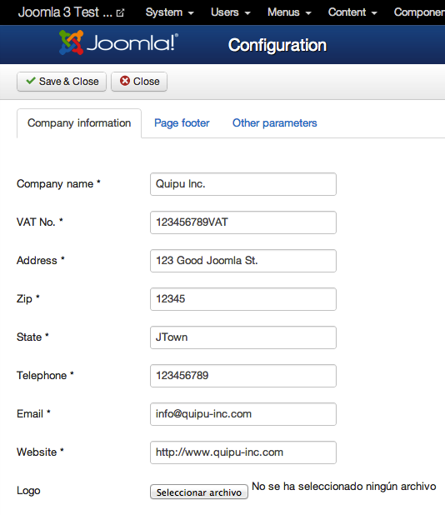
Quipu configuration contains the following values:
- Company name. Your company name.
- VAT No. Your company's VAT number.
- Address. Your company's address.
- Zip. Your company's postcode.
- State. Your company's state, town, etc.
- Telephone. Your company's contact phone.
- Email. Your company's contact email.
- Website. Your company's web site url.
- Logo. Use this field to upload an image file that will be embedded in printed documents (invoices, orders, purchase orders). Please note that the image will be inserted “as is” in the generated pdf files, so it is up to you to provide an image with the right dimensions.
- Page footer. The text that you want to appear in page footer in printed documents.
- Next invoice number. The number of the next invoice that will be generated.
- Next refund number. The number of the next refund that will be generated. A refund document is an invoice that rectifies another one. Following several countries' tax law, Quipu will prefix it with “R-” and include in the refund document the number of the rectified invoice.
- Next order number. The number of the next order that will be generated.
- Next purchase order number. The number of the next purchase order that will be generated.
- Currency symbol. The symbol to use in all money amounts. If you leave this blank, Quipu will try to use your server's locale configuration to format values, but this doesn't provide good results in most cases.

Taxes
Taxes are added to each product or service in both sell and purchase orders. You can have as many tax definitions as you need, and apply different taxes to the products in an order.
To create a tax definition, simply go to Taxes, and click on the “New” button. A tax is defined by only two parameters:
- Name: the name of the tax factor.
- Factor: the value to apply to the item price.
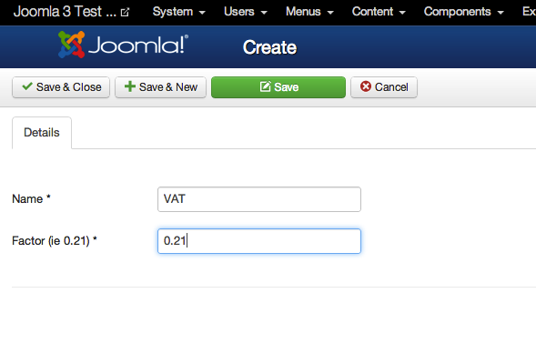
For example, if sold items in your country have a 21% VAT, then you have to create a tax factor of 0.21.

Bank accounts
Quipu helps you keep track of your bank accounts. You can define several accounts and manage all banking activities, and set relations between them and your sell and purchase orders as they get paid.

Create a bank account
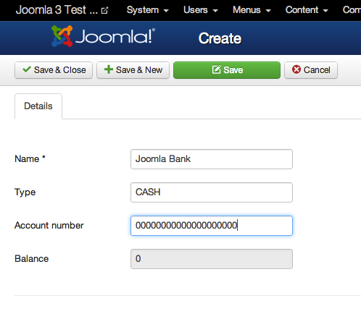
To create a bank account, go to Banks and click on the “New” button. A bank account contains this fields:
- Name: The name of the bank where you have your account.
- Type: The type of account.
- Account number: the account number.
- Balance (read only): the current balance of the account at present time.

Once you have created a bank account, you can manage the account movements with Quipu. When you go to Bank Movements you will see a screen similar to this one:
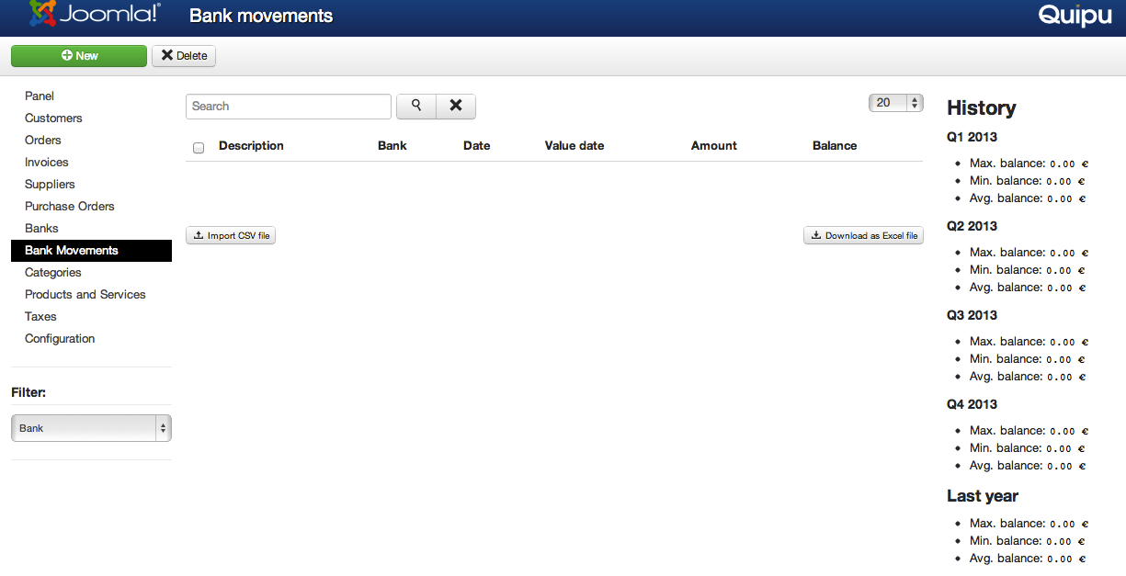
From this screen you can filter your movements by bank account, and see your balance history. This includes the maximum, minimum and mean balances in current year by quarter, and the same values for the previous year, for comparison purposes.

Create bank movements manually
When you are in the Bank movements screen, You can create bank movements by pressing the “New” button. A bank movement contains the following fields:
- Bank: the bank account that the movement belongs to.
- Date: the actual date of the account movement.
- Value date: the value date of the bank movement.
- Description: the description of the movement.
- Amount: the amount.
- Balance: the resulting balance in the account.
- Reference: you can assign a reference to the movement for internal classification.
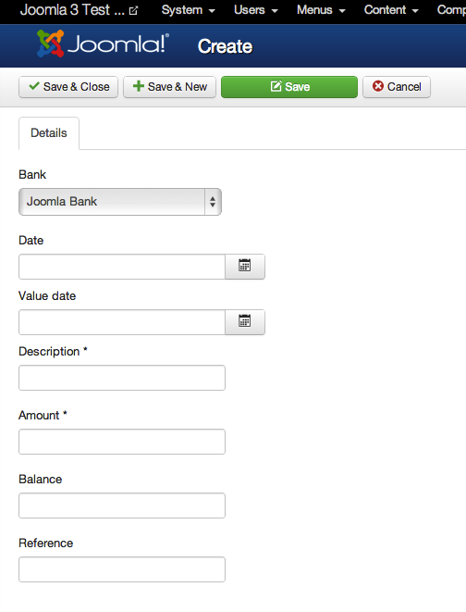

Import CSV files with bank activities
Although creating bank movements can be useful in certain cases, the powerful feature about this is to import the files that your bank will surely let you download from theirs user account management. When you are in the Bank Movements screen, if you click in the “Import CSV file” button, you will open a dialog to upload a Comma Separated Value file with bank accounting information. This files can be generated from all popular spreadsheet software like MS Excel and Libre / Open Office.
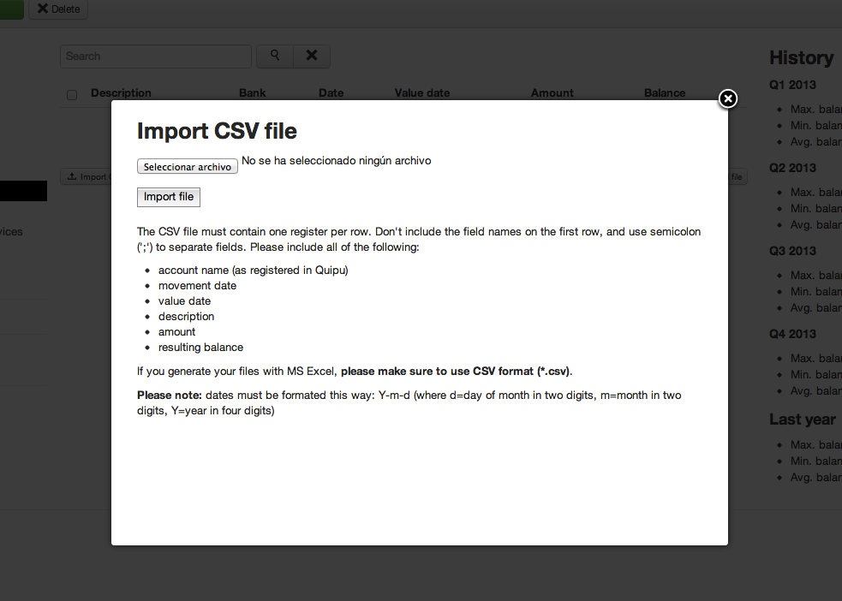
The dialog will contain information about the required file format and structure, including the required columns and details about date fields format.

Products and services
Products and services are the things you buy and sell. In Quipu they are classified in categories, and can be easily managed and imported or exported.

Create products and categories.
A category is simply a name, not much to explain here. You can create as many categories as you want by going to the Categories screen and clicking on the “New” button. In the category form, just enter the name for the category and click on “Save and Close” to save it and go back to categories listing.
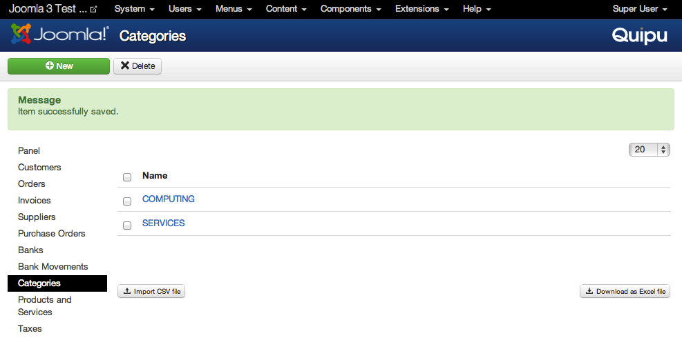
As for products and services, they can be managed from the “Products and Services” view and have the following fields:
- Name: the name for the item.
- Category: the category the item belongs to.
- Tax rate: the tax item (from the ones registered in “Taxes”) that applies to this item.
- Net cost price: the price you pay for this item (excluding taxes). This value will be used for profitability calculation. Each time you register a sell order, Quipu will calculate the profit you obtain with this product by subtracting this value from the sell price. So, you can use this field to register both the buy price, if this is an item like a monitor or a computer, or the fixed timely cost you pay in salaries and material if it is a service.
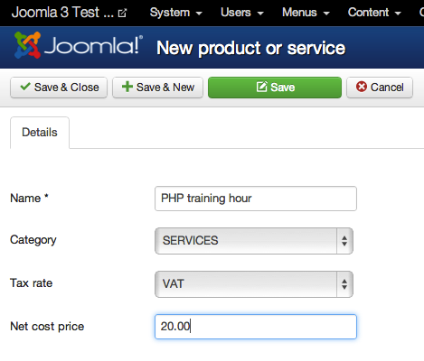

Import CSV files with product listings.
Same as bank movements, Categories and Products can be imported from CSV files.
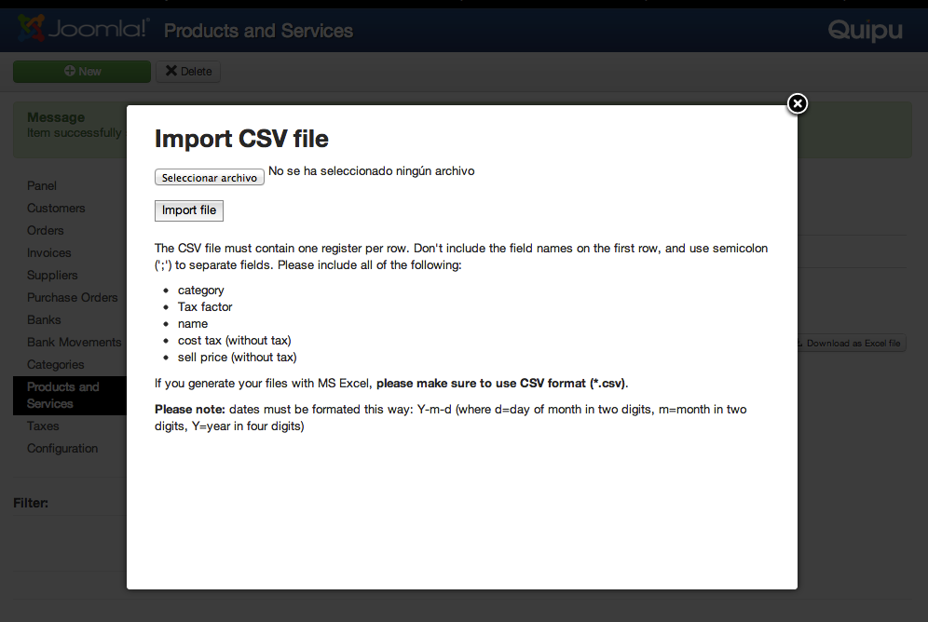
When you click in the “Import CSV file” button of the Products and Services screen, you will be presented with a modal that explains the required fields and date format.
The required fields are:
- Category: the name of the category, as you registered it in Quipu (ie. “COMPUTING”).
- Tax factor: the factor value, as you registered in Qiupu (ie. “0.18”).
- Name: the name of the product or service.
- Cost price (without tax): The price you pay for this item, or the cost it has to you without taxes.
- Sell price (without tax): this value will be used internally for statistics calculation. You can set a different price for each item in every order, and Quipu remembers the last sell price.

Sales and Customer management
Quipu lets you keep track of your sells by managing customers and their orders, including the basic order life cycle.

Creating and managing customers
To create a customer, go to the “Customers” screen and press the “New” button:
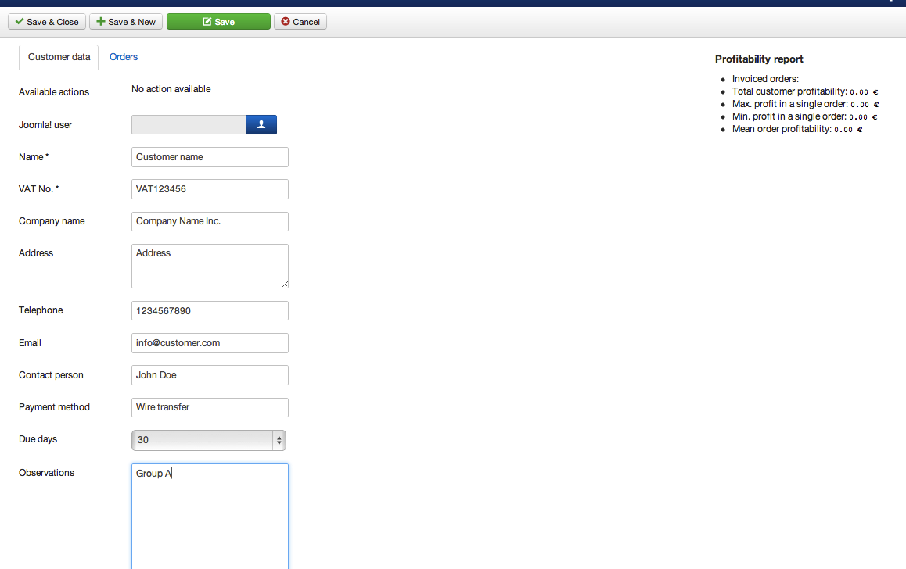
A customer record contains the following fields:
- Joomla user: this is the user name that your customer can use to access the frontend private area.
- Name: the name of your customer.
- VAT No. : your customer's VAT number.
- Company name: your customer's company name as it has to be shown in invoices.
- Address: your customer's address.
- Telephone: your customer's phone number.
- Email: your customer's contact email.
- Contact person: the name of your contact person in your customer's company.
- Payment method: a simple text field to have a note about how your customer prefers to make its payments.
- Due days: This field will be used to calculate the expected payment date for your customer's invoices.
- Observations: this is your private record about this customer. The notes you take here will not be shown.
Once you save a customer, you will see a new field in the form with the title “Available Actions”. You will see this kind of field in other screens too, to give you access to the different task you can do on a particular artifact (customer, supplier, order, invoice, etc) depending on its state:
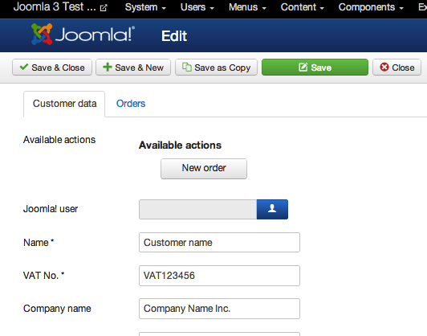
In this case you will be presented a button to create an order for this customer. There is another way of doing this, by clicking in the corresponding button in customers listing:
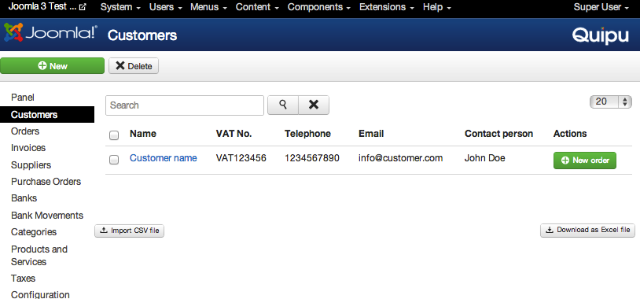

Importing customer from CSV files
As with other kinds of data, Customers can be created in bulks by importing CSV files. In the customers screen, click on the “Import CSV file” to open the import dialog:

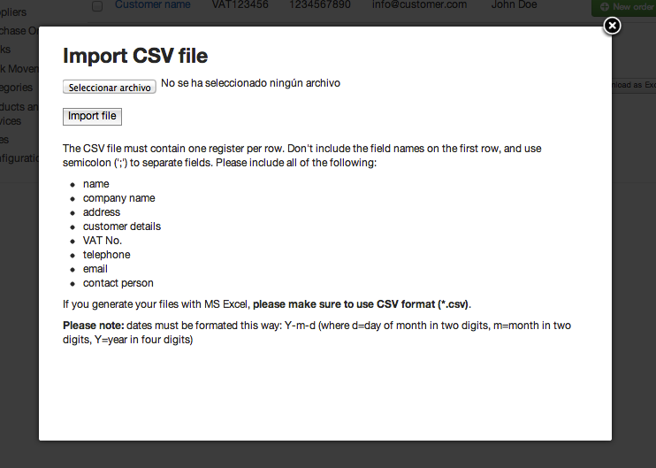

Analyzing customers profitability
As we saw in the chapter about products and services, each item you sell has a cost price registered. This way when you register an order for a particular customer, Quipu can calculate how much revenue you get from it.
When you open a customer's record, you will see a profitability report like this:
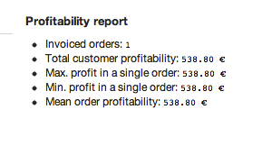
The profitability report will show you this data:
- Invoiced orders: the number of orders that have generated invoice for this customer (orders that do not have invoice are not counted).
- Total customer profitability: the total amount you have earned with this customer.
- Max. profit in a single order: the biggest amount you have earned with this customer in a single order.
- Min. profit in a single order: the smallest amount you have earned with this customer in a single order.
- Mean. Order profitability: the average revenue of this customer's orders.

Creating orders
The first thing to note about orders is that they are not created from the Orders view (there is no “New” button there). Instead, orders are created from the Customers view, by clicking in the “New Order” button of the corresponding Customer:
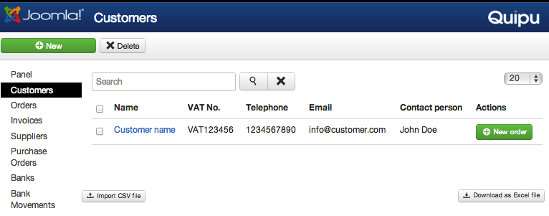
Then, you will get to the order screen where you can fill the data about the order. In Joomla 3+, this form has two tabs: one for general data and another one for the items included in the order.
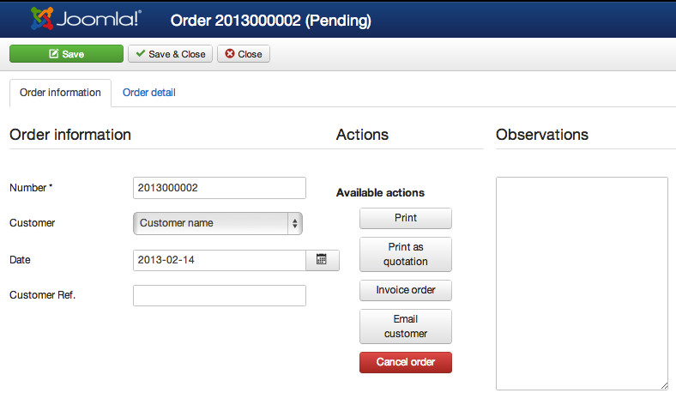
The data you have to provide about the order include the following fields:
- Number: this is the unique order number, generated as a sequence using the “Next order number” you provided in “Configuration”.
- Customer: the customer of this order.
- Date: the date of this order (by default, the current date).
- Customer ref (optional): here you can fill a reference provided by your customer if he wants it to appear in the printed docs, ie. their purchase order number.
- Observations: this field is for your private record about this order. Whatever you type here will only be visible in this screen, but not in printed documents nor in the frontend of your site.
You will also see a list of action buttons, that will vary depending on the status or this order:
- Print: will open a new browser window with the pdf version of this order.
- Print as quotation: will do the same as “Print”, but the document will have the header “Quotation” instead of “Order”.
- Invoice order: will transition the order to the “Invoiced” state and generate a new invoice for this order (note that an order in this state cannot be modified).
- Email customer: will send an email to your customer with the pdf of this order as an attached document.
- Cancel order: will transition the order to the “Cancelled” order. No further actions will be possible on this order.
The other tab of this screen “Order detail” lets you manage the products included in this order:
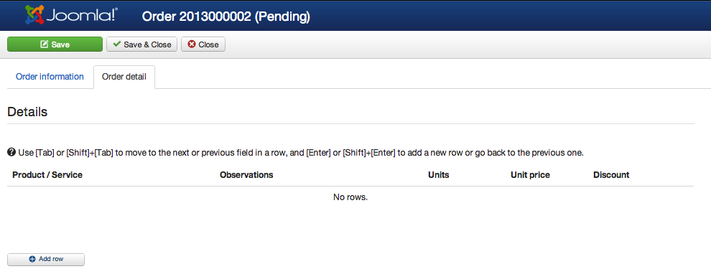
To add the first product row to the table, click on the “Add row” button. Then, you will have to select the product in the first column and fill the other fields on the row:
- Observations: details about this row (this field WILL be shown in pdf document )
- Units: how many units of this product belong to the order.
- Unit price: the price of this product for this order. Note that if you setup a unit price lower than the net cost of the product you will se an alert telling you that you are going to lose money with this item. You can create the order anyway, it is just for your information.
- Discount: the percent discount of this product.
As the legend in the table states, you will add rows automatically as you fill the table. Hitting tab will take you to the next col to the left, or if you are in the last one, to the first column of the next row. Hitting Enter will take you to the next row, keeping you in the same column. In both cases, if you hit Shift too, the action is inverted (Shift + Tab goes to the previous field, Shift + Enter goes to the previous row)
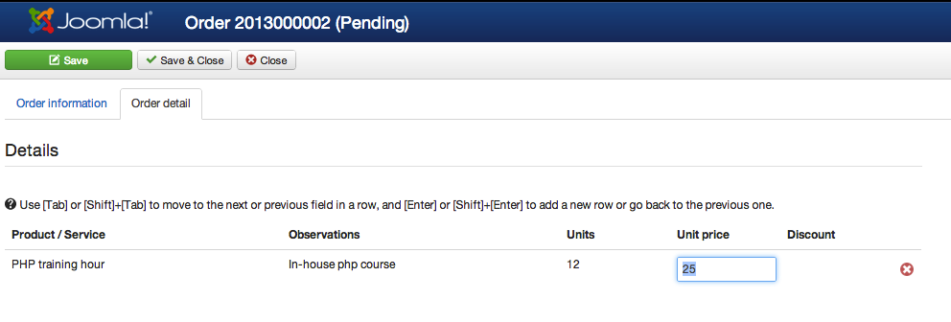

The order life cycle
As any other ERP software, Quipu implements an order lifecycle that defines the different states an order can be in, and the actions you can do on it in each state. But we wanted Quipu to be as simple as we could make it so that it could be useful in most cases, so we have the most basic set of states and actions for an order.
An order can be one of this states:
- Pending: This is the initial state for every order. A pending order can be modified by adding or removing products, and also lets you do these actions:
  - Print: generates a PDF document of the order.
  - Print as quotation: generates the same document but with the heading “Quotation”, instead of “ORDER”.
  - Invoice order: create an invoice for this order and transition it to the “Invoice” state.
  - Cancel order: transition this order to the “Cancelled” state.
  - Email Customer: generate the pdf and send to the customer attached in an email.
- Cancelled: If you click on the “Cancel order” action button, your order will be cancelled. This means that you won't be able to modify it (add or remove products, change units, etc) nor do any other state transition on it. The only available actions will be “Print” and “Print as quotation”.
- Invoice: When you click on the “Invoice order” action button in an order, then a new invoice is generated in the system, and the order transitions to the “Invoice” state. In this state you cannot modify the order (add or remove products, nor change units or prices) and the only actions available will be “Print” and “Print as quotation”.

Invoicing
When you click on the “Invoice order” action button of an order, a new invoice is generated in Quipu. An invoice is a new artifact, related to the original order, that contains the data of the items sold, the customer and payment configuration for this order.
Customer and products data is copied to the invoice when it's generated, so that you can change them afterwards without braking any previously generated invoice. You can, for example, delete old products you won't be selling anymore and your old invoicing information will still be complete.
An invoice also has a lifecycle that contains these states:
- Pending: A pending invoice has not been paid, but is still in time.
- Charged: An invoice transitions to charged when you register its payment through the “Register payment” action button.
- Overdue: A pending invoice transitions automatically to this state when the payment date passes.
- Refunded: You can generate a refund for any invoice by clicking in the “Generate Refund” action button. Quipu will generate a new invoice (a “rectifying invoice”, with a different sequence) with a negative value equal to the invoice total.

Creating a private area in frontend for your customers
Although most of the work you do with Quipu takes place in the administrator backend, there is also an important feature that you can use in the frontend: a private area where your customers can access to and review and download their orders and invoices.
As we saw when we talked about creating customers, you can assign a Joomla user to each customer, so when they log in in the front end they can access to their private area. To create that private space, you have to register a Menu Item of the type “Quipu > Private customer area”:
- Go to the Joomla Menu where you want the menu item to be shown.
- Click on the “New” button to create a new Menu Item.
- Click the “Select” button to choose the Menu Item Type:

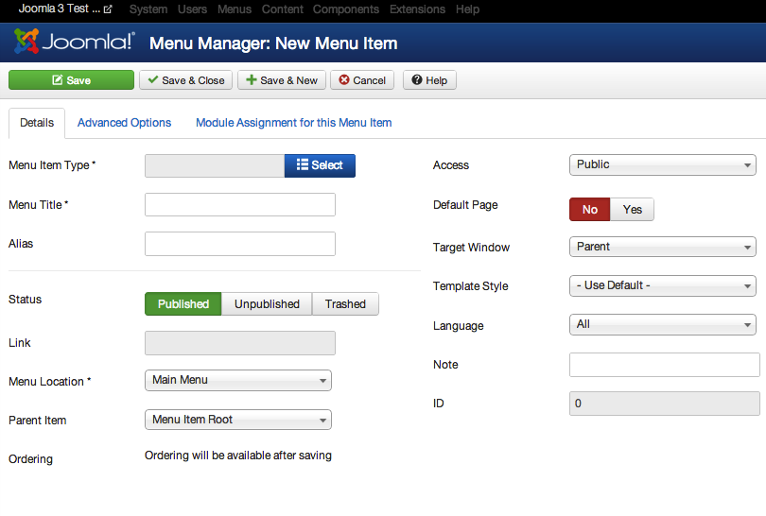
- In the dialog to choose the Menu Item Type, choose quipu > Customer Private Area:
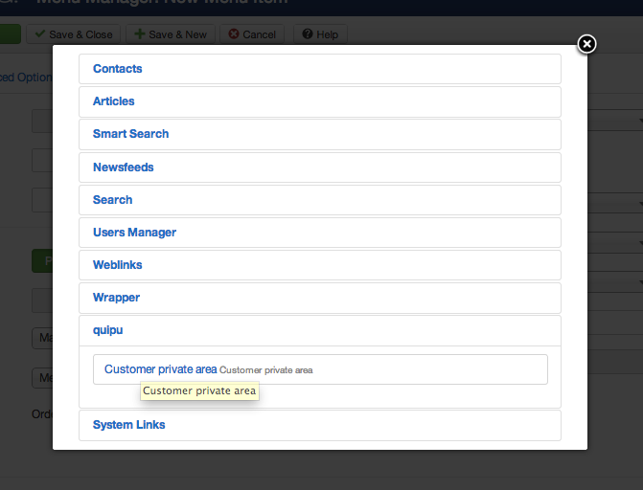
- Fill the other required fields, and make sure to choose the “Registered” Access level:
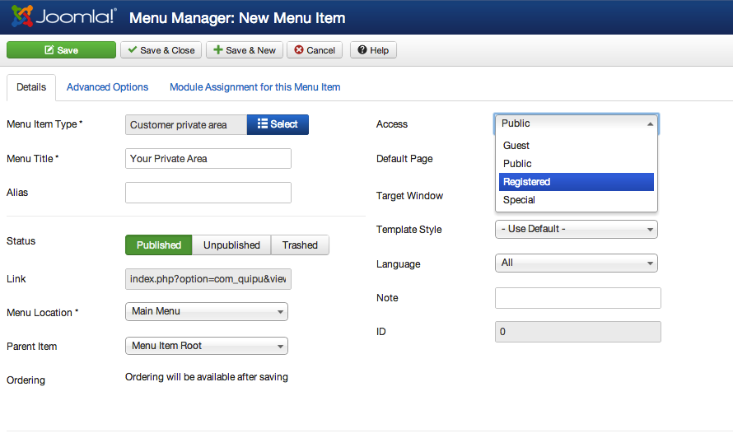
Once the Menu Item is created, when a frontend user logs in he will see a “Your Private Area” link:
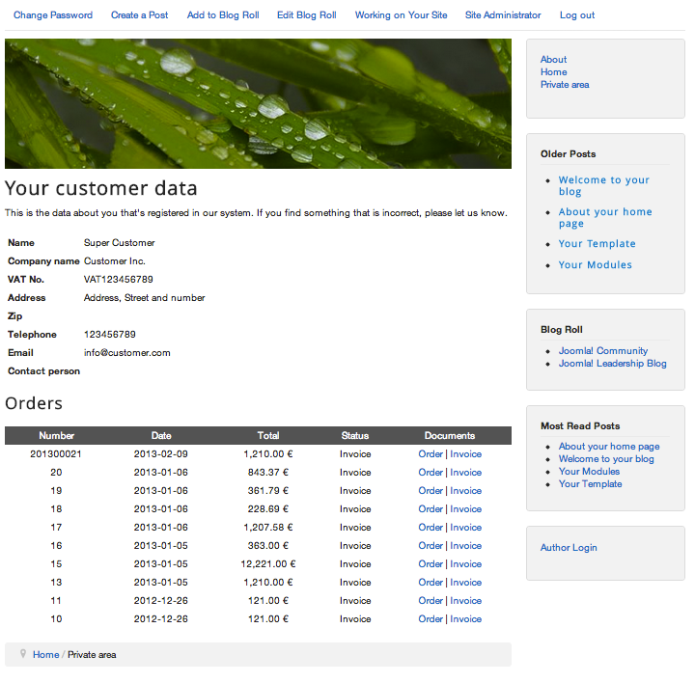

Purchases and supplier management
Selling goods or services is just half of your business. The other half is, obviously, purchasing. Quipu helps you in the task of managing your suppliers, purchase orders and supplier payments.

Creating suppliers
A supplier is someone that you purchase products or services from. Their management lifecycle is very similar to the Customers one. You can create a new supplier by going to the “Suppliers” area and clicking on the “New” button.
The fields you will have to provide are:
- Joomla User: You can assign a joomla! User to each supplier, although Quipu doesn't use it at this moment. It's there just for future features.
- Name: The name of this supplier as you want it to appear in listings.
- VAT No.: Your supplier's VAT number.
- Company name: Your supplier's company name.
- Address: Your supplier's contact address.
- Telephone: Your supplier's concat phone.
- Email: Your supplier's concat email.
- Contact person: Your contact person in your supplier's company.
- Due days: The days after a purchase order invoice is registered that it will be considered as overdue if it's not paid.
- Observations: Your private notes about this supplier. They won't be visible in printed orders.
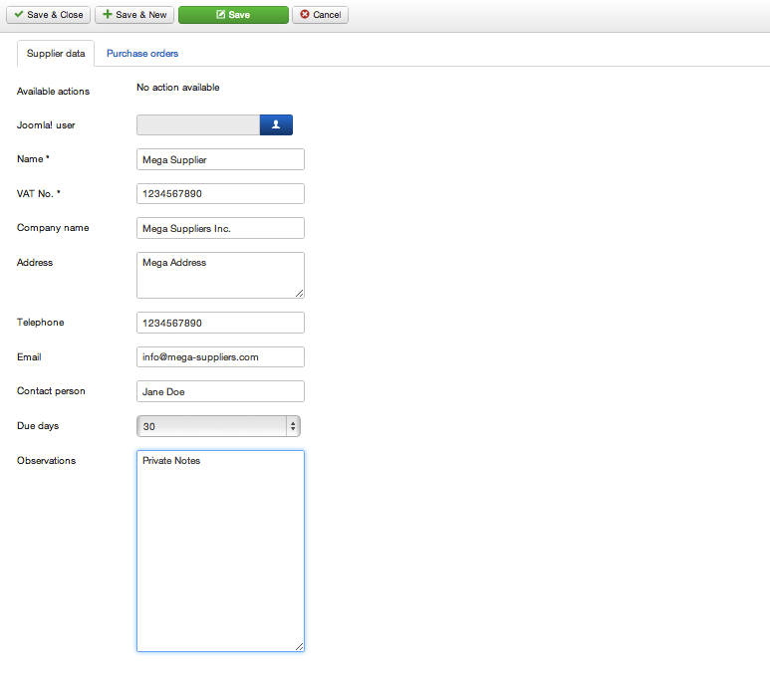

Importing suppliers from CSV files
You can also import supplier lists to Quipu using CSV files, the same way as Customers:
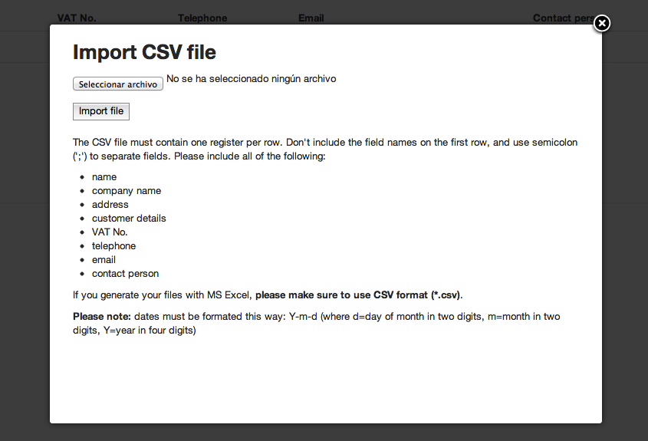

Creating purchase orders
A purchase order is a document that contains your agreement with a supplier to purchase some goods or services at a given price. The mechanics to create and manage purchase orders are very similar to when you are selling:
- In the suppliers screen, click on the “Register purchase order” button next to the supplier that you are going to buy the items from.
- Fill out the fields:
  - Supplier: In case you need to change it.
  - Payment bank account: The bank account that you will use to pay this purchase.
  - Date: The date of the purchase.
  - Paid on: The date that the purchase order was paid. It will be filled automatically when you register the payment.
  - Supplier reference: The reference of your supplier for this order, if any.
  - Supplier invoice: You can append a file with the invoice that your supplier sends you when you place your order. Take into account that when you append an invoice to the order it will transition automatically to the “Invoiced” status (see purchase order lifecycle)
  - Observations: Your private notes about this order.
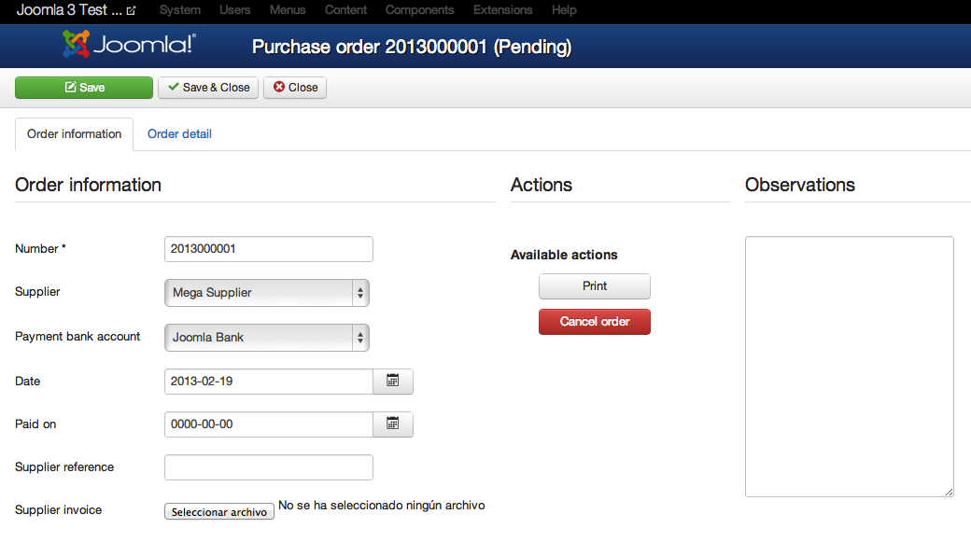
Then, you will have to add the products you are going to buy in the “Order detail” tab, in the same way you do when you register a sell order.

The purchase order life cycle
The purchase order life cycle is simpler than the sell orders one, since the invoicing is not processed here, and you just have to input the information to keep your purchasing information up to date.
A purchase order can be one of this states:
- Pending: This is the initial state for every order. A pending order can be modified by adding or removing products, and also lets you do these actions:
  - Print: generates a PDF document of the order.
  - Cancel order: transition this order to the “Cancelled” state.
- Cancelled: If you click on the “Cancel order” action button, your purchase order will be cancelled. This means that you won't be able to modify it (add or remove products, change units, etc) nor do any other state transition on it. The only available actions will be “Print”.
- Invoice: This transition is not triggered by an action button, but implicitly when you upload your suppliers invoice document for this purchase order. When you do so, Quipu assumes that the deal with your supplier is closed and automatically transitions the purchase to the invoiced state.

