[unnamed.png](https://nwaudeobinna.wixsite.com/restaurant)

[Home](https://nwaudeobinna.wixsite.com/restaurant" \t "_self)

[Menus](https://nwaudeobinna.wixsite.com/restaurant/menus" \t "_self)

[Orders](https://nwaudeobinna.wixsite.com/restaurant/online-ordering" \t "_self)

[About](https://nwaudeobinna.wixsite.com/restaurant/about" \t "_self)

[Our Team](https://nwaudeobinna.wixsite.com/restaurant/our-team" \t "_self)

[Gallery](https://nwaudeobinna.wixsite.com/restaurant/gallery" \t "_self)

[Book a Table](https://nwaudeobinna.wixsite.com/restaurant/book-a-table" \t "_self)

* [Google Places](https://maps.google.com/?cid=1862343090540590737)

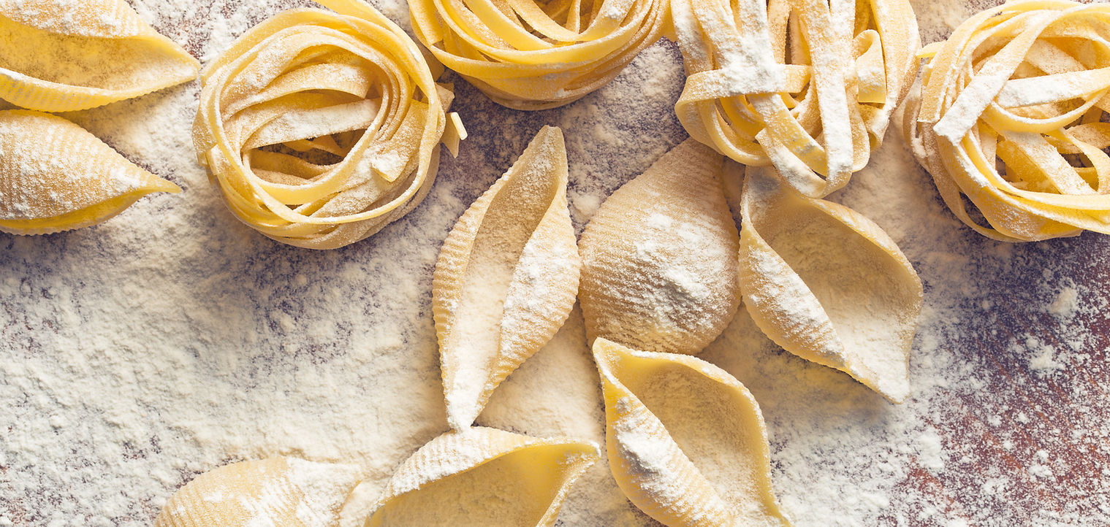

**Oberlo Restaurants**

Celebrate Your Senses

**Who We Are**

We started our business in 2000 with one goal in mind: providing an enjoyable dining experience to the San Francisco area. Thanks to our experience and dedication, we’ve managed to become masters of the craft. Providing dishes that are fresh, hearty and simply unforgettable.

Get in Touch

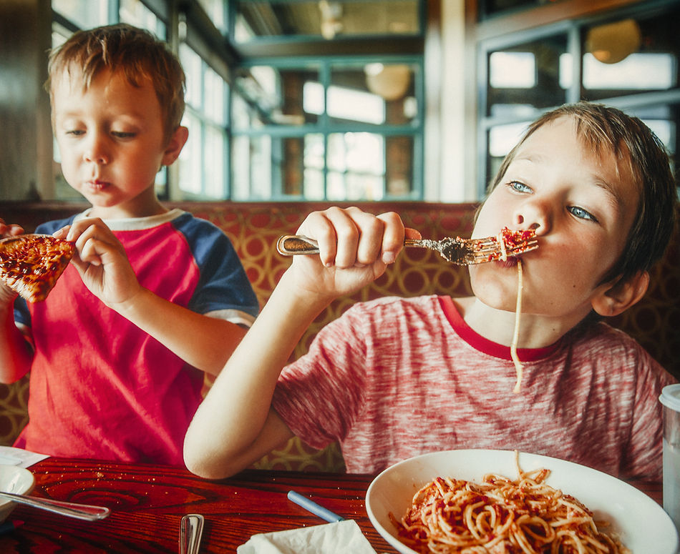

**Our Food**

Fresh Fare

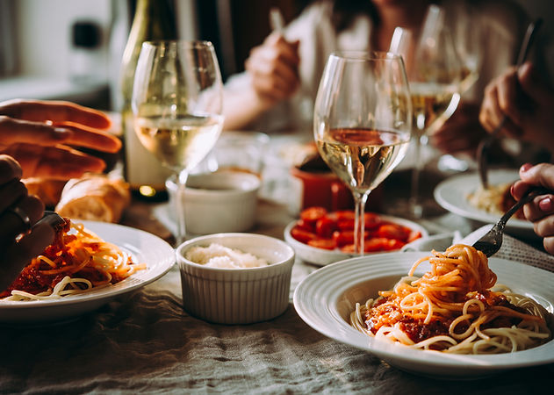

**Chef’s Special**

This latest addition to our menu has already become our customers’ favorite. Day or night, our Chef’s Special is the dish you’ve been craving. Don’t forget to ask your server about our special extras!

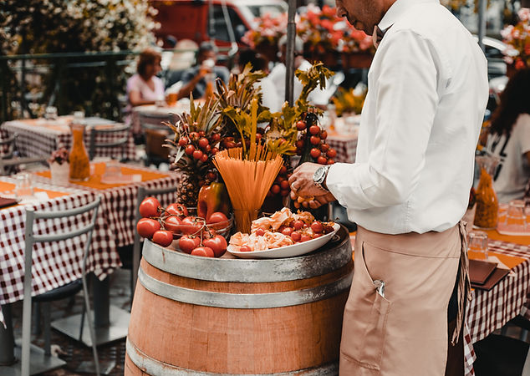

**Veggie Delight**

Many restaurants have their own take on this recipe, but we’re confident that ours is the best, always prepared to perfection. Share it with friends or have it all to yourself—you’ll enjoy it till the very last bite.

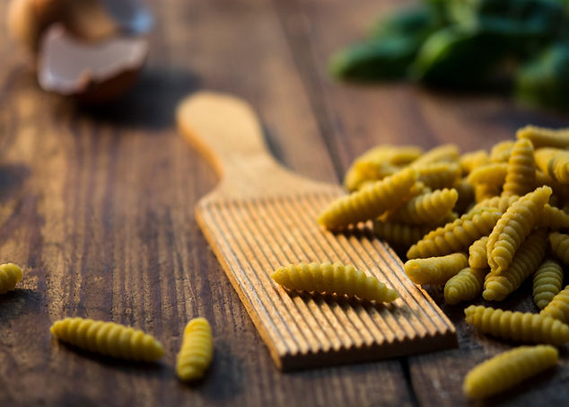

**Soup of the Day**

With our Soup of the Day we’ve managed to put a new spin on an old classic. Simplicity is the name of the game: we use fresh ingredients and offer a variety of extras on the side. Are you ready for this culinary sensation?

**Contact**

R. Martim Francisco, 136 - Santa Paula, São Caetano do Sul - SP, 09541-330, Brazil

[nwaude.obinna@gmail.com](mailto:nwaude.obinna@gmail.com)

(11) 4637-3158

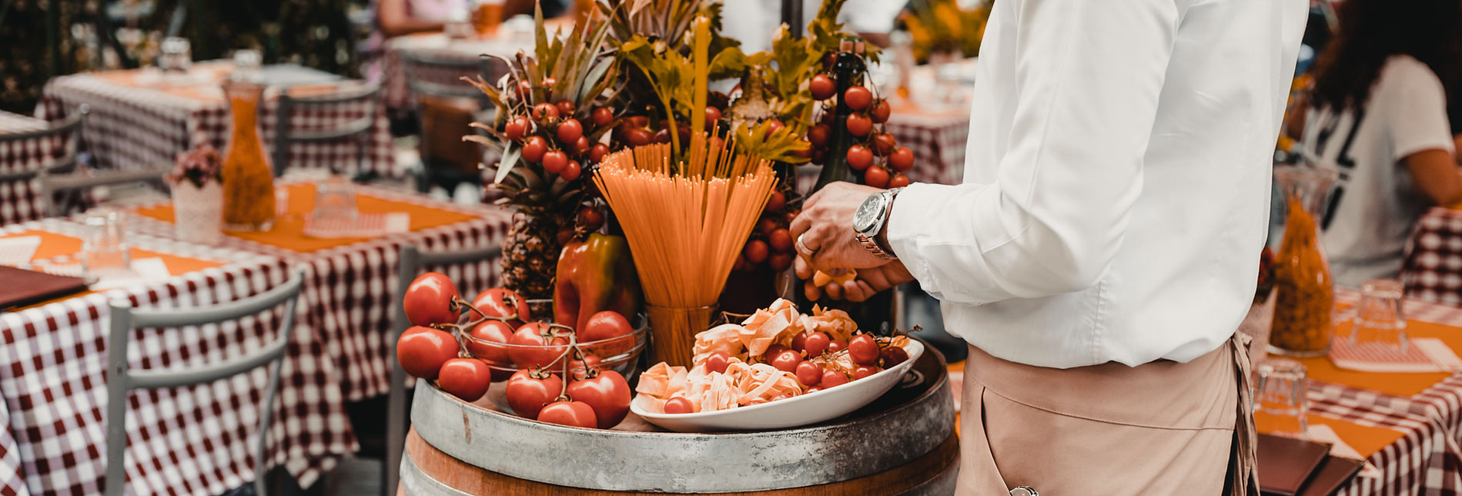

**Opening Hours**

Dine In or Take Away

Monday - Saturday: 11am - 11pm  
Sunday: 11am - 7pm

(11) 4637-3158

©2021 by Oberlo Restaurants. Proudly created with Wix.com