Louis Yencken

08/03/2020

Basic Python

Assignment 5

**ToDoList**

**Assignment overview:**

This script requires input from the user and is then depending on the input the script will execute the menu choice. Depending on the choice the script will either input data to a text file, remove data from the text file, save and exit the script. The text file must exist for the script to be able to execute the script. The data inside the file also needs to have be in the text file for the script to be able to remove the data from the file.

The text file was created outside of the script so that the list could be housed correctly in the script. This was done because the script would not read the text file from the selection without the any data was input. It would instead bring a traceback error. I also had difficulties with accidently inputting data manually which caused a traceback error.

**Creating my Assignment05**

When I started the script I edited the Starter Lab5-1-Starter. This was one of the more difficult scripts to work with. As stated in the course video editing existing scripts has its difficulties. Trying to restructure the existing script I first started by creating my variables. Once this was completed the menu list was created. The previous script that I created for Assignment04 I used keys instead the menu list for Assignment05. Assignment04 held the keys inside a dictionary. The input block of code initially caused difficulties with the formatting. The data was being exported into the text file with multiple entries of the same data. I realised that this was being caused from a for loop not being closed out correctly.

After the input section block of code was done the next menu selection (and block of code) was the read selection. This selection simply printed the text file showing all current data entries. This was a basic section. The difficult section was the removal block of code. The formatting of the code was not working correctly (it wasn’t removing data rows correctly). These rows weren’t being removed because the dictionary block wasn’t formatted correctly which was interrupting the block of code executing correctly. The other piece that was used to ensure that if any input that wasn’t recognised from the existing data was a ‘try-except’ block. This caused the script to run smoother and to stop tracebacks from typos.

The remainder of code was simple to construct and didn’t require much formatting. The only difficulty was that indenting of the save section block of code caused issues but was corrected quickly.

In summary this was difficult to get correct. For all blocks of code to work correctly in unison was the most time intensive component of this script. It seemed that every time one block of code was corrected another block was affected negatively which then caused issues. For example at one point if I input data it would input four lines of that data into the text file. It also would erase all previous entries. This was because the list formatting in my dictionary wasn’t correct and it would replace all lines. This was fixed but took a very long time to workout what was wrong. The script once complete was satisfying to watch move through each block seamlessly.

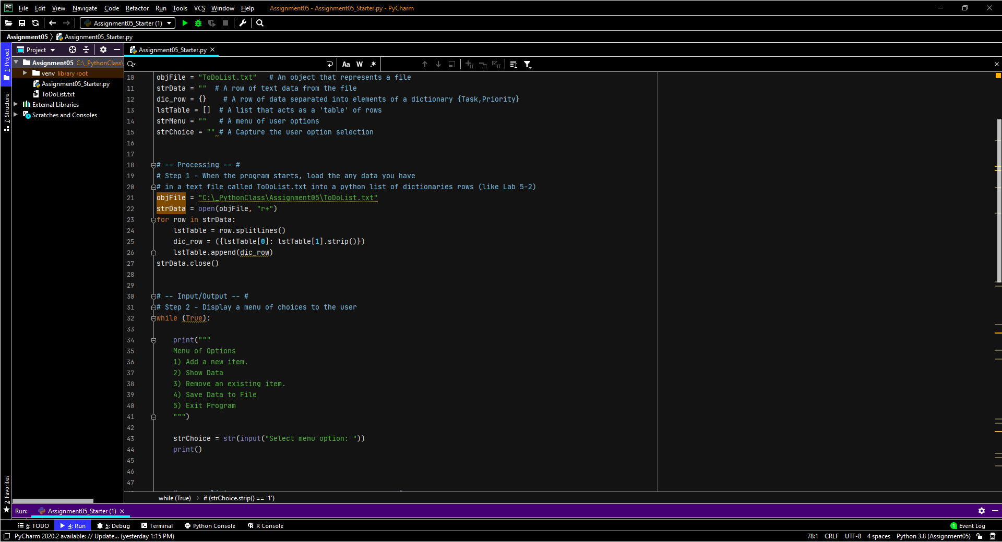

Fig 1: variables and menu block

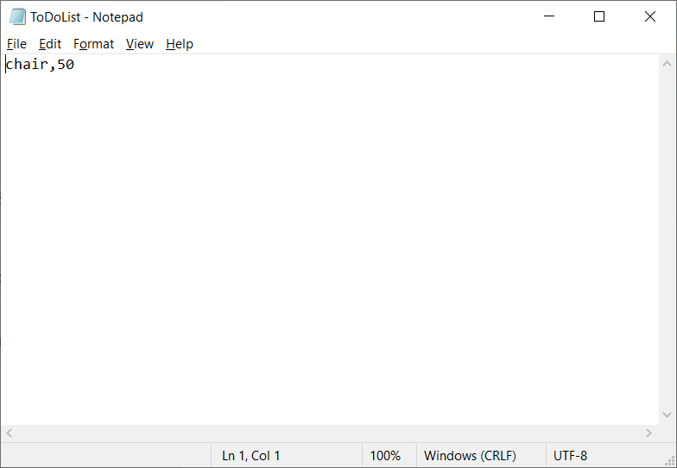

Fig 2: List from data input to script

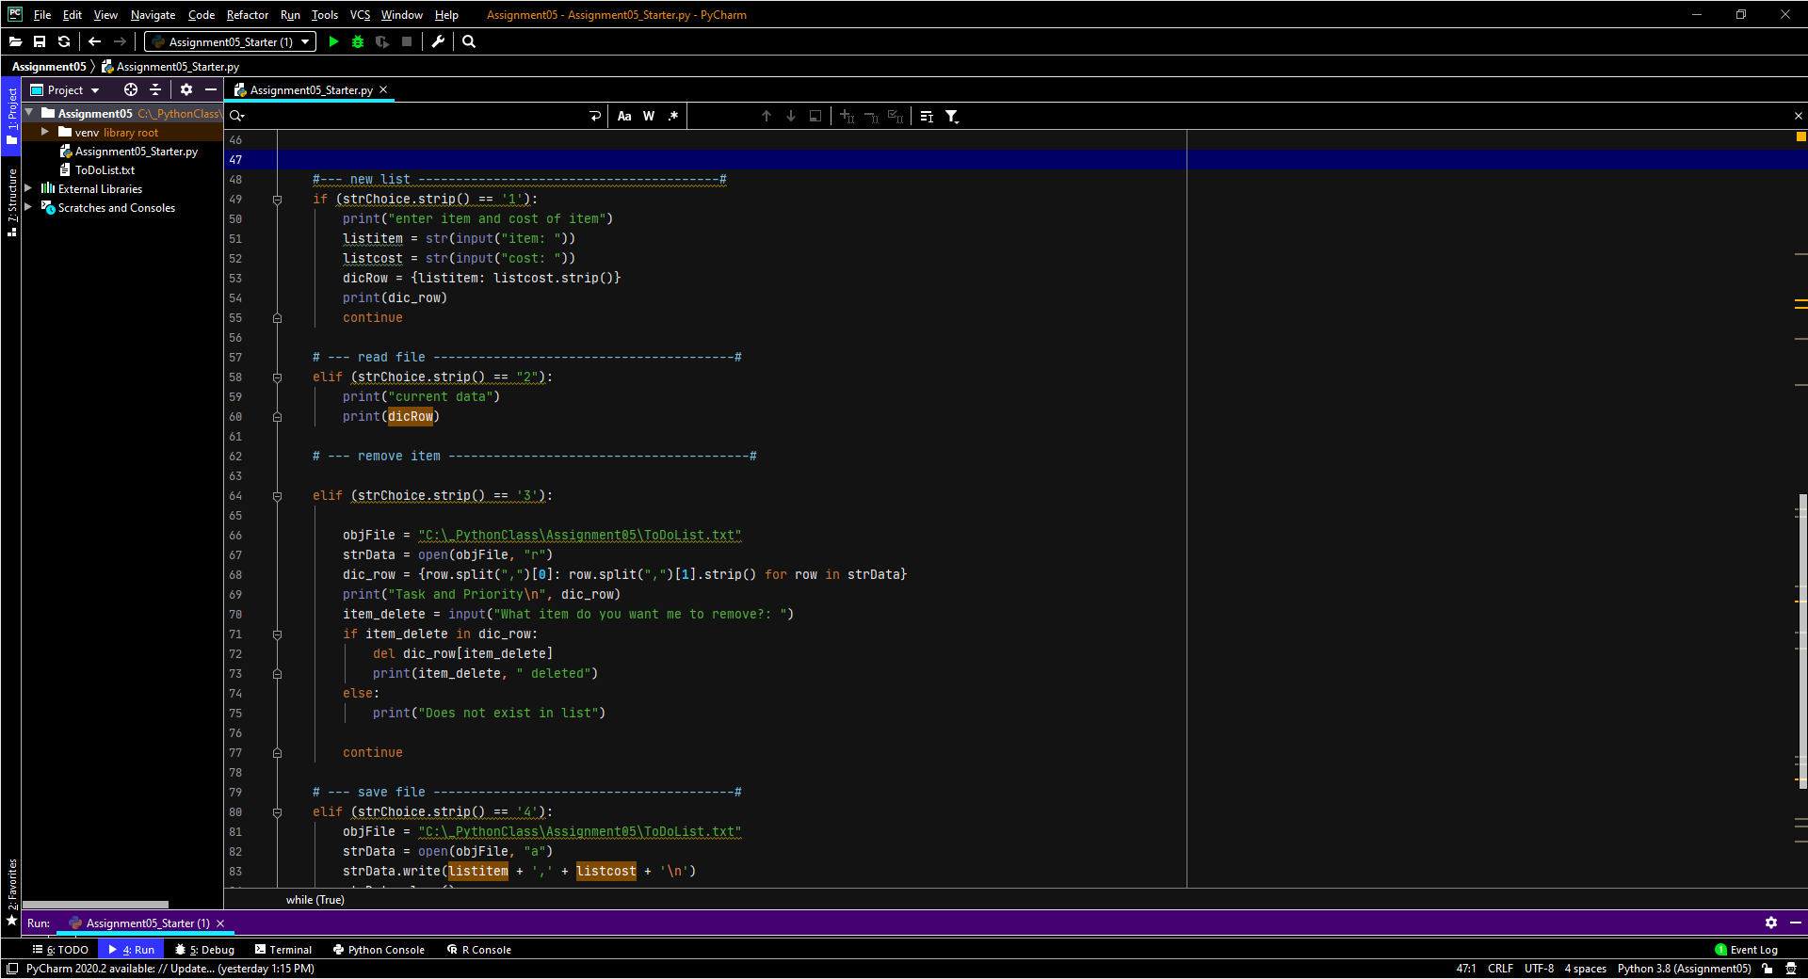

Fig 3: Input, read and remove block of code

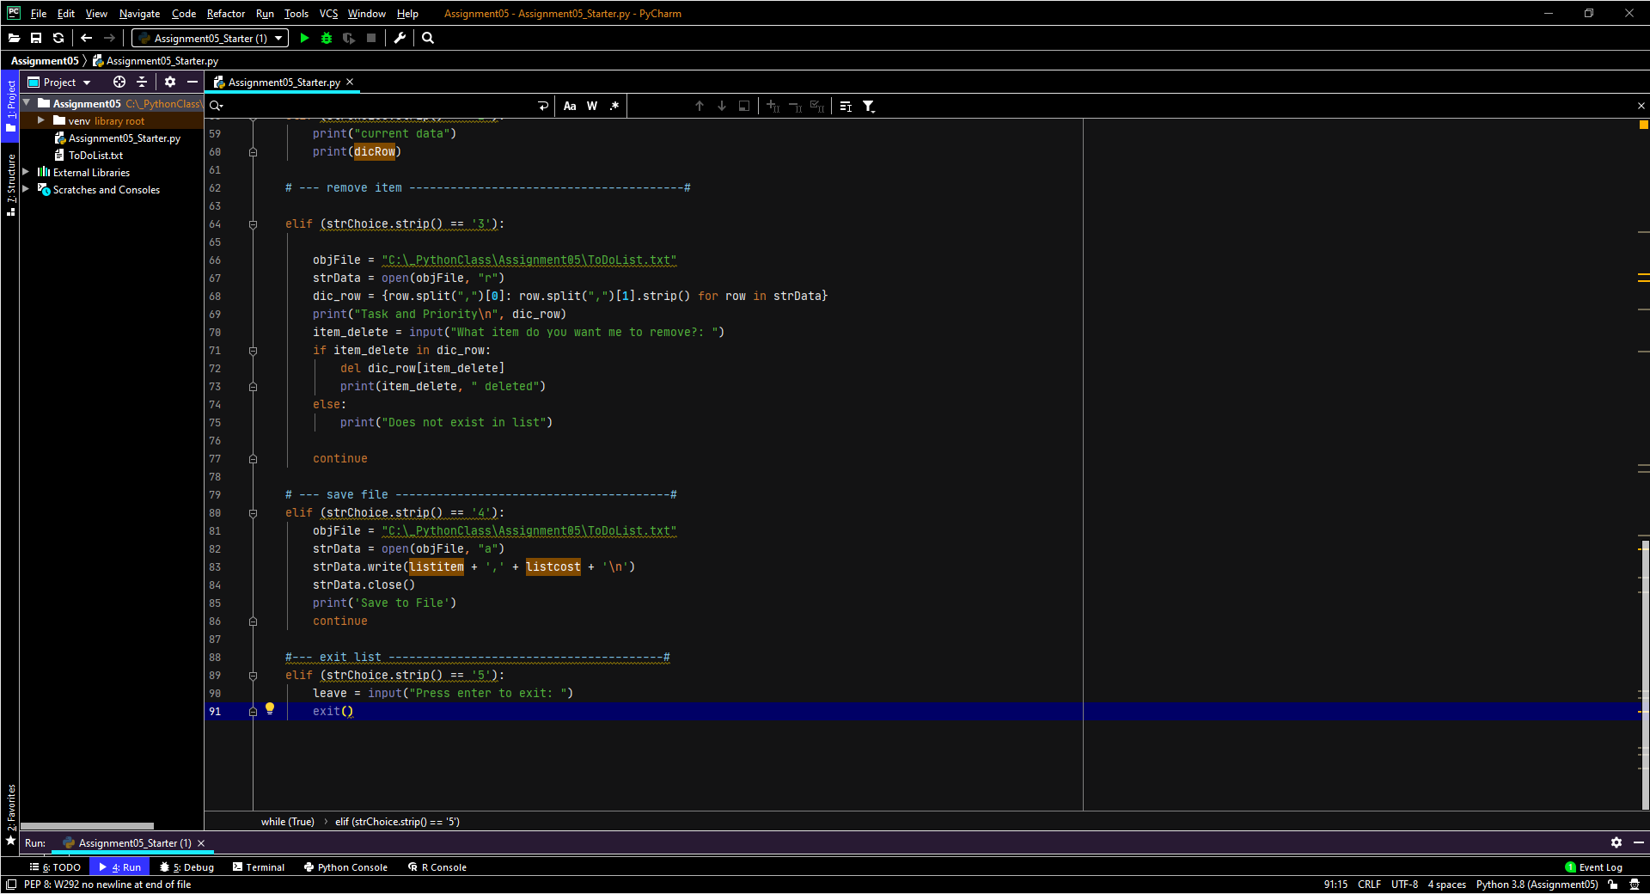

Fig 4: remove item and exit script block

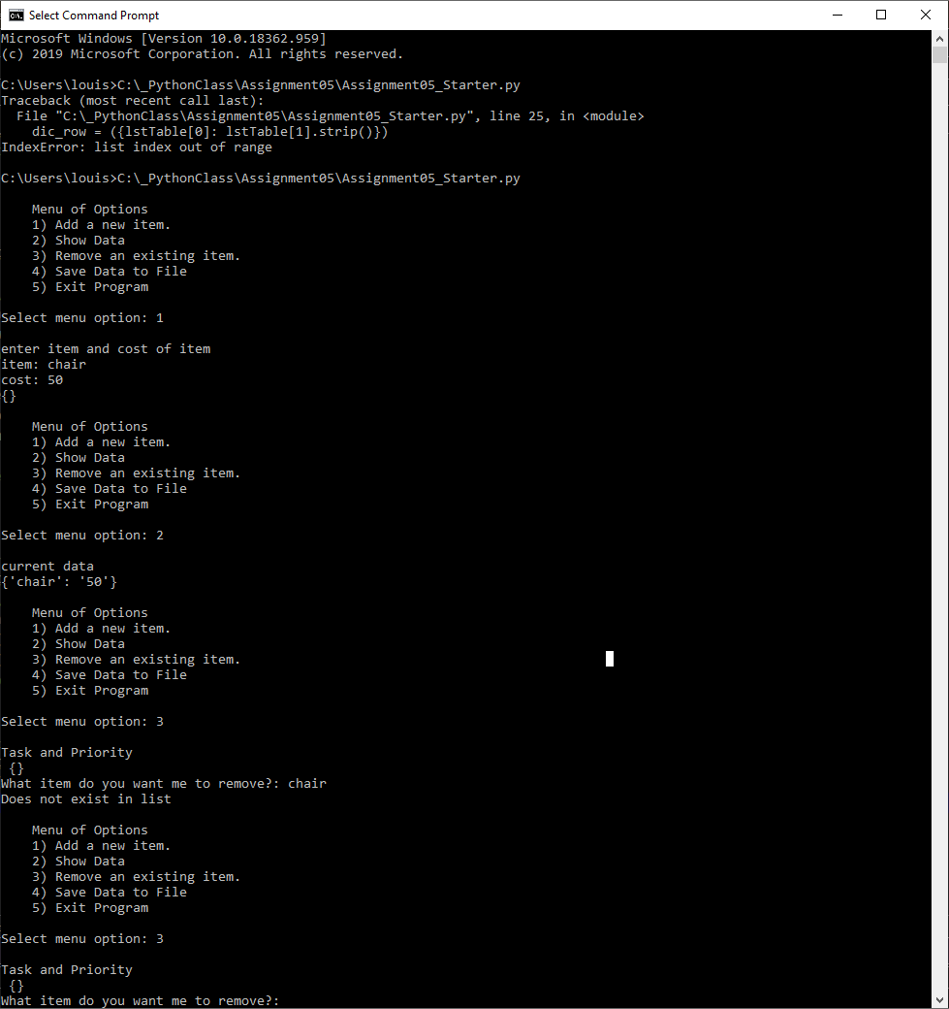

Fig 5: Running Command prompt

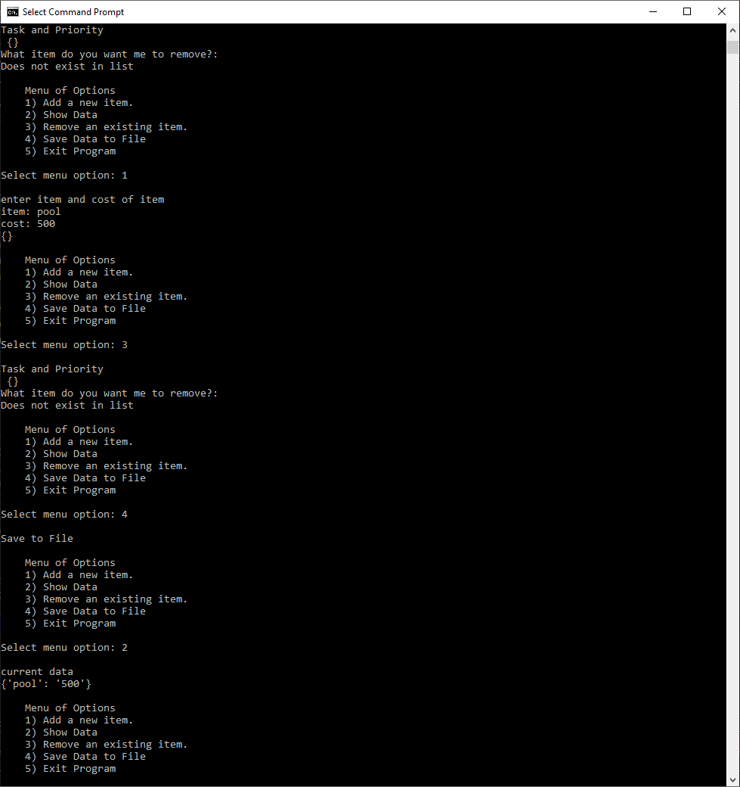

Fig 6: Command prompt continued

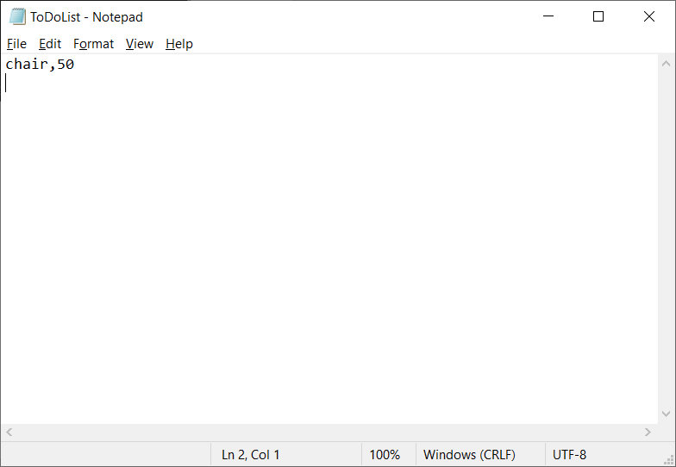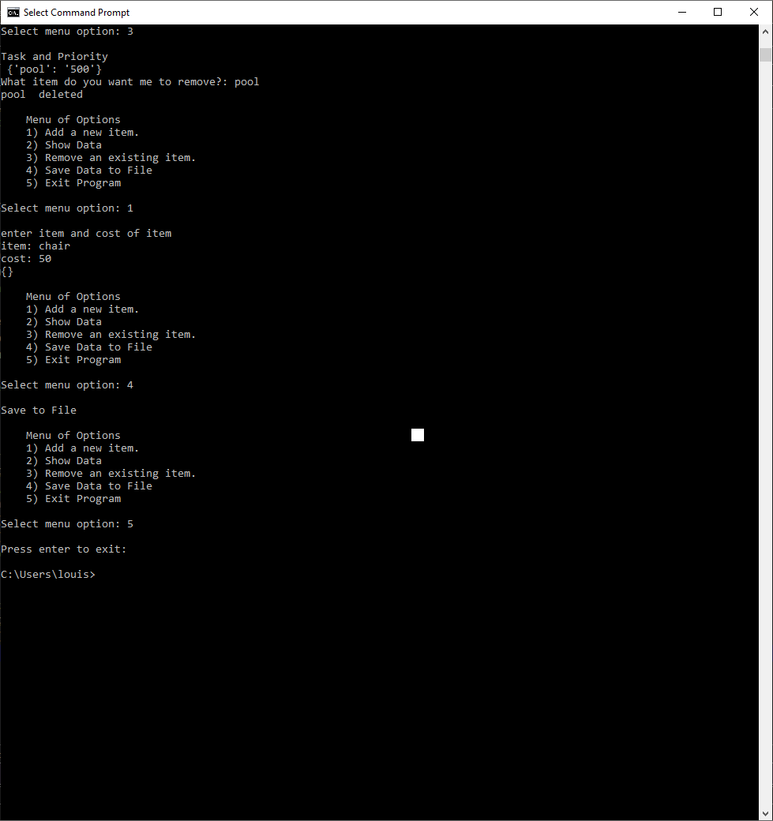

Fig 7: Entering chair into list and exiting Command prompt

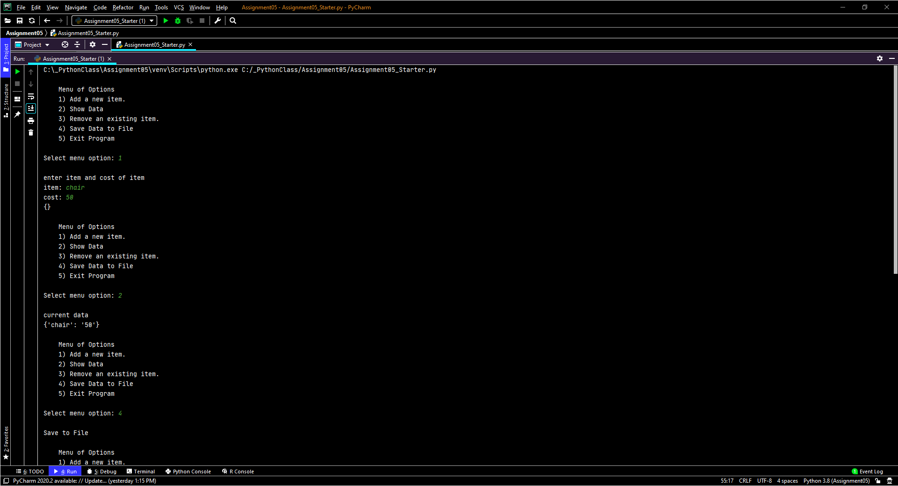

Fig 8: running in PyCharm

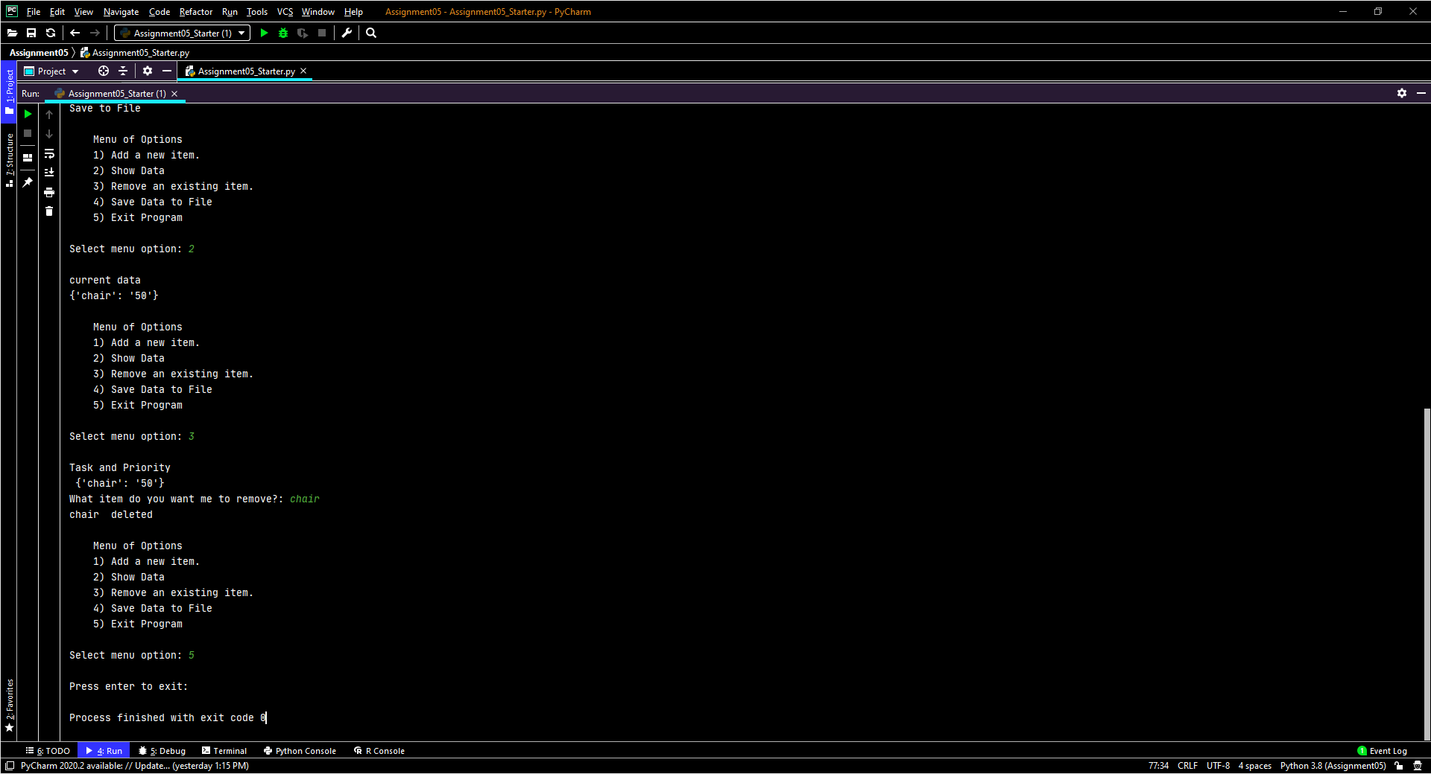

Fig 9: run script and closeout