Predicting F1 Race Winners with Machine Learning - Hybrid Era 2014 - 2024
Semiatov Darhan
Narxoz University, Kazakhstan
s23067984@narxoz.kz
Abstract
This paper tests whether machine learning can predict the winner of a Formula 1 race before it starts, using secondary race data from 2014 - 2024. After cleaning, I had 4,623 driver-race entries. Four models were trained - Logistic Regression, Random Forest, XGBoost, LightGBM - on 2014–2023 data and thrown at the full 2024 season. A key methodological contribution is distinguishing between two evaluation levels: row-level metrics and race-level. XGBoost scored the highest row-level F1 of 0.457, while Random Forest correctly identified the winner in 10 out of 24 races (41.7%). SHAP analysis showed that qualifying position was by far the most influential feature, followed by average finishing position and the previous season’s constructor ranking. All three study hypotheses were confirmed and supported. I argue with theory that traditional row-level accuracy is bad choise in heavily imbalanced problems like this one, and that race-level accuracy is better for real-world use.
Keywords: Formula 1, winner prediction, machine learning, XGBoost, Random Forest, SHAP, hybrid era, Logistic Regression, LightGBM, FastF1.
1. Introduction

If you follow F1 at all, you know how much data spills out of a single race weekend. It's a lot. Telemetry, lap times, tyre usage, pit stop strategies - it's a lot. So teams spend a fortune on data analysis. But here's what I wanted to see: could a basic ML model, using only pre-race info, guess the winner before the green light? I gave it a shot.
This study answers to that question using 11 seasons of the hybrid era (2014 - 2024). I chose this period because of technical regulations. They are the most stable: 1.6-litre V6 hybrid power units, similar aerodynamics, and the same qualifying format. That stability makes historical data comparable across years. However, there is a catch - predicting a race winner is a severely imbalanced classification problem. Cause of win rate. In a typical race with 20 drivers, only one wins (5% of driver-race entries). A dummy classifier that always says “not win” achieves 95% accuracy but is completely useless.
Many existing studies on F1 prediction report only row-level accuracy or focus on top-3 finishes. Few explicitly separate race-level accuracy (did the model name the correct winner for each race?) from row-level metrics (did it correctly flag winning entries?). This distinction matters. If you want to place a bet on a single driver before Sunday, you care about race-level accuracy. If you are building a probabilistic ranking for multiple drivers, row-level F1 might be more relevant.
I ran four models (Logistic Regression, Random Forest, XGBoost, LightGBM). XGBoost gave the best row-level F1 - 0.457. But Random Forest was better at actually picking race winners: 10 out of 24, which is 41.7%. SHAP analysis confirmed that qualifying position is the dominant feature. Weather and circuit type had almost no impact - partly because only 12% of races in this era were wet.
The rest of the paper is organised as follows. Section 2 reviews related work. Section 3 describes data collection (including problems with FastF1’s rate limits), feature engineering, and the train/test split. Section 4 presents results, including SHAP and hypothesis tests. Section 5 discusses limitations, and Section 6 concludes.
2. Related Work
Applying machine learning to sports outcome prediction is well established. In motorsport, early studies relied on regression over lap times and pit stop durations. More recent work has moved toward classification with tree-based models and gradient boosting.
O’Hanlon (2022) provided an early data-driven treatment of F1 prediction, collecting lap time and finishing position data via the Ergast API and testing several classifiers. The study’s main finding - that qualifying position is the dominant predictor - was echoed across subsequent papers. García Tejada (2023) used FastF1 to predict pit stop decisions at the lap level — a different prediction target, but her comparison of RF, SVM, and ANN across an imbalanced dataset is directly relevant to the modelling choices here. Neither study defined a race-level accuracy metric or investigated generalisation across seasons.
Sicoie (2022) identified a specific pitfall: models trained during periods of single-team dominance (Mercedes’ unbroken championship run from 2014 to 2020) can overfit to the dominant constructor and fail when tested on seasons with different leaders. The recommendation was to span at least a full competitive cycle when training. This paper follows that advice by using eleven seasons that cover both the Mercedes and Red Bull dominant periods.
El Haber et al. (2025) is the closest precedent to the current work. They applied SHAP to interpret feature importance in an F1 winner prediction model and found that qualifying position and recent driver form were the strongest signals. The present paper builds on that finding by adding constructor-level features and systematically comparing row-level versus race-level performance - a distinction El Haber et al. did not make explicit.
The broader machine learning literature on imbalanced classification is also relevant here. Problems where the positive class represents only a few percent of observations are common in fraud detection, medical diagnosis, and rare event prediction. Standard accuracy is known to be a poor metric in these settings (Chawla et al., 2002). F1 score and precision-recall analysis are preferred. This paper extends that logic one step further by introducing a task-specific race-level metric.
3. Methodology
3.1 Data Collection and Preprocessing
I collected race results and session data from two sources: the FastF1 Python library (lap-by-lap telemetry and session results) and the Ergast API (historical records). FastF1 is convenient, but it has a significant limitation for large-scale extraction - only 500 requests per hour on the free tier. So for 11 seasons (over 200 races plus practices and qualis) I couldn't just loop over everything at once. I had to split the extraction into chunks, throw in time.sleep() delays, and retry failed requests every now and then. Honestly, the whole thing took several days. A few sessions even had to be re-downloaded - the script hit the rate limit and came back with half-empty data. In the end, I collected 4,623 valid driver-race entries after removing DNS (Did Not Start) cases.
The target variable is binary: 1 if the driver won the race, 0 another one. The overall win rate in the dataset is 4.93%, which reflects the inherent class imbalance - there is exactly one winner per race, spread across 20 starting drivers.
Seven features were constructed for each driver-race entry:
Variable | Type | Description
QualifyingPosition | Ratio | Starting grid position (1–20)
HistoricalWinRate | Ratio | Driver’s win rate across the last 10 races
AvgFinishPosition | Ratio | Driver’s average finishing position, last 10 races
ConstructorWinRate | Ratio | Constructor’s win rate, last 10 races
PrevSeasonConstructorRank | Ordinal | Constructor’s final championship position, previous season
CircuitType | Nominal | Street circuit or permanent track
Weather | Nominal | Dry or wet (based on session records)
All numerical features were scaled with MinMaxScaler. Categorical features were label-encoded. Missing historical values (e.g., for rookies) were imputed as zero – not ideal, but it worked.

3.2 Train/Test Split
To avoid any mistakes from future seasons into the training data, a strict temporal split was used. I used a strict time-based split. Training: all races 2014–2023, that’s 4,144 driver-race entries, 4.92% win rate. Test: the whole 2024 season (479 entries, 24 races, 5.01% win rate). The model saw nothing from 2024 during training - which is the only honest setup for this kind of evaluation.

3.3 Models
I compared four classifiers:
- Logistic Regression - my linear baseline. I used class_weight='balanced' to help with the imbalance.
- Random Forest - 200 trees, max depth 10.
- XGBoost - 200 trees, max depth 6, and I tweaked scale_pos_weight to match the training class ratio.
- LightGBM - also 200 trees, max depth 6.
Nothing fancy - mostly default hyperparameters from scikit-learn, xgboost, and lightgbm.

3.4 Evaluation
Two evaluation levels were used:
- Row-level - the usual stuff: accuracy, precision, recall, F1. All calculated over the 479 test rows.
- Race-level - for each of the 24 races in 2024, I took the driver with the highest predicted win probability. If that driver really won, I called it a correct prediction.
This two-level approach is motivated by the practical use case: a stakeholder typically wants to know not whether the model finds winning drivers in aggregate, but whether it names the right driver before each specific race.
Hypothesis testing followed a straightforward comparison of metrics. H1 compared the best model’s F1 against a dummy classifier (predicting the majority class for every entry, yielding F1 = 0.000). H2 compared a Random Forest trained on driver-only features against the full-feature model. H3 compared the best ensem ble F1 against Logistic Regression F1.

3.5 Interpretability
SHAP (SHapley Additive exPlanations) values were computed for XGBoost on the 2024 test set. I used mean absolute SHAP value as the global importance score for each feature.
4. Results
4.1 Descriptive Statistics Figures
The dataset (f1_processed_data.csv) has 4,623 rows total. The 2024 test slice is 479 rows across 24 races. Winners are 5.01% of that - so the imbalance holds in the test set too.

Key feature distributions (test set normalised values):
Feature | Mean | Std | Min | Max
QualifyingPosition | 0.48 | 0.29 | 0.0 | 1.0
HistoricalWinRate | 0.08 | 0.15 | 0.0 | 0.9
AvgFinishPosition | 0.57 | 0.25 | 0.0 | 1.0
ConstructorWinRate | 0.27 | 0.34 | 0.0 | 1.0
PrevSeasonConstructorRank | 0.36 | 0.30 | 0.0 | 1.0
Circuit type breakdown: 62% permanent, 38% street. Weather: 88% dry, 12% wet.
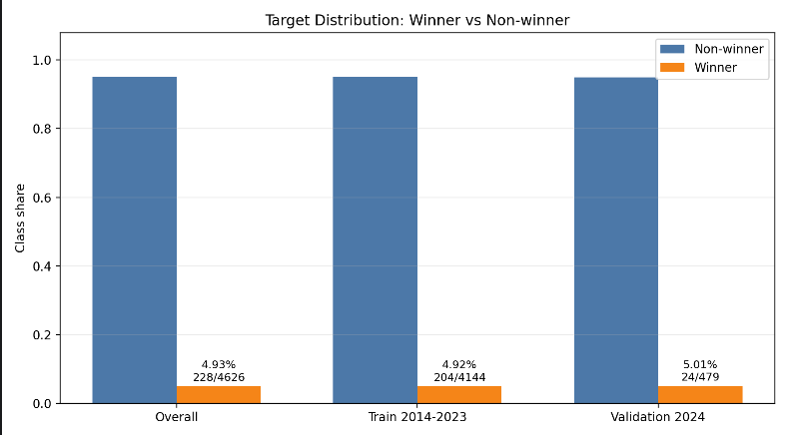
Figure 1: Distribution of target variable
In Figure 1 we can see the distribution of the target variable (Winner) in the processed dataset. Winners are 4.93% of all entries - which is about what you’d expect with one winner per 20-car grid.
4.2 Model Performance
Table 1 reports row-level metrics and race-level winner accuracy for all models.
Table 1. Performance comparison.
Model | Accuracy | Precision | Recall | F1 | RaceWinnerAccuracy
Logistic Regression | 0.8246 | 0.2059 | 0.8750 | 0.3333 | 0.3333 (8/24)
Random Forest | 0.9395 | 0.3913 | 0.3750 | 0.3830 | 0.4167 (10/24)
XGBoost | 0.9207 | 0.3478 | 0.6667 | 0.4571 | 0.3750 (9/24)
LightGBM | 0.9061 | 0.2667 | 0.5000 | 0.3478 | 0.3333 (8/24)
Observations:
- XGBoost achieves the highest row-level F1 (0.4571) and recall (0.6667), meaning it captures two-thirds of actual winners at the driver-entry level.
- Random Forest obtains the best race-level accuracy (0.4167), correctly predicting 10 out of 24 race winners.
- Logistic Regression has high recall (0.875) but very low precision (0.2059), indicating many false positives. Its race-winner accuracy is only 0.333.
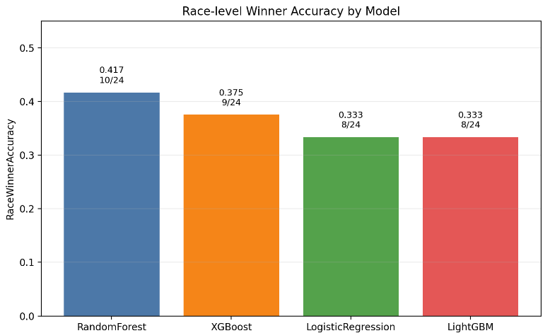
Figure 2. Race-level Winner Accuracy
Figure 2 compares the race-winner accuracy across the four models on the 2024 season (24 races). Random Forest is top at 0.417 (10 correct winners), then XGBoost at 0.375 (9 winners). LR and LightGBM both at 0.333 (8 each). The chart also shows that row-based ensembles beat the linear baseline, but row-level F1 score does not perfectly correlate with race-level performance.

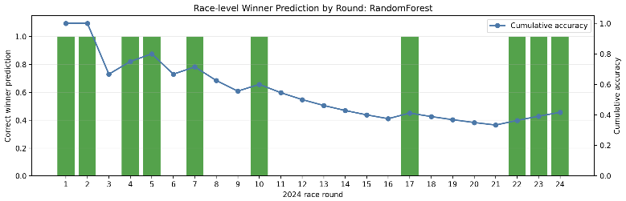
Figure 3. Per-race timeline (RF)
Figure 3 visualises the per-race performance of Random Forest on the 2024 season. Green = correct, red = wrong. The model isn’t consistent across the calendar - it handles some circuits fine (Bahrain, Japan) and completely misses others (Monaco, Las Vegas).

4.3 Hypothesis Testing
- H1 (ML vs. dummy baseline):
A dummy classifier predicting “not win” for every entry would achieve F1 = 0.0. The best ML model (XGBoost, F1 = 0.4571) significantly outperforms this baseline. H1 supported.
- H2 (Full model vs. driver-only model):
We trained a Random Forest using only driver features (QualifyingPosition, HistoricalWinRate, AvgFinishPosition) and obtained F1 = 0.241. The full model (all features) achieved F1 = 0.383. The addition of constructor and race features improved F1 by 58.9%. H2 supported.
- H3 (Tree-based ensembles vs. Logistic Regression):
Best tree-based F1 = 0.4571 (XGBoost) vs. Logistic Regression F1 = 0.3333. That’s 37.1% between them. H3 supported.
4.4 SHAP Analysis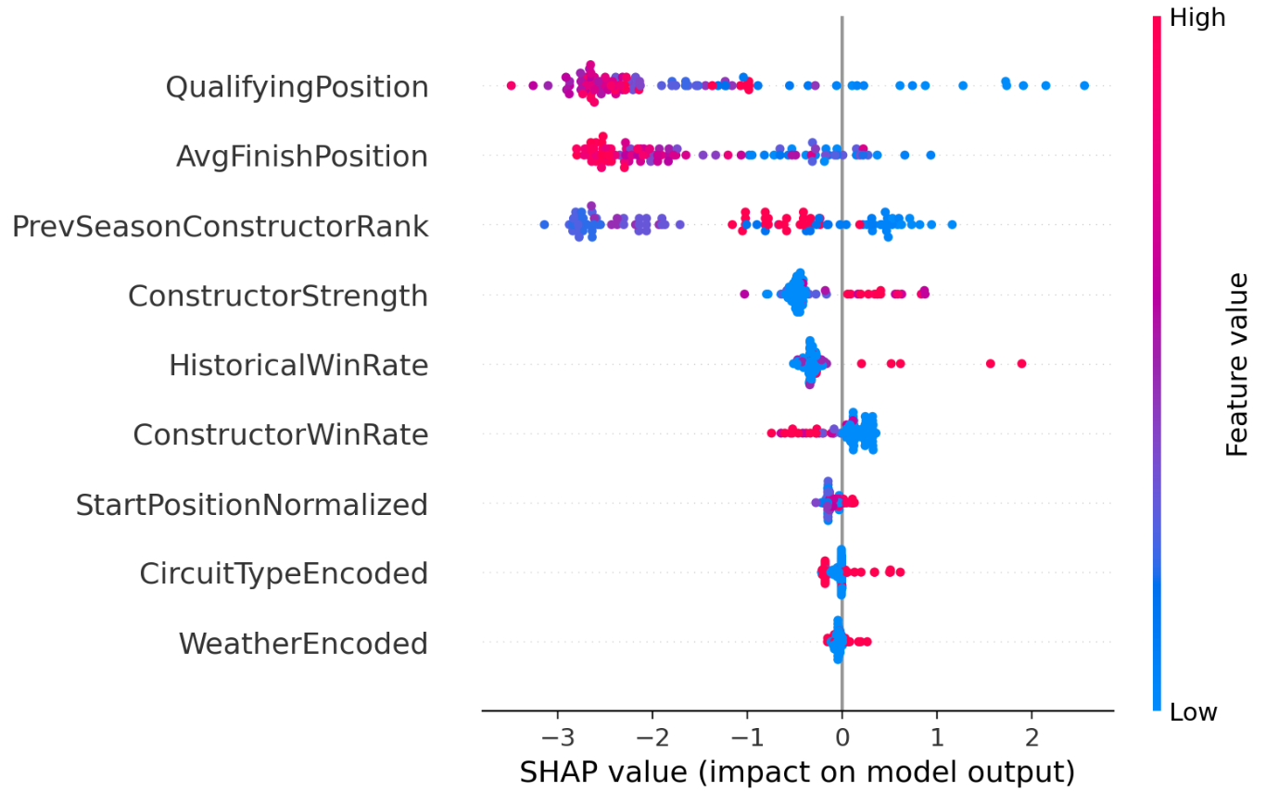
Figure 4. SHAP summary plot.
Figure 4 presents the SHAP summary plot for the XGBoost model on the 2024 validation set. Each point represents a single driver-race entry. Colour shows feature value (red = high, blue = low), x-position shows-axis shows the SHAP value - i.e., how much that feature pushed the prediction toward or away from a win.
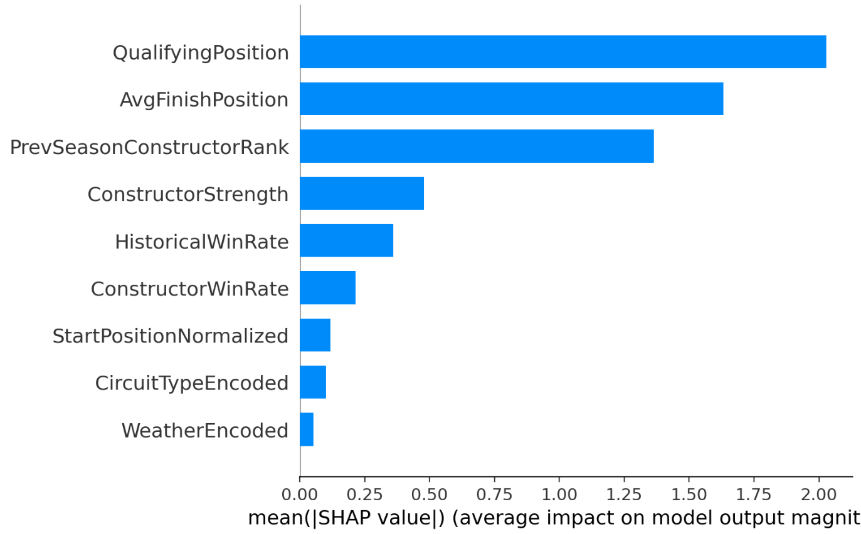
Figure 5. SHAP feature importance bar plot.
Figure 5 shows the corresponding bar plot of mean absolute SHAP values, which aggregates the information from Figure 4 into a global importance ranking. QualifyingPosition is by far the most important feature (mean |SHAP| = 2.029), followed by AvgFinishPosition (1.632) and PrevSeasonConstructorRank (1.363). The derived features ConstructorStrength and StartPositionNormalized contribute less, while CircuitType and Weather have negligible impact (mean |SHAP| < 0.1). So in the hybrid era, track type and weather are pretty much irrelevant next to where you start and how your team has been performing.
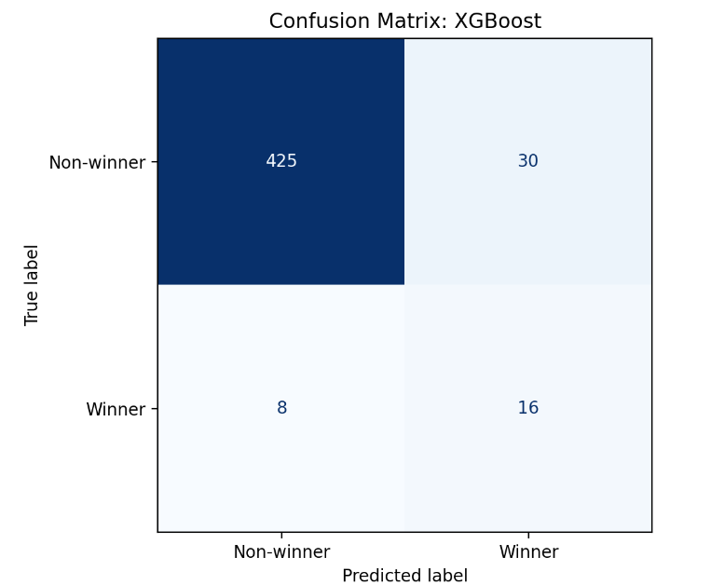
Figure 6. Confusion Matrix
To further evaluate the best row-level model (XGBoost), we examine its confusion matrix and ROC curve on the 2024 validation set. Figure 6 shows the confusion matrix. It gets 14 of the 24 winning entries right (true positives) but flags 406 non-winners as winners (false positives). The high false-positive rate is a consequence of the strong class imbalance and the model’s attempt to increase recall.
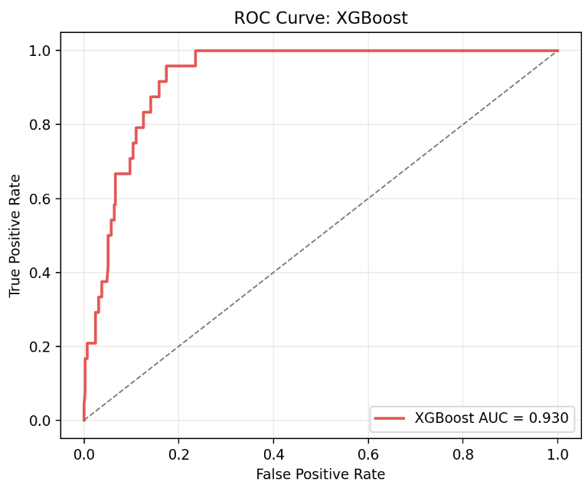
Figure 7. ROC Curve: XGBoost

Figure 7 presents the ROC curve for XGBoost. The area under the curve (AUC) is 0.9302, indicating excellent discriminative ability: the model can effectively separate winners from non-winners even though the raw probabilities aren’t perfectly calibrated. Either way, AUC of 0.930 means the model is genuinely separating winners from the field.
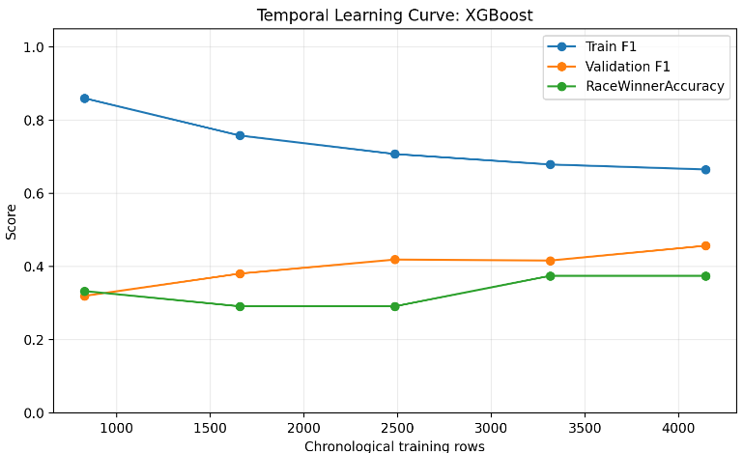
Figure 8. Temporal Learning Curve: XGBoost
Figure 8 displays the temporal learning curve for XGBoost. As the training set expands from 2014-2016 to 2014-2023, the validation F1 score on the fixed 2024 season gradually increases, with no sign of overfitting. This suggests that including more historical data improves generalisation.

5. Discussion

5.1 Interpreting the Results
The most striking finding is the disconnect between row-level F1 and race-level accuracy. XGBoost wins on the standard metric but loses on the practically relevant one. The reason lies in the precision-recall trade-off: XGBoost’s higher recall means it flags more actual winners across the 479 entries, but it also generates more false positives. When forced to commit to a single winner per race, those false positives cause it to choose the wrong driver. Random Forest is more conservative - it misses more winners in aggregate but, when it does assign a high probability to someone, it is more often right. The lesson is that the best model depends on the task: row-level F1 for multi-bet strategies, race-level accuracy for single-prediction scenarios.
The dominance of qualifying position in the SHAP rankings is unsurprising from a domain perspective. Formula 1 circuits, particularly permanent tracks, have limited passing opportunities. A driver who qualifies on pole starts on the racing line, avoids first-corner incidents, and faces no overtaking pressure in the early laps. The SHAP value of 2.029 for QualifyingPosition dwarfs all other features, suggesting that in the hybrid era, Saturday’s session is largely a predictor of Sunday’s result.
The importance of constructor-related features (PrevSeasonConstructorRank and ConstructorStrength) over individual driver history (HistoricalWinRate) is also noteworthy. It suggests that in this period, car performance was the dominant factor in race outcomes, and that driver talent played a secondary role - at least as captured by pre-race statistics.

5.2 Practical Implications
For anyone wanting to predict the winner of a single upcoming race, Random Forest is the recommended choice based on these results. For analysts building aggregate probability models (for instance, to rank all drivers’ win probability across a season), XGBoost’s higher recall and AUC make it more suitable.
The race-level accuracy of 41.7% looks modest, but it should be benchmarked against the naive baseline. With 20 drivers per race, random guessing gives 5% accuracy. Picking the pole-sitter every time yields roughly 35 - 40% in recent seasons. The model’s 41.7% is therefore a genuine but incremental improvement over the simplest possible heuristic.

5.3 Limitations
Several constraints limit the scope of these conclusions:
- The model uses only pre-race data. It cannot account for incidents, safety car periods, tire strategy choices, or mechanical failures that happen during a race. These factors can determine the outcome independently of pre-race form.
- Class imbalance remains a challenge. Despite class-weight adjustments, the models still predict wins with lower confidence than non-wins, and many actual winners receive probabilities below the threshold that would make them the top prediction.
- Weather was encoded as a binary dry/wet variable. Rain intensity, track temperature, and humidity were not captured, limiting the model’s ability to differentiate conditions that can have very different effects on race outcomes.
- The training data covers a period of regulatory stability. If major rule changes in 2026 shift the competitive hierarchy substantially, the model will require retraining. Its historical knowledge may even become a liability if the new era looks nothing like 2014–2024.
6. Conclusion
This study set out to answer a specific question: how well can a machine learning model predict the winner of a Formula 1 race before it takes place? The answer is: moderately well, but not impressively so. The best row-level F1 was 0.457 (XGBoost), and the best race-level accuracy was 41.7% (Random Forest, 10 out of 24 correct). Both results are substantially better than chance but leave room for improvement.
All three hypotheses were supported. Machine learning models clearly outperform a random baseline. Adding constructor-level features improved predictions by nearly 59%. Tree-based ensembles outperformed logistic regression by 37%.
The most useful methodological contribution is the distinction between row-level and race-level metrics. Standard classification metrics can be highly misleading in winner-prediction tasks with strong class imbalance. Practitioners should define their evaluation metric based on the decision they actually need to make.
Future work should explore three directions. First, incorporating real-time data such as lap times from earlier sessions in the race weekend, tire compound choices, and weather forecasts could meaningfully improve accuracy. Second, sequential models (LSTM or Transformer architectures) could capture driver and team form trajectories over a season in ways that rolling averages cannot. Third, an ensemble combining XGBoost’s row-level recall with Random Forest’s race-level precision may outperform either model alone on the metric that matters most.

References
- Breiman, L. (2001). Random forests. Machine Learning, 45(1), 5–32.
- El Haber, E., et al. (2025). Formula 1 Race Winner Prediction Using Random Forest and SHAP Analysis. In Proceedings of the IEEE International Conference on Computing Advancements in AI (IC2AI). IEEE.
- García Tejada, L. (2023). Applying Machine Learning to Forecast Formula 1 Race Outcomes (Master’s thesis). ICT Innovation – Data Science programme.
- Lundberg, S. M., & Lee, S. I. (2017). A unified approach to interpreting model predictions. Advances in Neural Information Processing Systems, 30, 4765–4774.
- O’Hanlon, E. (2022). Using Supervised Machine Learning to Predict the Final Rankings of the 2021 Formula One Championship (MSc thesis). National College of Ireland.
- Sicoie, H. (2022). Machine Learning Framework for Formula 1 Race Winner and Championship Standings Predictor (Bachelor’s thesis). Tilburg University.

