Aira AI Model Training Architecture Report
Dual-System Non-Autoregressive Triage, MCTS Reasoning, and Live Monitoring Web UI

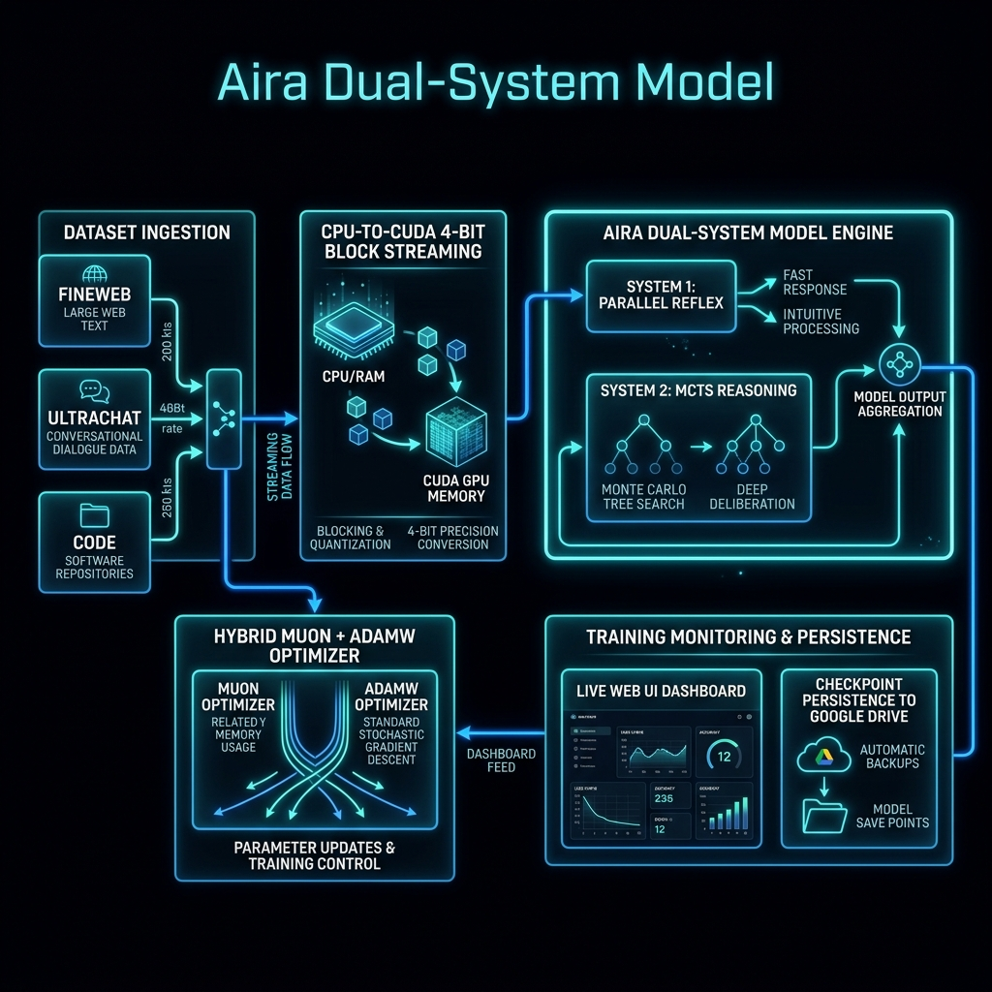
Figure 1: High-Level Architectural Block Diagram of Aira Dual-System Training Pipeline & Live Web UI

1. Executive Summary & Overview
This report provides an in-depth technical explanation of the newly implemented Aira Dual-System Training Loop (train_v2.py), its associated Live Web UI Monitoring Dashboard (live_dashboard.py), and the Google Colab execution launcher (run_colab_training_v2.py). Aira incorporates a hybrid Dual-System architecture combining System 1 (sub-70ms non-autoregressive parallel reflex triage) and System 2 (Monte Carlo Tree Search + Process Reward Model reasoning) to achieve frontier-level intelligence while maintaining ultra-low latency and deterministic guardrail compliance.

2. Core Features & Architectural Role in Aira

1. Data Ingestion & Streaming Pipeline
Combines FineWeb-Edu, UltraChat 200k, Orca Math, and CodeFeedback datasets. Normalizes and split-streams high-quality training pairs to the model.

2. CPU-to-CUDA 4-Bit NF4 Block Streaming
Streams model layer blocks from CPU RAM to CUDA GPU, allowing an 8B parameter model to train on a single 15GB Tesla T4 GPU with peak initialization VRAM under 4.0 GB.

3. Dual-System Loss Objectives
Calculates joint loss terms for System 1 (vault path indexing & AGENT.md rule compliance) and System 2 (MCTS reasoning step quality via PRM scoring).

4. Muon + AdamW Hybrid Optimizer
Uses Muon optimizer for 2D weight matrices (scaling tensor learning) combined with AdamW for 1D vectors, normalization layers, and embeddings.

5. Live Web UI Monitoring Dashboard
Provides real-time interactive tracking on port 7860 with glassmorphic UI, live Chart.js curves (Loss, Tok/s, VRAM), metric cards, and terminal log tail.

6. Google Colab Drive Persistence
Mounts /content/drive/MyDrive/AiraCheckpoints/ to automatically preserve all model weights and checkpoints across Colab sessions.

3. Future Plans & Strategic Roadmap
- Phase 1 (Current): Dual-System Training Loop v2 deployment with Colab Live Web UI and automated benchmark validation.
- Phase 2 (Q4 2026): Autonomous STaR (Self-Taught Reasoner) synthetic data loop to allow Aira to generate her own chain-of-thought training data from vault tasks.
- Phase 3 (Q1 2027): Latent space policy distillation, compressing System 2 MCTS search traces into System 1 sub-50ms neural heads.
- Phase 4 (Q2 2027): Full recursive self-improvement pipeline with parameter-efficient adapters (LoRA/DoRA) and EWC identity protection.

