**JS HOMEWORK ASSIGNMENT - 01**

**Web Programming & Security**

|  |
| --- |
|  |
| *Instructor: PhD Mahammad Sharifov / October 15, 2020* |

**TASK 1**

**Write a script in JavaScript to calculate below given form:**

**--** Max limit of Quantity is **10** and Min limit is **1**

**Products**

**Coat**

$170

**Jacket**

$75

**Belt**

$15

**Watch**

$120

Quantity

**Result**

**TASK 2**

**Write a script in JavaScript to calculate below given form:**

**--** Max limit of Quantity is **20** and Min limit is **1**

**--** Products list: **jacket ($220); coat ($145); boat ($85)**

Result

**Products**

Quantity

Product s

list

**TASK 3**

**Write a script in JavaScript to calculate below given form:**

**--** Max limit of Quantity is **20** and Min limit is **1**

Quantity

**Watch (**$120)

Quantity

**Belt (**$15)

**Result**

Quantity

**Jacket (**$75)

**TASK 4**

**Using JavaScript create below simple combination:**

**-- Create 2 buttons (or links) like LEFT and RIGHT arrows and 2 div layers (outside container and inside small div layers);**

**-- Each time by clicking LEFT or RIGHT buttons move inside small div layer accordingly LEFT or RIGHT about 10px;**

**-- When crossing the border of outside container, the inside small div element should be invisible.**

**<**

**>**

**TASK 5**

**Using JavaScript create below simple form:**

**--** When changing ‘BACKGROUND COLOR’ option body background should be changed

**--** When changing ‘TEXT COLOR’ option, all text colors should be changed



Bottom of Form

**TASK 6**

**Using JavaScript create below simple form:**

**--** When changing ‘BACKGROUND COLOR’ option body background should be changed

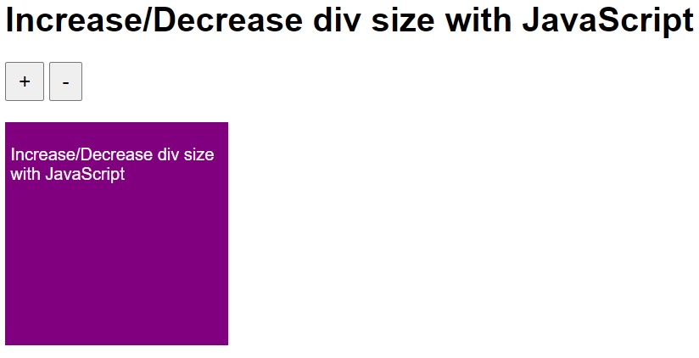

**TASK 7**

**Using JavaScript create below simple form:**

**--** Create 2 buttons (minus and plus buttons), and add sample paragraph text;

**--** Each time, when clicking ‘+’ button, increase all fonts by 2 px;

**--** Each time, when clicking ‘-’ button, decrease all fonts by 2 px;