**LCS:**

import java.util.*;

class lcs{

static String x,y;

static Scanner sc;

static int m,n;

static int b[][],c[][];

public static void main(String[] args) {

sc=new Scanner(System.in);

System.out.println("Enter x");

x=sc.nextLine();

System.out.println("Enter y");

y=sc.nextLine();

m=x.length();

n=y.length();

System.out.println(m+","+n);

b=new int[m+1][n+1];

c=new int[m+1][n+1];

for(int i=0;i<=m;i++){

c[i][0]=0;

}

for(int i=0;i<=n;i++){

c[0][i]=0;

}

for(int i=1;i<=m;i++){

for(int j=1;j<=n;j++){

if(x.charAt(i-1)==y.charAt(j-1)){

c[i][j]=c[i-1][j-1]+1;

b[i][j]=1; //1=/

}

else if(c[i-1][j]>=c[i][j-1]){

c[i][j]=c[i-1][j];

b[i][j]=0; //0=^

}

else{

c[i][j]=c[i][j-1];

b[i][j]=-1; //-1=<-

}

}

}

System.out.println("The arrow table:1=diagonal,0=up,-1=left");

display(b);

display(c);

printLcs(b, x, m, n);

}

static void display(int arr[][]){

for(int i=0;i<=m;i++){

for(int j=0;j<=n;j++){

System.out.print(arr[i][j]+" ");

}

System.out.println();

}

System.out.println("-------------");

}

static void printLcs(int b[][],String x,int i,int j){

if(i==0 || j==0)

return;

if(b[i][j]==1){

printLcs(b,x,i-1,j-1);

System.out.print(x.charAt(i-1));

}

else if(b[i][j]==0){

printLcs(b, x, i-1, j);

}

else

printLcs(b, x, i, j-1);

}

}

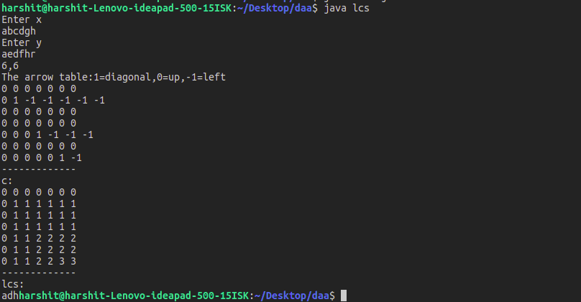

**ASSEMBLY LINE:**

import java.util.*;

class al{

static int n,e1,e2,x1,x2,f1[],f2[],l1[],l2[],res[],num_test;

static int a[][],t[][];

static Scanner sc;

public static void main(String[] args) {

sc=new Scanner(System.in);

//System.out.println("Enter number of toll booths");

num_test=sc.nextInt();

res=new int[num_test];

for(int x=0;x<num_test;x++){

n=sc.nextInt();

a=new int[2][n+1];

t=new int[2][n+1];

//System.out.println("Enter initial cost to go from starting to 1st toll on 1st track(=e1) and e2");

e1=/*sc.nextInt();*/0;

e2=0;/*sc.nextInt();*/

//System.out.println("Enter final cost to go from last toll on 1st track to end(=x1) and x2");

x1=0;

x2=0;

//System.out.println("Enter tolls along the tracks");

for(int i=0;i<2;i++){

for(int j=1;j<=n;j++){

a[i][j]=sc.nextInt();

}

//System.out.println("Enter along the next track");

}

//System.out.println("Enter tolls to cross over from tracks");

for(int i=0;i<2;i++){

for(int j=1;j<n;j++){

t[i][j]=sc.nextInt();

}

// System.out.println("Enter along the next track");

}

f1=new int[n+1];

f2=new int[n+1];

res[x]=fw();

}

for(int i=0;i<num_test;i++){

System.out.println(res[i]);

}

//display();

}

static int fw(){

f1[1]=e1+a[0][1];

f2[1]=e2+a[1][1];

// l1=new int[n+1];

//l2=new int[n+1];

for(int j=2;j<=n;j++){

if(f1[j-1]+a[0][j]<=f2[j-1]+t[1][j-1]+a[0][j]){

f1[j]=f1[j-1]+a[0][j];

//l1[j]=1;

}

else{

f1[j]=f2[j-1]+t[1][j-1]+a[0][j];

//l1[j]=2;

}

if(f2[j-1]+a[1][j]<=f1[j-1]+t[0][j-1]+a[1][j]) {

f2[j]=f2[j-1]+a[1][j];

//l2[j]=2;

}

else{

f2[j]=f1[j-1]+t[0][j-1]+a[1][j];

//l2[j]=1;

}

}

return (Math.min(f1[n], f2[n]));

}

static void display(){

System.out.println("f1");

for(int i=1;i<=n;i++)

System.out.print(f1[i]+ " ");

System.out.println("f2");

for(int i=1;i<=n;i++)

System.out.print(f2[i]+" ");

}

}

