Baker Hughes / Chart Industries: Merger and LBO Analysis
This document is an educational, illustrative analysis built from public SEC filings and labeled assumptions. It is not investment advice, a fairness opinion, or a solicitation, and it was not prepared by or for either company.

Deal Overview
On 2025-07-28, Baker Hughes Company (NASDAQ: BKR) agreed to acquire Chart Industries, Inc. (NYSE: GTLS) for 48.2mm fully diluted shares at $210.00 per share in an all-cash transaction. The transaction closed on 2026-07-16. Baker Hughes stated a total enterprise value of $13,600mm and an implied equity value of $10,100mm at signing, financed with newly issued senior notes, two 2-year unsecured term loans, and cash on hand; Chart's own outstanding notes, term loan and revolver were redeemed or repaid at closing.

Valuation and Sources and Uses
This model's independent reconstruction of the purchase price, using the fully diluted share count and Chart's FY2025 year-end net debt, implies an enterprise value of $13,415mm, a variance of -1.4% against the disclosed $13,600mm. The gap is explained by differing measurement dates: the disclosed figure reflects share count and net debt near signing (July 2025), while this model uses the closest pre-close print (Q1 2026) for shares and Chart's FY2025 10-K for net debt, since a full debt breakdown as of the actual close date was not separately disclosed.
Sources and Uses ($mm) | Amount
Equity purchase price | 10,125.0
Redeem Chart senior secured notes | 1,511.6
Redeem Chart senior unsecured notes | 534.2
Repay Chart term loan | 1,406.0
Repay Chart revolver and other debt | 283.0
Advisory and financing fees | 131.8
Total Uses | 13,991.7
New term loans | 2,000.0
New USD and EUR senior notes | 9,915.0
Cash on hand | 2,076.7
Total Sources | 13,991.7

Purchase Price Allocation
Applying illustrative fair-value step-ups to inventory, PP&E and identifiable intangibles (none of which Baker Hughes has separately disclosed), and a rebuilt deferred tax liability on those step-ups, this model computes goodwill of $3,962mm against total consideration of $10,125mm. The identifiable intangibles fair value ($4,500mm) and its useful life are illustrative assumptions, not disclosed figures; see the README for the full assumption list.

Accretion / Dilution
The press release states double-digit GAAP EPS accretion in the first full year after close. This independent model, which charges the combined entity the full incremental cost of financing the entire purchase (including refinancing Chart's own debt) at an illustrative 23% tax rate, and layers in amortization of the newly created intangible assets, finds the deal dilutive in year one (-9.2%) and roughly breakeven in year two (-0.8%), turning accretive from year three onward (+5.8% in 2028, reaching +10.8% by 2030). This gap against the company's own claim is reported here rather than smoothed over; it likely reflects a non-GAAP or cash-EPS basis, a lower assumed cost of the acquisition financing, or synergies realized faster than this model's illustrative phase-in.
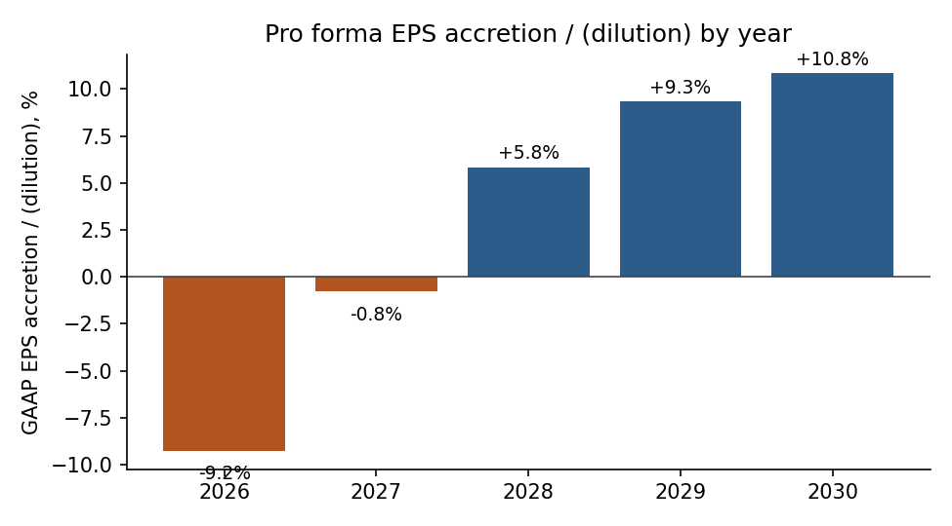

LBO: Hypothetical Sponsor Alternative
Chart was acquired strategically, not by a financial sponsor. The LBO below is a clearly hypothetical alternative capital structure for the same target at the same disclosed $210.00 per share price, built purely for comparison.
At entry leverage of 6.0x EBITDA ($4,564mm Term Loan B plus $1,521mm senior notes) and sponsor equity of $7,802mm, a 5-year hold exiting at 12.0x EBITDA produces a 1.61x MOIC and a 10.0% IRR. Both figures sit below typical sponsor return hurdles (often 20%+ IRR / 2.5x+ MOIC), which is a weak result worth stating plainly: at the actual deal price and this illustrative leverage and exit multiple, this is not an obviously attractive standalone buyout.
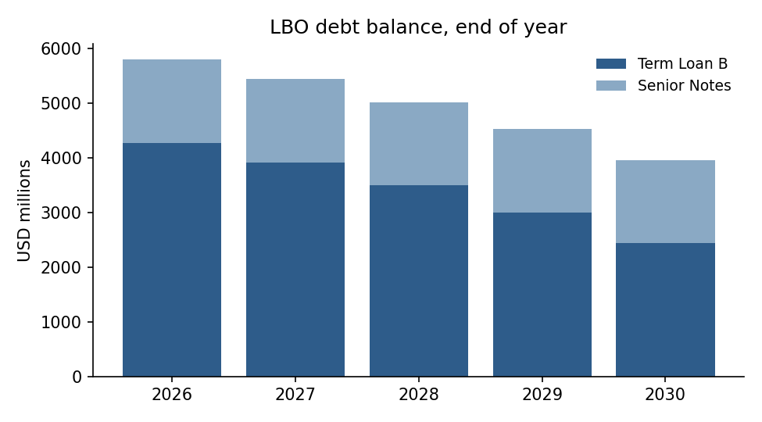

Key Assumptions and Risks
- Synergies: $325mm annualized cost synergies at year-3 run-rate is Baker Hughes' own disclosed figure; the ramp shape (25% / 60% / 100%) and the one-times cost to achieve them are illustrative.
- Tax rate: a 23% blended rate is used for deal adjustments; Baker Hughes' own FY2025 effective rate was materially lower (8.8%), so this is a conservative choice, not a forecast of the combined company's actual cash tax rate.
- Financing cost: the new debt's blended coupon is built from the actually disclosed tranche coupons and face amounts; the term loan margin (100bps over SOFR) is an assumption within the disclosed contractual range.
- LBO structure (leverage split, pricing, exit multiple, cash sweep): entirely illustrative, since Chart was not actually taken private.
- Purchase price allocation step-ups (inventory, PP&E, intangibles) are illustrative; Baker Hughes has not disclosed a final fair-value allocation as of this writing.

Disclaimer
This document is an educational, illustrative analysis built from public SEC filings and labeled assumptions. It is not investment advice, a fairness opinion, or a solicitation, and it was not prepared by or for either company.

