# Testing file - Nikko – Tochigi - Japan: A Comprehensive Guide

Test – **bold**, *italic*, underline, sub, sup, ~~cross~~, color, ***~~mix~~***

Align right

Align middle

**Align right and bold with green color**

[Linked text to arcgis.com](https://arcgis.com)

* List1.1
  + List 1.1,1
    - List1.1.1.1
* List1.2 – multiple different formatting - ~~crossed~~  sub sup *italic*
  + List 1.2.1
    1. **List 1.2.2.2 Bold and blue**
    2. List 1.2.2.3
    3. List 1.2.2.4
* List1.3 - [Linked text to youtube.com](https://www.youtube.com)

Ccyxcy

1. Ordered list 1 – multiple different formatting - ~~crossed~~  sub sup *italic*
2. Ordered list 1 red
   * Test
   * Test2
3. Ordered list 1
   1. Test

|  |  |
| --- | --- |
| **Zahlaví 1** | **Záhlaví 2** |
| Text sloupce 1 | Text sloupce 2 - [Linked text to idnes.cz](https://www.idnes.cz) |

Style named caption – when it is under table add to table subtitle

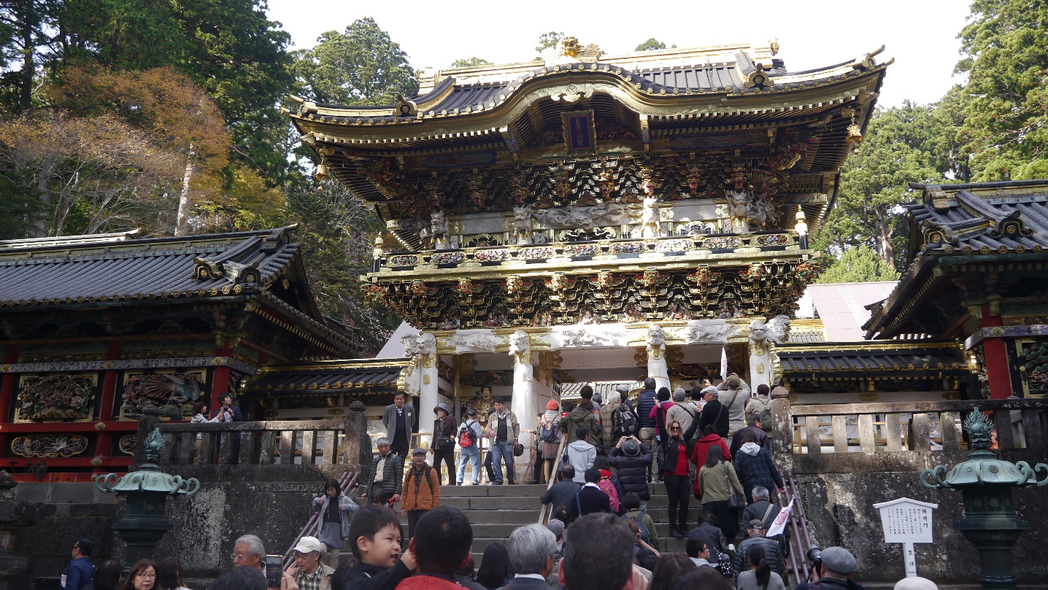

Style named caption – when it is under image add to table subtitle

Style named bibliography - should be normal text

Normální text

Style named code – should be code

Normální text

<a href=”x”><strong>text</strong></a>

Style name quote

## Introduction

Nikko (日光) is a small city in **Tochigi Prefecture, Japan**, nestled in the mountains north of Tokyo. Famous for its lavish temples, shrines, and natural beauty, Nikko has been a center of religious worship for centuries and is now designated as a UNESCO World Heritage site. The name “Nikko” means “sunlight” in Japanese, and according to local folklore, the beauty of the region is so magnificent that visitors are urged to “not say ‘magnificent’ until you’ve seen Nikko” (日光を見ずして結構と言うなかれ, “*Nikko wo mizushite kekko to iunakare*”).

Located approximately 140 kilometers north of Tokyo, Nikko serves as a perfect retreat from the bustling capital, offering breathtaking mountain landscapes, cascading waterfalls, and some of Japan’s most ornate religious structures. The area’s lush forests, particularly striking during autumn when leaves turn vibrant shades of red and gold, create a picturesque setting for the historical treasures found within.

### Tochigi Region Overview

Tochigi Prefecture is situated in the Kanto region of Honshu, Japan’s main island. The prefecture is known for its agricultural productivity, particularly strawberries, and its rich historical heritage. Beyond Nikko, Tochigi offers visitors attractions such as the Ashikaga Flower Park, the traditional town of Kuriyama, and the Nasu highland resort area.

The geography of Tochigi is characterized by plains in the south and mountains in the north, where Nikko is located. The mountainous terrain creates dramatic scenery including Lake Chuzenji and Kegon Falls, formed by ancient volcanic activity. The region enjoys four distinct seasons, with hot, humid summers and cold winters with significant snowfall in the mountainous areas.

### Nikko History Overview

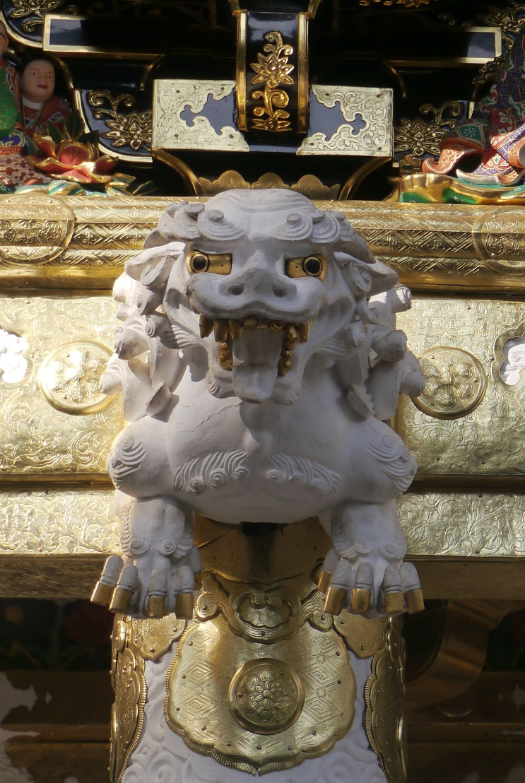Nikko’s history as a sacred site dates back to the 8th century when the Buddhist monk Shodo Shonin founded the first temple in the area. Legend has it that he crossed the Daiya River with the assistance of two mystical snakes that formed a bridge, a story commemorated by the famous Sacred Bridge (Shinkyo).

Word made image desription

The area gained tremendous importance in the early 17th century when Tokugawa Ieyasu, the founder of the Tokugawa Shogunate that ruled Japan for over 250 years, chose Nikko as his final resting place. His grandson, Tokugawa Iemitsu, commissioned the lavish Toshogu Shrine complex to honor his grandfather’s memory and deify him as a Shinto god. This marked the beginning of Nikko’s development as a major religious center featuring an extraordinary blend of Buddhist and Shinto elements.

During the Meiji Restoration (1868), when Japan modernized and Shinto was established as the state religion, many of Nikko’s Buddhist elements were removed or separated from Shinto structures. However, unlike in many other places in Japan, Nikko preserved much of its Buddhist heritage alongside Shinto elements, resulting in the unique religious landscape we see today.

In 1999, the shrines and temples of Nikko, along with their natural surroundings, were designated as a UNESCO World Heritage Site, recognizing their cultural and historical significance.