TRAVEL HUB ARMENIA
Database Architecture
MySQL Schema Design for a World-Class Travel Marketplace
Version 1.0 · Confidential · Database Architecture Team

Table of Contents

1. Architecture Principles
The schema is designed as the permanent system of record: normalized for integrity, denormalized only where read performance demands it, and built so every module can scale independently as the marketplace grows.
- Third normal form (3NF) as the baseline — every non-key attribute depends on the whole key and nothing but the key
- Polymorphic core entities (listings, media, favorites, reviews, notifications, audit_logs) so new modules plug into existing infrastructure instead of duplicating it
- No native MySQL ENUM columns — all fixed vocabularies (statuses, types) are lookup tables, so new values never require a schema migration
- Every business table carries created_at, updated_at, deleted_at (soft delete) and created_by / updated_by (audit trail)
- Money is always stored as a fixed-point decimal paired with an explicit currency_id — never a float, never an implicit currency
- InnoDB storage engine throughout for row-level locking, foreign keys, and transactional integrity
- Every foreign key is indexed; every table has a single-column surrogate primary key (BIGINT UNSIGNED, auto-increment) even where a natural key exists
- Read-heavy, write-light modules (catalog, search) are architected to tolerate later denormalization/caching without breaking the source-of-truth schema

2. Naming Convention

2.1 General Rules
- snake_case for all tables and columns, always lowercase
- Table names are plural nouns: listings, bookings, payments
- Primary key column is always id (BIGINT UNSIGNED, auto-increment)
- Foreign key columns are {singular_referenced_table}_id — e.g. listing_id, booking_id, user_id
- Junction / pivot tables join two singular entity names alphabetically: permission_role, role_user, listing_amenity
- Boolean columns are prefixed is_ or has_ — is_active, has_pool
- Timestamps: created_at, updated_at (always present); deleted_at (soft-delete tables only)
- Audit columns: created_by, updated_by, deleted_by — nullable FK to users.id
- Translation child tables are suffixed _translations — listing_translations, cms_page_translations
- Historical/append-only log tables are suffixed _history or _logs — booking_status_history, audit_logs
- Money columns are suffixed _amount or _price and always paired with a currency_id column
- Date-only fields end in _date, full timestamps end in _at

2.2 Indexing Convention
- Primary key index: PRIMARY (implicit)
- Single FK index: idx_{table}_{column} — idx_bookings_user_id
- Composite index: idx_{table}_{col1}_{col2} — idx_availability_calendar_unit_date
- Unique constraint: uq_{table}_{column(s)} — uq_coupons_code
- Full-text index: ft_{table}_{column} — ft_listing_translations_search

3. High-Level Domain Map
The schema is organized into nine domains. Every module (Hotels, Vacation Houses, Restaurants, Car Rentals, Tours, Events, SPA, Entertainment) is a thin extension of one shared Catalog Core, so Booking, Pricing, Availability, and Engagement logic is written once and reused by all eight modules.
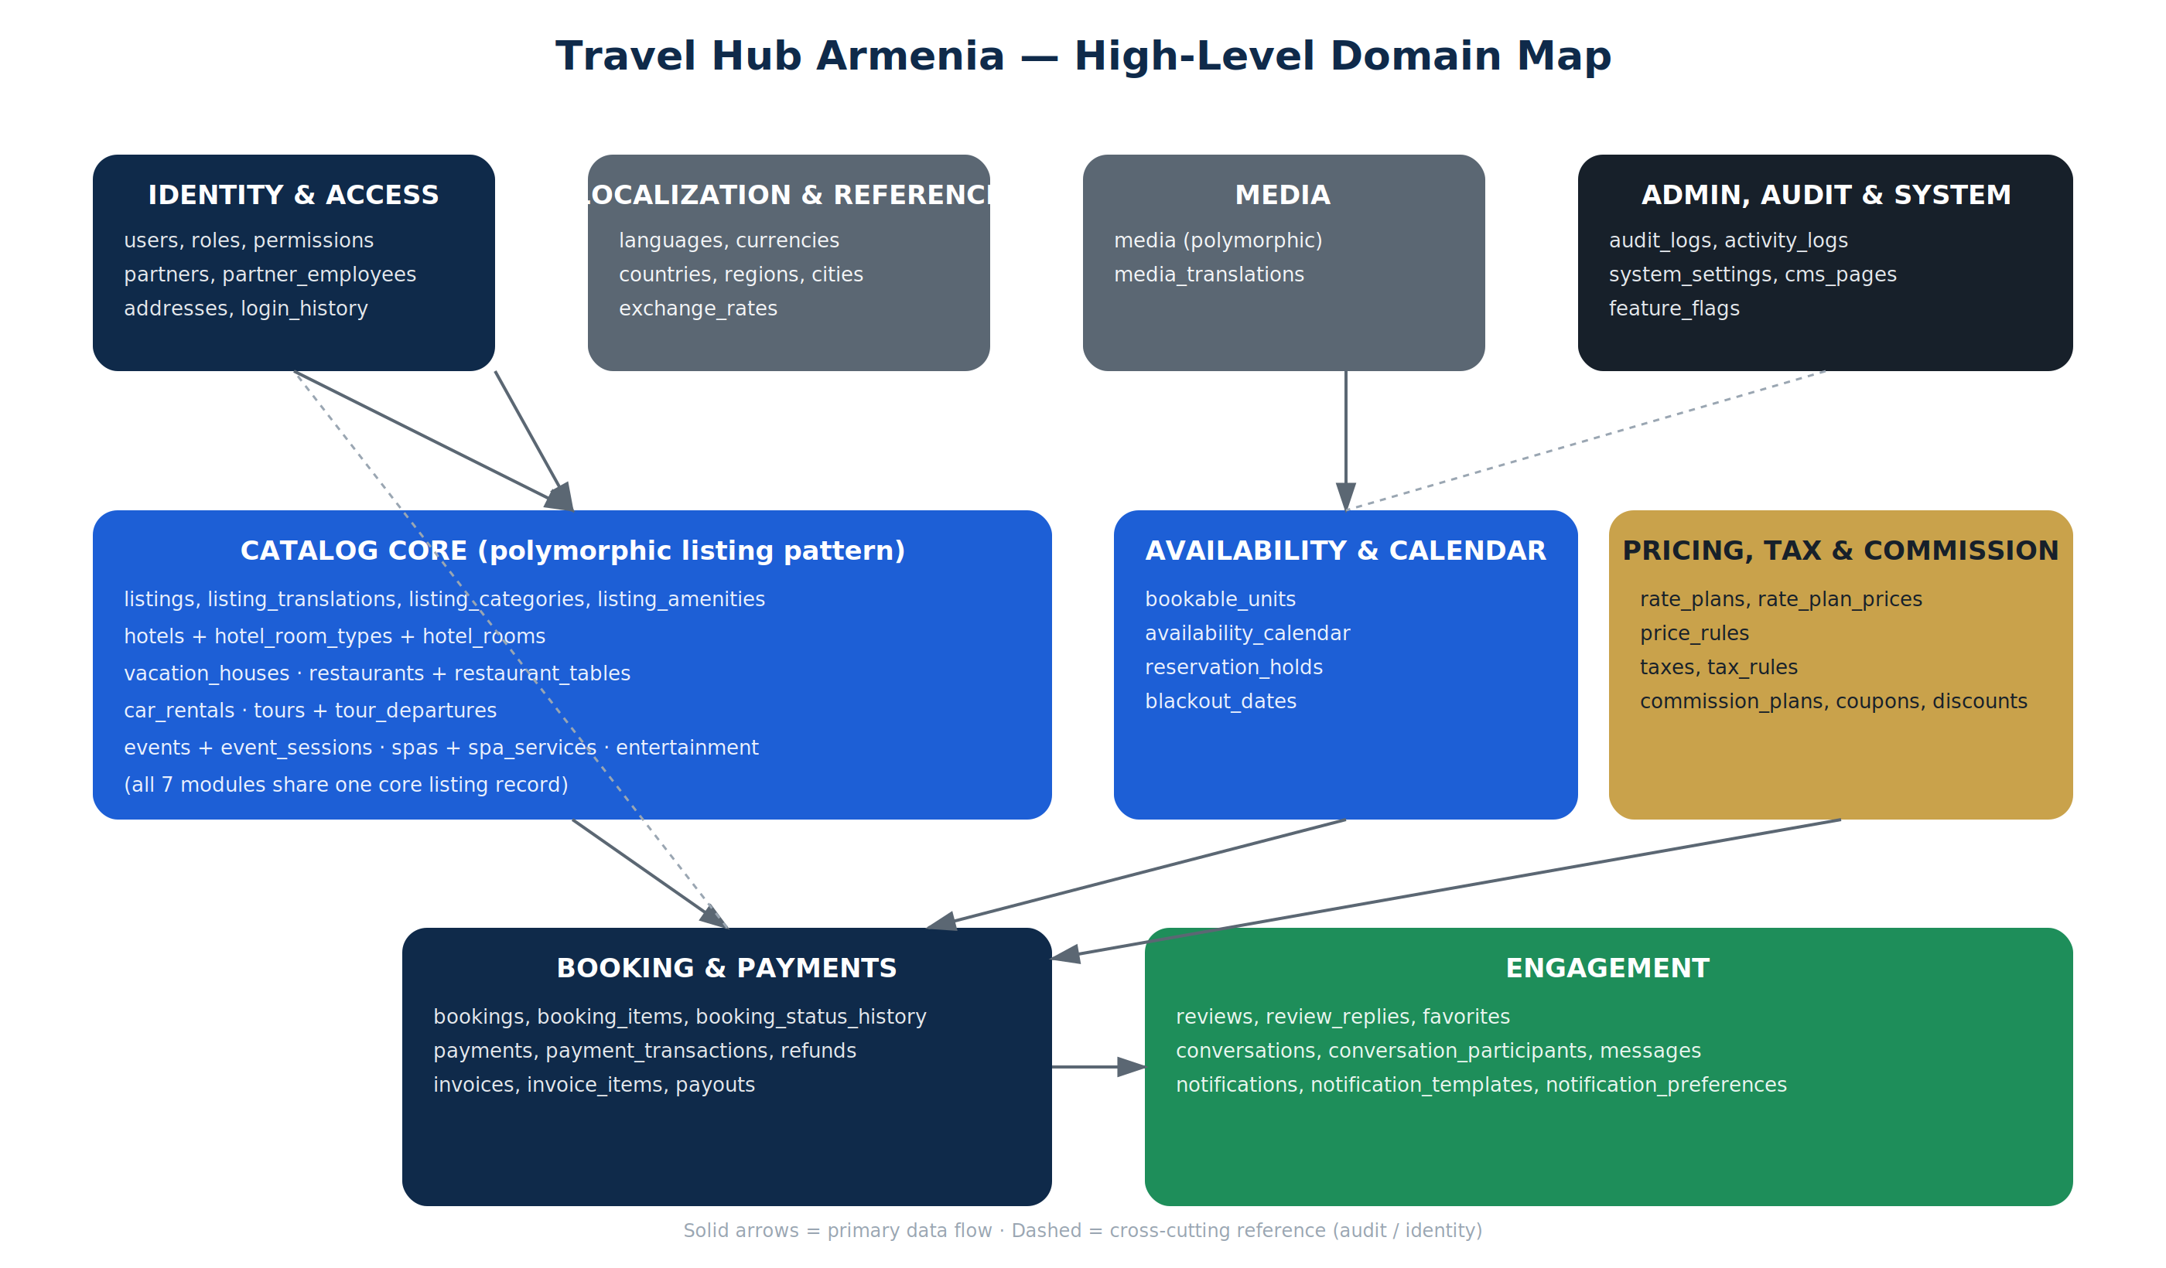
Figure 1 — High-level domain map and primary data flow

4. Full Table Catalog
Sixty-six tables across nine domains. Every bookable module (Hotels, Vacation Houses, Restaurants, Car Rentals, Tours, Events, SPA, Entertainment) shares the same listings / bookable_units / availability_calendar / bookings backbone — only the module-specific extension tables differ.

4.1 Identity & Access
Table | Purpose | Key Columns | Relations
users | Platform account — guest, customer, partner staff, or admin | id, email, phone, password_hash, status, deleted_at | 1:1 user_profiles · M:N roles
user_profiles | Extended personal data kept off the hot users table | id, user_id, date_of_birth, avatar_media_id, locale | 1:1 users
addresses | Polymorphic address book (users, partners, bookings) | id, addressable_type, addressable_id, line1, city_id, geo_point | N:1 cities
roles | Named role — super_admin, admin, moderator, partner_owner, partner_staff, customer | id, name, scope (global/partner) | M:N users, M:N permissions
permissions | Fine-grained capability — booking.cancel, listing.publish | id, name, module | M:N roles
role_user | Pivot — assigns roles to users | role_id, user_id | N:1 roles · N:1 users
permission_role | Pivot — assigns permissions to roles | permission_id, role_id | N:1 permissions · N:1 roles
partners | Business entity that owns listings (hotel chain, agency, individual host) | id, business_name, legal_name, status, commission_plan_id, deleted_at | 1:N listings · 1:N partner_employees
partner_employees | Staff member linked to a partner account with a scoped role | id, partner_id, user_id, role_id, status | N:1 partners · N:1 users
login_history | Append-only login/security audit trail | id, user_id, ip_address, user_agent, success, created_at | N:1 users

4.2 Localization & Reference Data
Table | Purpose | Key Columns | Relations
languages | Supported locales (hy, ru, en) | id, code, name, is_default | referenced by every _translations table
currencies | ISO currency list | id, code, symbol, decimal_places | referenced by pricing/payment tables
exchange_rates | Daily FX rate snapshot for display conversion | id, currency_id, rate_to_base, rate_date | N:1 currencies
countries | Reference country list | id, iso_code, name | 1:N regions
regions | State / province / marz | id, country_id, name | N:1 countries · 1:N cities
cities | City reference data used by listings and addresses | id, region_id, name, geo_point | N:1 regions

4.3 Catalog Core (shared by all 8 modules)
Table | Purpose | Key Columns | Relations
listings | One row per bookable product across every module | id, partner_id, listing_type, slug, status, base_price, currency_id, deleted_at | N:1 partners · 1:1 module extension · 1:N bookable_units
listing_translations | Localized name / description per listing | id, listing_id, locale, name, description | N:1 listings, N:1 languages · full-text indexed
listing_categories | Category taxonomy (Luxury, Budget, Family, Adventure...) | id, parent_id, name | self-referencing tree
listing_category_listing | Pivot — listing to category | listing_id, category_id | N:1 listings · N:1 listing_categories
listing_amenities | Amenity master list (Wifi, Pool, Parking...) | id, name, icon_media_id | M:N listings
listing_amenity_listing | Pivot — listing to amenity | listing_id, amenity_id | N:1 listings · N:1 listing_amenities
listing_locations | Geo point + structured address per listing | id, listing_id, address_id, geo_point (SPATIAL) | 1:1 listings

4.4 Module Extensions
Table | Purpose | Key Columns | Relations
hotels | Hotel-specific attributes (star rating, check-in policy) | listing_id (PK/FK), star_rating, check_in_time, check_out_time | 1:1 listings · 1:N hotel_room_types
hotel_room_types | Room category within a hotel (Deluxe, Suite) | id, listing_id, name, max_occupancy, base_price | N:1 hotels · 1:N hotel_rooms
hotel_rooms | Physical, individually bookable room (= a bookable_unit) | id, room_type_id, room_number | N:1 hotel_room_types · 1:1 bookable_units
vacation_houses | Whole-property rental attributes | listing_id (PK/FK), bedrooms, bathrooms, max_guests | 1:1 listings
restaurants | Cuisine, price tier, seating attributes | listing_id (PK/FK), cuisine_type, price_tier | 1:1 listings · 1:N restaurant_tables
restaurant_tables | Bookable table / seating slot | id, restaurant_id, table_number, capacity | N:1 restaurants · 1:1 bookable_units
car_rentals | Vehicle fleet attributes | listing_id (PK/FK), make, model, year, transmission, seats | 1:1 listings · N:1 vehicle_categories
vehicle_categories | Economy, SUV, Luxury, Electric... | id, name | 1:N car_rentals
tours | Tour attributes (duration, difficulty, group size) | listing_id (PK/FK), duration_hours, difficulty, max_group_size | 1:1 listings · 1:N tour_departures
tour_departures | Scheduled departure date/time (= a bookable_unit) | id, tour_id, departure_at, seats_available | N:1 tours · 1:1 bookable_units
events | Concert / festival / conference attributes | listing_id (PK/FK), venue_id, event_category | 1:1 listings · 1:N event_sessions
event_sessions | Individual date/time session with seat inventory | id, event_id, starts_at, capacity | N:1 events · 1:1 bookable_units
spas | SPA venue attributes | listing_id (PK/FK), facility_type | 1:1 listings · 1:N spa_services
spa_services | Bookable treatment/service (= a bookable_unit) | id, spa_id, name, duration_minutes, base_price | N:1 spas · 1:1 bookable_units
entertainment_venues | Attractions, activities, entertainment centers | listing_id (PK/FK), venue_type | 1:1 listings · 1:N entertainment_sessions
entertainment_sessions | Timed entry slot / session (= a bookable_unit) | id, venue_id, starts_at, capacity | N:1 entertainment_venues · 1:1 bookable_units

4.5 Media
Table | Purpose | Key Columns | Relations
media | Polymorphic image/video attachment for any entity | id, mediable_type, mediable_id, type, url, thumbnail_url, position, is_cover | attaches to listings, reviews, users, partners
media_translations | Localized alt text / captions per media item | id, media_id, locale, alt_text, caption | N:1 media, N:1 languages

4.6 Availability, Calendar & Inventory
Table | Purpose | Key Columns | Relations
bookable_units | Unified abstraction — a room, vehicle, table, tour departure, spa slot, or event session | id, listing_id, unit_type, source_table, source_id, capacity, deleted_at | N:1 listings · 1:N availability_calendar · 1:N booking_items
availability_calendar | Date-level status and optional price override per unit | id, bookable_unit_id, date, status, price_override, quantity_available | N:1 bookable_units · UNIQUE(bookable_unit_id, date)
reservation_holds | Short-lived lock preventing double-booking during checkout | id, bookable_unit_id, user_id, start_date, end_date, expires_at | N:1 bookable_units · N:1 users
blackout_dates | Partner-defined dates a unit or listing is closed | id, listing_id, bookable_unit_id, date_from, date_to, reason | N:1 listings / bookable_units

4.7 Pricing, Tax & Commission
Table | Purpose | Key Columns | Relations
rate_plans | Named pricing strategy per listing (Flexible, Non-refundable) | id, listing_id, name, cancellation_policy, is_active | N:1 listings · 1:N rate_plan_prices
rate_plan_prices | Date-range / seasonal price override for a rate plan | id, rate_plan_id, date_from, date_to, price, currency_id | N:1 rate_plans
price_rules | Length-of-stay and day-of-week modifiers | id, listing_id, rule_type, condition_value, adjustment_percent | N:1 listings
taxes | Tax type master (VAT, City Tax, Service Fee) | id, name, calculation_type | 1:N tax_rules
tax_rules | Jurisdiction- and module-specific tax rate | id, tax_id, country_id, listing_type, rate_percent | N:1 taxes · N:1 countries
commission_plans | Named commission structure assignable to a partner | id, name, default_rate_percent | 1:N partners · 1:N commission_rules
commission_rules | Module- or volume-based commission override | id, commission_plan_id, listing_type, rate_percent, tier_min_amount | N:1 commission_plans
coupons | Promotional code definition | id, code (unique), discount_type, value, usage_limit, valid_from, valid_to | 1:N coupon_redemptions
coupon_redemptions | Usage record — enforces per-user and total limits | id, coupon_id, user_id, booking_id, redeemed_at | N:1 coupons · N:1 users · N:1 bookings
discounts | Listing-level promotional pricing (early-bird, last-minute) | id, listing_id, discount_type, value, starts_at, ends_at | N:1 listings

4.8 Booking & Payments
Table | Purpose | Key Columns | Relations
bookings | Order header — one trip/purchase, may span multiple modules | id, user_id, partner_id, status, total_amount, currency_id, deleted_at | N:1 users · 1:N booking_items · 1:N payments
booking_items | One reserved unit + date range + price within a booking | id, booking_id, bookable_unit_id, rate_plan_id, date_from, date_to, quantity, unit_price | N:1 bookings · N:1 bookable_units
booking_guests | Guest/traveler details attached to a booking item | id, booking_item_id, full_name, document_number | N:1 booking_items
booking_status_history | Append-only audit trail of status transitions | id, booking_id, from_status, to_status, changed_by, created_at | N:1 bookings · N:1 users
payments | Payment attempt/capture against a booking | id, booking_id, amount, currency_id, method, status, gateway_reference | N:1 bookings · 1:N payment_transactions
payment_methods | Saved/tokenized payment instrument for a user | id, user_id, type, token_reference, is_default | N:1 users
payment_transactions | Gateway-level event log (authorize, capture, decline) | id, payment_id, event_type, raw_response, created_at | N:1 payments
refunds | Full or partial refund against a payment | id, payment_id, amount, reason, status, processed_by | N:1 payments
invoices | Customer-facing invoice/receipt document | id, booking_id, invoice_number, issued_at, total_amount | N:1 bookings · 1:N invoice_items
invoice_items | Line item on an invoice — price, tax, commission breakdown | id, invoice_id, description, amount, tax_amount | N:1 invoices
payouts | Platform-to-partner settlement batch | id, partner_id, period_from, period_to, amount, status | N:1 partners

4.9 Engagement (Reviews, Favorites, Messaging, Notifications)
Table | Purpose | Key Columns | Relations
reviews | Polymorphic rating/review of a listing or partner | id, reviewable_type, reviewable_id, user_id, rating, comment, deleted_at | N:1 users · attaches to listings
review_replies | Partner response to a review | id, review_id, partner_id, comment | N:1 reviews · N:1 partners
favorites | Polymorphic saved/wishlist item | id, user_id, favorable_type, favorable_id | N:1 users · UNIQUE(user_id, favorable_type, favorable_id)
conversations | Message thread between two or more parties | id, subject, context_type, context_id | 1:N conversation_participants · 1:N messages
conversation_participants | Pivot — who is in a conversation | conversation_id, user_id | N:1 conversations · N:1 users
messages | Individual message within a conversation | id, conversation_id, sender_id, body, read_at | N:1 conversations · N:1 users
notifications | Polymorphic in-app/email/push notification | id, notifiable_type, notifiable_id, type, data (JSON), read_at | attaches to users/partners
notification_templates | Reusable, localized notification content | id, code, channel | 1:N notification_template_translations
notification_preferences | Per-user channel opt-in/out | id, user_id, channel, is_enabled | N:1 users

4.10 Admin, Audit & System
Table | Purpose | Key Columns | Relations
audit_logs | Central, polymorphic change-history for every table | id, auditable_type, auditable_id, actor_id, action, old_values (JSON), new_values (JSON), created_at | attaches to any entity · N:1 users (actor)
activity_logs | General user/admin activity feed (non-diff events) | id, user_id, action, description, ip_address, created_at | N:1 users
system_settings | Key-value platform configuration | id, key (unique), value, is_public | —
cms_pages | Static/marketing content pages (About, Terms) | id, slug, status, deleted_at | 1:N cms_page_translations
cms_page_translations | Localized CMS content | id, cms_page_id, locale, title, body | N:1 cms_pages, N:1 languages
feature_flags | Toggle for phased rollout of new modules/features | id, key (unique), is_enabled, rollout_percent | —

5. Core Entity Relationships
The diagram below traces the primary path from Partner and User through the shared Catalog Core into Availability, Pricing, Booking, and Payment — the transactional heart of the platform that every module reuses.
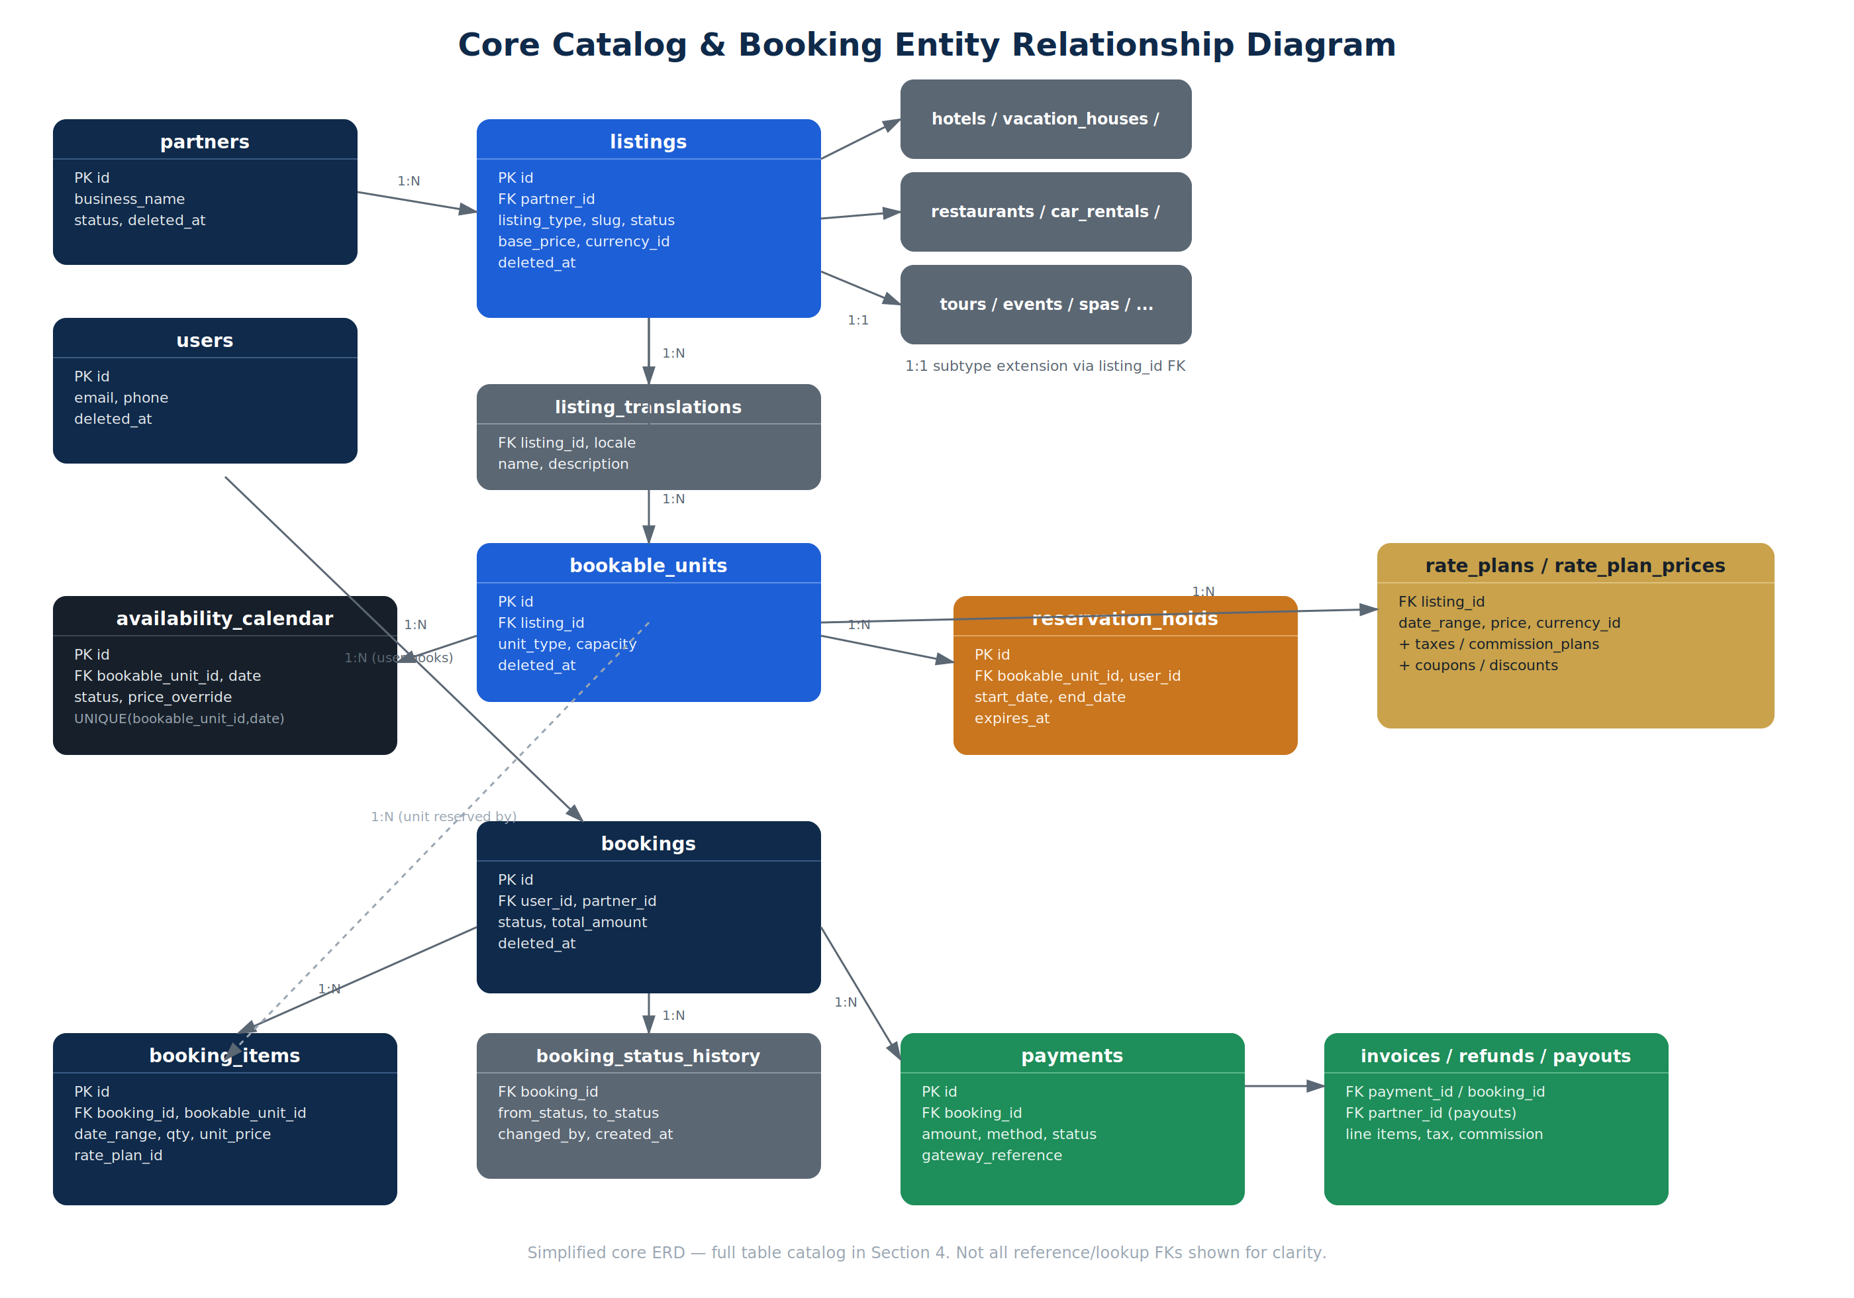
Figure 2 — Core catalog and booking ERD (simplified; reference/lookup FKs omitted for clarity)

5.1 Key Relationship Rules
- partners (1) → listings (N): a partner can list many properties/services; every listing belongs to exactly one partner
- listings (1) → module extension table (1): hotels/vacation_houses/restaurants/etc. share the listing's primary key as their own primary key (shared-PK 1:1 pattern) — avoids duplicating common fields and keeps one polymorphic parent
- listings (1) → bookable_units (N): a hotel listing has many rooms, a tour listing has many departures, a spa listing has many services — all normalized as bookable_units
- bookable_units (1) → availability_calendar (N): one row per unit per date; a composite unique index prevents duplicate date entries
- users (1) → reservation_holds (N) → bookings (1): a hold is a temporary claim; on payment success it is converted into a confirmed booking_item and the hold is deleted
- bookings (1) → booking_items (N) → bookable_units (N:1): a single booking (one checkout) can contain items across different modules — e.g., a hotel room plus an airport transfer
- bookings (1) → payments (N): supports split payments, retries, and partial captures
- payments (1) → refunds (N) and (1) → payment_transactions (N): full gateway audit trail without mutating the original payment row
- reviews, favorites, notifications, media, and audit_logs all use the polymorphic {x}able_type / {x}able_id pattern so any current or future entity can plug in without new join tables

6. Indexing Strategy

6.1 Standard Indexes (every table)
- Clustered primary key on id
- Non-unique index on every foreign key column
- Index on deleted_at where soft delete is used, typically combined as (deleted_at, id) to keep default list queries fast

6.2 High-Value Composite & Special Indexes
Table | Purpose | Key Columns | Relations
availability_calendar | UNIQUE (bookable_unit_id, date) | Prevents duplicate calendar rows; powers the single most frequent read ("is this unit free on this date?")
reservation_holds | INDEX (expires_at) | Background job scans and releases expired holds every few seconds
reservation_holds | INDEX (bookable_unit_id, start_date, end_date) | Fast overlap-check before granting a new hold
listings | INDEX (partner_id, status, created_at) | Partner dashboard listing table, paginated and filtered by status
listing_translations | FULLTEXT (name, description) per locale | Search-as-you-type and destination search
listing_locations | SPATIAL INDEX (geo_point) | Radius / "near me" search using MySQL spatial functions
bookings | INDEX (user_id, status, created_at) | "My Trips" and support lookups
booking_items | INDEX (bookable_unit_id, date_from, date_to) | Conflict detection and reporting
coupons | UNIQUE (code) | O(1) coupon lookup at checkout
favorites | UNIQUE (user_id, favorable_type, favorable_id) | Prevents duplicate favorites, enables instant toggle
audit_logs | INDEX (auditable_type, auditable_id, created_at) | Entity change history lookup from any admin screen
notifications | INDEX (notifiable_type, notifiable_id, read_at) | Unread-count queries on every page load
payments | INDEX (booking_id, status) | Checkout status polling and reconciliation

6.3 Rules of Thumb
- Composite indexes are ordered most-selective-first, and always lead with the column used in equality filters before range filters (e.g., unit_id = ? before date BETWEEN ? AND ?)
- Covering indexes are used for hot dashboard queries to avoid a secondary lookup to the clustered index
- No more than 5–6 secondary indexes per high-write table (bookings, payments, availability_calendar) to keep INSERT/UPDATE throughput high

7. Soft Delete Architecture
- Every primary business entity (users, partners, listings, bookable_units, bookings, reviews, cms_pages) carries a nullable deleted_at timestamp — rows are never physically removed
- All application queries are scoped by default to deleted_at IS NULL; an explicit admin "include trashed" flag is required to see soft-deleted rows
- Because MySQL cannot express a native partial-unique index, uniqueness that should only apply to active rows (e.g., one active coupon code) is enforced by pairing the unique index with deleted_at, or via a generated column that collapses all soft-deleted rows to a single sentinel value
- Cascading soft delete is handled at the application/service layer, not via ON DELETE CASCADE — deleting a listing marks its bookable_units and calendar rows as deleted in the same transaction, preserving full historical bookings
- Hard-delete (purge) is a separate, explicit, permission-gated operation reserved for compliance/GDPR-style data-removal requests, never triggered by normal admin actions

8. Audit Log Architecture
- audit_logs is the single, polymorphic ledger for who changed what, when, and how — auditable_type, auditable_id, actor_id, action (created/updated/deleted/restored), old_values and new_values stored as JSON diffs, plus ip_address and user_agent
- High-frequency state machines get a dedicated, queryable history table instead of relying on JSON parsing — booking_status_history and payment_transactions are the two most important examples
- Audit rows are immutable and insert-only; no update or delete operation ever targets audit_logs
- Audit writes are performed asynchronously (queued) where possible so they never add latency to the user-facing transaction
- Retention: audit_logs is partitioned by month (see Section 12) and archived to cold storage after 18 months, keeping the hot table fast for recent lookups

9. Roles & Permissions (RBAC)
- Global roles: super_admin, admin, moderator, customer — assigned via role_user
- Partner-scoped roles: partner_owner, partner_manager, partner_staff — assigned via partner_employees.role_id, scoped to a single partner_id so one user can hold different roles at different partner accounts
- Permissions are fine-grained and module-qualified (booking.cancel, listing.publish, payout.approve) and attached to roles via permission_role — never checked by role name directly in application code
- New permissions can be introduced and reassigned to roles without any schema change, since both roles and permissions are data, not code
- Every privileged/admin action is expected to write an audit_logs row identifying the actor and the permission that authorized it

10. Calendar, Availability & Reservation Hold Design

10.1 Unified Bookable Unit Model
Rather than building separate availability logic per module, every reservable thing — a hotel room, a rental car, a restaurant table, a tour departure, a spa slot, an event seat block — is normalized into a single bookable_units table, linked back to its module-specific source row via source_table and source_id. This lets Availability, Pricing, and Booking be built once and reused by all eight modules.

10.2 Flow
- availability_calendar holds one row per unit per date with a status (available, booked, blocked) and an optional price_override — this is the table every search/date-picker query reads against
- When a user selects dates, a row is written to reservation_holds with a short expiry (e.g., 15 minutes); a uniqueness/overlap check against existing holds and confirmed booking_items prevents double-booking at write time
- A scheduled background job (or a Redis-backed TTL, see Section 12) deletes expired holds and frees the corresponding availability_calendar rows
- On successful payment, the hold is converted atomically (single transaction) into a booking + booking_items row, and the relevant availability_calendar rows are flipped to booked
- blackout_dates lets a partner close a listing or a specific unit for a date range (maintenance, personal use) independently of the booking flow

11. Pricing, Tax, Commission & Coupon Engine
- Base price lives on the listing (and can be overridden per bookable_unit for heterogeneous inventory such as differently priced hotel rooms)
- rate_plans let one listing expose multiple purchasable strategies (e.g., Flexible vs. Non-refundable) at different prices, each with its own cancellation policy
- rate_plan_prices supplies date-range/seasonal overrides (high season, holidays) without needing one row per calendar day
- price_rules layer on length-of-stay discounts and day-of-week surcharges as percentage or fixed adjustments evaluated at checkout time
- taxes + tax_rules separate the concept of a tax (VAT, city tax) from its jurisdiction- and module-specific rate, so a new country or a new module can be taxed correctly without new tables
- commission_plans + commission_rules define the platform's cut per partner, with support for flat, percentage, or tiered-by-volume rules — assigned at the partner level, overridable per module
- coupons are validated against usage_limit, valid_from/valid_to, and per-user limits enforced via coupon_redemptions; discounts apply listing-level promotions (early-bird, last-minute) independently of coupons
- Every applied tax, commission, and discount is written as an explicit invoice_items line at checkout — the final price is always fully traceable, never recomputed retroactively from rules that may since have changed

12. Multi-Language Strategy
- Armenian, Russian, and English are first-class locales; every user-facing entity (listings, CMS pages, notification templates, media captions) has a matching _translations child table rather than one giant polymorphic translations table
- Per-entity translation tables keep composite indexes and full-text search fast and scoped, instead of forcing every language query through one oversized shared table
- Each translation row is keyed by (entity_id, locale) with a composite unique constraint; the base entity table never stores language-specific text directly
- Missing-translation fallback (e.g., show English if Armenian is incomplete) is resolved at the application/service layer, not in the schema
- Every new translatable field is added as a column on the existing _translations table — it never requires a new table

13. Media Architecture
- A single polymorphic media table serves images and videos for every entity (listings, reviews, users, partners, CMS pages) via mediable_type / mediable_id
- The database stores only metadata and a URL — actual files live in object storage (e.g., S3-compatible cloud storage) and are served through a CDN, keeping the database small and fast
- position orders gallery items; is_cover flags the primary listing image used in cards and search results
- media_translations carries localized alt text and captions for accessibility and SEO, independent of the file itself

14. Favorites, Messaging & Notifications
- favorites is polymorphic (favorable_type / favorable_id) so users can save listings today and, later, tours, events, or partners without a new table; a composite unique index prevents duplicate saves
- Messaging is modeled generically as conversations + conversation_participants + messages so the same tables support guest-to-partner chat, guest-to-support tickets, and future partner-to-partner threads
- notifications is polymorphic on the recipient (notifiable_type / notifiable_id — a user or a partner) with a JSON data payload for channel-specific rendering, plus read_at for unread-count queries
- notification_templates centralizes copy per notification type and channel, translated via a template-translations table, so marketing/product can edit notification content without a deploy
- notification_preferences lets each user opt in/out per channel (email, SMS, push, in-app) per notification category

15. Future Scalability

15.1 Vertical & Horizontal Read Scaling
- Read replicas for catalog/search traffic, keeping the primary MySQL instance dedicated to writes (bookings, payments)
- ProxySQL or an equivalent proxy layer for automatic read/write splitting and connection pooling as traffic grows

15.2 Partitioning & Archival
- High-volume, time-ordered tables — bookings, payments, audit_logs, availability_calendar, notifications — are partitioned by RANGE on created_at (monthly or quarterly) to keep indexes small and queries fast as data accumulates
- Data older than the active reporting window (e.g., 18–24 months) is archived to cold storage (data warehouse / object storage), leaving the operational database lean

15.3 Search & Caching Offload
- Full catalog search (text + geo + facet filtering) is offloaded to a dedicated search engine (OpenSearch/Elasticsearch), fed from MySQL via change-data-capture (e.g., Debezium) — MySQL remains the source of truth, search stays fast and independently scalable
- Redis is introduced for two things as volume grows: (1) hot availability lookups, and (2) reservation_holds themselves, using native TTL instead of a database row plus a cleanup job — confirmed bookings are still persisted to MySQL

15.4 Path to Microservices
- The domain boundaries in Section 3 (Catalog, Availability, Pricing, Booking/Payments, Engagement, Identity) are intentionally drawn so each can be extracted into its own service with its own database later, without redesigning the data model
- Booking and Payments are the most likely first extraction (highest compliance and scaling requirements); Catalog and Search follow as read traffic grows
- If multi-region write scaling is eventually required, surrogate keys can migrate from auto-increment to Snowflake-style IDs generated at the application layer without changing any relationship

15.5 Schema Evolution Discipline
- No native ENUM, no multi-purpose "type" columns without a backing lookup table — every future status or category is addable via a data insert, not a migration
- Additive migrations only in production (new nullable columns, new tables) — destructive changes (drops, renames) are always done via expand-and-contract over two deploys
- Every new module follows the same pattern established in Section 4.4: one row in listings, one 1:1 extension table, and bookable_units rows for whatever is actually reservable — guaranteeing Booking, Pricing, and Availability never need to change

16. Governance
This document is the single source of truth for the Travel Hub Armenia data model. Every new table, column, or index is checked against Sections 2 (naming), 4 (does it belong to an existing domain or genuinely need a new one), and 15 (does it preserve future scalability) before being added.
- Schema changes are proposed as amendments to this document and reviewed by the Database Architecture lead before implementation
- This is a living document — versioned and dated; changes are tracked, never silently edited

— End of Database Architecture Document —

