Digital Decimation Filter Design for a Sigma-Delta ADC
Electronics Club, Technical Board, IIT Guwahati | VLSI Track Workshop & Bootcamp
Submitted github repo is divided into 2 branches each for one task

Task 1: Standalone CIC Decimation Filter
Parameter | Value | Reason
Order N | 4 | Good noise rejection without excessive droop
Decimation R | 2048 | Full OSR in one stage, giving a 2 kHz output
Differential delay M | 1 | M = 2 would put a null at 1 kHz and crush the 990 Hz tone
Input width | 2 bits signed | Matches the testbench bits signal
Output width | 20 bits | Hard limit
GAIN_BITS | 1 | Uses spare 20-bit headroom, worth about +6 dB

B_max = N·log2(R·M) + B_in = 4 × 11 + 2 = 46 bits
Architecture
- 4 integrators at the input clock.
- An 11-bit counter that selects every 2048th integrator output.
- 4 comb stages at the decimated rate, enabled by a strobe pipeline.
- An output stage that rounds, scales and saturates to 20 bits.
The DC gain is (R·M)^N = 2^44. Mapping full scale to 2^19 needs a right shift of 44 − 19 = 25, and GAIN_BITS = 1 reduces it to 24. The output is rounded (+0.5 LSB before the shift) and saturated at ±2^19, so it cannot wrap.
Tone | SNDR (dB)
10 Hz | 116.78
500 Hz | 146.02
990 Hz | 101.37
Note on the 500 Hz figure. At a 2 kHz output rate a 500 Hz tone repeats every 4 samples, so the record is exactly periodic. All error power then falls at DC, 500 Hz and 1000 Hz. The script excludes DC, counts 500 Hz as signal and sees almost nothing elsewhere, so it reports a value above the 122 dB white-noise limit. This reflects the test record, not the filter. The result is dominated by the 10 Hz noise floor minus the 3.6 dB droop, so the expected true 500 Hz performance is roughly 110 dB.
Effect of GAIN_BITS - With GAIN_BITS = 0 the results were about 111 dB (10 Hz) and 95 dB (990 Hz). One extra bit raised both by about 6 dB, which shows the output was limited by 20-bit quantization noise, with no clipping.
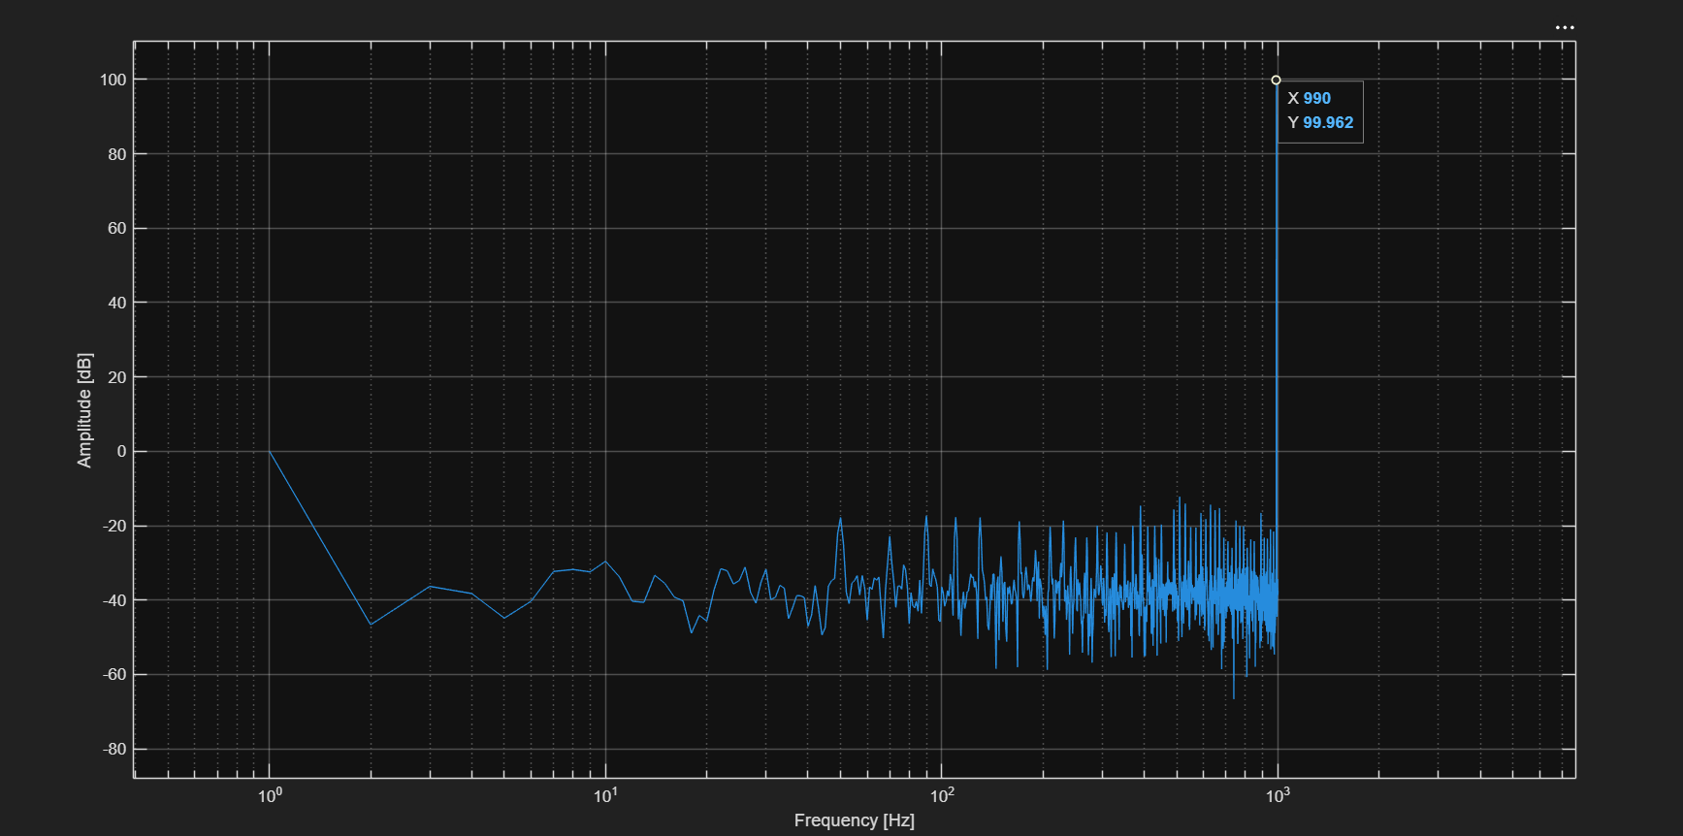
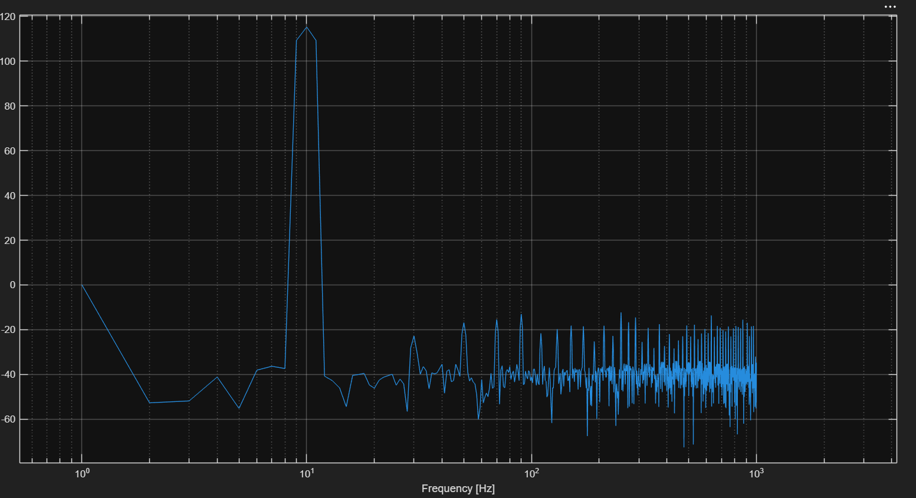
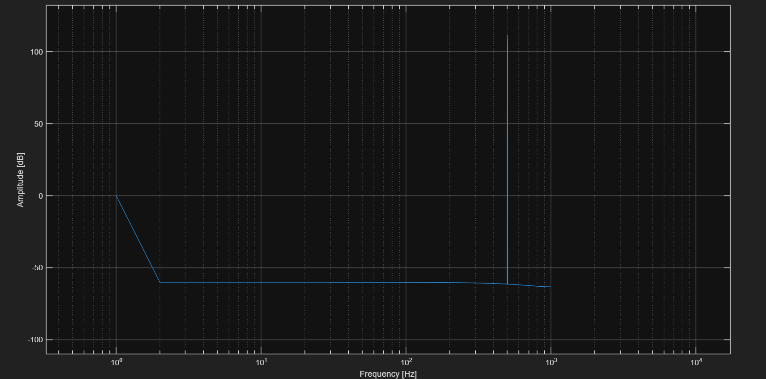
Task 2: CIC with FIR Droop Compensator
Architecture
The decimation is split into two stages:
- CIC, R = 512, N = 4, M = 1, GAIN_BITS = 1. This is the same module as Task 1. Output rate 8 kHz, with only about 0.9 dB droop at 990 Hz. Register width = 4 × 9 + 2 = 38 bits, output shift = 36 − 19 − 1 = 16.
- FIR compensator, decimate by 4. It runs at 8 kHz and produces the 2 kHz output.
Splitting the decimation leaves the FIR only a mild droop to correct, and the FIR also removes 1 to 4 kHz noise before decimation so it cannot fold into the band.

Parameter | Value
NTAPS | 63
AW | 6 (address width, ceil(log2 63))
Input width DW | 20 bits
Coefficient width CW | 18 bits, Q1.17 (FRAC = 17)
Decimation DEC | 4
Output width OW | 20 bits
Design method | Equiripple (firpm), amplitude following 1/|H_CIC(f)|
Passband / stopband edges | 950 Hz / 1150 Hz
Weights (pass / stop) | 1 / 100

The FIR is a serial multiply-accumulate unit. One multiplier is shared across all 63 taps, so one output costs 63 clock cycles, well inside the 2048 cycles available between outputs. Samples are stored in a circular buffer, and coefficients come from a generated ROM (fir_coef_rom.v). The accumulator is 45 bits wide (20 + 18 + AW + 1), so overflow is impossible. The result is rounded, shifted right by 17 and saturated to 20 bits.
Design trade-off: filter length
The record has only 2000 output samples and the filter starts empty, so a long filter spends much of the record in its start-up transient. A MATLAB model of the full chain, validated against Vivado (84.2 dB predicted vs about 85 dB simulated at 10 Hz for 255 taps), was used to sweep the design.
Results below are without GAIN_BITS:
NTAPS | 10 Hz (dB) | 990 Hz (dB)
511 | 63.9 | 58.3
255 | 84.2 | 74.5
127 | 104.3 | 88.7
63 | 110.9 | 97.7
31 | 109.6 | 108.2
SNR rises as the filter gets shorter, because transient loss outweighs the extra stopband depth. The submitted design uses 63 taps.
Results
Tone | Task 1 (dB) | Task 2 (dB) | Change (dB)
10 Hz | 116.78 | 116.70 | −0.08
500 Hz | 146.02 (periodic-record artifact) | 107.82 | not comparable
990 Hz | 101.37 | 104.64 | +3.27
The 990 Hz tone improves by 3.3 dB while the 10 Hz result is unchanged, as expected, since the compensator is flat at low frequency. The 500 Hz result now shows the real noise behavior: the FIR start-up transient breaks the exact periodicity that inflated the Task 1 figure. 107.8 dB is below the 122 dB quantization limit, as it should be for a realistic signal.
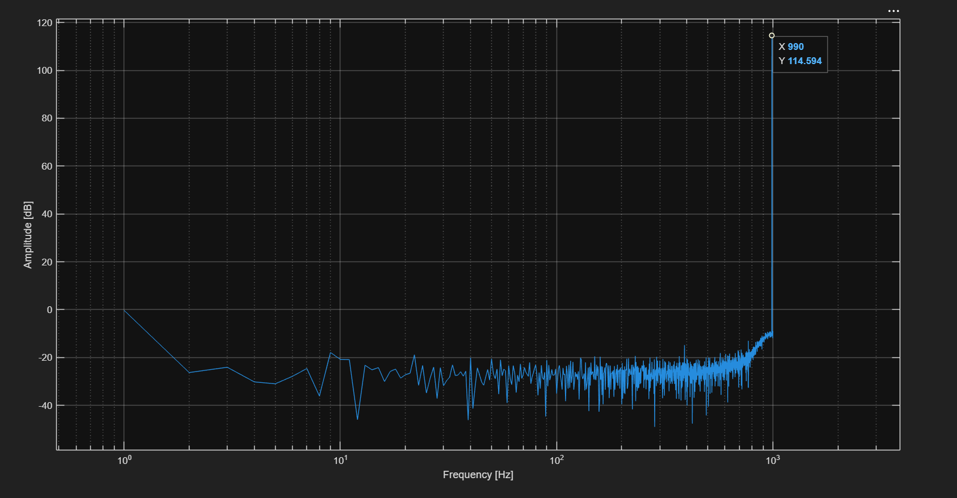
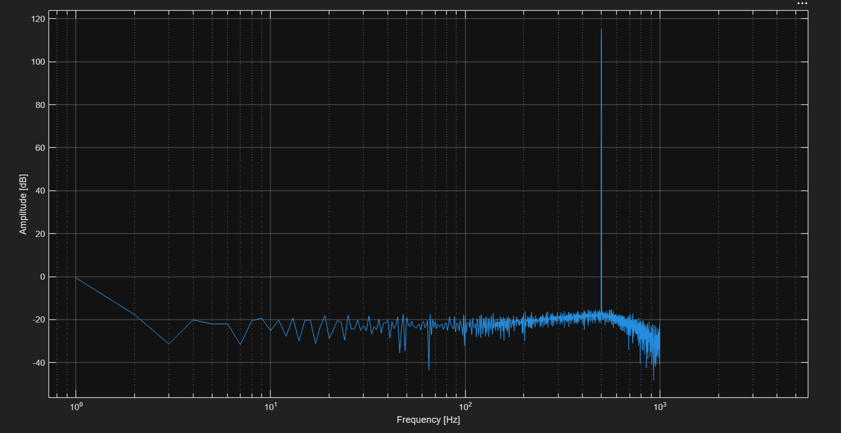

Verify
- Simulated in Vivado XSim with the 2 provided testbenchs, 4,096,026 input samples per tone, yielding 2000 output samples.
- SNR measured with the unmodified official fft_2.m (Hann window, 2000-point FFT, noise integrated to Nyquist).
- Output bus is 20 bits at the final stage, with rounding and saturation so no wrap-around can occur.
- Task 2's testbench writes the output on the FIR's valid signal, giving exactly one line per output sample.
Conclusion
The standalone 4th-order CIC (R = 2048) reaches 116.78 dB at 10 Hz and 101.37 dB at 990 Hz. The cascaded CIC (R = 512) plus 63-tap inverse-sinc FIR, decimating by 4, raises the 990 Hz result to 104.64 dB while keeping 10 Hz at 116.70 dB. The sweeps showed that for a 2000-sample record the filter length matters as much as the cutoff sharpness, since shorter filters spend less of the record in their start-up transient.

