**Student Number:ST10119186**

**Pathway: APDS7311**

**LECTURER: Isaac Leshaba**

**APDS7311 Final POE: Document**

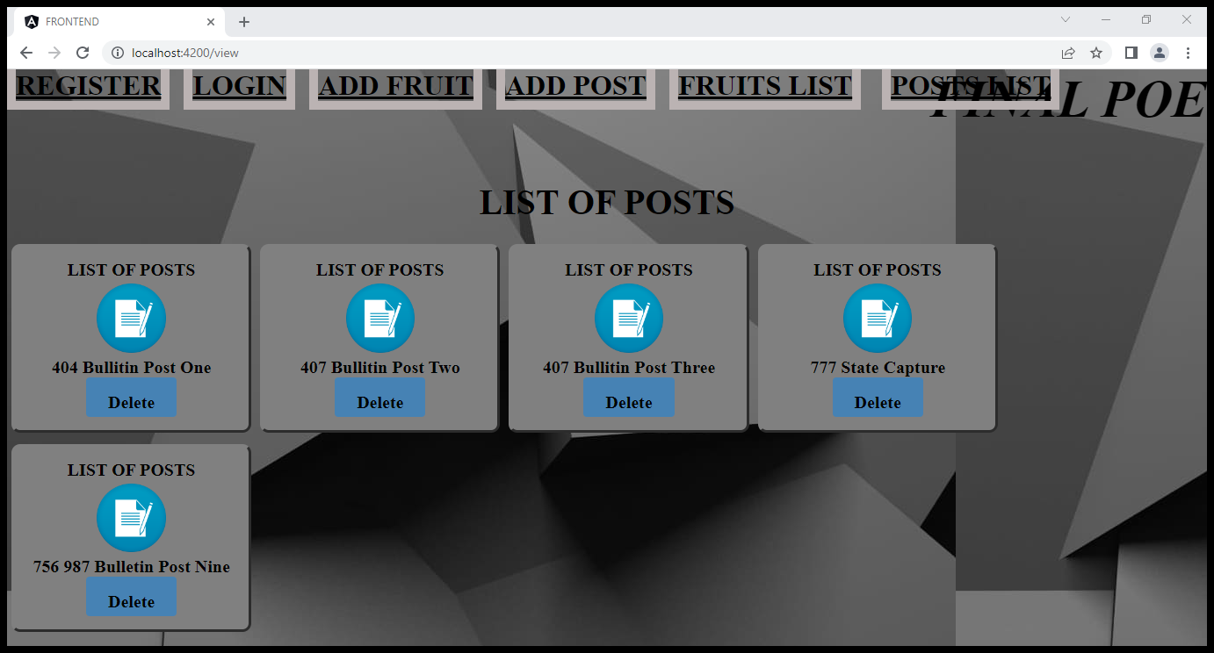

**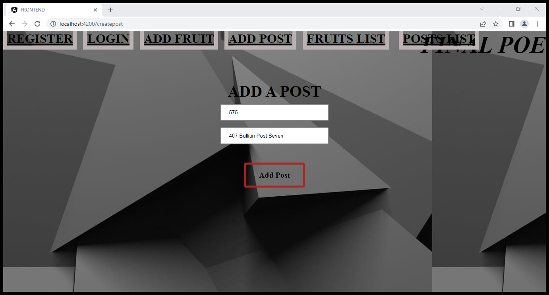  
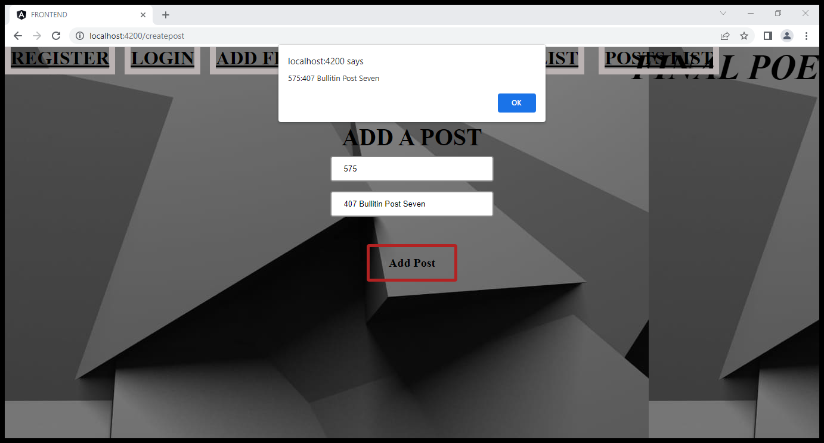**

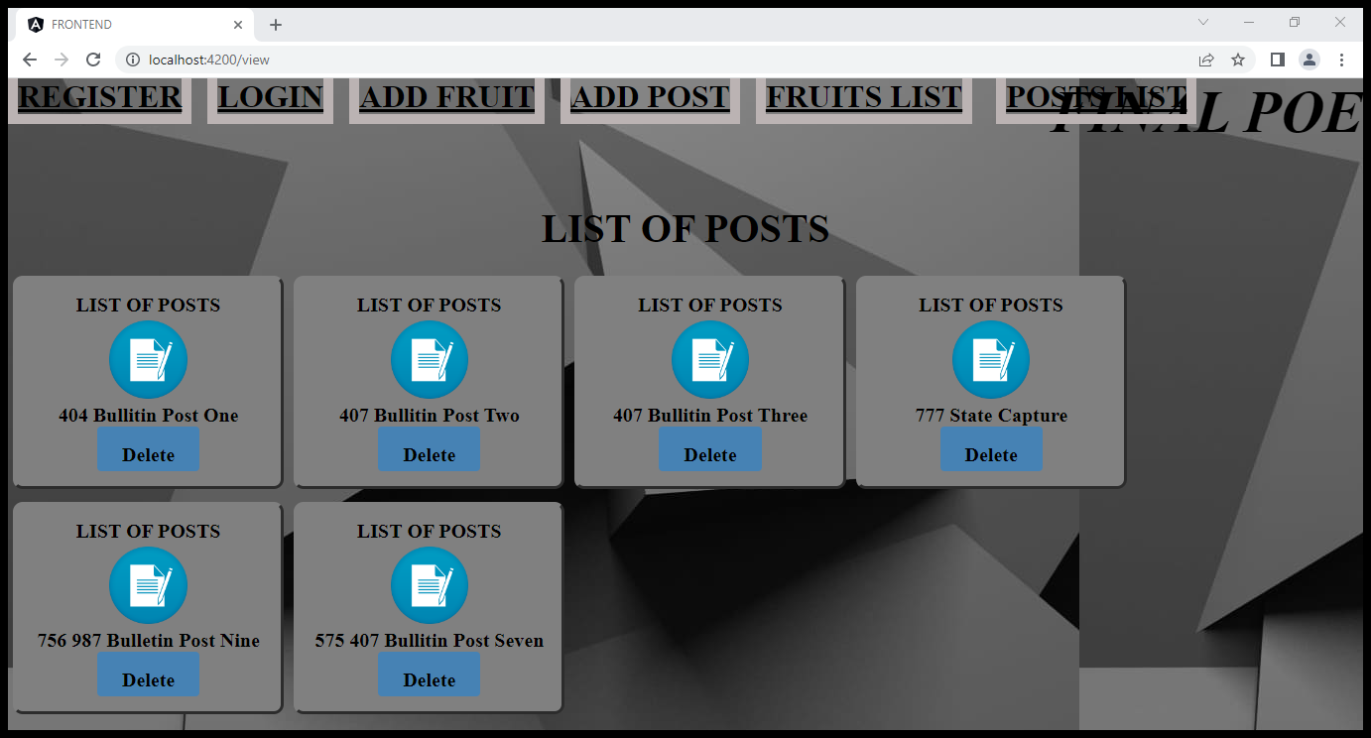

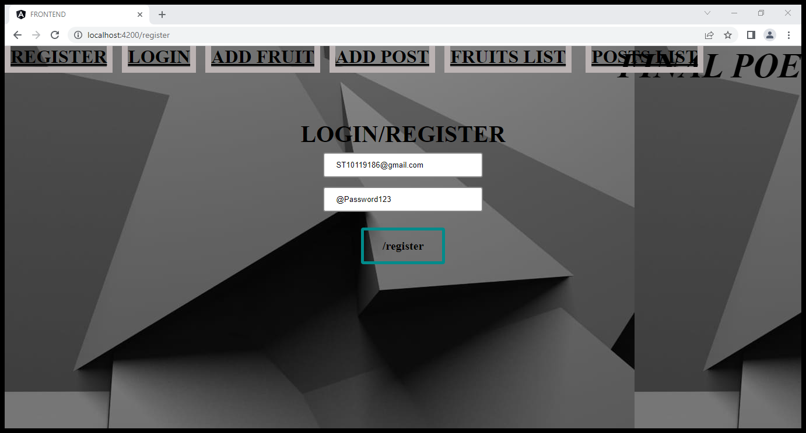

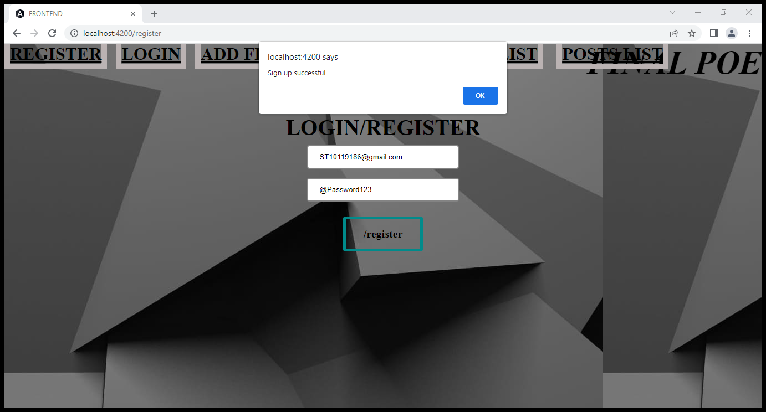

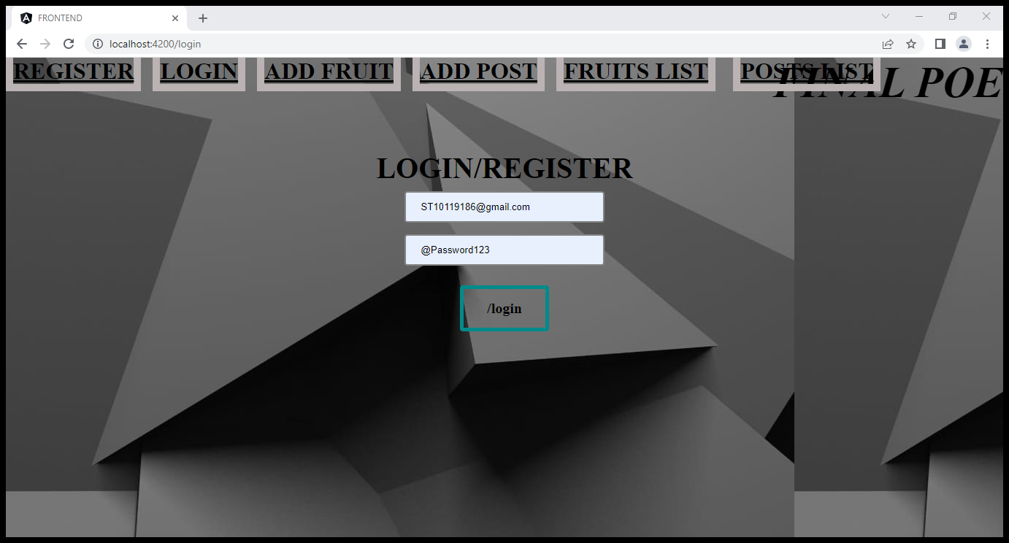

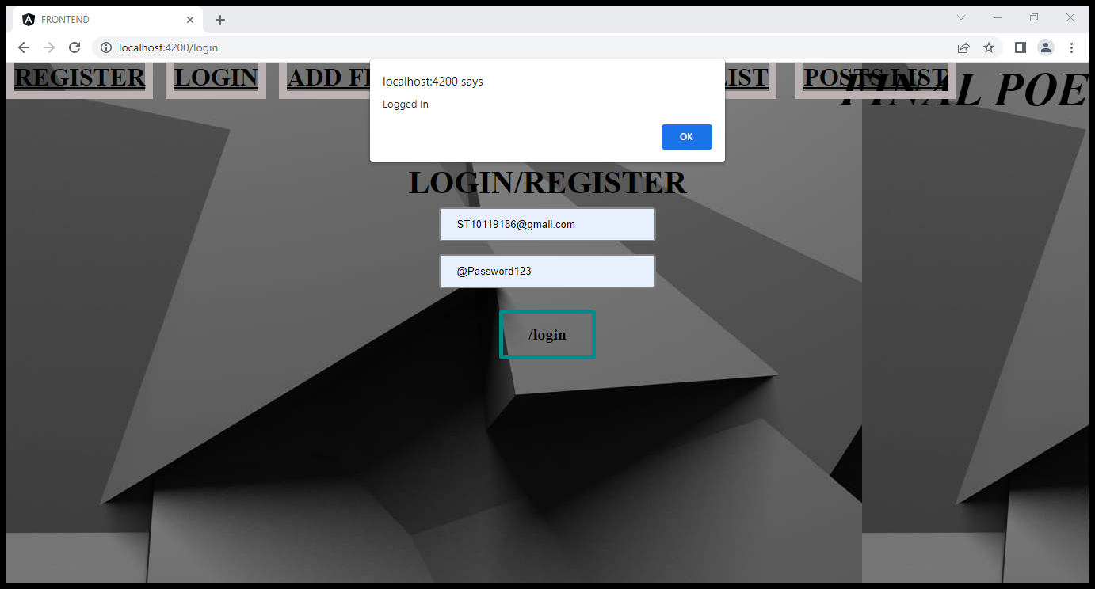

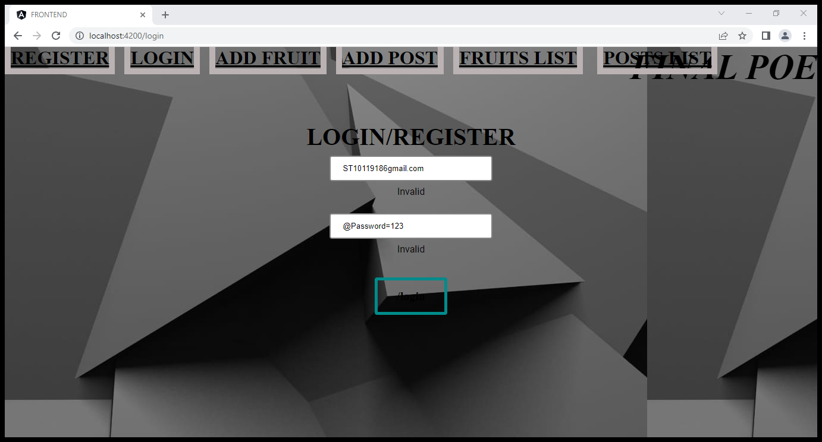

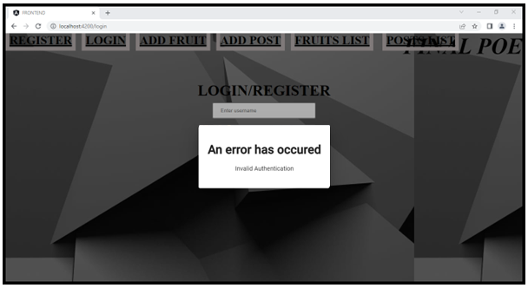

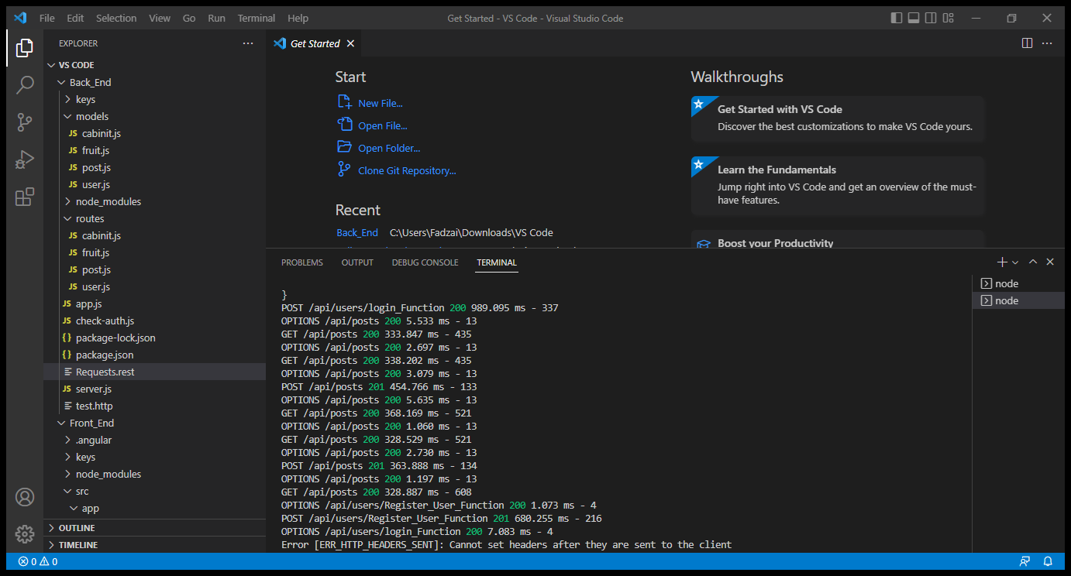

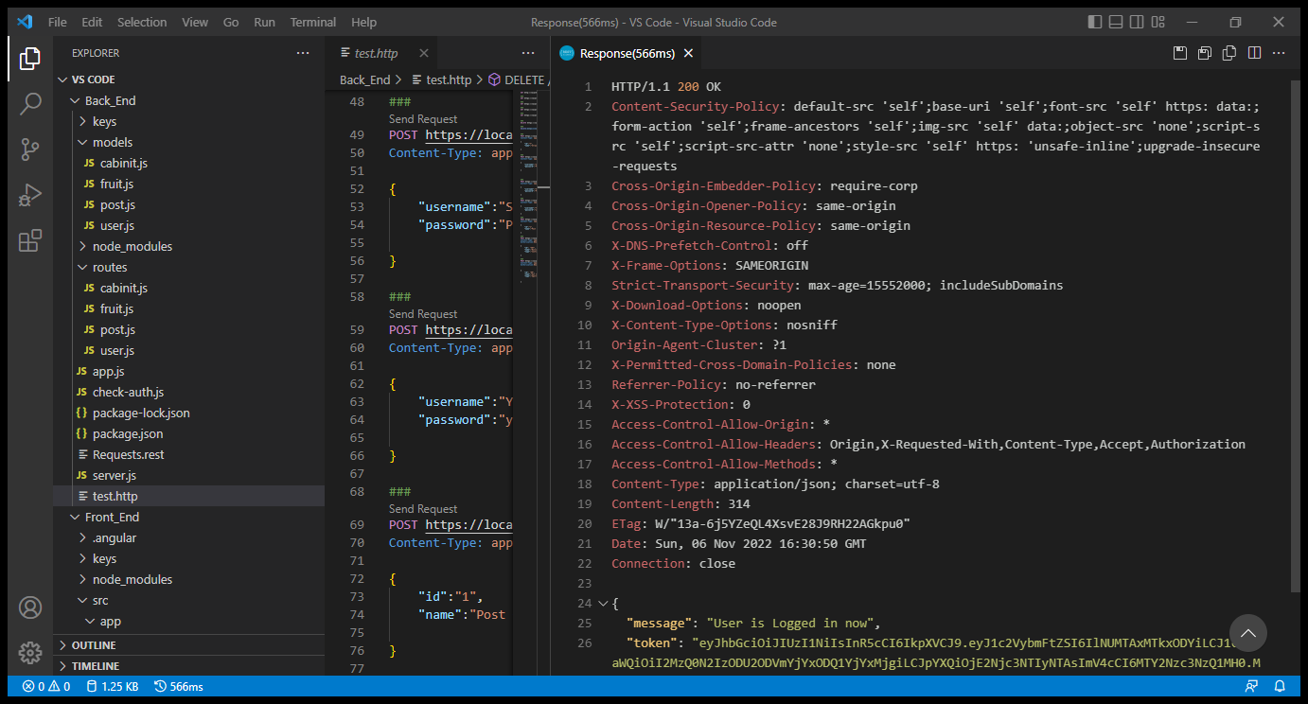

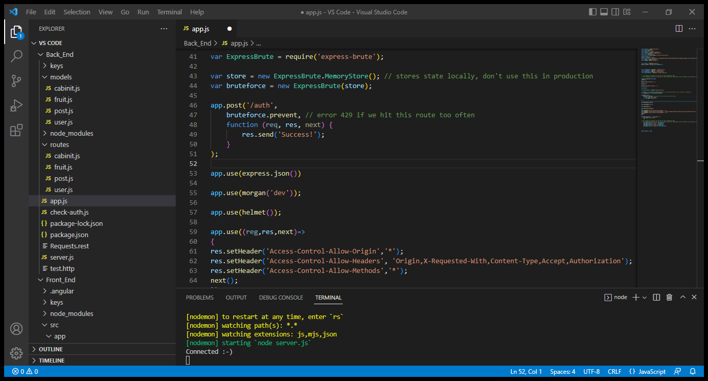

REFERENCE LIST

JWT Authentication Tutorial - Node.js. 2021. YouTube video, added by. Web Dev Simplified. [Online]. Available at: <https://www.youtube.com/watch?v=mbsmsi7l3r4> [Accessed 7 October 2022]

The Independent Institute of Education. 2022. Application development security APDS7311 Lab Guide 2022 (First Edition:2021)

Geeksforgeeks. 2022. Node.js Securing Apps with Helmet.js- Node.js [Online]. Available at: <https://www.geeksforgeeks.org/node-js-securing-apps-with-helmet-js/> [Accessed 7 November 2022]

npmjs. 2022. express-brute [Online]. Available at: <https://www.npmjs.com/package/express-brute> [Accessed 7 November 2022]

Geeksforgeeks. 2022. What is MORGAN in Node.js ? [Online]. Available at: <https://www.geeksforgeeks.org/what-is-morgan-in-node-js/> [Accessed 7 November 2022]