**Text of Speech**

**Thursday 5-6 Group 8 -- 21307149黄政菘**

Hello, everyone. My name is Janson. The theme of my introduction is **"The Social Value of Love".**

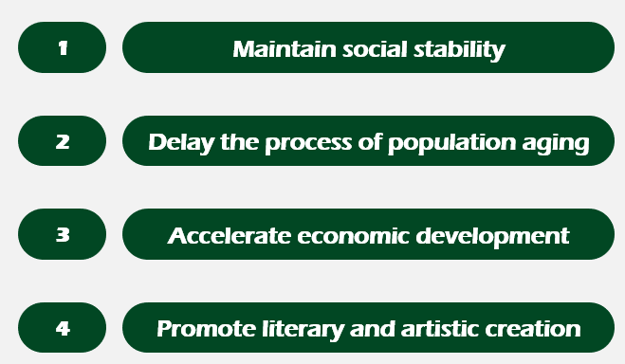

In my opinion, the social values of love mainly include the following four: **Maintain social stability, Delay the process of population aging, Accelerate economic development and Promote literary and artistic creation.**

**The first value to be introduced is to maintain social stability.** A couple in love can make a family happy. If all the couples in the society love each other, the whole society will be harmonious and stable. This explains the fundamental reason why our society needs love. This is also the basis for our society to exist.

In addition, love can also create a positive atmosphere. Research has shown that married people are happier than those who have never married or divorced. If everyone can be happier through love, then the society will be more positive and stable.

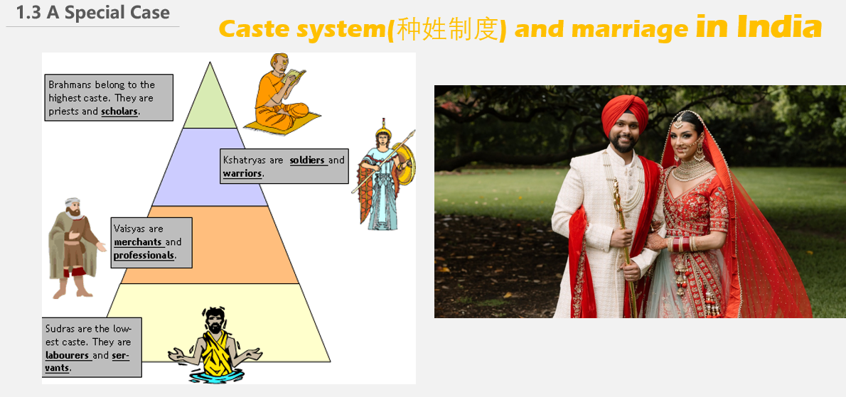

Next is a special example -- Caste system and marriage in India. Restricted by the caste system, Indians have very limited choices for marriage, so they should remain loyal to each other and manage their love with heart. At the same time, low caste wives are required to maintain absolute obedience to high caste husbands, so India has a relatively low divorce rate, a high overall happiness index and a relatively stable society.

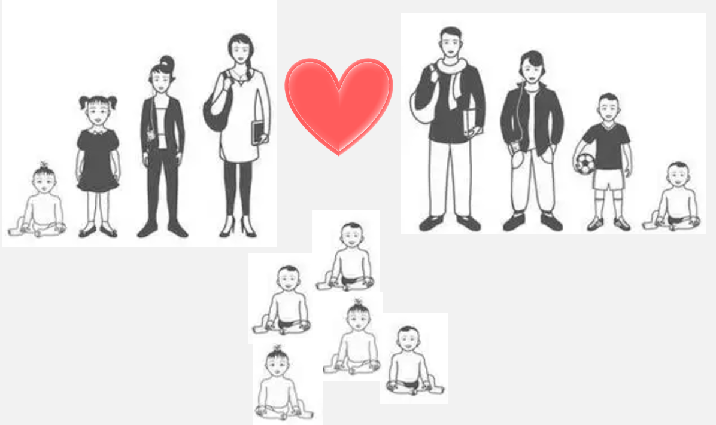

**The second social value of love is to delay the process of population aging.** As we all know, each of us will experience the process of aging. Too many people in society are aging, which will lead to the aging of the population. Therefore, we need to give birth to children through love, and bring them up to supplement more new labor force for the society to ensure the needs of social productivity.

At present, the pyramid of age structure in our country is static. This is a perfect structure. In this way, there will be no social pressure caused by too many new people, nor will it aggravate the problem of population aging.

**The third social value of love is to accelerate economic development.** As we all know, love costs a lot of money. Couples need to spend money on dating, giving birth to children, buying milk powder, buying a house, and providing school for their children. This has directly promoted economic development.

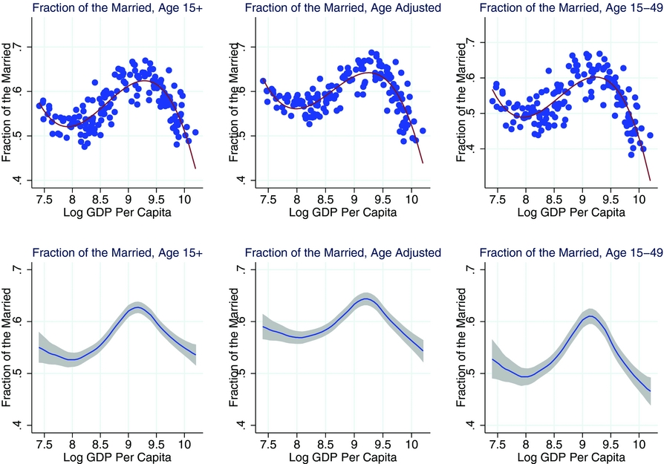

Foreign studies have found that the more people marry in a society, the faster the local GDP will grow. This proves the important value of love in promoting economic development with data.

**The last social value of love is to promote literary and artistic creation.** Love is the eternal theme of mankind and the inexhaustible source of artists' creation. For thousands of years, countless great love works have given people beautiful illusions and power to move forward.

The novel Gone with the wind, Jane Eyre and Pride and Prejudice all told about the heroine's yearning for beautiful love and expressed their unyielding spirit.

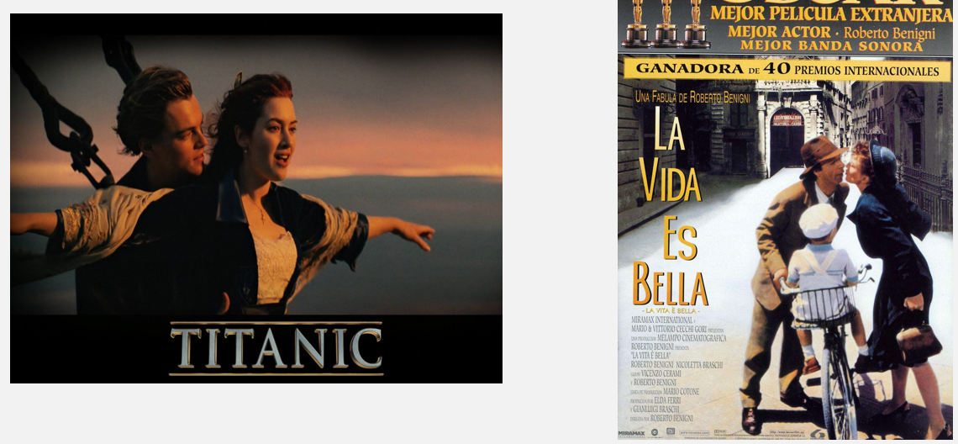

The film Titanic and Life Is Beautiful both tell about the beauty of love in the tragic context, making people cherish our love now.

**In a word, love gives us the power to live. Love is beautiful.**

This is the social value of love I want to introduce. My speech is over, thank you!

Reference:

[1] Moro, A., Moslehi, S., & Tanaka, S. (2017). MARRIAGE AND ECONOMIC DEVELOPMENT IN THE TWENTIETH CENTURY. Journal of Demographic Economics, 83(4), 379-420. doi:10.1017/dem.2017.18

[2] [Marriage Falls in China, Transforming Finances and Families - The New York Times (nytimes.com)](https://www.nytimes.com/2016/09/12/business/international/china-marriage-falls.html?_r=1&utm_source=Pinterest&utm_medium=Organic%20Social&utm_term=Marketing&utm_content=Article&utm_campaign=Marketing)

[3] [Are Married People Still Happier? | Institute for Family Studies (ifstudies.org)](https://ifstudies.org/blog/are-married-people-still-happier)

[4] Liu Xiaolan. An Analysis of the Indian Caste System [J]. Legal Expo, 2018 (19): 225-226