Learning activity 1

Evidence: Safety rules

Based on the image write safety rules into the format.

Unsafe house image.

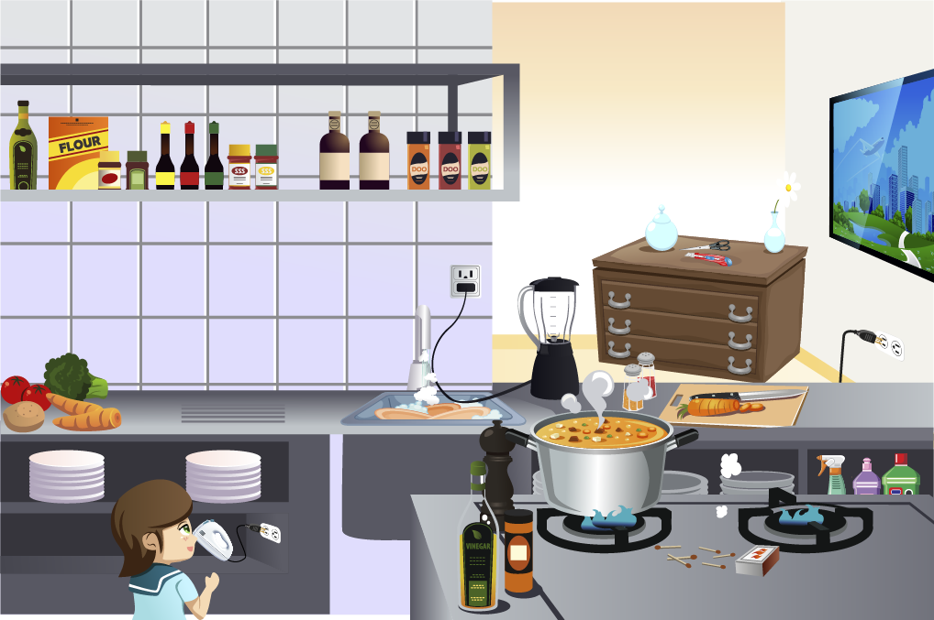

Fuente: SENA

- Example: keep children away from power cords. | 7.
2. | 8.
3. | 9.
4. | 10.
5. | 11.
6. | 12.

When you finish your work, send the file to your instructor through the platform as follows:

To do this evidence you should complete the following:

- Do the activities according to the instructions given in the file.
- Click on “Ver Evidencia” button.
- Attach the file which must be previously saved on the computer.
- Leave a comment for the instructor (optional).

Para desarrollar esta evidencia debe realizar lo siguiente:

- Desarrolle la evidencia siguiendo los pasos mencionados en el documento.
- Clic en el botón "Ver Evidencia".
- Adjuntar el archivo el cual debe estar previamente guardado en el equipo.
- Dejar un comentario al instructor (opcional).

Note: This evidence is an individual activity. Remember to check the learning guide in order to know if you have done all the assigned activities, know how to develop them and deliver them correctly.

Criterios de evaluación
Propone normas de seguridad teniendo en cuenta la estructura y el vocabulario requerido.

