**Calculator**

**By Braeden Scott**

**System Analysis and Design (INFO 1113) S10  
group Braeden Scott (100413491) , Simran (100404857), and Jobanpreet Singh (100402373)**

**November 30, 2021**

<https://sites.google.com/view/system-analysis-website/home> (Braeden’s Website)

<https://sites.google.com/view/system-analysis-2021-s10/home> (Simran’s Website)

[<https://sites.google.com/d/1Xle97F-o2jY9QdWeOzXDZNOqKG41wbil/p/1kNGKuEXhSvM8idFDn-A1bfehaOQPPSxi/edit>t](https://sites.google.com/view/letsworkout) (Joban’s Website)

[simran12@email.kpu.ca](mailto:s%69mra%6e1%32@%65ma%69l%2e%6bp%75.%63%61)

[braeden.scott@email.kpu.ca](mailto:%62r%61%65%64e%6e%2e%73%63%6ftt@%65%6d%61%69l.k%70u%2e%63a)

[jobanpreet.singh7@email.kpu.ca](mailto:%6a%6fb%61%6e%70%72ee%74%2e%73%69%6e%67%687@e%6d%61%69%6c%2ekpu%2e%63a)

**Table of Contents**

1. Project intro pg. 3
2. Use-Case diagram and Use-Case description pg. 4
3. Other things I did pg. 6
4. Websites pg. 7
5. Work cited pg. 8

**Project Intro**

The project we decided on using for this project is a calculator. Specifically, a calculator that is like the one you find when you look up calculator on google. This one though is not one found on the website it is instead a program that can be run on a computer. A use-case diagram and descriptions were made to show the functions of the project and how it works. Relational database tables were made to show the project’s data in a table. A class diagram was made to describe the classes and their relationships. A prototype was made to show how the project would work and look like when the user goes to use it. Project requirements were made to show the functional and non-functional requirements of the project.

**Use-Case diagram and Use-Case descriptions**

Use Case Diagram:

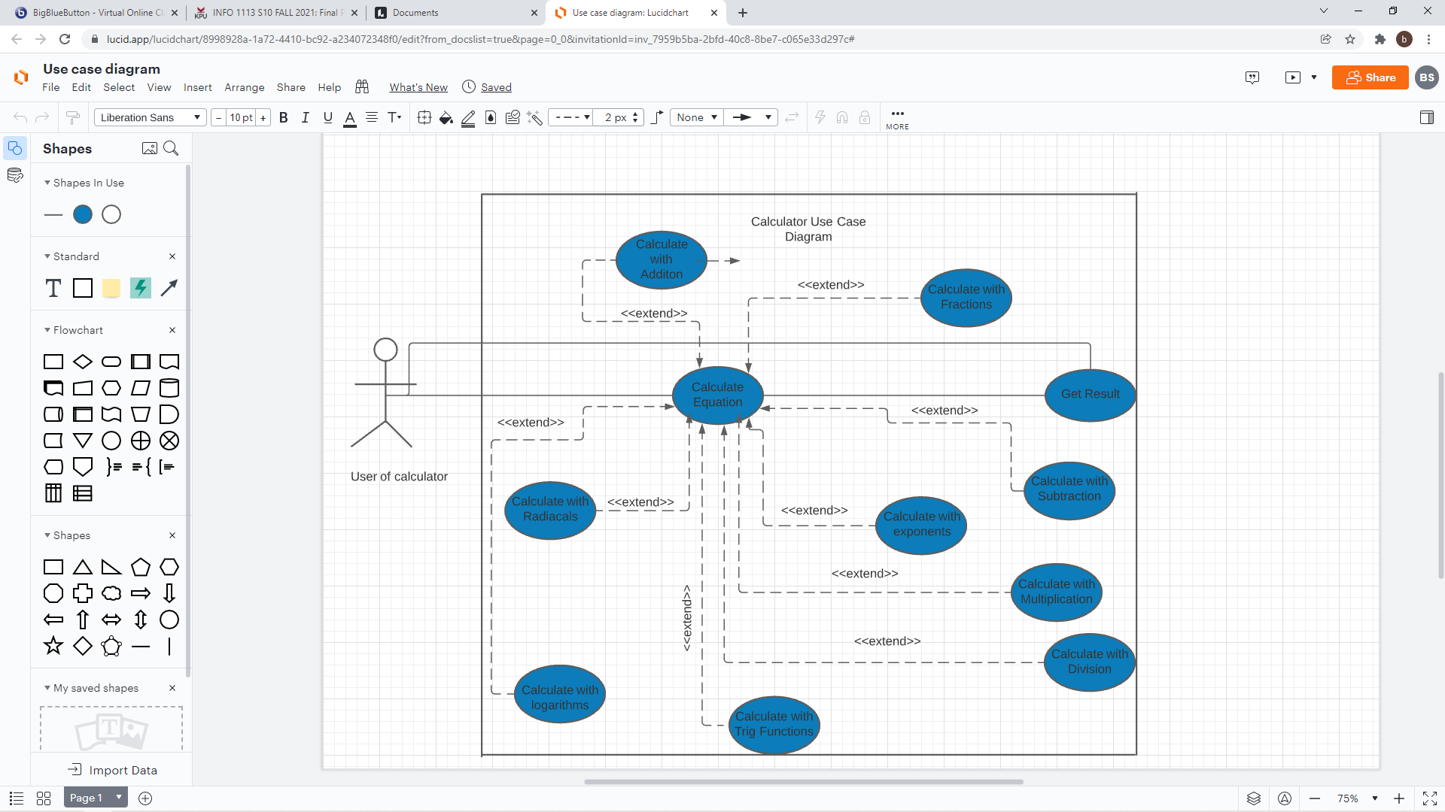

|  |
| --- |
| Use Case Title: Calculator |
| Primary Actor: User of the calculator |
| Level: Kite (summary) |
| Stakeholders: User of the calculators, Programmers |
| Precondition: User opens up the calculator program |
| Minimal Guarantee: Rollback of any failed calculation |
| Success Guarantee: The solution to the calculation |
| Trigger: Starting to type in an equation |
| Main Success Scenario:   1. User types in an equation. 2. User clicks the equal button. 3. Calculator calculates the equation. 4. Calculator gives result to the equation. |
| Extension:  1a. Error message appears because invalid equation was inputted.  1a1. User clicks the clear button and starts over.  1a2. User closes program.  2a. Too big of a number error appears.  2a1. User clicks the clear button and starts over.  2a2. User closes program.  2b. Too small of a number error appears.  2b1. User clicks the clear button and starts over.  2b2. User closes program.  3a. Calculation is interrupted.  3a1. Calculation is rolled back to the beginning. User starts over  3a2. Calculation is rolled back to the beginning. User closes  program. |

**Other Things I Did**

I created and managed the Trello site, I created the GitHub site, I also created the title page and table of contents for the group to use as templates for their reports. I edited some of the group’s paragraphs, helped with the project experience, and edited that. I created the zip file for the group and handed everything in. I helped everyone with things when they needed it. I edited the website the group website a bit also. I contacted everyone and created the group chat for everyone to discuss stuff in. I was pretty much the group leader for the project.

**Websites**

Trello: <https://trello.com/invite/b/obJed7rq/ca5ed56804526f8fa8ef333be4a9fa09/final-project>

GitHub group: <https://github.com/DarkShadowGithub/Group-Cs-Group->

Group’s Website: <https://sites.google.com/view/system-analysis-s10/home>

Braeden’s GitHub: <https://github.com/DarkShadowGithub/Group-C>

Simran’s GitHub: <https://github.com/Sim-09/Use-case-title>

Joban’s GitHub: <https://github.com/Aulakhjoban/Final-Project>

**Work Cited**

Petersen, C. (n.d.). *What is a software calculator?* What Is a Software Calculator? (with picture). Retrieved September 30, 2021, from <https://www.wise-geek.com/what-is-a-software-calculator.htm>.

Anonymous. (2021, August 16). *What is a calculator?* What is a Calculator? Retrieved October 1, 2021, from <https://www.computerhope.com/jargon/c/calc.htm>

Contributor, T. T. (2005, September 21). *What is calculator? - definition from whatis.com*. WhatIs.com. Retrieved December 2, 2021, from <https://whatis.techtarget.com/definition/calculator>.