PQ-KMS
Architecture of a Post-Quantum Key Management System
Reference implementation · Version 1.0
Prepared by Claude
2026-04-17

Executive summary
PQ-KMS is a Key Management System designed to resist cryptanalytic attacks from both classical and quantum computers. Today's public-key cryptography — RSA, Diffie-Hellman, and elliptic-curve schemes — rests on problems (integer factorization, discrete logarithms) that Shor's algorithm solves in polynomial time on a sufficiently large quantum computer. A KMS protecting secrets with long shelf life (compliance archives, healthcare records, credentialing authorities) must be engineered to survive that transition, and must also resist harvest-now-decrypt-later attacks where adversaries capture ciphertext today for future cryptanalysis.
PQ-KMS addresses this by combining NIST-standardized post-quantum primitives (ML-KEM-768, ML-DSA-65) with well-vetted classical primitives (X25519, Ed25519) in a hybrid construction. Both must fail simultaneously for security to break, and a tagged algorithm-suite identifier on every ciphertext enables clean migration to future standards without invalidating stored data.

At a glance
Classical primitives | X25519 (ECDH), Ed25519 (signatures), AES-256-GCM (AEAD)
Post-quantum primitives | ML-KEM-768 (FIPS 203), ML-DSA-65 (FIPS 204)
Hybrid construction | HKDF-SHA384 combining classical + PQ shared secrets
Root key protection | Argon2id passphrase stretching (64 MiB cost) + AES-256-GCM wrap
Key hierarchy | Passphrase → Wrapping key → Root KEK → per-key versions → data keys
Audit log | Hash-chained with hybrid-signed entries; tamper-evident
Crypto agility | 1-byte suite ID prefixes every ciphertext; old data stays decryptable after migration
Storage | SQLite (WAL mode); all sensitive fields AEAD-encrypted at rest
API | FastAPI with token-based auth; six scopes (admin / read / encrypt / decrypt / sign / verify)
Deployment | Single-container Docker Compose; liboqs built from source for PQC support

Threat model

Adversaries in scope
- A network attacker capable of passive interception and active manipulation of all API traffic.
- A future adversary with access to a cryptographically-relevant quantum computer, including one that stored encrypted network traffic captured today.
- An attacker who steals the SQLite database file by exfiltrating backup media or compromising the filesystem.
- A malicious insider with legitimate API credentials of limited scope attempting privilege escalation.
- An operator post-compromise who needs audit trails of all prior cryptographic operations to reconstruct what was accessed.

Adversaries out of scope
- An attacker with kernel-level code execution on the running KMS host while it is unlocked. Keys in memory cannot be protected from a fully compromised operating system. Hardware root-of-trust options are discussed in the hardening section.
- A successful side-channel attack on the underlying cryptographic libraries (cryptography, liboqs). Mitigation is library hygiene, not KMS design.
- Loss or disclosure of the operator passphrase. Recovery is deliberately impossible by design; Shamir secret sharing is the recommended mitigation.

Security goals
- Confidentiality of all managed keys and all payloads encrypted under them, even against an adversary with a large quantum computer.
- Integrity and authenticity of signatures, wrapped keys, and audit log entries.
- Forward secrecy across key rotations: compromise of key version N does not compromise versions N+1 or N−1.
- Tamper evidence on the audit trail: any retroactive edit to historical entries is detectable.
- Graceful migration to successor algorithms without breaking stored ciphertexts.

Runtime topology
The runtime is a stateless HTTP API backed by a single stateful component: the unlocked Root KEK held in process memory. Every other piece of state — managed keys, audit entries, tokens — is persisted in SQLite, but every sensitive field is AEAD-encrypted before it is written. An attacker who steals the database file without the operator passphrase recovers nothing but encrypted blobs.
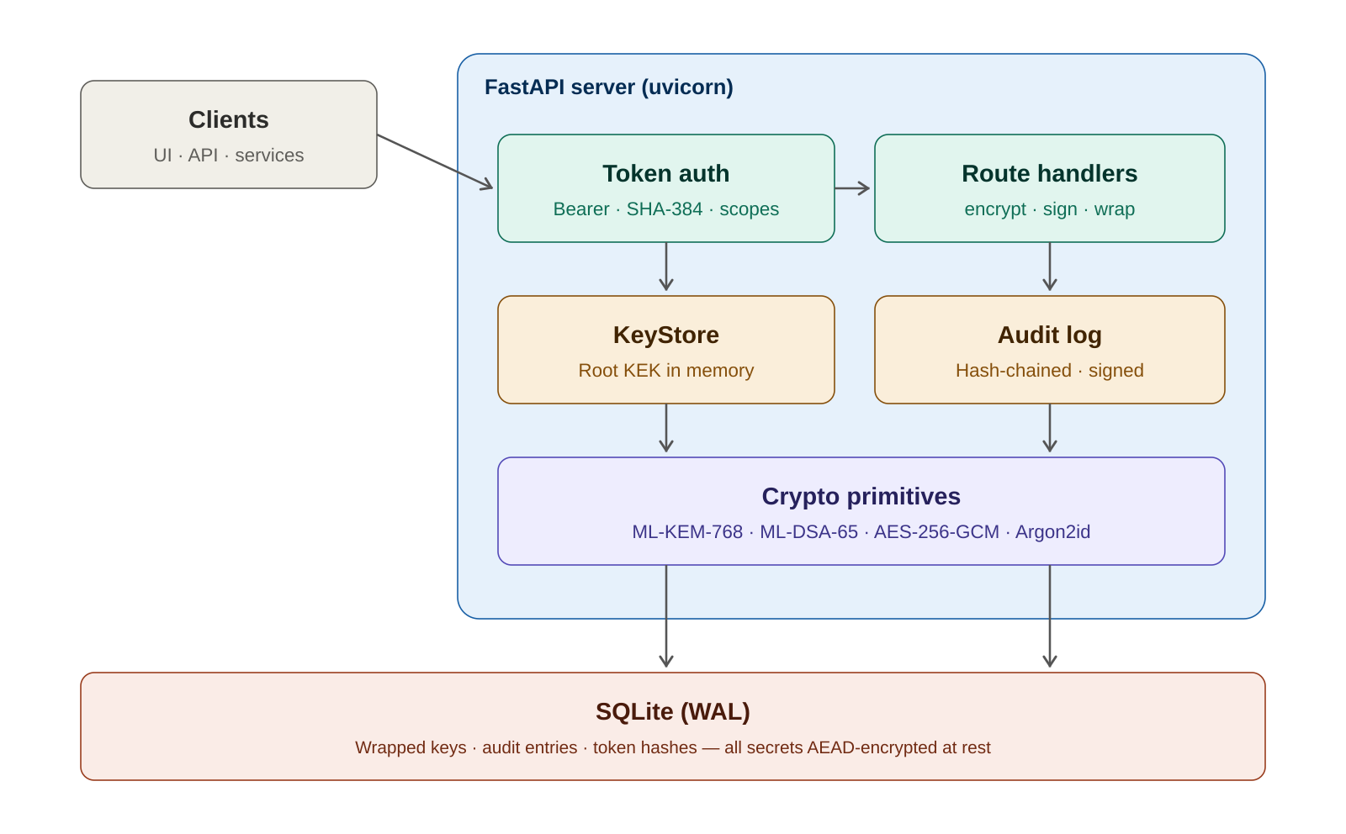
Figure 1. Runtime topology. Requests flow through the auth layer to route handlers, which use the KeyStore (holding the unlocked Root KEK in memory) and emit audit entries.

Request path
A client request first enters the auth layer, which extracts the bearer token from the Authorization header and looks up its SHA-384 hash in the tokens table. If the token is valid and its scope set includes the required scope for the requested route (or the admin scope, which satisfies any requirement), the request proceeds. Otherwise, it is rejected with 401 or 403.
Route handlers translate the HTTP payload into a call on the KeyStore. The KeyStore loads the relevant key version from SQLite, unwraps it in memory with the Root KEK, performs the cryptographic operation, and returns the result. Every state-changing operation appends a signed, hash-chained entry to the audit log before the HTTP response is returned.

Module boundaries
app/crypto/ | Hybrid KEM, hybrid signatures, AEAD, HKDF, Argon2id. Pure primitives with no KMS-specific state.
app/storage/ | SQLite schema, KeyStore (key hierarchy and envelope encryption), audit log.
app/api/ | FastAPI routes, token authentication, scope enforcement.
app/ui/ | Single-file HTML admin dashboard consuming the same API.
app/main.py | Bootstrap: initialize or unlock the KMS, create audit signing key on first run, print bootstrap admin token.

Key hierarchy
The central property of a well-designed KMS is that no two layers share fate. PQ-KMS uses a four-level hierarchy rooted in an operator passphrase and extended down to short-lived data keys.
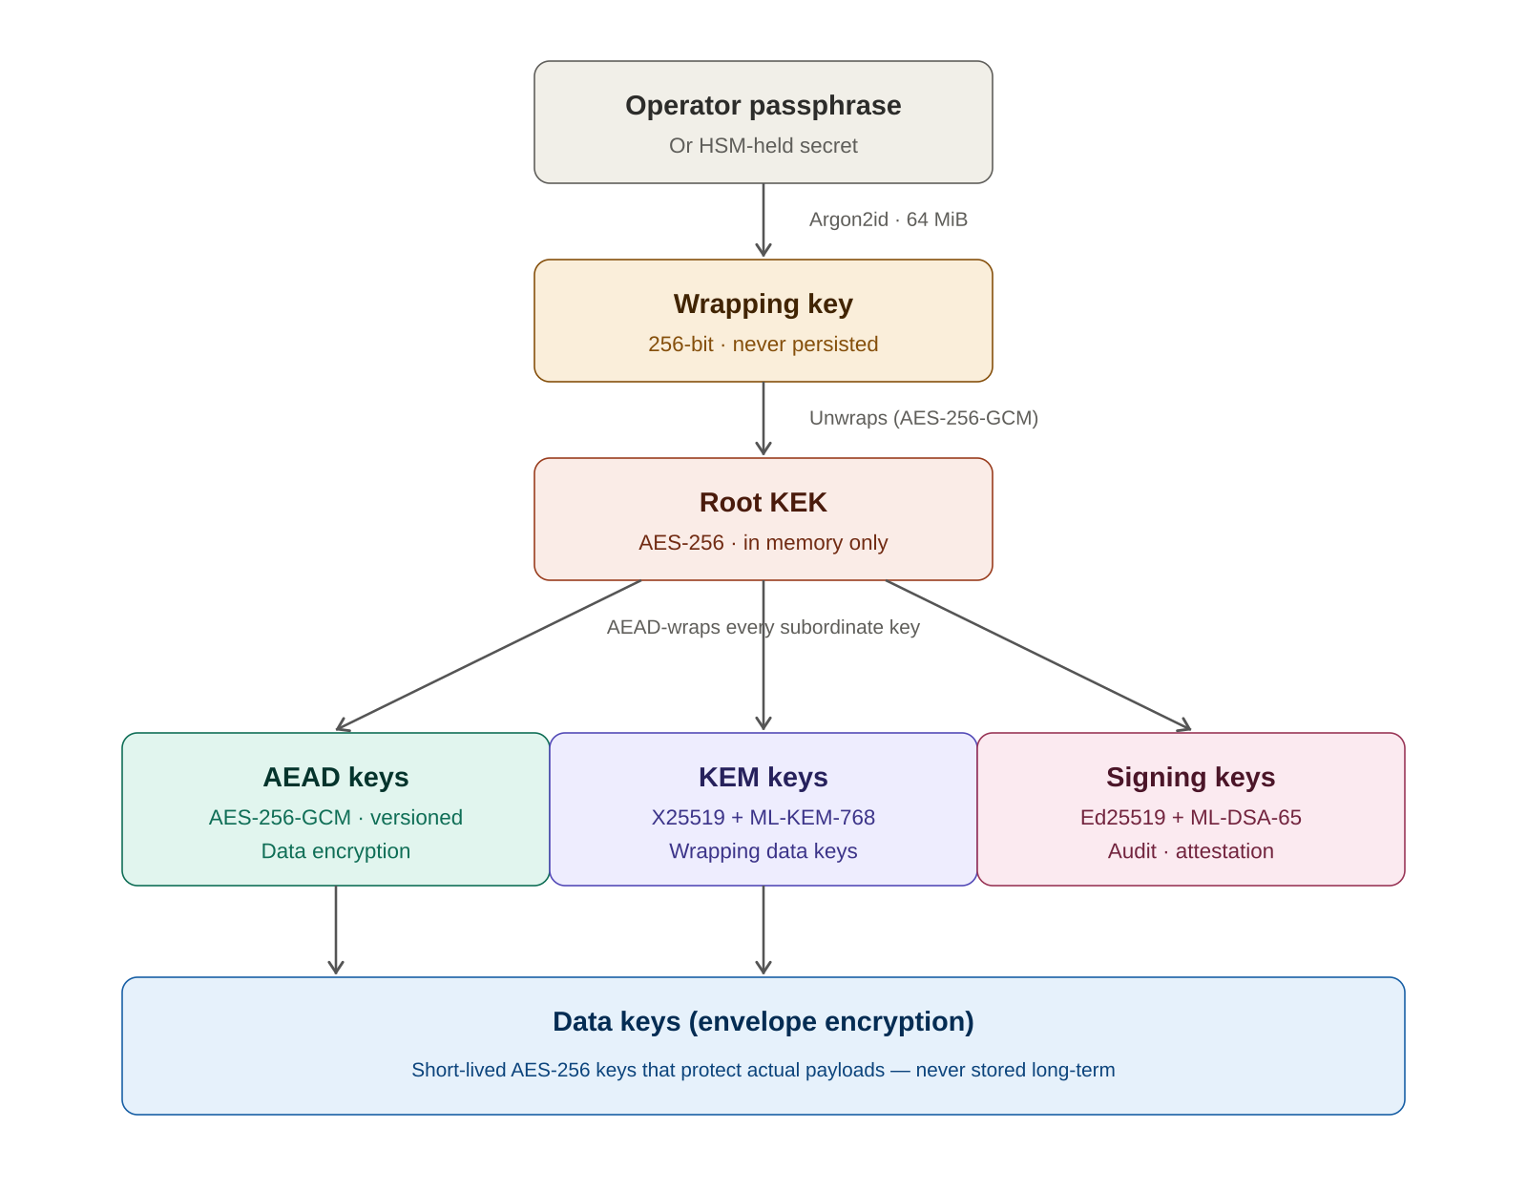
Figure 2. Key hierarchy. Argon2id stretches a passphrase into a wrapping key that decrypts the Root KEK. The Root KEK AEAD-wraps every managed-key version. Each managed key either encrypts data directly or wraps short-lived data keys.

Passphrase to wrapping key
On first bootstrap the operator provides a passphrase. It is not stored. Argon2id (time cost 3, memory cost 64 MiB, parallelism 4) stretches the passphrase, combined with a per-installation random salt, into a 256-bit wrapping key. The memory cost is the primary defense against offline brute-force if the SQLite file is ever stolen: an attacker's parallel GPU farm is severely constrained by the per-attempt memory requirement.

Wrapping key to Root KEK
The Root KEK is a randomly generated 256-bit symmetric key. It is AEAD-encrypted under the wrapping key using AES-256-GCM with a unique AAD string, and the ciphertext is stored in the kms_meta table. On startup the operator supplies the passphrase again; the KMS re-derives the wrapping key, decrypts the Root KEK into memory, and then holds it for the lifetime of the process. Restarting the service requires the passphrase again.
A separate passphrase-verification value (also AEAD-encrypted under the wrapping key) lets the KMS detect a wrong passphrase and refuse to boot rather than silently operating with a corrupted Root KEK.

Root KEK to managed keys
Every managed key — AEAD, KEM, or signing — has its private or symmetric material wrapped by the Root KEK before being written to SQLite. The wrap includes per-key AAD of the form pqkms/key/<key-id>/v<version>, which binds the ciphertext to its logical identity. An attacker who swaps one row's wrapped_secret with another's will see AEAD verification fail at unwrap time.

Managed keys to data keys
AEAD-type managed keys encrypt data payloads directly. KEM-type managed keys wrap short-lived data keys using the hybrid KEM construction described in the next section. In envelope-encryption usage, the data key is generated at random, used to encrypt a single payload, then thrown away — only its wrapped form persists. Compromise of one data key exposes only that single payload.

Versioning and rotation
Every managed key is versioned. Rotation creates a new version with fresh key material and marks the previous version's state as rotated. Encrypt and sign operations always use the current version; decrypt and verify operations look up the version embedded in the ciphertext or signature header, so ciphertexts produced under version N remain decryptable indefinitely after rotation to N+1. This gives clean key lifecycle management without breaking stored data.

Cryptographic design

Algorithm suites
Every wrapped secret and every ciphertext produced by PQ-KMS is tagged with a 1-byte algorithm suite identifier. The KMS currently supports the following suites:
Suite ID | Name | Use
1 | hybrid-x25519-mlkem768-aes256gcm | Hybrid KEM for wrapping data keys
2 | hybrid-ed25519-mldsa65 | Hybrid signatures
10 | x25519-aes256gcm (classical) | Fallback when liboqs unavailable
11 | ed25519 (classical) | Fallback when liboqs unavailable
20 | aes256gcm | Symmetric root-KEK wrapping of subordinate keys

Hybrid key encapsulation
When a KEM-type managed key is used to wrap a data key, the KMS runs two encapsulations in parallel and combines their shared secrets through HKDF.
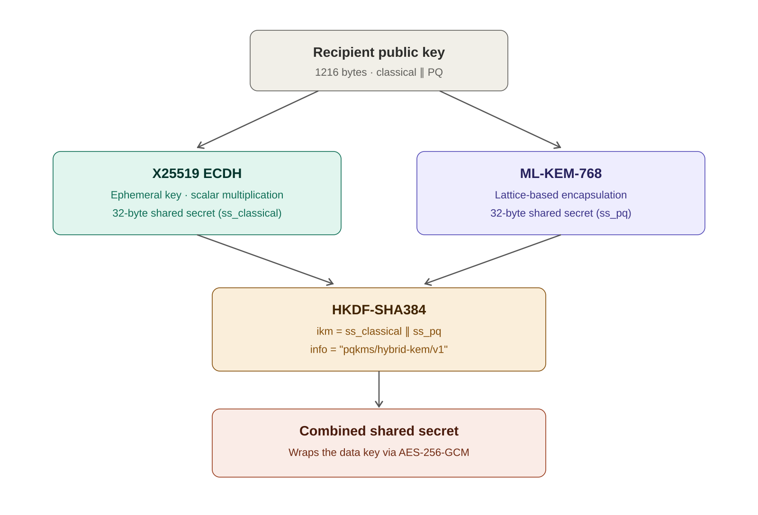
Figure 3. Hybrid KEM flow. The recipient's public key carries both an X25519 portion and an ML-KEM-768 portion. The sender performs both encapsulations and combines the two 32-byte shared secrets via HKDF-SHA384, producing a single wrapping key that is secure as long as either primitive remains unbroken.
The security property is that an attacker must break both X25519 and ML-KEM-768 to recover the combined secret. A future quantum computer running Shor's algorithm breaks X25519 in polynomial time but does not solve the module-lattice problem underlying ML-KEM. Conversely, an unexpected classical cryptanalysis of ML-KEM (as happened catastrophically to SIKE in 2022) leaves X25519 providing the guarantee. HKDF-SHA384 ensures the two shared secrets cannot be attacked independently: a single bit of difference in either input produces an unpredictable output.

Hybrid signatures
Signing keys hold both an Ed25519 keypair and an ML-DSA-65 keypair. A signature is the concatenation of both signatures under both algorithms:
[2 bytes: suite][4 bytes: classical_sig_len][classical_sig][pq_sig]
Verification requires both signatures to validate. This is a stronger property than the KEM combiner: no key-derivation step is involved, so the two signatures are genuinely independent. An adversary must simultaneously forge Ed25519 (requires solving the discrete log on curve25519) and ML-DSA-65 (requires solving module-lattice problems). This is why hybrid signatures are used for the audit log, where forgery of any entry must remain infeasible for the expected archival lifetime of the system.

Ciphertext envelope format
Every AEAD ciphertext returned by PQ-KMS has a fixed wire format that carries enough metadata for the system to route decryption correctly years later, even after multiple algorithm migrations.
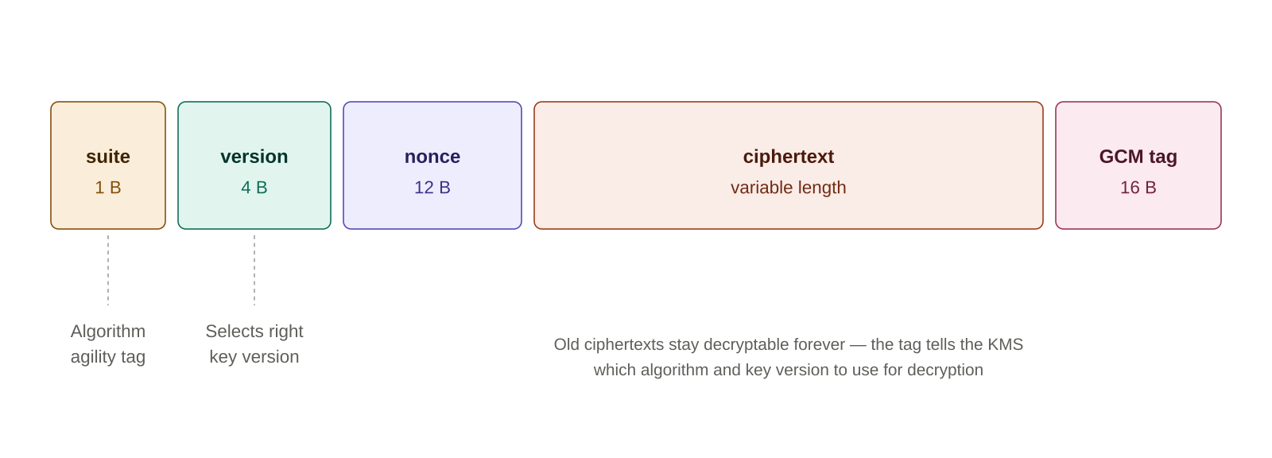
Figure 4. Ciphertext envelope format. The leading 1-byte suite identifier and 4-byte key-version field together tell the KMS which algorithm implementation and which key version to use for decryption.
The concrete benefit is that when a successor PQ KEM is standardized in, say, 2031, an operator can add suite ID 3 to PQ-KMS, start new encrypt operations under the new suite, and leave existing ciphertexts alone. Both generations of ciphertext coexist in the same database. Decryption of an old ciphertext reads the 1-byte prefix, selects the corresponding code path, and succeeds.

Audit log
The audit log is an append-only table where each entry contains:
- A timestamp, actor identifier (hashed token prefix plus scopes), action name, target object ID, and JSON detail payload.
- A reference to the previous entry's hash.
- A SHA-384 hash of (previous-hash || this-entry-payload).
- A hybrid Ed25519+ML-DSA-65 signature over that hash, signed with a keypair that was itself AEAD-wrapped under the Root KEK.
Tampering with any historical entry — for example, editing a detail field after the fact — changes that entry's computed hash and therefore invalidates the signature on it and breaks the hash-chain linkage to every subsequent entry. The /api/v1/audit/verify endpoint walks the entire log and returns the sequence number of the first bad entry, if any.
Because the audit signing key is wrapped under the Root KEK, the log cannot be forged offline by an adversary who only has the database file. It also cannot be forged by an adversary who has runtime access but not the signing key material, because the private key is unwrapped freshly on each signature operation and not persisted in a decrypted form anywhere.

API surface
All endpoints live under /api/v1/ and require a bearer token with appropriate scope.

Endpoints
Method + Path | Required scope | Purpose
GET /status | read | Service health, PQ availability
POST /keys | admin | Create a new managed key (aead | kem | sig)
GET /keys | read | List all keys and current versions
POST /keys/{id}/rotate | admin | New version; old stays decryptable
POST /keys/{id}/encrypt | encrypt | AEAD encrypt payload
POST /keys/{id}/decrypt | decrypt | AEAD decrypt; routes on version in header
POST /keys/{id}/sign | sign | Produce hybrid signature
POST /keys/{id}/verify | verify | Verify hybrid signature
POST /keys/{id}/wrap | encrypt | Hybrid-KEM-wrap a data key
POST /keys/{id}/unwrap | decrypt | Reverse of wrap
GET /audit | read | Recent audit entries
GET /audit/verify | admin | Walk the chain; report first bad entry
POST /tokens | admin | Issue a new scoped token (shown once)
DELETE /tokens/{id} | admin | Revoke

Authentication
Tokens are opaque strings of the form pqkms_<prefix>_<secret>. The server stores only their SHA-384 hashes; raw tokens are returned exactly once at creation time. A bootstrap admin token is printed to container logs on first launch. All further tokens are created through the API and can be scoped narrowly — for example, a per-service token with only the decrypt and read scopes.

Deployment

Container
The Dockerfile is a multi-stage build. The builder stage compiles liboqs from source with only the ML-KEM-768 and ML-DSA-65 algorithms enabled (OQS_MINIMAL_BUILD), minimizing binary size and attack surface. The runtime stage installs the shared library and the Python application. The container runs as a non-root user with no added capabilities and no privilege escalation.

Configuration
PQKMS_PASSPHRASE | The operator passphrase that unlocks the Root KEK. Required. In production, inject from a secrets manager; never bake into the image.
PQKMS_DATA_DIR | Directory for SQLite storage. Default /var/lib/pqkms. Should be mounted on persistent, backed-up storage.
Port 8080 | HTTP API and admin UI. Put behind a TLS-terminating reverse proxy in production; consider PQ-hybrid TLS via OpenSSL 3.5+.

Testing
The reference implementation ships with 24 unit tests covering AEAD roundtrips, hybrid KEM encapsulation/decapsulation, hybrid signature verification, passphrase unlock, rotation behavior, audit tamper detection, and token auth. A self-contained end-to-end integration test spawns the server, drives every endpoint, and verifies the full request-response cycle under real PQ algorithms. All tests pass on the reference container.

Production hardening
The reference implementation is designed to be correct and auditable first, and to leave specific hardening choices to the operator. The following are recommended before exposing the system to real secrets.

Key material
- Move the Root KEK into a hardware security module. AWS CloudHSM, Thales Luna, and Entrust nShield all ship PQC firmware as of 2025. The KMS can continue to use the same key hierarchy with the HSM providing unwrap operations in place of the in-memory Root KEK.
- Split the bootstrap passphrase using Shamir secret sharing (for example, 3 of 5) across multiple operators, so no single individual can unlock the system alone.
- Do not commit the passphrase to environment variables in long-lived orchestration files. Inject at startup from a secrets manager that supports audit logging of reads.

Transport
- Front the service with TLS 1.3. Use a reverse proxy (Caddy, nginx, Envoy) configured with the X25519MLKEM768 hybrid key exchange group to defend against harvest-now-decrypt-later attacks on the transport.
- Require client certificates (mTLS) for internal service-to-KMS traffic. Rotate client certificates on a short cycle.

Access control
- Issue narrowly-scoped tokens per service or per human role. Use the decrypt scope sparingly; revoke unused tokens promptly.
- Add IP allowlisting and rate limiting at the reverse-proxy layer.
- Enable session-based UI authentication rather than storing admin tokens in browser session storage.

Observability and recovery
- Mirror the audit log to an append-only external transparency log or WORM storage bucket in real time. The internal hash chain is tamper-evident, but off-site replication makes tampering detectable even if the host is fully compromised.
- Back up the SQLite database regularly. Backups are safe to ship off-box because all secrets are AEAD-encrypted, but treat them as hostile in recovery scenarios — verify integrity on restore.
- Document an unlock-recovery procedure that does not depend on any single operator. Losing the passphrase means losing every managed key. This is a deliberate property, not a bug.

Glossary
AEAD | Authenticated Encryption with Associated Data. A symmetric encryption mode providing both confidentiality and integrity. PQ-KMS uses AES-256-GCM.
Argon2id | Memory-hard password-hashing function. Used to stretch the operator passphrase into a wrapping key while resisting GPU-accelerated brute force.
Ed25519 | Classical elliptic-curve digital signature scheme. Fast, small signatures; not quantum-resistant on its own.
Envelope encryption | Pattern where a short-lived data key encrypts a payload and is itself encrypted (wrapped) under a longer-lived key. Compromise of one data key exposes only one payload.
HKDF | HMAC-based Key Derivation Function. Used here to combine classical and PQ shared secrets into a single key.
HSM | Hardware Security Module. Tamper-resistant device that performs cryptographic operations without exposing key material to the host.
Hybrid construction | Combining classical and post-quantum primitives such that breaking one alone does not compromise the whole.
KEK | Key-Encryption Key. A key whose only job is to encrypt other keys.
KEM | Key Encapsulation Mechanism. Public-key primitive that establishes a shared secret between two parties, replacing traditional key exchange in a post-quantum setting.
ML-DSA-65 | Module-Lattice-based Digital Signature Algorithm (FIPS 204). NIST-standardized quantum-resistant signatures, originally Dilithium.
ML-KEM-768 | Module-Lattice-based Key Encapsulation (FIPS 203). NIST-standardized quantum-resistant KEM, originally Kyber.
Shor's algorithm | Quantum algorithm that breaks RSA, ECDH, ECDSA in polynomial time. The reason a post-quantum KMS is necessary.
X25519 | Elliptic-curve Diffie-Hellman on curve25519. Classical primitive used as the non-PQ half of the hybrid KEM.

