

Edwyn Mckie

1901418

CMP203- Graphics Programming



Contents

Brief Interpretation 3

Disclaimer 4

User Controls 4

Lighting 5

Geometry 7

Camera and Interaction 11

Hierarchical Modelling 13

Advanced Features 14

Wireframe mode 15

Classes 16

Models 17

Textures list 19

Reference list 22

# Brief Interpretation

I have been asked to create a scene to demonstrate key techniques in graphics programming. The application will be a recreation of the fairy tail guild from the anime. by using openGL I am going to recreate the guild by using procedural rendering and vertex arrays. Lighting will be used in the scene to make it more realistic. There will be some interactivity from the player that will allow them to control the day-night cycle.

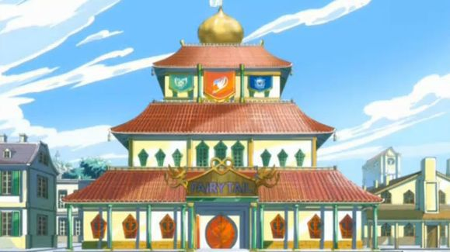

# Disclaimer

The copyright for fairy tail and all objects associated with it are with Hiro Mashima the original creator. There is a vast amount of fan made content online for fairy tail and that is what I have used as the sources for my textures and models. However the entire fairy tail series is the property of Hiro Mashima

# User Controls

|  |  |
| --- | --- |
| **Function** | **Key** |
| Move camera | W,A,S,D |
| Rotate camera | I,J,K,L,U,O |
| Camera mode | F,T |
| Change camera | 0,1,2,3,4,5 |
| Wireframe mode | R |
| Pause day/night cycle | P |
| Quit the application | Esc |

# Lighting

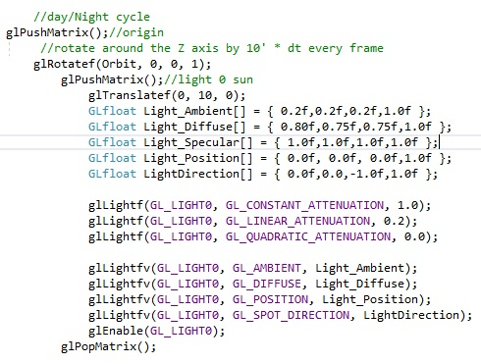In the scene I have used 8 lights, to light key locations in the building.

Light 0 is the sun and has a slight red glow.

Light 1 is the moon and is positioned 20 units away from the sun, it produces a weaker light with a slight blue tint. Both the sun and moon are point lights. Both the sun and the moon orbit the guild hall and are rotated by 10 degrees * dt; every frame unless the player presses "P"

Lights 2 through 4 are directional lights they emit a white light in the centre if each floor in the guild. they are disabled before rendering the next floor in order to prevent the light from affecting the higher floors and walls.

C:\Users\User\Downloads\code.jpg

Light 5 is placed in the basement beneath the guild and is a point light that emits purple light around the surrounding area. it produces the following effect. The image on the left is the example it was based on.

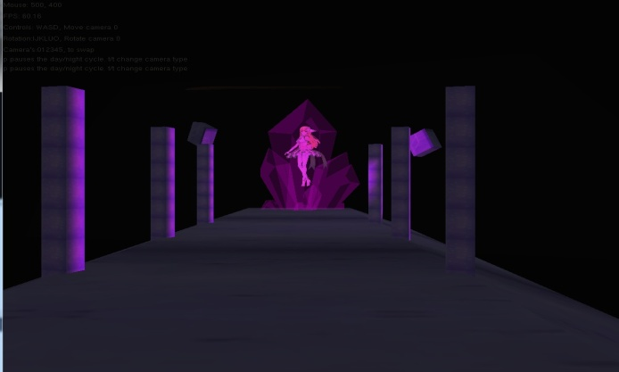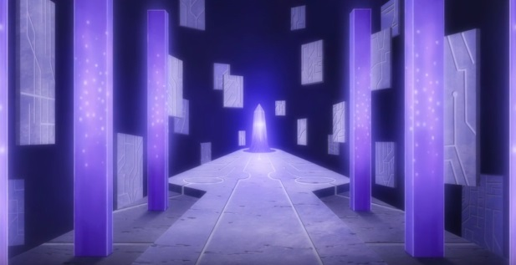

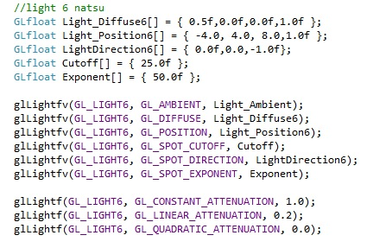Light 6 is placed under Natsu and is a spot light emitting red light upwards in the Y axis. This is used to match the characters design in the anime as well as to show how good the models are.

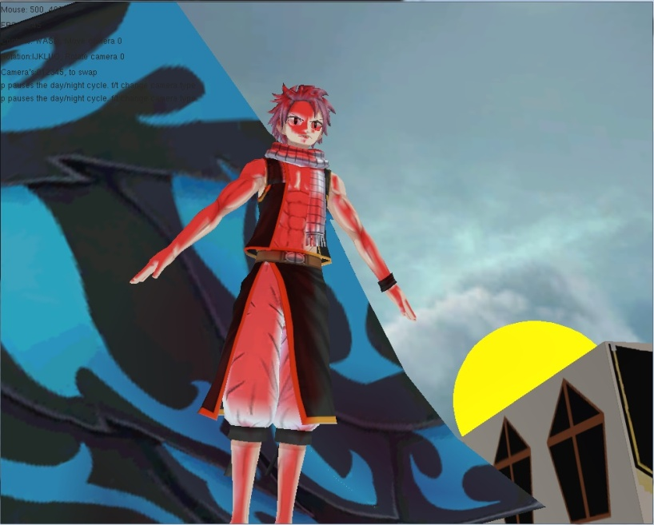

Light 7 is placed under Gray and is also a spot light that is emitting a deep blue light upwards in the Y axis. This is used to match the characters magic in the anime as well as to highlight his position in the world.

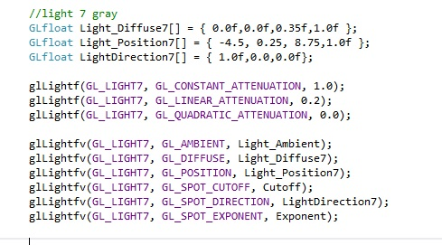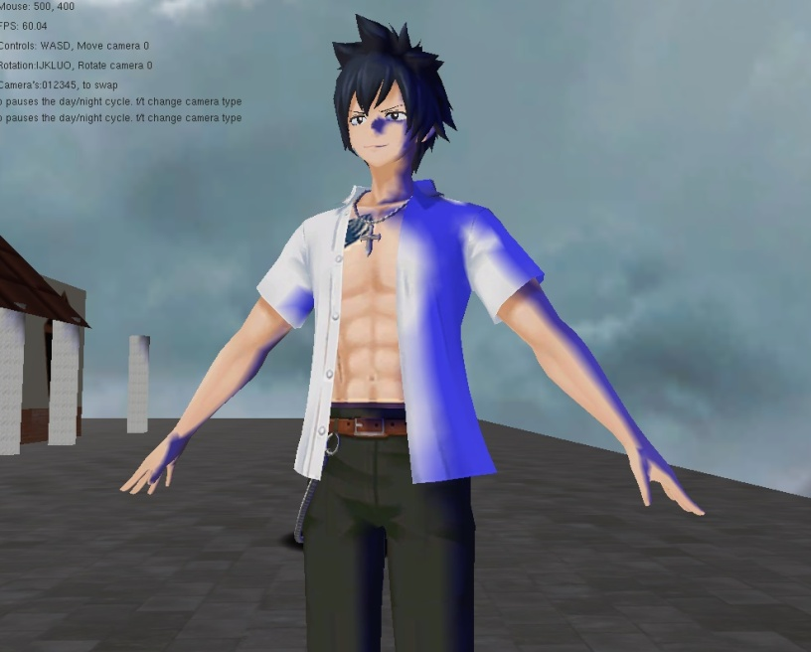

# Geometry

To create my scene I have hand coded the basic geometry and used a nested for loop in order to iterate through the grid and draw my building.

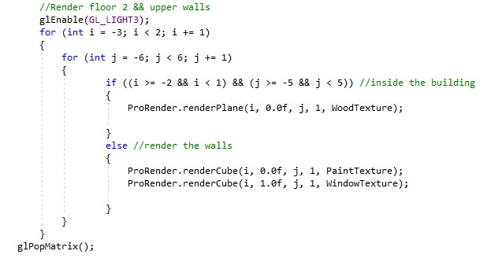

I have used this method in order to create the scene as this makes aligning objects in my scene much easier to set up in the grid style, I originally used a single cube and scaled it to match the size of the wall however the texture was distorted. In order to fix this I decided to focus on using the nested loops method. All the objects drawn around the building are created using this approach and are all textured and lit correctly.

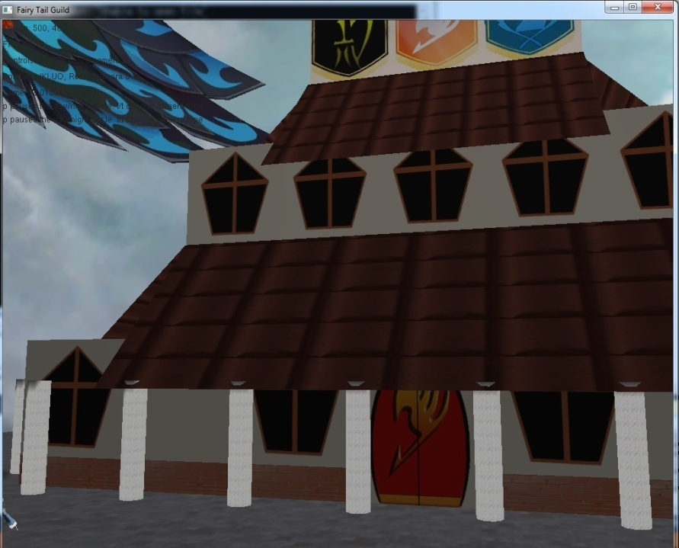

I have used a combination of cubes, planes and cylinders. I have used these to try and match the exterior of the building as well as to highlight the effect of the lighting in the scene. By using these in conjunction with the nested loop I am able to get a very nice effect and look on the building as a whole. It does not affect the speed of the game either as it continues to run at a constant 60 frames per second.

Depth sorting is used in the skybox and when drawing the objects inside the building as you do not see the models in the building when looking from outside.

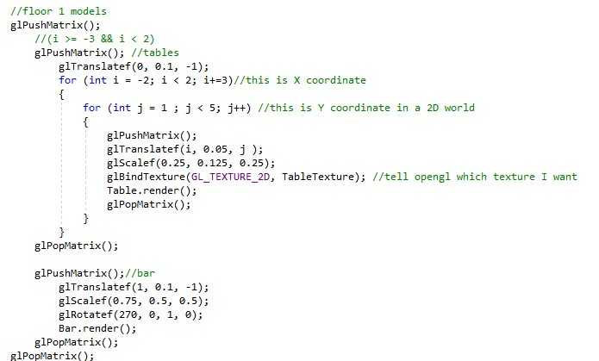Transparency is used in the skylight for the top floor of the building, rendered in the correct order to avoid issues with looking through objects. The window is used to allow the camera to see the golden sphere on the top of the guild that is also rendered using the procedural renderer.

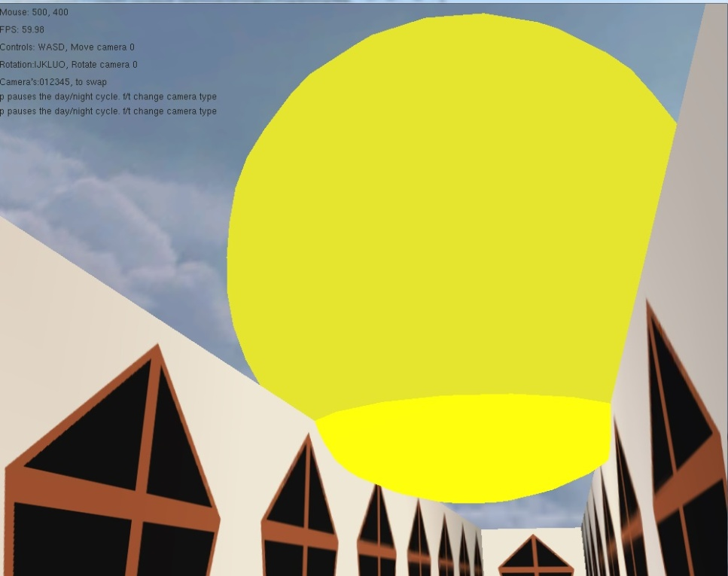

This is the code for generating the cylinders that are used around the building as well as in the basement, the code draws a disk at either end and then proceeds to calculate the position of the vertices based on how many segments we want. for each segment of the cylinder it will create a quad, made of two triangles. and connect it to the previous one it does this all the way around until it completes the circle,. It then iterates up by 1 and repeats this process. It will continue to do this until it has reached the amount of segments that the user has requested.

# C:\Users\User\Downloads\code.jpg

In the scene I have used vertex arrays to create the cube under Natsu's foot and the cube used for the basement. These cubes are then scaled to look correctly in the scene. They also have been textured appropriately to match the area they are being placed in. I have placed it in the floor and expanded it to create a blacked room to use as the basement.

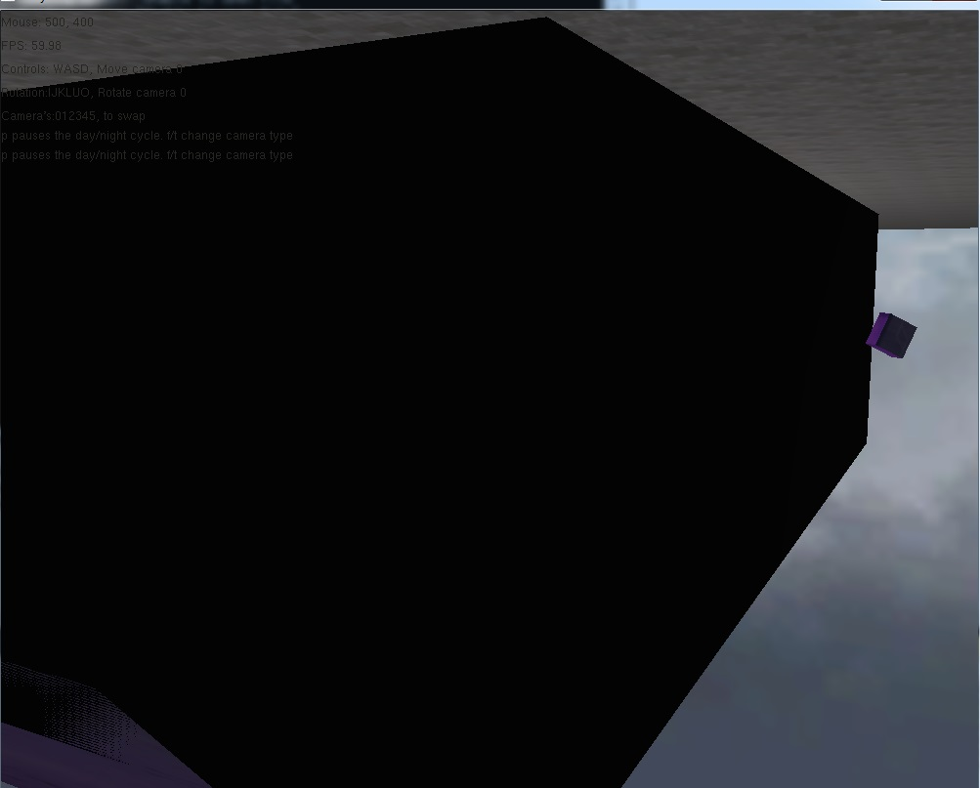

# Camera and Interaction

The scene has a moving camera, called Camera0. This camera can be freely moved via the player controls.

There are multiple camera's in the scene. These are used to highlight the key rooms in the guild. camera 5 rotates and looks around the room it is placed in. This is done to show off how the guild looks inside and to demonstrate how we can move the camera scene via code.

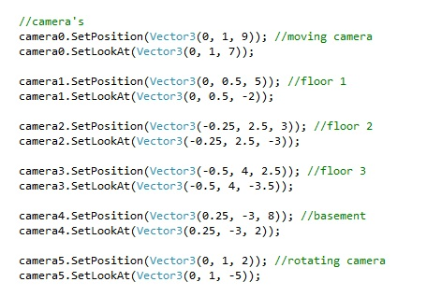

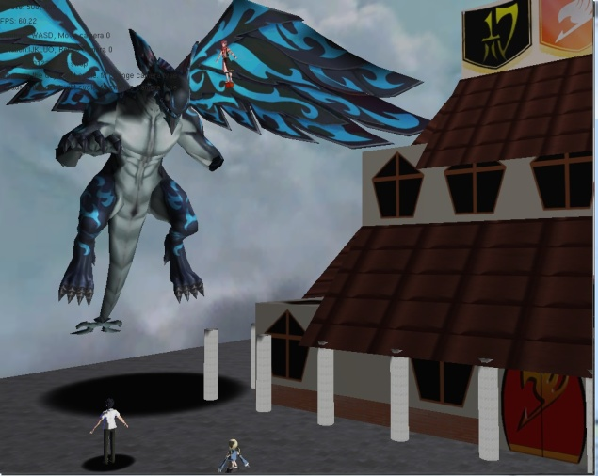The player can change from camera to camera by using the number keys of 0 to 5. only camera's 0 and 5 have moment applied as they are used to show the look of each floor.

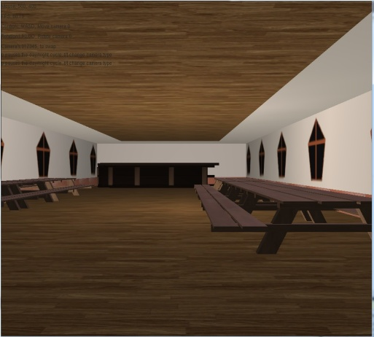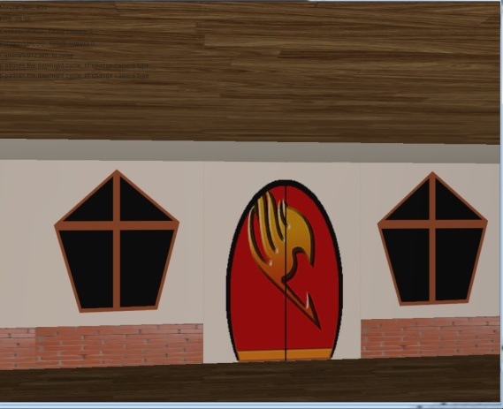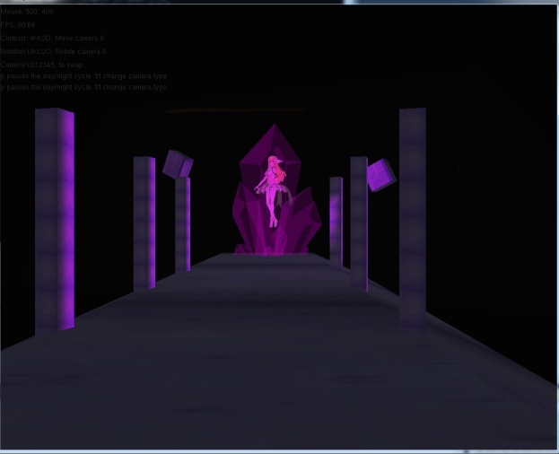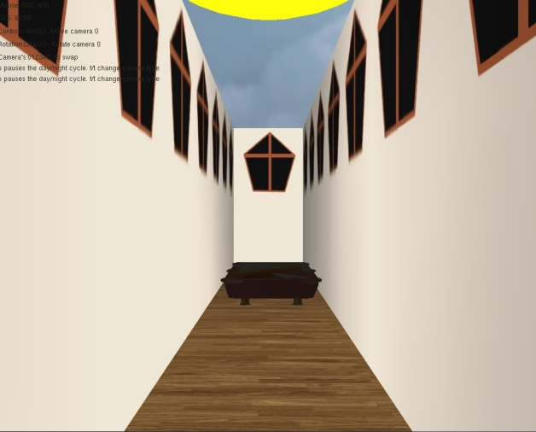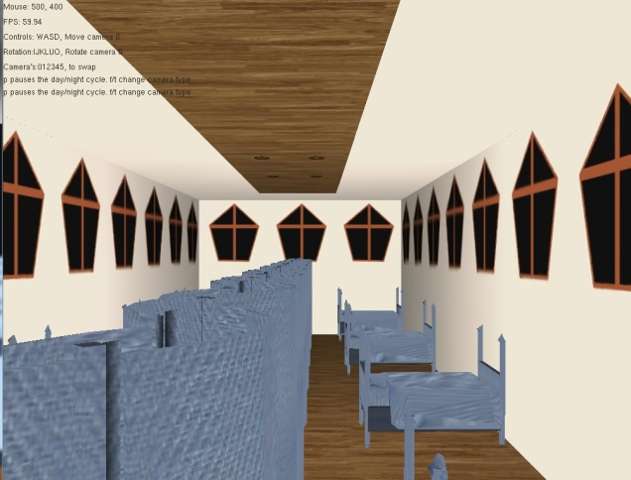

# Hierarchical Modelling

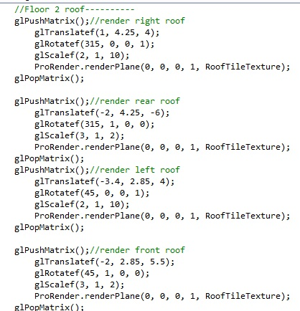I have used a hierarchy everywhere in my scene as I used it to control where each floor is drawn and positioned as well as by using it to allow me to position objects correctly in the scene.

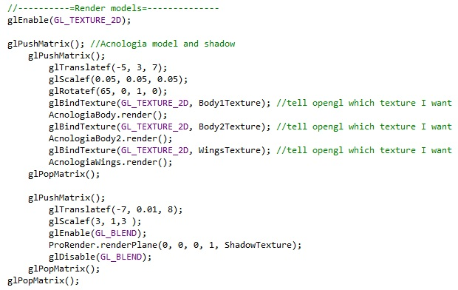I have also used it to position the shadows correctly for my models as they allow me to move the shadow down in the Y axis to align with the models feet correctly.

# Advanced Features

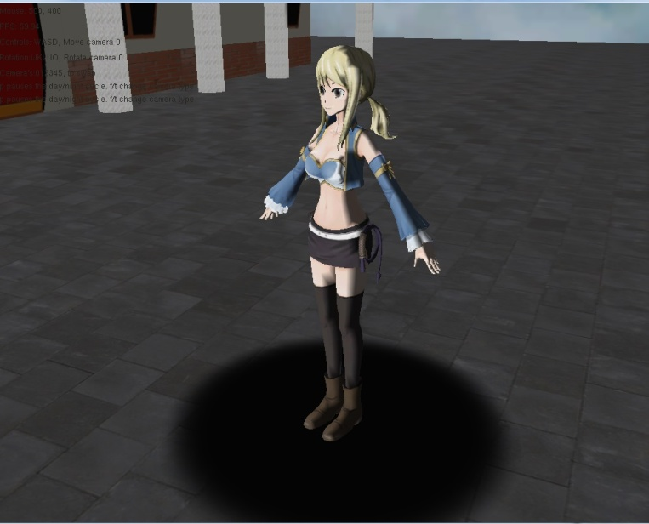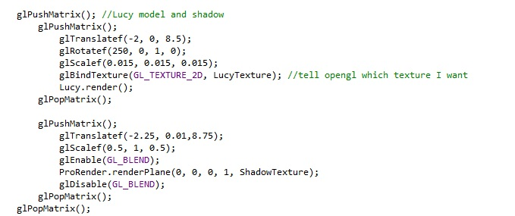I am using imposter shadows to demonstrate what the shadows should look like in my scene. these work well however when the light moves due to the day night cycle it becomes rather obvious that they are imposters.

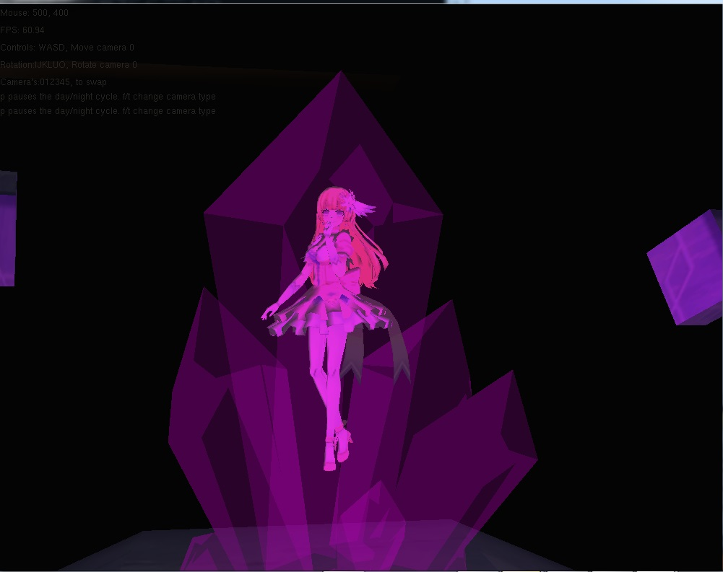I have used the stencil buffer to replicate the effect of placing a character model inside the crystal.

I have achieved this effect by using the stencil buffer to draw the model in there but if we look inside the model is not there. This is due to creating the object before rendering to the frame buffer. we then draw the crystal twice, once with the object in it which is fully transparent. Then we render the crystal that we see but without the model in it, by using this we can get the effect of the model being there without it actually being there.

# Wireframe mode

There is a wireframe mode available to the player if they press "r" however due to generating the building by using a grid of cubes this mode is rather limited in its effectiveness.

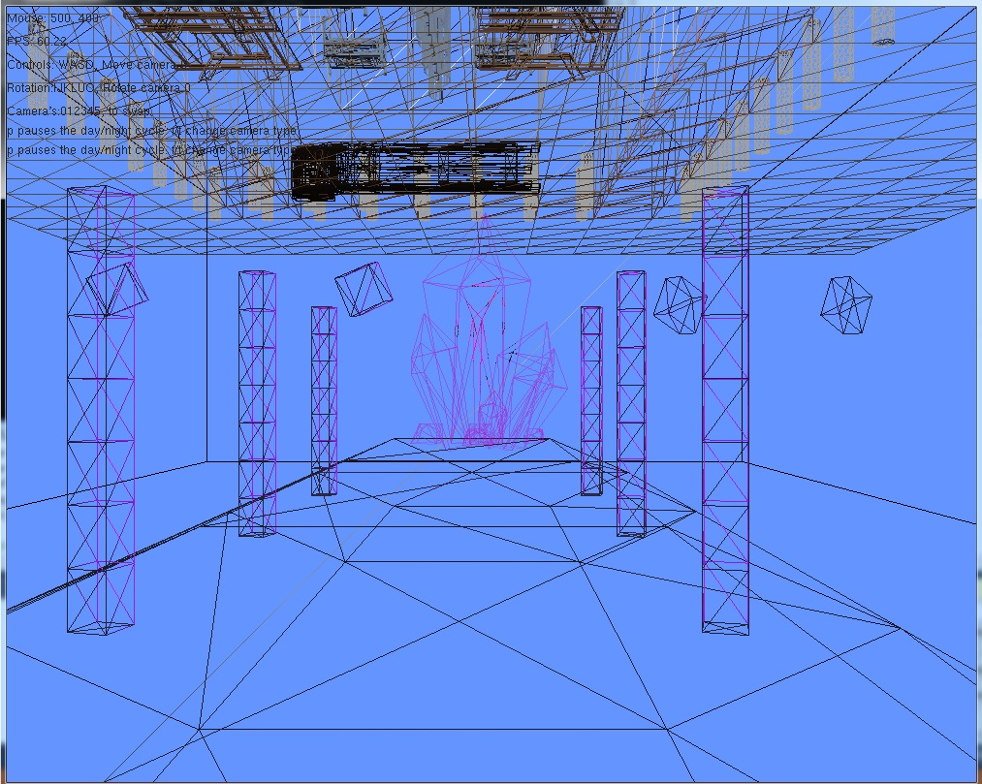this also demonstrates that the stencil buffer is functioning as intended.

# Classes

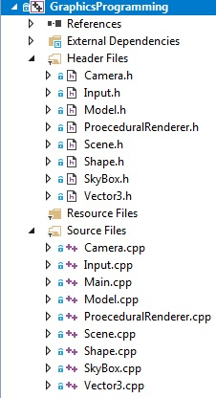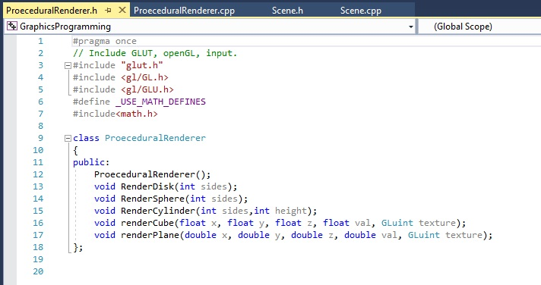The scene is constructed by using classes to call code that renders the cubes and planes, we also have a predefined class for our model loader and skybox. These classes are used to reduce the amount of lines of code needed to create the scene. I decided to make these separate classes as they contain functions that I used often and will therefore slow the scene down.

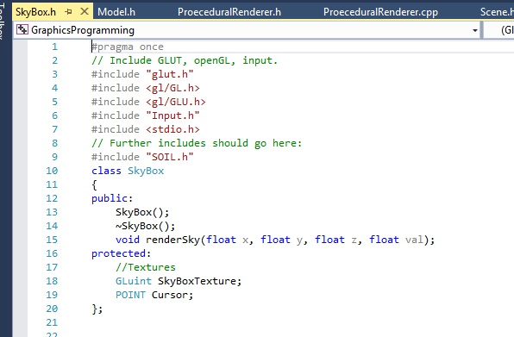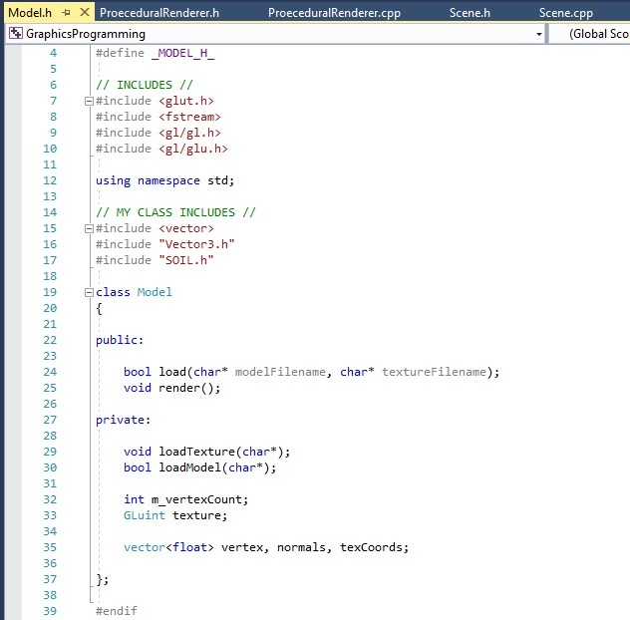

# Models

|  |  |  |  |  |
| --- | --- | --- | --- | --- |
| **Asset** | **Use in scene** | **Link** | **Creator** | **Copyright licence** |
| Fairy Tail - Lucy Heartfilia | Lucy model | <https://sketchfab.com/3d-models/fairy-tail-lucy-heartfilia-11703f9879104087b53b008c2788261c> | Gigano Regulus | Creative Commons Attribution |
| Fairy Tail - Natsu Dragneel | Natsu model(in mid-air) | <https://sketchfab.com/3d-models/fairy-tail-natsu-dragneel-5b1fe7ebfe254a099dc39e185c8449bf> | Gigano Regulus | Creative Commons Attribution |
| Fairy Tail - Gray Fullbuster | Gray model | <https://sketchfab.com/3d-models/fairy-tail-gray-fullbuster-55b75a7ae25141e48c13609284071d95> | Gigano Regulus | Creative Commons Attribution |
| Fairy Tail - Acnologia | Acnologia(dragon model) | <https://sketchfab.com/3d-models/fairy-tail-acnologia-2d0436d4b9144e92a483e9f04eb654b1> | Gigano Regulus | Creative Commons Attribution |
| Miku Izayoi | Miku(the model in the crystal) | <https://sketchfab.com/3d-models/1-55b6057f41e04c82a0ed22948f4e969e> | YU | Creative Commons Attribution |
| PicnicTable | Tables in the guild | <https://sketchfab.com/3d-models/picnic-table-93a6d86f97ff49e18220c8d5af6f2410#download> | calebjtv | Creative Commons Attribution |
| Desk (Bank Teller) | Desk(top floor) | <https://sketchfab.com/3d-models/desk-bank-teller-a5c7f6dfcea747c38f59ba7746d06209> | abdillaamy | Creative Commons Attribution |
| Crystal | Crystal(basement) | <https://sketchfab.com/3d-models/crystal-980b0873e5294ba999ddd6c7f0d767df> | maxbiba | Creative Commons Attribution |
| Bed | Beds on floor 2 | <https://www.turbosquid.com/FullPreview/Index.cfm/ID/253476> | NerdMonkey | [Royalty Free License](https://blog.turbosquid.com/royalty-free-license/?p=7952) |
| Bar | Bar in the back of the first floor | <https://www.turbosquid.com/FullPreview/Index.cfm/ID/923794> | Krasotikin | [Royalty Free License](https://blog.turbosquid.com/royalty-free-license/?p=7952) |
| Billiard Table | Pool table on the top floor | <https://www.turbosquid.com/FullPreview/Index.cfm/ID/718046> | mikahoo | [Royalty Free License](https://blog.turbosquid.com/royalty-free-license/?p=7952) |
| Screen | Dividers in the second floor | <https://www.turbosquid.com/FullPreview/Index.cfm/ID/239347> | Fworx | [Royalty Free License](https://blog.turbosquid.com/royalty-free-license/?p=7952) |

# Textures list

|  |  |  |  |  |
| --- | --- | --- | --- | --- |
| **Asset** | **Use in scene** | **Link** | **Creator** | **Copyright licence** |
| BlackTexture | Basement cube texture | N/A | Edwyn Mckie | Creative Commons Attribution |
| BluePegasusBanner | Blue banner at front wall | N/A | [Hiro Mashima](https://en.wikipedia.org/wiki/Hiro_Mashima) | Creative Commons Attribution |
| Brick | Brick texture for foundation of house | <https://openphoto.net/gallery/image/view/20917> | [Adrian van Leen](http://taluda.openphoto.net/gallery/) | Creative Commons Attribution |
| Crystal | Texture the crystal in the basement | <https://sketchfab.com/3d-models/crystal-980b0873e5294ba999ddd6c7f0d767df> | maxbiba | Creative Commons Attribution |
| Door | Front door texture | N/A | Edwyn Mckie | Creative Commons Attribution |
| FairyTailBanner | Red banner at front wall | <https://fairytail.fandom.com/wiki/Fairy_Tail_(Guild)> | [Hiro Mashima](https://en.wikipedia.org/wiki/Hiro_Mashima) | Creative Commons Attribution |
| FlameTexture | Fire texture under Natsu's feet | <https://www.deviantart.com/hhh316/art/Seamless-Fire-Texture-333891187> | Hhh316 | [Royalty Free License](https://blog.turbosquid.com/royalty-free-license/?p=7952) |
| FloatingStoneTexture | Texture for floating stones near crystal | N/A | [Hiro Mashima](https://en.wikipedia.org/wiki/Hiro_Mashima) | Creative Commons Attribution |
| Imposter | Texture for imposter shadow | Sourced from University | N/A | Creative Commons Attribution |
| OracienSiesBanner | Black banner at front wall | N/A | [Hiro Mashima](https://en.wikipedia.org/wiki/Hiro_Mashima) | Creative Commons Attribution |
| PurpleTexture | Purple texture for columns in basement | N/A | EdwynMckie | Creative Commons Attribution |
| RoofTile | Texture for the roofs | <https://www.needpix.com/photo/731360/texture-roof-tileytyvae-seamless-roof-tile-building-stone> | Artturi_Mantysaari | Creative Commons Attribution |
| Skybox | Texture for skybox | Sourced from University | N/A | Creative Commons Attribution |
| Stone | Texture used for stone plane | <http://texturelib.com/texture/?path=/Textures/brick/pavement/brick_pavement_0132> | Dmitrity Chugai | Creative Commons Attribution |
| StonePillarTexture | Texture used for stone pillars | N/A | Edwyn Mckie | Creative Commons Attribution |
| WallPaint | Texture used for walls | N/A | Edwyn Mckie | Creative Commons Attribution |
| WallPaintWindow | Texture used for walls with windows | N/A | Edwyn Mckie | Creative Commons Attribution |
| Wood | Texture used in guildhall | <http://www.everystockphoto.com/photo.php?imageId=9126801> | N/A | Creative Commons Attribution |
| Cloth | Texture used on models in floor 2 | <https://www.turbosquid.com/FullPreview/Index.cfm/ID/253476> | NerdMonkey | [Royalty Free License](https://blog.turbosquid.com/royalty-free-license/?p=7952) |
| Body | Texture used on Acnologia main body | <https://sketchfab.com/3d-models/fairy-tail-acnologia-2d0436d4b9144e92a483e9f04eb654b1> | Gigano Regulus | Creative Commons Attribution |
| Body2 | Texture used on Acnologia sub body | <https://sketchfab.com/3d-models/fairy-tail-acnologia-2d0436d4b9144e92a483e9f04eb654b1> | Gigano Regulus | Creative Commons Attribution |
| Gray | Texture used on Gray model | <https://sketchfab.com/3d-models/fairy-tail-gray-fullbuster-55b75a7ae25141e48c13609284071d95> | Gigano Regulus | Creative Commons Attribution |
| Lucy | Texture used on Lucy model | <https://sketchfab.com/3d-models/fairy-tail-lucy-heartfilia-11703f9879104087b53b008c2788261c> | Gigano Regulus | Creative Commons Attribution |
| MikuIzayoi | Texture used on Miku model | <https://sketchfab.com/3d-models/1-55b6057f41e04c82a0ed22948f4e969e> | YU | Creative Commons Attribution |
| MikuIzayoiAlt | Alternate texture used on Miku | <https://sketchfab.com/3d-models/1-55b6057f41e04c82a0ed22948f4e969e> | YU | Creative Commons Attribution |
| MikuIzayoiAlt2 | Alternate texture used on Miku | <https://sketchfab.com/3d-models/1-55b6057f41e04c82a0ed22948f4e969e> | YU | Creative Commons Attribution |
| Natsu | Texture used on Natsu model | <https://sketchfab.com/3d-models/fairy-tail-natsu-dragneel-5b1fe7ebfe254a099dc39e185c8449bf> | Gigano Regulus | Creative Commons Attribution |
| PoolTable | Texture used on pool table model | <https://www.turbosquid.com/FullPreview/Index.cfm/ID/923794> | Krasotikin | [Royalty Free License](https://blog.turbosquid.com/royalty-free-license/?p=7952) |
| Table | Texture used on picnic table model | <https://sketchfab.com/3d-models/picnic-table-93a6d86f97ff49e18220c8d5af6f2410#download> | calebjtv | Creative Commons Attribution |
| Wings | Texture used on Acnologia wings | <https://sketchfab.com/3d-models/fairy-tail-acnologia-2d0436d4b9144e92a483e9f04eb654b1> | Gigano Regulus | Creative Commons Attribution |
| DeskUV | Texture used on desk model | <https://sketchfab.com/3d-models/desk-bank-teller-a5c7f6dfcea747c38f59ba7746d06209> | abdillaamy | Creative Commons Attribution |
|  | | | | |

# Reference list

* Learnopengl.com. (2019). *LearnOpenGL - Stencil testing*. [online] Available at: https://learnopengl.com/Advanced-OpenGL/Stencil-testing [Accessed 7 Dec. 2019].
* Learnopengl.com. (2019). *LearnOpenGL - Model*. [online] Available at: https://learnopengl.com/Model-Loading/Model [Accessed 6 Dec. 2019].
* Natureofcode.com. (2019). *The Nature of Code*. [online] Available at: https://natureofcode.com/book/chapter-4-particle-systems/ [Accessed 1 Dec. 2019].
* Opengl-tutorial.org. (2019). *Particles / Instancing*. [online] Available at: http://www.opengl-tutorial.org/intermediate-tutorials/billboards-particles/particles-instancing/ [Accessed 1 Dec. 2019].
* Overvoorde, A. (2019). *OpenGL - Textures*. [online] Open.gl. Available at: https://open.gl/textures [Accessed 25 Nov. 2019].
* Overvoorde, A. (2019). *OpenGL - Introduction*. [online] Open.gl. Available at: https://open.gl/ [Accessed 2 Dec. 2019].