**Question 1:** Read and print the pixel values of an image

**Code:**

#include <opencv2/opencv.hpp>

#include <iostream>

#include <string>

int main()

{

std::string filename;

std::cin >> filename;

cv::Mat img = cv::imread(filename);

int rows = img.rows, cols = img.cols * img.channels();

std::cout << img.rows << '*' << img.cols << " Channels: " << img.channels() << '\n';

const uchar* ptr;

if(img.isContinuous())

{

cols *= rows; rows = 1;

}

for(int i = 0; i < rows; i++)

{

ptr = img.ptr<uchar>(i);

for(int j = 0; j < cols; j++)

std::cout << (int)ptr[j] << ' ';

std::cout << '\n';

}

}

**Output:**



**Question 2: Print histogram of pixel values of a grey image**

**Code:**

#include <opencv2/opencv.hpp>

#include <iostream>

#include <vector>

#include <array>

int main()

{

cv::Mat src = cv::imread("/home/rohan/Downloads/OpenCVWorkshop2019/images/sharpening.png");

std::vector<cv::Mat> bgr_planes;

cv::split(src, bgr_planes);

int histSize = 256;

std::array<float, 2> range = {0, 256};

const float* histRange = {range.data()};

cv::Mat b_hist, g_hist, r_hist;

cv::calcHist(&bgr_planes[0], 1, 0, cv::Mat(), b_hist, 1, &histSize, &histRange);

cv::calcHist(&bgr_planes[1], 1, 0, cv::Mat(), g_hist, 1, &histSize, &histRange);

cv::calcHist(&bgr_planes[2], 1, 0, cv::Mat(), r_hist, 1, &histSize, &histRange);

int hist_w = 512, hist_h = 400;

int bin_w = cvRound((double)hist_w / histSize);

cv::Mat histImage(hist_h, hist_w, CV_8UC3, cv::Scalar(0, 0, 0));

cv::normalize(b_hist, b_hist, 0, histImage.rows, cv::NORM_MINMAX, -1, cv::Mat());

cv::normalize(g_hist, g_hist, 0, histImage.rows, cv::NORM_MINMAX, -1, cv::Mat());

cv::normalize(r_hist, r_hist, 0, histImage.rows, cv::NORM_MINMAX, -1, cv::Mat());

for(int i = 1; i < histSize; i++)

{

cv::line(histImage, cv::Point(bin_w * (i - 1), hist_h - cvRound(b_hist.at<float>(i - 1))),

cv::Point(bin_w * (i), hist_h - cvRound(b_hist.at<float>(i))), cv::Scalar(255, 0, 0));

cv::line(histImage, cv::Point(bin_w * (i - 1), hist_h - cvRound(g_hist.at<float>(i - 1))),

cv::Point(bin_w * (i), hist_h - cvRound(g_hist.at<float>(i))), cv::Scalar(0, 255, 0));

cv::line(histImage, cv::Point(bin_w * (i - 1), hist_h - cvRound(r_hist.at<float>(i - 1))),

cv::Point(bin_w * (i), hist_h - cvRound(r_hist.at<float>(i))), cv::Scalar(0, 0, 255));

}

cv::imshow("Source Image", src);

cv::imshow("calcHist Demo", histImage);

cv::waitKey();

}

**Output:**

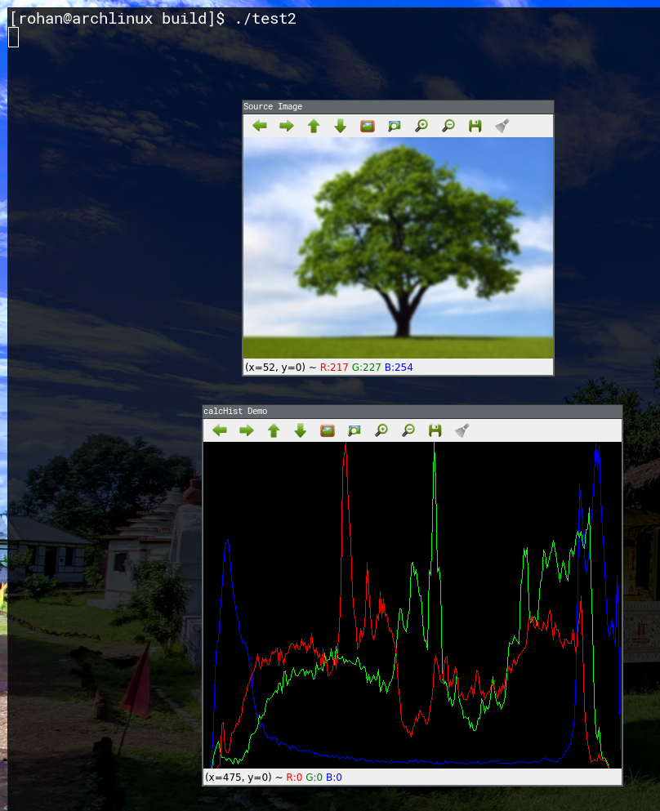

**Question 3:** Display inverted gray image

**Code:**

#include <iostream>

#include <string>

#include <opencv2/opencv.hpp>

int main()

{

std::string filename; std::cin >> filename;

cv::Mat img = cv::imread(filename), img_gray;

cv::imshow("original", img);

cv::cvtColor(img, img_gray, cv::COLOR_BGR2GRAY);

cv::imshow("Gray", img_gray);

cv::waitKey();

}

**Output:**

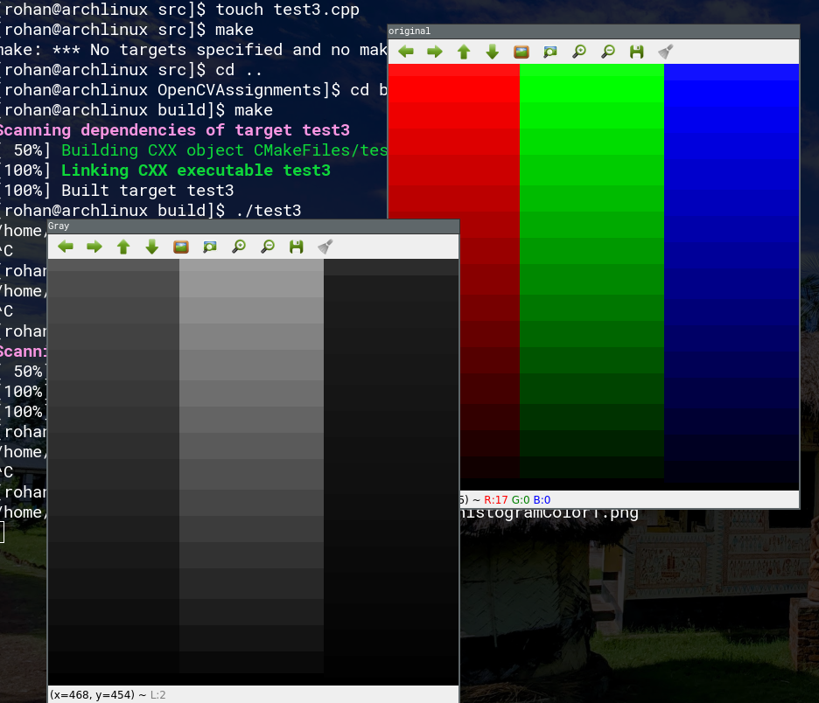

**Question 4:** Enhance overall brightness of a grey image by a given value.

**Code:**

#include <opencv2/opencv.hpp>

#include <iostream>

#include <string>

int main()

{

std::string filename; std::cin >> filename;

cv::Mat img = cv::imread(filename);

float beta; std::cin >> beta;

cv::imshow("Original", img);

cv::Mat lookupTable(1, 256, CV_8U);

uchar* p = lookupTable.ptr();

for(int i = 0; i < 256; i++)

p[i] = cv::saturate_cast<uchar>(i + beta);

cv::LUT(img, lookupTable, img);

cv::imshow("Altered Image", img);

cv::waitKey();

}

**Output:**

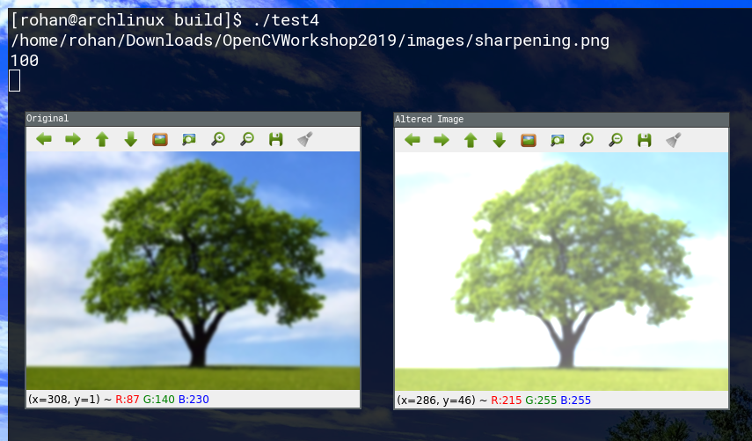

**Question 5:** Enhance contrast of a grey image.

**Code:**

#include <opencv2/opencv.hpp>

#include <iostream>

#include <string>

int main()

{

std::string filename; std::cin >> filename;

cv::Mat img = cv::imread(filename);

float alpha; std::cin >> alpha;

cv::imshow("Original", img);

cv::Mat lookupTable(1, 256, CV_8U);

uchar* p = lookupTable.ptr();

for(int i = 0; i < 256; i++)

p[i] = cv::saturate_cast<uchar>(i * alpha);

cv::LUT(img, lookupTable, img);

cv::imshow("Altered Image", img);

cv::waitKey();

}

**Output:**

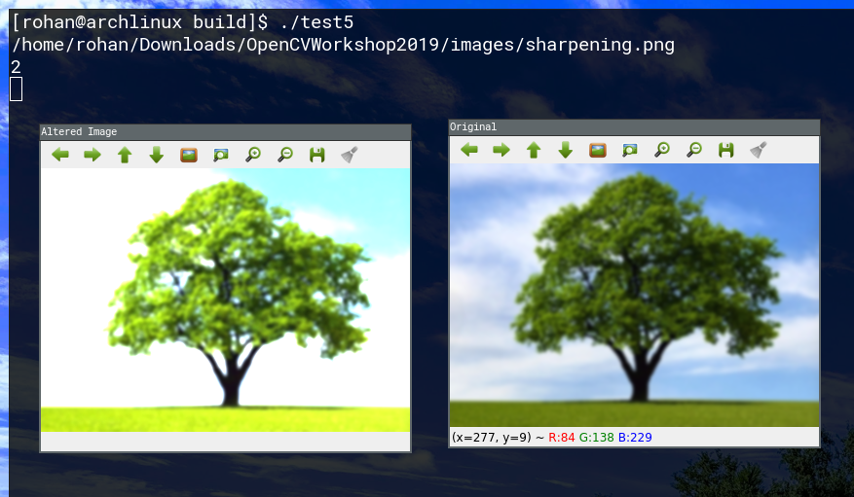

**Question 6:** Perform histogram equalization to enhance quality of a grey image.

**Code:**

#include <opencv2/opencv.hpp>

#include <iostream>

#include <string>

int main()

{

std::string filename; std::cin >> filename;

cv::Mat img = cv::imread(filename);

cv::cvtColor(img, img, cv::COLOR_BGR2GRAY);

cv::imshow("Original", img);

cv::Mat m_img;

cv::equalizeHist(img, m_img);

cv::imshow("Equalized", m_img);

cv::waitKey();

}

**Output:**

