DARKSTAR
v8 TOY DYNAMICAL TEST
Scott Hunter Hughes “DarkStar Aurora Shockwave”
October 1, 2026

Purpose
This is a deliberately minimal numerical experiment. It is not a realistic black-hole simulation and does not establish DarkStar. Its purpose is to expose the bookkeeping consequence of introducing an explicit recycling fraction.

Toy equation
dM_BH/dt = (1 − ε − f_rec) Ṁ_acc
Parameters used only for demonstration: M0 = 1 normalized mass unit, Ṁ_acc = 0.1 mass units per time unit, ε = 0.1, and f_rec varied from 0 to 0.5. The model requires 0 ≤ ε + f_rec ≤ 1.

Numerical result
f_rec=0.0: final M_BH=1.900; recycling channel=0.000 per time unit; radiative channel=0.010; retained growth=0.090.
f_rec=0.1: final M_BH=1.800; recycling channel=0.010 per time unit; radiative channel=0.010; retained growth=0.080.
f_rec=0.3: final M_BH=1.600; recycling channel=0.030 per time unit; radiative channel=0.010; retained growth=0.060.
f_rec=0.5: final M_BH=1.400; recycling channel=0.050 per time unit; radiative channel=0.010; retained growth=0.040.
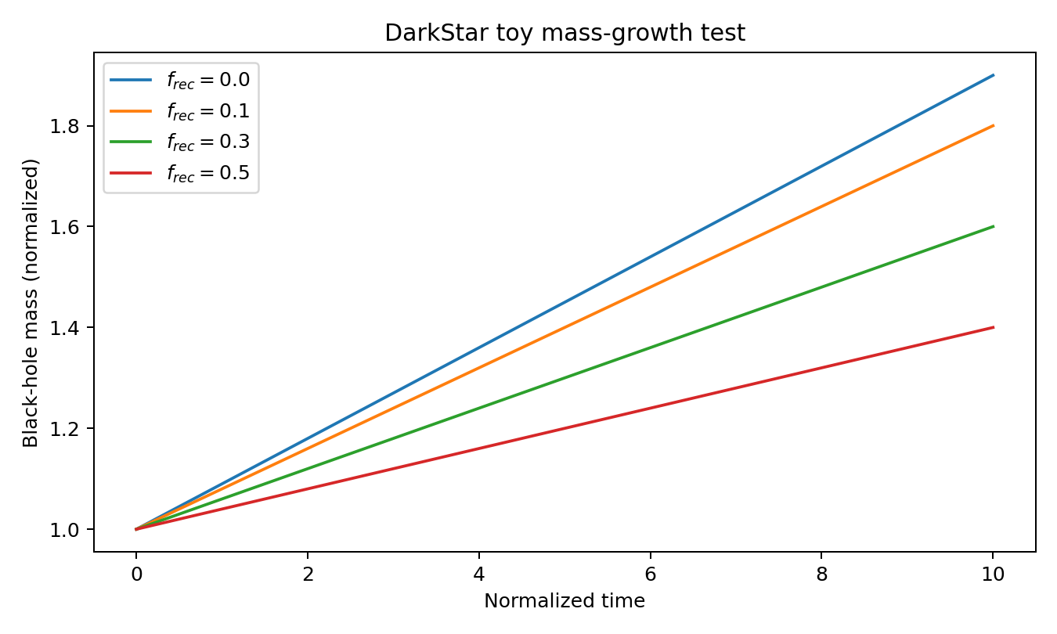

Interpretation
The toy model produces exactly what conservation accounting predicts: increasing f_rec reduces the amount of accretion energy available to increase black-hole mass, unless the recycled channel is returned to the system in a way that is explicitly modeled. Nothing in this calculation demonstrates that such a channel exists.
Therefore the next scientifically meaningful DarkStar task is not to choose a large f_rec. It is to derive or measure f_rec from observations and to determine whether it differs from zero after established radiation, jet, wind, and stellar processes are included.

Cosmological constraint
A separate cosmological model is required. Standard FLRW dynamics do not generate a radiation-driven rebirth merely by retaining a radiation background. A DarkStar bounce must specify additional dynamics—such as curvature, a new effective stress-energy component, or modified gravity—and then satisfy H=0 at turnaround/bounce plus ä>0 at the bounce.

Stress-test conclusion
The toy calculation survives as a bookkeeping framework but contains no new physics by itself. This is a useful result: it tells us exactly where the real DarkStar claim begins—the physical derivation and observational determination of a nonzero recycling channel.

