GIMP DDS plug-in

Documentation of advanced features

April 16, 2008

Documented by: Shawn Kirst <skirst@insightbb.com>

GIMP DDS plug-in home page

Contents

- Saving general images
- Saving cube map images
- Saving volume map images

Saving general images

Saving images with the GIMP DDS plug-in is a rather straight-forward task, yet there are some things that can happen that may cause confusion for some users. Most importantly, when the image you are trying to save contains multiple layers. Normal 2D DDS images cannot contain layers in the same way a Photoshop (PSD) or GIMP (XCF) image can. The simplest way to save your image is to composite all your layers down to a single layer. This can be accomplished in 3 ways:

- Using the 'Flatten Image' function from the Image menu
- Making all your layers visible, and using the 'Merge visible layers' function from the layers menu.
- Deleting all the layers from the image except the one you wish to save.

You must do one of the three in order to save your image.

The other option is to save only the layer you are interested in, or each layer to a separate image file. To do this, select the layer you want to save in the Layers dialog, and save the image as normal. You might get prompted with a warning dialog that asks if you are trying to save a volume or cube map image, and that it can't due to certain properties of the image not satisfying that type of image. Ignore this. From the GIMP DDS save dialog, there is an option labled 'Save'. Select the option that says 'Selected layer'.
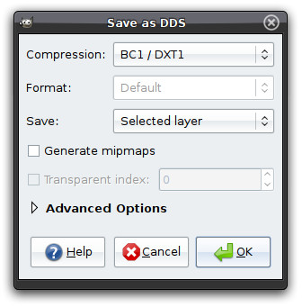

You can now choose the other properties you wish to save the image with such as compression or pixel format. Clicking the 'OK' button will save the layer you selected to the file you specified.

Saving cube map images

Saving cube map images allows you to save an image with 6 layers, with each layer being a face of a cube. Your image must have exactly 6 layers, and each layer must have the same width, height and color depth (all with alpha channel or not). Each layer name must contain an identifier for which face of the cube it represents. The layer name does not have to be the identifier itself, it only needs to appear somewhere in the layer name. The names are as follows:

Face name identifier | Alternatives
right | +x, positive x, pos x
left | -x, negative x, neg x
top | +y, positive y, pos y
bottom | -y, negative y, neg y
back | +z, positive z, pos z
front | -z, negative z, neg z

Your layers should look something like this:
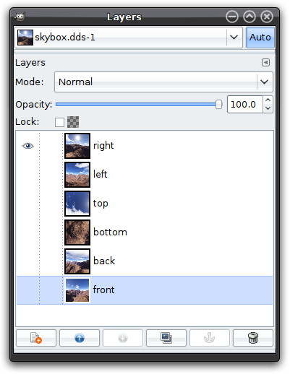

Save your image as DDS. If the plug-in sees that your image is a cube map, the DDS plug-in save dialog should appear, with the 'Save' option set to 'As cube map'.
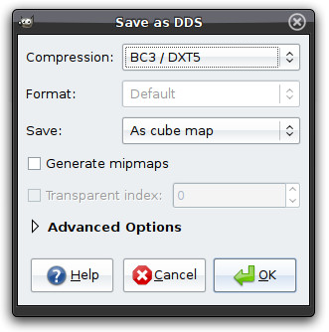

If the plug-in finds anything wrong with your image, such as a discrepancy in the six layers (all layers not the same width, height and color depth, or missing a cube face) it will show you a warning. To save the cube map, simply click the OK button.
Saving volume map images

Saving volume maps, or 3D textures is similar to saving a cube map. Your layer names do not have to be anything special. They do however, need to all be the same width, height and color depth. Your layers should look something like this:
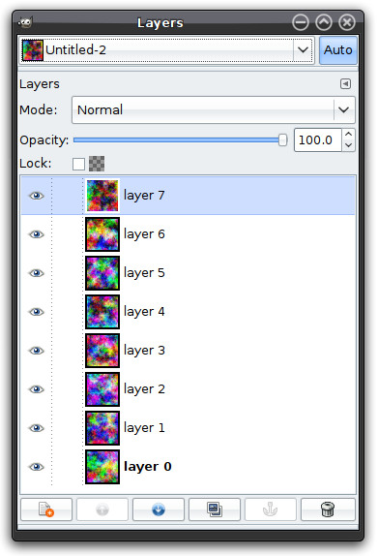

Save your image as DDS. If the plug-in sees that your image is a volume map, the DDS plug-in save dialog should appear, with the 'Save' option set to 'As volume map'.
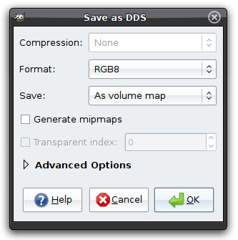

If the plug-in finds anything wrong with your image, such as a discrepancy in the layers (all layers not the same width, height and color depth) it will show you a warning. To save the volume map, simply click the OK button.

