Lab 1: Requirements Engineering & UML Use-Case Modelling
Problem Statement #04 — Student Project Portfolio & Showcase App
Actors: Student Team | Panel Judge | Public Voter | Event Admin

1. Requirements Table
Five Functional Requirements (FR-001 to FR-005) and two Non-Functional Requirements (NFR-001 & NFR-002).
Req ID | Type | Description | Priority | Acceptance Criteria | Rationale
FR-001 | Functional | The system shall enable student teams to create showcase profiles containing abstract summaries, demo video links, and verified GitHub repository URLs. | High | Pass: Profile is published to showcase catalog upon validation of repository link. Fail: Invalid URL format accepted. | Core submission functionality required for expo participation.
FR-002 | Functional | The system shall allow Panel Judges to score projects using a digital rubric with defined criteria (innovation, execution, presentation). | High | Pass: Score is saved only when all rubric fields are completed. Fail: Partial or incomplete rubric submission is accepted. | Ensures structured, consistent, and fair grading across all judges.
FR-003 | Functional | The system shall allow a verified public user to cast exactly one vote per project. | High | Pass: A second vote attempt from the same verified account is blocked. Fail: A duplicate vote is recorded. | Anti-sybil protection to preserve voting integrity.
FR-004 | Functional | The system shall generate a live leaderboard combining judge scores (weighted 70%) and public votes (weighted 30%). | Medium | Pass: Leaderboard reflects a new vote or score within 300 ms. Fail: Ranking is stale after an update. | Provides transparency and real-time feedback to participants and organizers.
FR-005 | Functional | The system shall allow an Event Admin to create an expo event and configure judging and voting time windows. | Medium | Pass: Voting/judging actions are rejected outside the configured window. Fail: Actions are allowed after the window closes. | Controls the expo lifecycle and prevents late or invalid submissions.
NFR-001 | Non-Functional (Performance & Security) | The public voting and leaderboard calculations shall update in real-time with an API response latency under 300 ms. | High | Pass: Benchmarking tests confirm target latency and security standards under simulated peak load. | Expo-day traffic can spike; the system must remain responsive and secure under load.
NFR-002 | Non-Functional (Reliability & Availability) | The system shall maintain 99.5% uptime during active expo hours (judging and public voting windows). | High | Pass: Uptime monitoring logs show downtime of 0.5% or less during the event window. Fail: Downtime exceeds 0.5% during active hours. | Voting and judging are time-boxed and cannot tolerate outages without disrupting the expo.

2. UML Use-Case Diagram
The diagram below shows all actors, use cases within the system boundary, and the required «include» and «extend» relationships. A separate high-resolution PDF export is also submitted alongside this document.
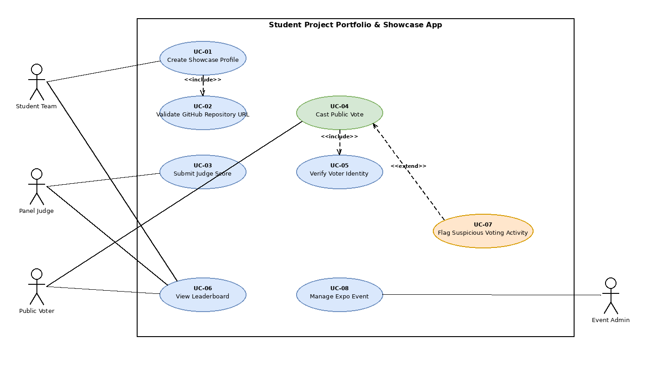
«include»: UC-01 Create Showcase Profile → UC-02 Validate GitHub Repository URL (always executed); UC-04 Cast Public Vote → UC-05 Verify Voter Identity (always executed).
«extend»: UC-07 Flag Suspicious Voting Activity → UC-04 Cast Public Vote (executes only when anomalous voting patterns are detected).

3. Use-Case Flow Specification

Use Case: UC-04 — Cast Public Vote
Preconditions:
- The voter has a verified account / active session.
- The public voting window for the expo event is currently open.
- The project catalog has been published by the Event Admin.
Postconditions:
- The vote is permanently recorded against the selected project.
- The leaderboard reflects the updated vote tally in real time.
Main Success Scenario:
1. Public Voter browses the showcase catalog and selects a project.
2. System displays the project details (abstract, demo video link, GitHub repository link).
3. Voter clicks "Cast Vote."
4. System verifies the voter's identity and active session (includes UC-05 Verify Voter Identity).
5. System checks whether the voter has already voted for this project.
6. System records the vote against the project.
7. System updates the leaderboard in real time (within 300 ms, per NFR-001).
8. System displays a confirmation message to the voter.
9. Use case ends successfully.
Alternate Flow — 5a. Duplicate Vote Attempt:
- 5a1. System detects that the voter has already voted for this project.
- 5a2. System displays the message: "You have already voted for this project."
- 5a3. The vote is not recorded; the use case ends without completing step 6 onward.
Alternate Flow — 4a. Suspicious Voting Pattern Detected (extension point):
- 4a1. System flags the voting session as anomalous (extends UC-07 Flag Suspicious Voting Activity), e.g. rapid repeated votes from related accounts or the same device fingerprint.
- 4a2. System places a temporary hold on the vote pending review, and notifies the Event Admin.
- 4a3. Voter is informed their vote is under verification; use case pauses until resolved.

