Basis Path Testing – Add Profile
Use Case 3.1.12 | Budgetly Application

Use Case Overview
- Description: The user creates a new profile to store separate transactions, goals, and groups.
- Actor: User
- Trigger: User wants to create a profile.
- Pre-condition: Program is running.
- Post-condition: A new profile is created.

Method Under Test
The core logic for this use case is in Controller.createProfile():

public void createProfile(String name, String desc) {
Profile p = new Profile();
p.setID(profileSeq.getAndIncrement());
p.setDisplayName(name);
p.setDescription(desc == null || desc.isBlank() ? null : desc);
p.setBankRoll(0.0);
profiles.add(p);
if (activeAccount != null) {
activeAccount.addProfileToList(p);
}
accOperations.setProfile(p);
accOperations.addProfileDB(p);
if (activeProfile == null) {
activeProfile = p;
activeProfileId = p.getID();
}
}

1. Flow Graph
Nodes:

Node | Description
1 | Entry: create Profile, setID, setDisplayName, setBankRoll
2 | Decision: desc == null || desc.isBlank()
3 | [TRUE] setDescription(null)
4 | [FALSE] setDescription(desc.trim())
5 | setBankRoll(0.0), profiles.add(p)
6 | Decision: activeAccount != null
7 | [TRUE] activeAccount.addProfileToList(p)
8 | [FALSE] skip
9 | accOperations.setProfile(p), accOperations.addProfileDB(p)
10 | Decision: activeProfile == null
11 | [TRUE] activeProfile = p, activeProfileId = p.getID()
12 | [FALSE] skip
13 | Exit

Edges: 1→2, 2→3, 2→4, 3→5, 4→5, 5→6, 6→7, 6→8, 7→9, 8→9, 9→10, 10→11, 10→12, 11→13, 12→13

Cyclomatic Complexity V(G) = 3 decisions + 1 = 4

2. Independent Paths

Path | Nodes Traversed | Conditions
1 | 1→2→3→5→6→8→9→10→11→13 | desc blank/null, no account, no active profile
2 | 1→2→3→5→6→7→9→10→12→13 | desc blank/null, account exists, active profile exists
3 | 1→2→4→5→6→7→9→10→11→13 | desc provided, account exists, no active profile
4 | 1→2→4→5→6→8→9→10→12→13 | desc provided, no account, active profile exists

3. Test Cases

Test Case 1 – Path 1
Field | Details
Path | 1→2→3→5→6→8→9→10→11→13
Description | First profile ever created, blank description, no active account
Input: name | "Daniel"
Input: desc | "" (blank/empty)
Input: activeAccount | null
Input: activeProfile | null
Expected Output | Profile created with description = null. Profile added to profiles list. activeProfile set to new profile. activeProfileId set to new profile ID.
Verify in MySQL | SELECT * FROM Profile;
Note | activeAccount will be set via login in manual testing. Full isolation of this path requires unit testing.

Test Case 1 – Results
Test Case 1 – Results
Input Used | “Daniel”, desc = blank
Actual Output | Profile created successfully, description saved as null in database
MySQL Result | 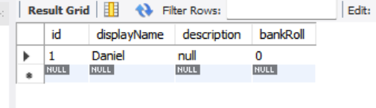
Status (Pass/Fail) | PASS

Test Case 2 – Path 2
Field | Details
Path | 1→2→3→5→6→7→9→10→12→13
Description | Additional profile, blank description, account exists, active profile already set
Input: name | "Work"
Input: desc | null
Input: activeAccount | existing Account object
Input: activeProfile | already set to another profile
Expected Output | Profile created with description = null. Profile added to profiles list and to account profile list. activeProfile remains unchanged.
Verify in MySQL | SELECT * FROM Profile;
How to Run | Log in with Test Case 1 account. Create a second profile with no description.

Test Case 2 – Results
Test Case 2 – Results
Input Used | “Work”, dec = blank/null (logged into same account from TC1)
Actual Output | Second profile created successfully, description saved as null, activeProfile remained unchanged
MySQL Result | 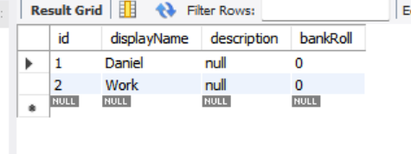
Status (Pass/Fail) | PASS

Test Case 3 – Path 3
Field | Details
Path | 1→2→4→5→6→7→9→10→11→13
Description | First profile, description provided, account exists
Input: name | "Vacation"
Input: desc | "Hawaii trip savings"
Input: activeAccount | existing Account object
Input: activeProfile | null
Expected Output | Profile created with description = "Hawaii trip savings". Profile added to profiles list and account profile list. activeProfile set to new profile. activeProfileId updated.
Verify in MySQL | SELECT * FROM Profile;
How to Run | Register a brand new account. Create your first profile with a description.

Test Case 3 – Results
Test Case 3 – Results
Input Used | “Vacation:, dec = “Hawaii trip savings” (registered brand-new account)
Actual Output | Profile created successfully, description saved as “Hawaii trip savings”, activeProfile set to new profile
MySQL Result | 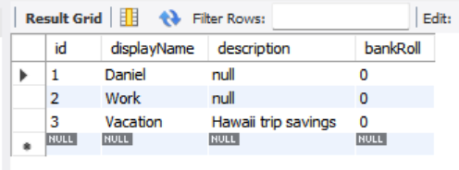
Status (Pass/Fail) | PASS

Test Case 4 – Path 4
Field | Details
Path | 1→2→4→5→6→8→9→10→12→13
Description | Additional profile, description provided, no active account, active profile already set
Input: name | "Business"
Input: desc | "Business expenses"
Input: activeAccount | null
Input: activeProfile | already set to another profile
Expected Output | Profile created with description = "Business expenses". Profile added to profiles list only. activeProfile remains unchanged.
Verify in MySQL | SELECT * FROM Profile;
How to Run | Stay logged into Test Case 3 account. Create a second profile with a description.
Note | activeAccount will be set via login in manual testing. Full isolation requires unit testing.

Test Case 4 – Results
Test Case 4 – Results
Input Used | “Business”, desc = “Business” (stayed logged into TC3 account)
Actual Output | Profile created suucessfully, description saved as “Business expenses”, activeProfile remained unchanged
MySQL Result | 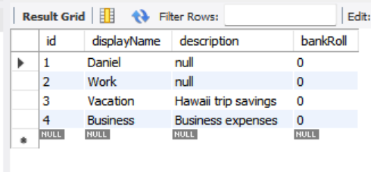
Status (Pass/Fail) | PASS

