SCHOOL OF COMPUTING
UNIVERSITY OF TEESSIDE
MIDDLESBROUGH
TS1 3BA

AI for Games
(COM3049)

ICA3 Group Report

CROWS
Opeoluwa Ladeinde, Danny Wesson, Martin Robertson

Table of Contents
1 System Architecture Overview 3
2 Motion planning 5
3 Task planning 7
4 Plan Executive 10
5 Results 12

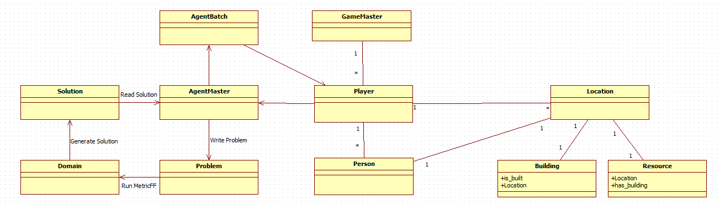
System Architecture Overview

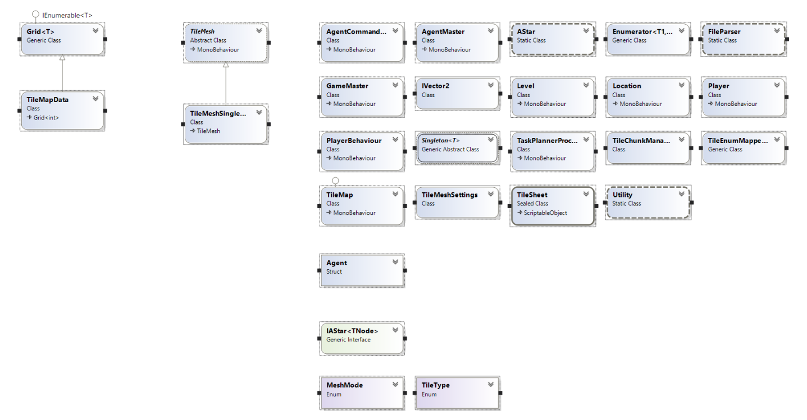

Motion planning
For the motion planning we did it so that the same person was in charge of generating the map that the agents would navigate around. For this the map data is read from a file parser which obtains the map dimensions and the raw data in the file. The data is processed during the reading of the lines where each character is converted into the enumerator-space which in turn makes sharing and accessing easier. Unfortunately during this the original data pointing to special characters is lost to give better maintainability and readability.

Once the scene has loaded and called the file parser is updates the “TileMeshSettings” for the maps dimensions and the per-tile resolution. It does all this using a tile sheet already in the project. The tile-sheets themselves can be anything due to the nature of the code. For simplicity the tile sheet should be configured within the editor by just adding it to the “TileEnumMapper”. This creates a key pair value between the sprite types and also its index within the tile sheet so it can be easily harnessed within the code.

Once the tile sheets and the above parts have been implemented it is time to load the file to the screen. To do this it draws the tiles corresponding with the data file to a Texture2D which in turn is then splatted onto the mesh in the scene as a material. Unfortunately this technique takes three or more seconds on a larger map and because of this some optimisations have been considered with a selection implemented:
- There is less draw calls by doing it per line rather than a tile by tile basis which would require a sprite batching per row
- Detecting the most significant sprite to be used. i.e. if there is mostly grass in the scene the entire texture will be drawn as grass before filling in the minor details.
- Chunking has been partially implemented to allow the generation of bigger maps on the off chance the map is bigger than the texture limit. If it is then the resolution of the tiles can be reduced to accommodate.
The file parser retains the map data while the scene handles retrieving and setting tiles. Along with this because the partially implemented chunking there is it loading the single first chunk on the smaller maps. Also the “TileMap” and “TileMesh” generally handle the maps interaction as a whole as opposed to per tile. It also includes the functions that allow entities in the world to transform their position into the tile map space with correct alignment.

For the actual movement of the objects the A* algorithm was used do to is ability to find paths with the best solution quickly in most scenarios. It does have some drawbacks but for the most part it is exactly what we needed. This algorithm uses a cost to find the best path along a given distance by evaluation the heuristic to see which will take less time. It runs through different options assessing the cost and based on which will return the next best tile in the path until it reaches its destination.

A* was not necessarily intended to be the choice we chose however, as D* copes with complex maps much better. For example on the maze map A* seems to have some trouble but as we will not have a maze map it isn’t too much to worry about.
The reason A* was kept over D* was also down to the fact chunking was not fully implemented and by having A* (quick means to add path planning) it meant time could be spent elsewhere to better effect. The drawbacks were considered with AStar and its limitations with ability but possibly one of its biggest flaws is its memory requirement as the entire open list has to be saved.

For the implementation each entity handles its own path planning. There is a generic static class that can be called by each entity allowing several paths to be planned at once. To initialise the plan itself it is simple: Specify where the end position is using a Vector2, which has checks to make sure the location is not in an inaccessible location. Included within here is a speed variable to determine how fast they move along the path. This itself is done within coroutines rather than loops so it will run on a separate thread reducing backlogs and stalling. By having these measures in place it assures a smooth path planning experience for each object and its respected path.

Task planning
For the task planning we used a language that attempts to standardise planning domain and problem description languages. We used PDDL (Planning Domain Definition Language) for the problem definition, processing and solution. The way it works is the executive declares a problem that is written into the PDDL problem file. By using Metric FF in tandem with the PDDL we can generate a solution from beginning to goal.

Inside the actual PDDL there is multiple options that can be used to solve any given problem it is presented with. Most of the different tasks have a similar format and there is three main types of actions that can be done. The first of which is training someone. This is done by first making sure that there is two people at the same place. There is two types of training one of which is long and only requires two people to be in the same place and the second where a school and a trained teacher take part. If there is a teacher then it takes less labour cost to teach the labourer a skill. In both situations in the outcome of the domain is that the person getting trained now has a skill point to spend training in anything. The main template for training is shown below:
Train
Parameters | ?teacher ?student – person ?location - location
Precondition | ?teacher is the same place ?student  (?location has-school) if necessary
Effect | ?student +1 skill point to spend  Labour cost increased

Learn Skill
Parameters | ?student – person
Precondition | ?student has a skill point  ?student is not already proficient in particular skill
Effect | ?student is trained  ?student doesn’t have skill point

For the building of specific buildings we decided to take inspiration from age of empires and amend it more to the brief. We have it so once resources are stored they can be used globally like inside age of empires however you still have to build a storage unit. This requires fluents for the overall amount of resources but still the ability of the people to carry resources. The layout of the actions are still very similar it’s just how the resources are passed that may change. The layout is shown in the table below:
Build
Parameters | ?p – person ?l -location
Precondition | ?p is at ?location  ?p has he resources at ?location  ?p is trained in correct proffesion  ?l has any prerequisite properties  ?l doesn’t already have a building on it
Effect | ?l has building  ?p does not have resources  ?p can now use action that requires a building  Labour cost increased

The only difference between some of these actions is that the person may not need the resources at that specific location if they have stored resources. If they need to make a storage container then they will need to move the resources as necessary. Also some buildings like mines require a minable resource to be accessible from the problem file. This enables the buildings of mines to be directly on the resource so they do not get built in any random location.

For the final actions which are the labour type jobs or manufacturing. These include moving, chopping trees, and refining resources into some others. The actions vary slightly between each one so the main differences are shown below as there is ones where it doesn’t require a building and ones where it does.

Simple labour action
Parameters | ?p – person ?l - location
Precondition | ?p is at ?l  ?l has the correct resource  ?p doesn’t already have some of the resource
Effect | ?p has resource  Labour cost increased

Labour action with building
Parameters | ?p – person ?l - location
Precondition | ?p is at ?l  ?l has the correct building  ?p has necessary prerequisites  ?p is qualified
Effect | ?p has resource  Labour cost increased

Obviously the above tables show the basic layout that will give a basic overview of each action. It uses a series of predicates to dictate if a person is qualified or has resources and then fluents to represent the labour cost or the total amount of stored resources. Along with this the types vary depending on the need. For example for people there is just one but for locations it itself has three shown in the diagram below.

OBJECT
Person
Location
Forest
MiningResource
Stone

By having the locations like this it aids with the domain and the problem solving because only locations set into those will be the parameters and preconditions. There was multiple ways that I went about attempting this but the way it is now is the one I settled on. At first I tried doing it with each person a separate object type however there was problems when it came to training the person and then carrying on with the solution as I did not know how to change the object type mid problem so changed it to use predicates and then this can be specified in the problem and allows for training to be take into account in the overall arc of the problem.

Plan Executive
For the plan executive we decided to make sure the structure of the program was flexible so that it could work with external input/output (IO) like PDDL. It had to be made in a way that when it read the tasks from the solution file that it could turn the tasks into corresponding functions that the game would understand and be able to do things with. To do this there was an Agent class created which worked by using a set of delegates which could be assigned functions. The agents would contain a start, update, end, and Boolean. These would allow the specific things to happen when a task began, when the task was being simulated, when the task ended, and the final bool to signal the “AgentMaster” telling it that the specific task was completed.

The “AgentMaster” is a class that would associate agents with the PDDL functions. This means that it is in charge of reading the solution files and differentiating the agents and making sure to call the correct function based of what the solution file has returned with. More specifically it turns the solution file into a series of strings that are used to identify and command the correct agents. On top of this the agent master is the class in charge of creating the problem file in the first place using the information from the world and the agents themselves. Once it writes it executes the MetricFF to reveal the solution which is then read back in.

As can be deduced this required the executive programmer to communicate the problems with the task planning programmer. By doing this it means the overbearing structure could be established when writing the problems. This would allow constraints to be figured out as well as how the planning was being limited and conducted to it could be mirrored in the game itself. One a parallel had been reached the “AgentMaster” could write the problems like discussed earlier and the solutions could be read and utilised within the game itself to carry out the tasks required.

Once the framework and the minor details communicating with both had been ironed out it was a case of linking the motion planner to the executive so that all three would work together in tandem and come together to have some essence of the final product. For this it required everyone’s input into the agents framework as everyone had specific knowledge of their own parts. For example the motion planner would have to work on actually moving the sprites on screen as they know how their path planner worked whereas the task planner would work on the functions along with the executive as knew what the final possible output was in the solution file. This leads to every possible instruction being completed and having the possibility to be completed, thus not leaving the program in a situation where it would crash due to not having a correct corresponding function.
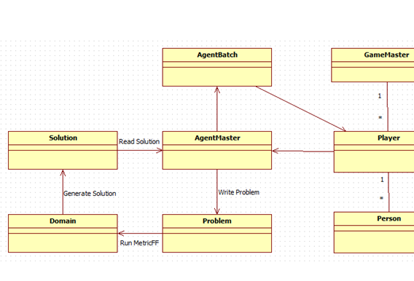
Figure 1, TaskPlanner ← Executive
Shown on figure 1 in the image is how everything cycles round. It is also a snapshot from the overall program diagram. It shows that the program talks to the agent master representing its own details to be written into the problem file. The agent master takes this and writes it into the file to be read for the Metric FF and PDDL. Once the problem has been written it executes the solving and then reads the solution file. It takes care of the solution and sends it to the agent batch area for the information to be processed into actions for the player.

Results
In this section there will be images demonstrating the main stages that we reached during the building of this program. There will be screenshots to illustrate the points being made and to show what we have done.

As can be seen from the sections above we successfully managed to get all the parts of the game working successfully leading to the framework and initial aspects of the game being done to allow for rapid development of the other parts. We have the map loading in with a sprite sheet to allow any different look or feel to the game be allowed. We also have it being able to read a variety of map sizes and types. The only downside is the fact that the chunking of the map has not been done and thus on some machines the texture limit can be reached. On the plus side of this however we can easily reduce the size of the textures to allow for the larger maps to be loaded. In accompaniment of this we have the transforming positions of entities on the map to allow easy path planning and development of the game world and movement in said game world. We also have it successfully using A* for a optimised path planning using a cost analysis to better its route. This not only shows the algorithm working but it also means it gives the people on screen a more realistic path leading to more of an immersive feel of the elements being alive and making their own decision on where they should go.

For the task planner it successfully solves problems that are given to it whist having certain limitations to allow for complex solutions to be found and allowing for there to be limits within the game. By doing this it allows for the AI to be held to the same standard that a player would be and makes sure that they cannot cheat the system to get a head. This improves playability as it won’t frustrate people and also realism as it means they have to gather their resources. The image below is a solution file to building a school to show that it can handle even the more hefty problems from starting with nothing.
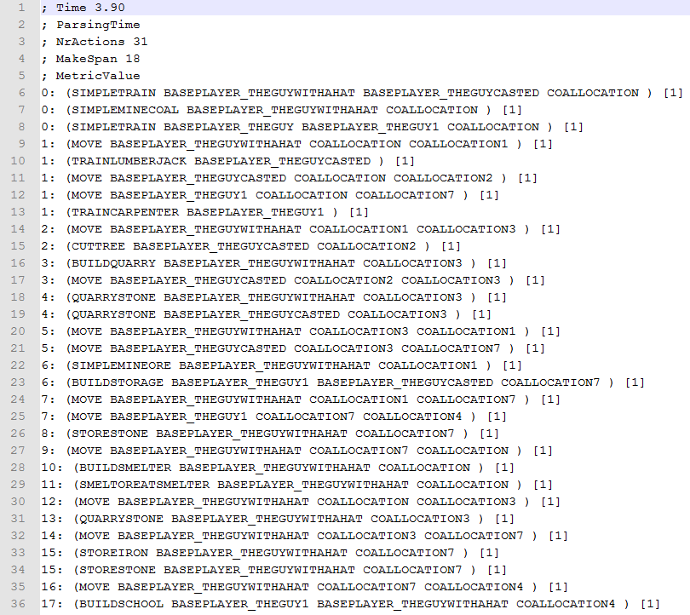
There are multiple ways to do PDDL but the final domain we came to was to have it slightly more specific. By doing this it means that the executive can interperate the move into a direct command for the entities in the world which it does so pefectly.

To go along with the PDDL task planner there was a problem that we were experiencing where it would take over 70+ seconds to generate a solution or it would not generate one at all. What we ended up doing to solve this was that we realised it was mistakingly building over the goal location and then could not actually build the goal. In order to fix this we made sure that when the problem file is generated that instead of using ‘and’ for the definition we used ‘or’ and placed all th avalible locations into it. In order to have mutiple solutions we can utilise both ‘and’ + ‘or’ to give us a significant speed increase with the generation of the solution. When we did this the search time to build a school went from generating half the time and taking 76 scnds to 0.83 secnds.

For the executive it successfully turns what is on the map itself into a stored list and then converts it into a problem file. It excecutes the task planner and then successfully reads in the solution file. Once the file has been read then it manages to evaluate it into sections to call the appropriate functions on a agent to allow the tasks to be carried out. It can also utilise the movement planner to actually move the agents around to carry out the solutions generated from the PDDL. It can generate any file and working with both other aspects comes together nicely to round it off and have all the major parts implemented and communicating. Most of the problems that cropped up in this part of the program were either grematical or slight mis comunication between two of the aspects the program has.

In conclusion a large percentage of the game scenario has been completed especially as the framework is there and working successfully together. Every aspect could do with slight polish but for the most part a lot has been done. We have the sections of the program working indevisually and on top of that working well together. There are a few aspects that would need inproving or adding to but the main core is complete along with the basis for the AI to successfully play against a player as there is a variable for allocating what team everything is assigned to.

Inprovements that would be the next part on the list would be re-looking at how the task planner works and seeing if there are any specifics to change maybe even reduce the detail so the executive can make more informed decisions using distances to reduce time. Along with this we would look at getting chunking working for the map generation allowing possibly infinitely sized maps to be allowed and also to enable to larger maps not to be shrunk slightly. If chunking was implemented more than it alreadyy is then we could also look at implementing the D* search algorithm to allow for more optomised and faster execution of complex path planning. We would also look at having pre-defined goals for the AI to achieve. For example there would be a list of what they have to do and what their end game is in order for them to be able to be played against. This is simple as the functionality is there it just requires time to do. It would also reduce compute times on the PDDL solution file as it would only have to solve on a building to building base or even two or three max. If we got all of this Implemented combat would be included within it as in order for the goal state to be a win state there has to be a way to destoy/beat th othe player. Further in the future we can look at adding trading and more fluents for that into the PDDL domain and also look at improving visuals but they are not a huge concern.

