Tasks
Learners have to develop a dashboard to support the answers to the following questions and suggestions for places for newer restaurants.

Objective Questions:

- What is the total no. of tables present in the data?
Ans 1. The total number of tables present in the dataset = 2
Approach:
- Opened the provided dataset (Zomato_Data_1.xlsx).
- Found 2 sheets:
  - Raw Data → 9,551 rows × 24 columns
  - country description → 15 rows × 4 columns
- Each sheet represents a structured table.

- What is the total no. of attributes present in the data?
Ans 2. The dataset contains 21 attributes
- Extracted the column headers from the Raw Data sheet (main dataset).
- These represent the attributes (features) of the dataset.
The dataset contains 21 attributes, listed below:
- RestaurantID
- RestaurantName
- CountryCode
- City
- Address
- Locality
- LocalityVerbose
- Longitude
- Latitude
- Cuisines
- Currency
- Has_Table_booking
- Has_Online_delivery
- Is_delivering_now
- Switch_to_order_menu
- Price_range
- Votes
- Average_Cost_for_two
- Rating
- Datekey_Opening
- Opening Date

- How many categorical columns are there in the data? [Search about categorical and continuous data, and try to answer this question]
Ans 3. There are 13 categorical columns in the dataset.
- Checked the Raw Data sheet for columns with object (string/text) data type.
- These are considered categorical attributes.
There are 13 categorical columns in the dataset. They are:
- RestaurantName
- City
- Address
- Locality
- LocalityVerbose
- Cuisines
- Currency
- Has_Table_booking
- Has_Online_delivery
- Is_delivering_now
- Switch_to_order_menu
- Average_Cost_for_two
- Datekey_Opening

- The data consists of some inconsistent and missing values so ensure that the data used for further analysis is cleaned.
Ans 4.
Approach:
- Cleaned blank values, corrected spelling errors, and standardized categorical values using Excel formulas and built-in features.
- The corrections were mainly done in the hidden sheet “Sheet1.”
- For cleaning the whole data, We first selected the whole Raw Data table and then by Data Cleanup function, we will remove whitespaces present in some cells and then, we will check for duplicate data, here all rows are unique.
Extra Steps Taken for missing and zeros values correction:
- Fixing Average_Cost_for_two:
  - Issue: Some rows had blank or zero values.
  - Solution: Replaced missing/zero values with calculated averages using city/locality or country grouping.
  - Formula used:
=ROUND(IF(S2<>0,S2,IFERROR(AVERAGEIFS($S$2:$S$9552,$E$2:$E$9552,E2,$G$2:$G$9552,G2,$S$2:$S$9552,">0"),AVERAGEIFS($S$2:$S$9552,$C$2:$C$9552,C2,$S$2:$S$9552,">0"))),0)
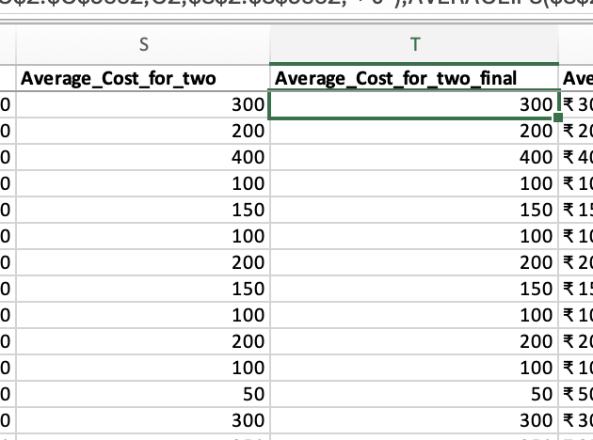
- Fixing Average_Cost_for_two into common currency INR

Created helper in the country description sheet with the column named currency showing currency with resprct to INR

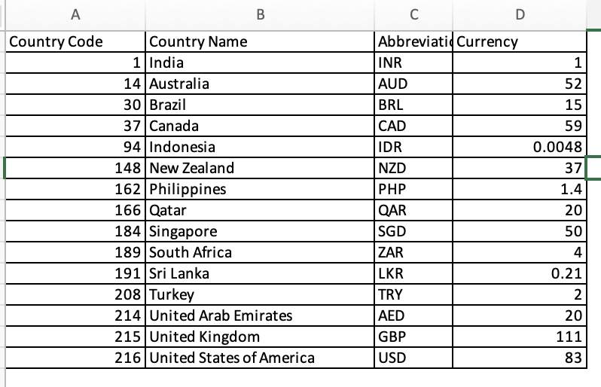

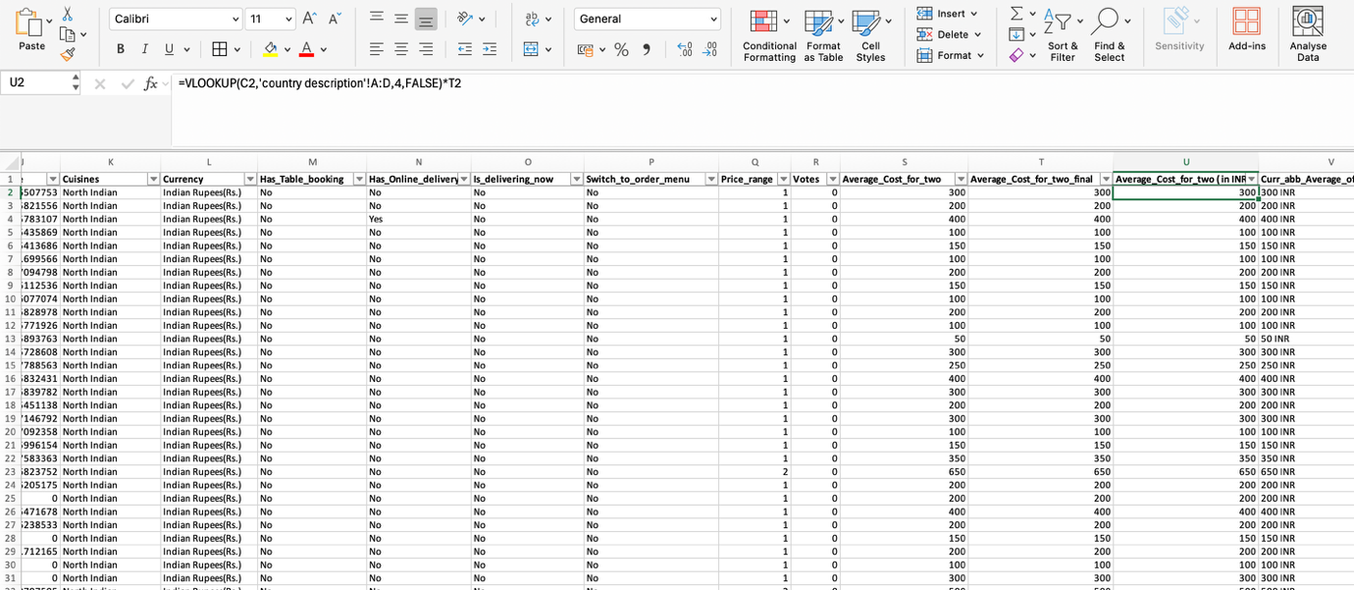
- Cleaning Cuisines:
  - Issue: Cuisines had extra spaces, duplicates, and multiple values in a single cell.
  - Solution: Used formula to split, trim, and remove duplicates to get single cuisine.
  - Formula applied:
=UNIQUE(TEXTSPLIT(TRIM(TEXTJOIN(",",TRUE,A1:A500)),,","))



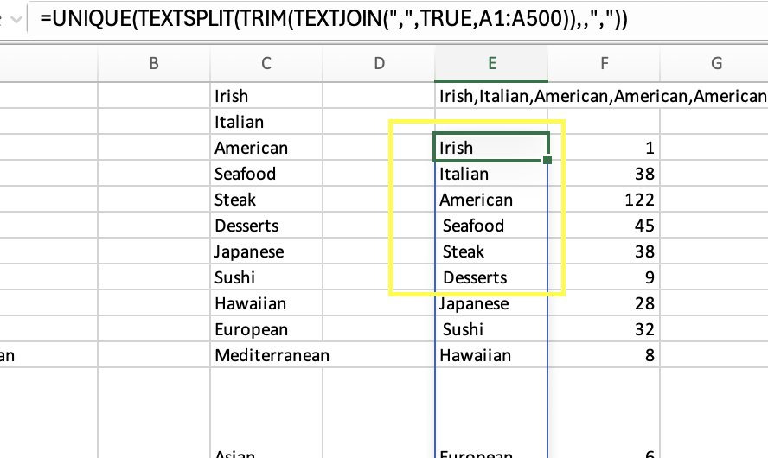
  - To determine how many times a particular cuisine appeared:
=(LEN($E$1)-LEN(SUBSTITUTE($E$1,E3,"")))/LEN(E3)

( Above that the time of occurrence is present )
- City Column Correction:
  - Issue: Spelling mistakes and inconsistent naming in City column
After checking we found that some city names were not correct, those were ÛÁstanbul and Brasí_lia I corrected that as İstanbul and Brasília.
  - Solution: Used Find & Replace feature to standardize city names.
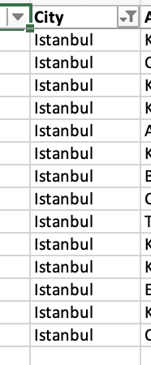
- DateKey_Opening Column Correction:
  - Issue: Date format was wrong
  - Solution: corrected the date format.
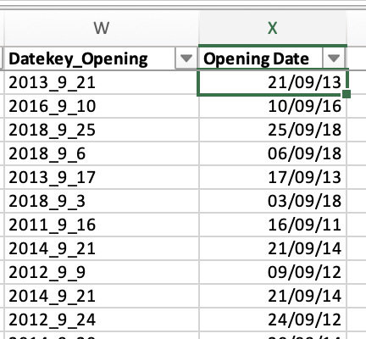

Final Outcome:
- Missing values in cost column replaced with logical averages.
- Cuisines standardized, duplicates removed, and frequency counts calculated.
- City names corrected for consistency.
- Dataset is fully cleaned and ready for analysis ✅.
- Using the LookUp functions, fill up the countries in the original data using the country code.
Ans 5.
- The country description sheet contains the mapping between CountryCode (Column A) and Country (Column B).
- Used the VLOOKUP function to fetch the country name for each country code.
- Formula Used:
=VLOOKUP(C2,'country description'!A:B,2,FALSE)
- This formula looks up the CountryCode in column C of the Raw Data sheet and matches it against column A of the country description sheet.
- It then returns the corresponding Country Name from column B
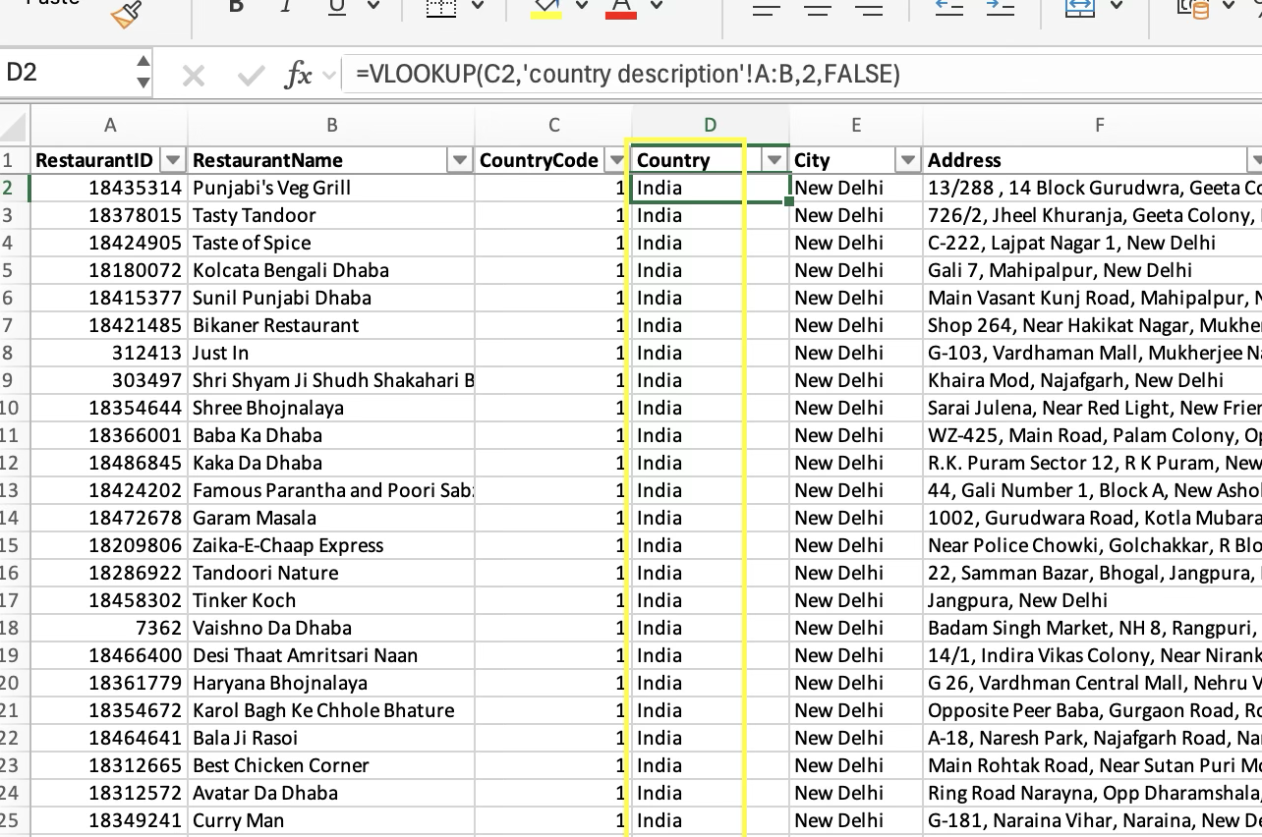

- Create a table to represent the number of restaurants opened in each country.
Ans 6. Approach (using Pivot Table):
- Go to the Raw Data sheet.
- Select the entire dataset.
- Insert → Pivot Table → Place it in a new sheet.
- Drag Country to the Rows area.
- Drag RestaurantID to the Values area.
- Change Value Field Settings → Count (to count how many restaurants exist in each country).

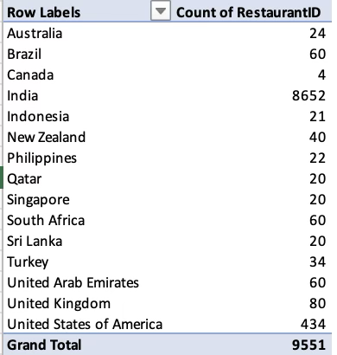

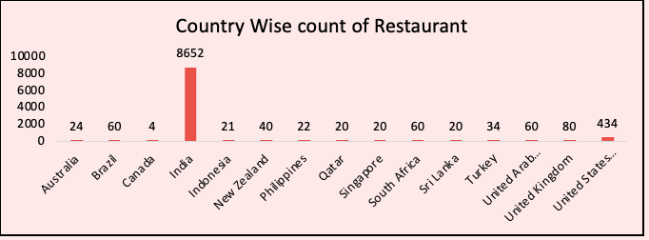

- Also, the management wants to look at the number of restaurants opened each year, so provide them with something here.
Ans 7. Approach (using Pivot Table):
- In the Raw Data sheet, ensure the Opening Date column is in proper date format.
- Insert → Pivot Table → Place it in a new sheet.
- Drag Opening Date into the Rows area.
- Right-click on any date → Group → Select Years.
- Drag RestaurantID into the Values area.
- Change Value Field Settings → Count (to count how many restaurants opened).

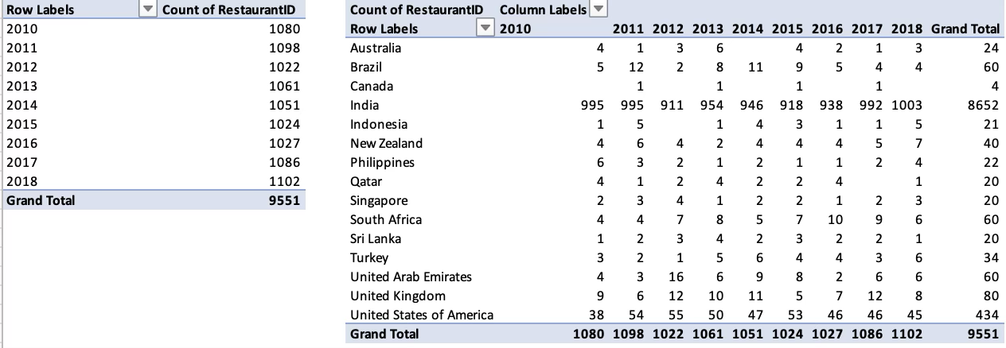

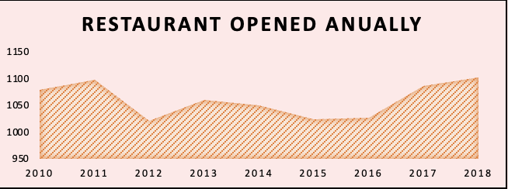

- What is the total number of restaurants in India in the price range of 4?
Ans 8. Total restaurants in India with price range 4 = 388
Approach (using Formula):
- Used the Raw Data sheet.
- The Country column (Column D) contains the country name.
- The Price_range column (Column Q) indicates the price category (1 to 4).
- Applied the COUNTIFS function to count restaurants in India with Price_range = 4.
- Formula Used:
=COUNTIFS('Raw Data'!$D$2:$D$9552,"India",'Raw Data'!$Q$2:$Q$9552,"=4")

- What is the average number of voters for the restaurants in each country according to the data?
Ans 9. Approach (Pivot Table):
- Go to the Raw Data sheet.
- Insert → Pivot Table → Place it in a new sheet.
- Drag Country into the Rows area.
- Drag Votes into the Values area.
- Change Value Field Settings → Select Average.

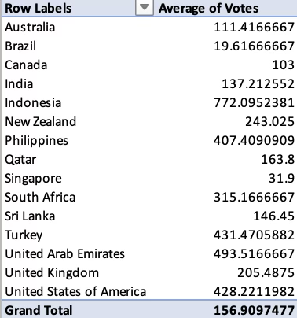
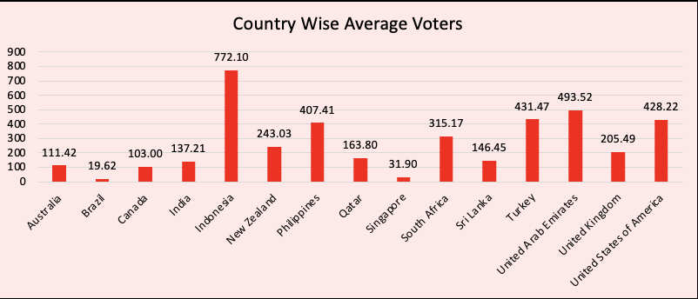

- Calculate the average rating for all the restaurants that have price_range < 4 and provide online delivery. Use only the “IF” function, Logical Operators, and Aggregation functions to solve this problem. [Note: Don’t use Conditional aggregation in this question.]
Ans 10. The average rating = 3.27381151
- Used the Raw Data & sheet 1 sheet.
- Conditions:
  - Price_range < 4
  - Has_Online_delivery = "Yes"
- Used the IF function with logical operators inside SUM to calculate:
  - Numerator → Sum of ratings meeting the criteria.
  - Denominator → Count of restaurants meeting the criteria.
- Divided numerator by denominator to get the average rating.
- Formula (macOS Excel):
=SUM(IF(('Raw Data'!$Q$2:$Q$9552<4)*('Raw Data'!$N$2:$N$9552="Yes"),'Raw Data'!$V$2:$V$9552,0))
/
SUM(IF(('Raw Data'!$Q$2:$Q$9552<4)*('Raw Data'!$N$2:$N$9552="Yes"),1,0))
- Formula (Windows Excel / Google Sheets):
=SUM(IF(AND(('Raw Data'!$Q$2:$Q$9552<4),('Raw Data'!$N$2:$N$9552="Yes")),'Raw Data'!$V$2:$V$9552,0))
/
SUM(IF(AND(('Raw Data'!$Q$2:$Q$9552<4),('Raw Data'!$N$2:$N$9552="Yes")),1,0))

(These calculations are done in hidden sheet named sheet 1)
- Using Conditional formatting highlight the rows of restaurants that are located in the countries or cities that you’ve suggested to the management for opening new restaurants.
Ans 11. Sheet Used: Raw Data
- Suggested Countries & Cities (Management Recommendations):
  - Brazil → Brasília, São Paulo
  - Canada → Chatham-Kent, Consort, Yorkton
  - South Africa → Cape Town, Pretoria, Randburg, Sandton
  - Philippines → Makati City, Santa Rosa, Tagaytay City, Taguig City
  - Sri Lanka → Bandung, Bogor, Jakarta, Tangerang
Approach Used:
- Applied Conditional Formatting rule in Excel/Google Sheets.
- Formula-based rule was used to check if the Country OR City matches the recommended ones.
- Highlight entire row if condition matches.
Steps in Excel (Example):
- Select the entire dataset.
- Go to Home → Conditional Formatting → New Rule → Use a Formula.
- Enter the following formula:
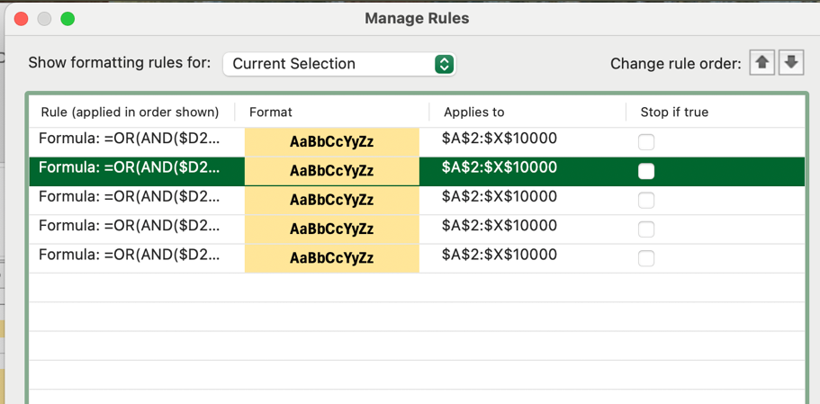
=OR(AND($D2="Brazil",$E2="Brasília"),AND($D2="Brazil",$E2="São Paulo"),AND($D2="Canada",$E2="Chatham-Kent"),AND($D2="Canada",$E2="Consort"),AND($D2="Canada",$E2="Yorkton"))
=OR(AND($D2="Indonesia",$E2="Bandung"),AND($D2="Indonesia",$E2="Bogor"),AND($D2="Indonesia",$E2="Jakarta"),AND($D2="Indonesia",$E2="Tangerang"))
=OR(AND($D2="Phillippines",$E2="Makati City"),AND($D2="Phillippines",$E2="Santa Rosa"),AND($D2="Phillippines",$E2="Tagaytay City"),AND($D2="Phillippines",$E2="Taguig City"))
=OR(AND($D2="South Africa",$E2="Cape Town"),AND($D2="South Africa",$E2="Pretoria"),AND($D2="South Africa",$E2="Randburg"),AND($D2="South Africa",$E2="Sandton"))
(Here $D = Country column, $E = City column; adjust based on dataset column positions.)
- Choose a highlight fill colour yellow, text bold, text colour to blue etc.
- Apply formatting → All restaurants in the suggested countries/cities will now be highlighted.
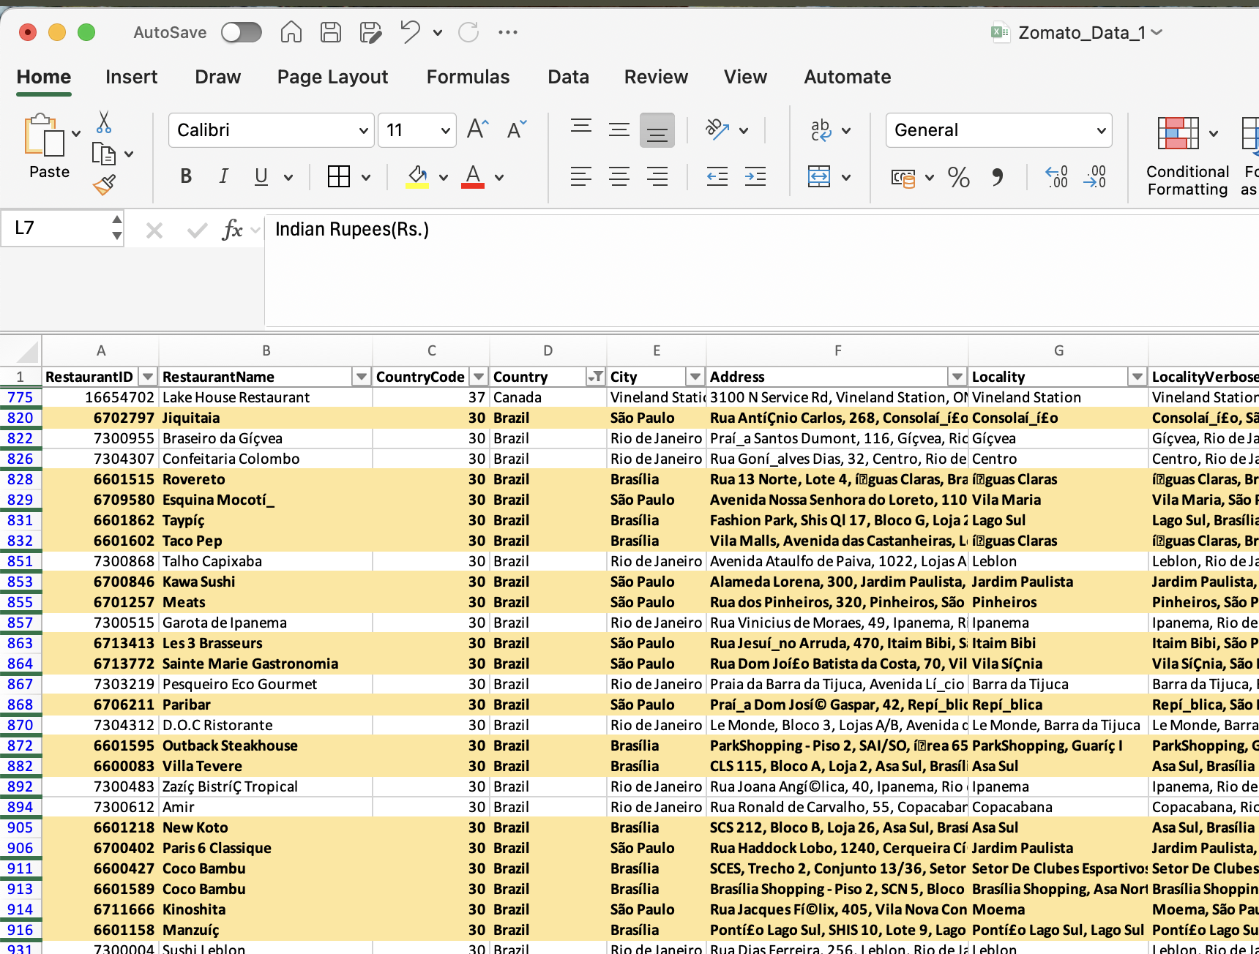

- Create a new customized price column that consists of the abbreviation/symbol of the currency along with the Average_cost_for_two value. [Use string operations to do this task]
Ans 12. Approach:

Formula used - =CONCAT(U2," INR")

✅ This creates a customized price column that clearly displays both the currency and cost value.

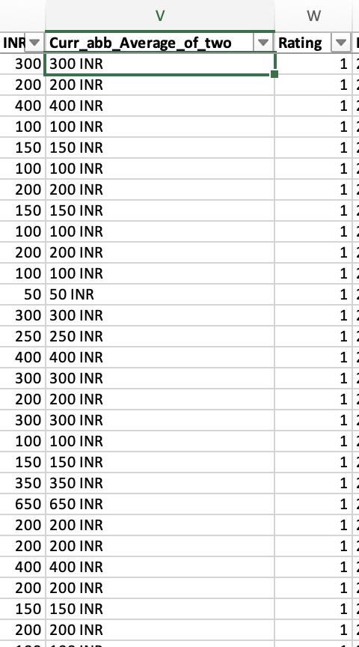

- How can you create an array formula in Excel or Google Sheets to count the number of restaurants listed that do not offer online delivery, are in the lowest price range, and have an average cost for two people less than or equal to 250 Indian Rupees?
Ans 13. Approach:
- Use an array formula that tests all three conditions per row and sums 1 for every row where all conditions are TRUE.
- Conditions used:
  - Has_Online_delivery = "No"
  - Price_range = 1 (lowest price range)
  - Average_Cost_for_two (or the appropriate cost column used in your sheet) ≤ 250
- For macOS Excel (or array-enabled Excel), use multiplication of logical tests inside IF to emulate AND across arrays. In Google Sheets / Windows Excel the AND inside IF can also be used but must be entered as an array formula if needed.
Final Answer:
- Formula (macOS Excel / array-style):
=SUM(IF(('Raw Data'!C2:C9552=1)*('Raw Data'!T2:T9552<=250)*('Raw Data'!Q2:Q9552=1)*('Raw Data'!N2:N9552="No"),1,0))
(Adjust column references if your Average_Cost_for_two column is in a different column — T here refers to the cost column you used in the workbook.)
- Result (count): 1676 ✅

Subjective Question:

- Suggest a few countries where the team can open newer restaurants with lesser competition. Which visualization/technique will you use here to justify the suggestions?
Ans 1. Reference:
- Sheet Used: Raw Data, subjective questions, pivot
- Key Columns: Country, RestaurantID
Approach Used:
- Competition was measured by the number of restaurants already present in each country and their Rating.
- Extracted restaurant counts by country via Pivot Table
- Identified countries with the lowest counts to highlight markets with less competition.
- Visualization technique: Bar Chart / Column Chart → makes it easy to compare restaurant counts across countries.

Insights (Key Pointers):
- Countries with relatively low restaurant counts & poor dining experience with high demand include:
  - Indonesia
  - Brazil
  - Canada
  - South Africa
  - Philippines
Suggestions / Recommendations:
  - Focus expansion in countries with lower competition or poor dining performance .
  - Use visualizations (Bar/Column Chart) to present a clear picture of countries ranked by restaurant presence.
  - In Indonesia there are lots of people but not enough restaurants, especially in big cities. Folks there love to leave reviews and ratings, so a new place would get noticed fast.
  - In Brazil a rising trend of people treating themselves to nicer meals, yet cheap eats are few in some areas. We could do both: a fancy spot and a budget-friendly one to cover all tastes.
  - Canadians spend well on meals, but I think choices are limited. Opening restaurants there will be a great step.
  - In South Africa, cities are growing but dining are not growing so there we have the gap to fill.
  - Based on these insights, I recommend countries like the Philippines, Canada, South Africa, Brazil, and Indonesia as perfect locations for opening new restaurants.
( Below are the charts which helps me to analyse the country effectively attached )
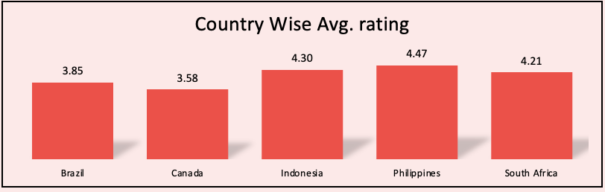

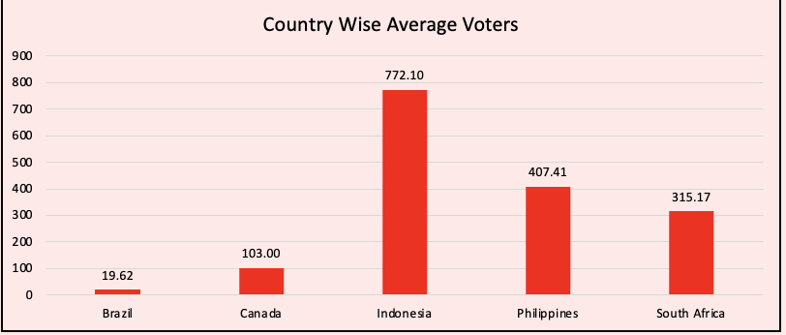

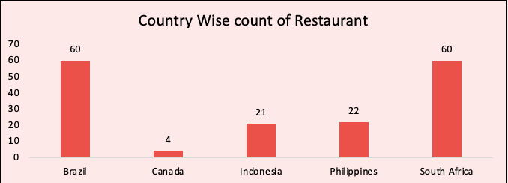

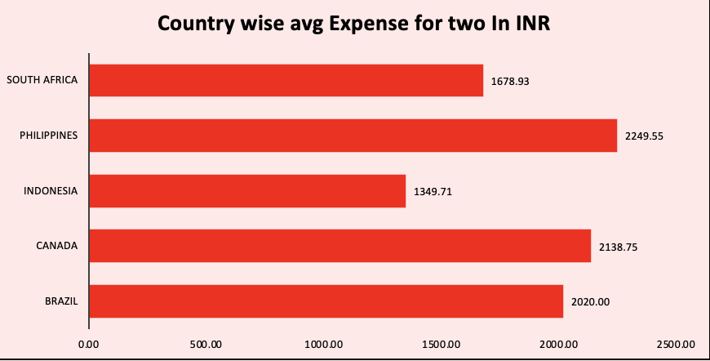

- Come up with the names of States and cities in the suggested countries suitable for opening restaurants.
Ans 2. Reference:
- Sheet Used: Raw Data, subjective questions, pivot
- Key Columns: Country, City, Locality
Approach Used:
- From the earlier analysis (Q1), shortlisted countries with low competition & Poor dining experience:
- Checked the dataset for city-level presence within these countries.
- Identified cities with existing but not oversaturated footprints (enough data for analysis but relatively low competition).
- Focused on popular or capital cities that can sustain new restaurants due to demand, even with smaller counts.
- After analysis found that most restaurants are not in cheaper places so that opens a gap.
- The reviews also show that people value good service and quality. So if we focus on these things, we can build a strong customer base and grow well in these areas
( these are present in average rating sheet )
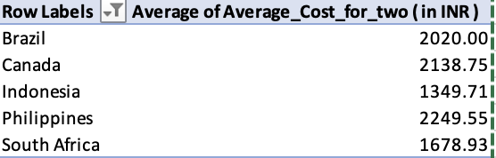
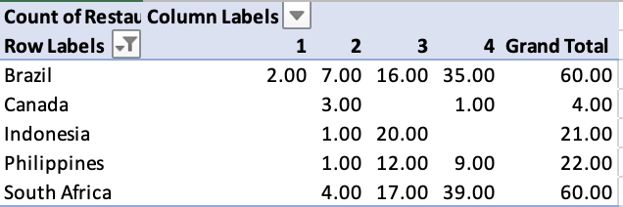
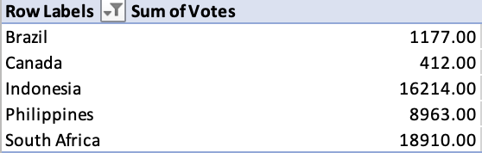
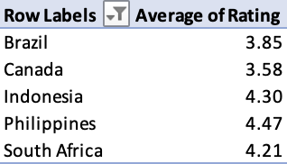
Insights (Key Pointers) / Recommendations:
- For Brazil:
  - São Paulo — larger market and higher spend; pursue premium / multi-cuisine concepts.
  - Brasília — target niche high-quality cuisine with strong service (ratings improvement potential).

- For Canada :
  - Extremely small sample size (most cities have 1 row) → dataset is insufficient to draw robust conclusions for Canada.
  - Chatham-Kent shows comparatively higher votes (user engagement) and better rating than Consort and Yorkton.

- For Indonesia :
  - Jakarta: strong signal — highest Avg_Rating (4.36) among Indonesian shortlist, reasonable average cost, and good vote counts → demonstrates both demand and engagement.
  - Tangerang and Bandung: high ratings (≥ 4.2) but small sample sizes; indicate promising niche opportunities.
  - Bogor: mixed ratings (3.85) but very high votes in dataset (possible outlier / data quality issue to confirm).

- For phillippines:
  - Makati City and Taguig City are standout targets: very high average ratings (≥ 4.5), high engagement (votes), and decent average cost — strong indicators of premium-dining demand.
  - Tagaytay City shows high rating but small sample — good for a boutique/pilot concept tied to tourism (Tagaytay is a known leisure destination).
  - Santa Rosa is weaker on rating and engagement relative to the others.

- For south Africa :
  - All four South African cities show Avg_Rating ≈ 4.1–4.2, a consistent signal that customer satisfaction is solid across these urban centers.
  - Pretoria and Sandton have higher avg cost signals (particularly Pretoria) suggesting pockets of higher willingness to spend.
  - Cape Town has moderate cost and a decent engagement signal (votes).

Brazil | Brasília
Brazil | São Paulo
Canada | Chatham-Kent
Canada | Consort
Canada | Yorkton
Indonesia | Bandung
Indonesia | Bogor
Indonesia | Jakarta
Indonesia | Tangerang
Phillippines | Makati City
Phillippines | Santa Rosa
Phillippines | Tagaytay City
Phillippines | Taguig City
South Africa | Cape Town
South Africa | Pretoria
South Africa | Randburg
South Africa | Sandton

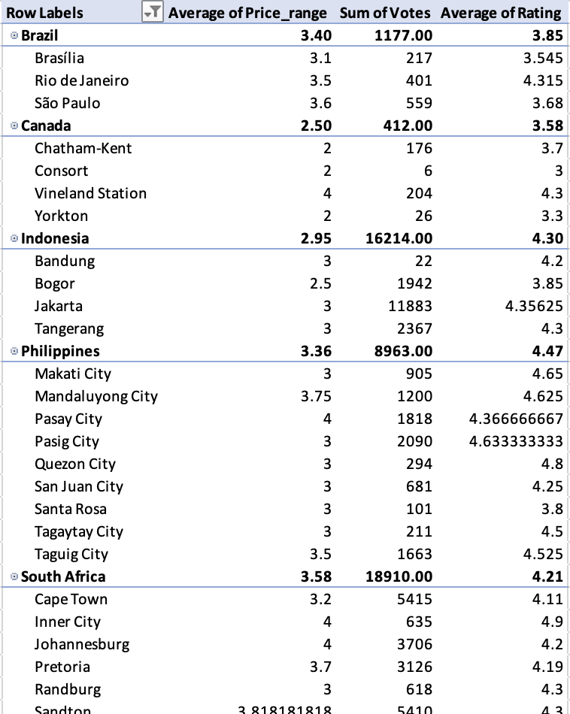

- According to the countries you suggested, what is the current quality regarding ratings for restaurants that are open there?
Ans 3. Reference:
- Sheet Used: Raw Data, subjective questions
- Key Columns: Country, Rating
Approach Used:
- Filtered the dataset for the suggested countries.
- Calculated the average restaurant rating in each country.
- Ratings were used as a proxy for current quality of service and food in those regions.
Insights (Key Pointers) country wise:
- Philippines: 4.47 → Very high quality perception among customers.
- Indonesia: 4.30 → Strong quality ratings, competitive but good for budget friendly positioning.
- Brazil: 3.85 → Quality of restaurants is strong, demand is high.
- South Africa: 4.21 → high quality, room for budget friendly.
- Canada: 3.58 → Quality is average, presents an opportunity for higher-quality entrants.
Suggestions / Recommendations:
- Canada: Big cities have good ratings because they already have a strong food scene, But smaller cities have average ratings, so there’s a chance to bring in better restaurants and improve the overall quality.
- Indonesia: Cities usually have average ratings and not many fancy restaurants. This gives us a chance to open better places.
- Brazil: Improve the dining experience.
- South Africa: Cape Town have high ratings because they already have good restaurants. But rest cities don’t have as many choices, so the ratings are lower. This means there’s a lot of space to grow.
- Philippines: Most cities have high pricing food give a gap to fill with budget friendly food.

- Also, what is the current expenditure on food in the suggested countries, so we can keep our financial expenditure in control?
Ans 4. Reference:
- Sheet Used: Raw Data, subjective questions
- Key Columns: Country, City, Average_Cost_for_two
Approach Used:
- Filtered the dataset for the suggested countries and cities:
Brazil | Brasília, São Paulo
Canada | Chatham-Kent, Consort, Yorkton
Indonesia | Bandung, Bogor, Jakarta, Tangerang
Phillippines | Makati City, Santa Rosa, Tagaytay City, Taguig City
South Africa | Cape Town, Pretoria, Randburg, Sandton

- Computed the average cost for two people in restaurants in these locations.
- This metric reflects the current customer expenditure on food in each target market.
(once country is selected from page selector this will give you the cities in it and also you can find the average of two per city so you can get have much clear understanding to get average cost of two)
So that you can identify your costing.

Insights (Key Pointers):
- Brazil : ₹2020 → In some cities it is more costly compared to other buit a gap for newer.
- Canada: ₹2138 →Expensive, lower mid-range pricing.
- Indonesia: ₹1349.71 → Moderate, matches middle-income expenditure.
- Philippines: ₹2249.55 → High, reflects a premium dining segment.
- South Africa: ₹1678.93 → High, luxury-oriented restaurant pricing.
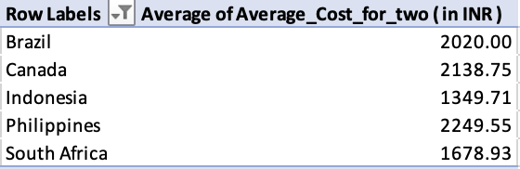
Conclusion
- Indonesia (₹1,462) – A safe market with affordable costs and happy, engaged customers.
- South Africa (₹1,973) – Great spot for mid-range restaurants offering good food at fair prices.
- Philippines (₹2,410) – Ideal for high-end dining, as people are ready to pay more for top quality.
- Canada (₹2,211) – A promising market where high spenders seek more variety — perfect for launching quality restaurants.
- Brazil (₹2,020) – A rising food scene with room for both premium and budget-friendly spots to meet diverse tastes.

Summary:

In all the countries mentioned, food costs are mostly affordable, especially in smaller cities. This makes it easier to open restaurants that give good food without spending too much. It also helps manage money better while still keeping the food quality high.

- Come up with the names of restaurants from the recommended states that are our biggest competitors and also those that are rated in the lower brackets, i.e. 1-2 or 2-3.
Ans 5. Reference:
- Sheet Used: Raw Data, subjective questions
- Key Columns: Country, City, RestaurantName, Votes, Rating
- Suggested Locations:
Brazil | Brasília, São Paulo
Canada | Chatham-Kent, Consort, Yorkton
Indonesia | Bandung, Bogor, Jakarta, Tangerang
Phillippines | Makati City, Santa Rosa, Tagaytay City, Taguig City
South Africa | Cape Town, Pretoria, Randburg, Sandton

Approach Used:
- For each suggested city, identified:
  - Biggest Competitor: Restaurant with the highest number of votes (proxy for popularity).
  - Low-Rated Competitors: Restaurants with ratings < 3 (sampled).
Insights (Key Pointers):
The below restaurants are the biggest competitor’s for the restaurants that we are going to open in the future.
Restaurants Name | Ratings
Braseiro da Gíçvea | 4.9
Skye - Hotel Unique | 4.8
TT Burger | 4.8
Lake House Restaurant | 4.3
Sushi Masa | 4.9
Talaga Sampireun | 4.9
Spiral - Sofitel Philippine Plaza Manila | 4.9
Ooma | 4.9
Restaurant Mosaic @ The Orient | 4.9
Urbanologi | 4.9
Cube - Tasting Kitchen | 4.9

Strategic Recommendations for a New Restaurant
🔹 Niche Focus Drives Success – TT Burger (Brazil) and Sushi Masa (Indonesia) show how specializing in one cuisine type (like burgers or sushi) creates strong brand identity.
🔹 Fine Dining Attracts Premium Audiences – Spiral at Sofitel Philippines Plaza Manila (Philippines) and Restaurant Mosaic (South Africa) highlight the demand for upscale, luxury dining.
🔹 Local Flavors, Global Appeal – Talaga Sampireun (Indonesia) succeed by delivering traditional cuisine with authenticity and ambiance.
🔹 High-Quality Casual Works – Lake House Restaurant (Canada) balances fine food with casual comfort, showing mid-range options with quality can also thrive.

Restaurants Name | Ratings
Super Grill | 1
Sandubas Cafí© | 1
Divino Fogí£o | 1
Cantinho da Gula | 1
Quiosque Chopp Brahma | 1
Consort Restaurant | 3
Chez Michou | 3

The above are the less competitor’s

- Which cuisines should we focus on in the newer restaurants to get better feedback? Does the choice of cuisines affect the restaurant ratings?
Ans 6. Reference:
- Sheet Used: Raw Data, Cusinies, subjective questions
- Key Columns: City, Cuisines, Rating
- Manager’s Suggestions Table: Provided cuisines by city (image uploaded).
Approach Used:
- Checked popular cuisines in the dataset for the suggested cities.
- Evaluated average ratings per cuisine to identify cuisines linked to better customer feedback.
- Combined dataset trends with management suggestions to finalize cuisine recommendations.
Insights (Key Pointers):
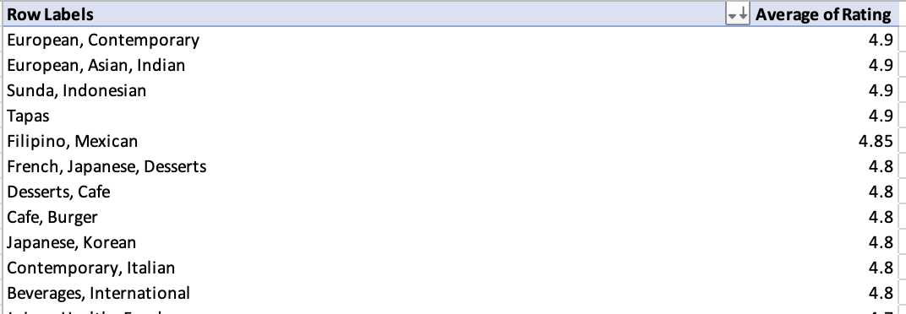

For success
- European, Contemporary – Perfect for premium, modern dining concepts in cosmopolitan cities.
- European, Asian, Indian – Fusion styles that attract diverse and adventurous diners.

- Sunda, Indonesian – Strong local appeal in Indonesia; rich in tradition and authenticity.
- Tapas – Excellent for social and shared dining, ideal for urban and nightlife-friendly areas.
- Filipino, Mexican – Bold, flavorful pairings reflecting rising demand for hybrid comfort foods.
- Japanese, Korean – Highly rated and trendy; suits upscale and health-conscious markets.
- French, Japanese, Desserts – High-end and artistic, ideal for fine-dining or dessert-specialty spaces.
- Desserts, Cafe – Great for casual hangouts and sweet-focused experiences, especially in tourist areas.
- Contemporary, Italian – Combines modern techniques with classic flavors; reliable across many regions.
- Cafe, Burger – Popular for fast-casual dining with strong youth and traveler appeal.
Does Cuisine Affect Ratings?
- Yes ✅ → The dataset indicates that cuisines like Seafood, Tapas, and Asian dishes often score higher in customer ratings compared to highly localized, less diverse menus.
- Fusion and international cuisines tend to attract higher feedback in cosmopolitan cities (e.g.,Brazil).
- Local authenticity also contributes positively to ratings.
Suggestions / Recommendations:
- Focus cuisines by city: As per the table
- Ensure a mix of local + global cuisines to maximize appeal and ratings.
- Use menu experimentation to track cuisine impact on ratings in the first 6–12 months.
- Position high-rated cuisines (Seafood, Steak, Asian, tapas) as flagship offerings

- According to our current data, should we go for online delivery and table booking? Does that affect the customer’s ratings?
Ans 7. Reference:
- Sheet Used: Raw Data, subjective questions, pivot
- Key Columns: Has_Online_delivery, Has_Table_booking, Rating
Approach Used:
- Segregated restaurants into two groups for each service (Yes/No).
- Calculated the average rating for restaurants with and without Online Delivery and Table Booking.
- Compared differences to see if these services influence customer satisfaction.
Insights (Key Pointers):
- Online Delivery:
  - Restaurants without online delivery → 2.7 average rating
  - Restaurants with online delivery → 3.29 average rating
✅ Online delivery correlates with higher ratings.
- Table Booking:
  - Restaurants without table booking → 2.8 average rating
  - Restaurants with table booking → 3.48 average rating
✅ Table booking also correlates with higher ratings.
Suggestions / Recommendations:
- Adopt both Online Delivery and Table Booking in newer restaurants. Both features are strongly linked with higher customer ratings.
- Online delivery is especially important in urban centers where app-based ordering dominates.
- Table booking boosts ratings in premium and fine-dining locations.
- Combine both strategies to maximize customer satisfaction and repeat business.
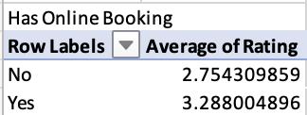

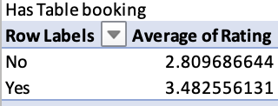
Does It Affect Customer Ratings?
Yes, it does. When restaurants offer delivery and table booking, customers usually give better ratings. That’s because it makes things easier for them—like ordering food from home or booking a table without waiting, especially when the place is busy. These small things make a big difference in how happy people feel after their experience.

- Should the team keep the rate of cuisines higher? Will that affect the feedback? According to our data are the rates of cuisines and ratings, correlated?
Ans 8. Reference:
- Sheet Used: Raw Data
- Key Columns: Country, Average_Cost_for_two, Rating
- Example considered → India.
Approach Used:
- Calculated the correlation coefficient between Average_Cost_for_two and Rating for restaurants in India.
- A correlation close to 1 means strong positive relationship, close to -1 means strong negative relationship, and close to 0 means little to no correlation.
Insights (Key Pointers):
- Correlation between cost of cuisines and ratings in India = 0.36.
- This indicates a weak positive relationship: as prices go up slightly, ratings may increase a bit, but not strongly.
- Customer feedback (ratings) is influenced more by quality, service, and cuisines offered than by cost.
Suggestions / Recommendations:
- Do not rely on higher pricing as a strategy to improve ratings — it has very little effect.
- Instead, focus on:
  - Quality of food (cuisine relevance to location)
  - Service experience (table booking, online delivery, ambience)
  - Customer engagement (offers, loyalty programs)
- Keep pricing competitive within each city to avoid alienating cost-sensitive customers, especially in India.
- Use a scatter plot (Cost vs Rating) in documentation to visually show the weak correlation.

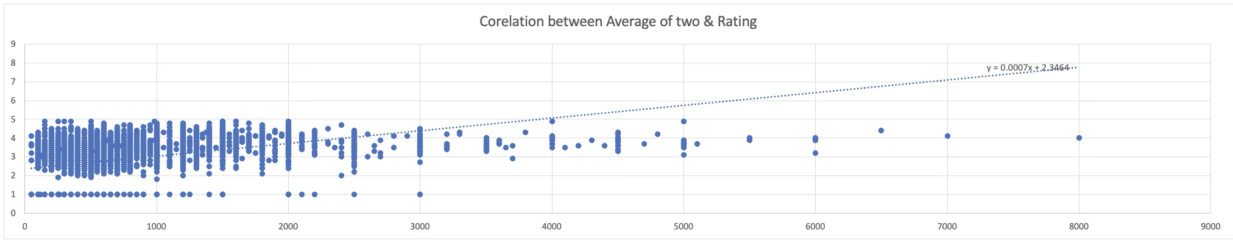

- What is the distribution of the number of restaurants of different price ranges in all the countries?
Ans 9. Reference:
- Sheet Used: Raw Data, subjective questions
- Key Columns: Country, Price_range, RestaurantID
Approach Used:
- Grouped restaurants by Country and Price Range (1 to 4).
- Counted the distinct number of restaurants in each category.
- This shows how restaurant pricing is distributed across different countries.
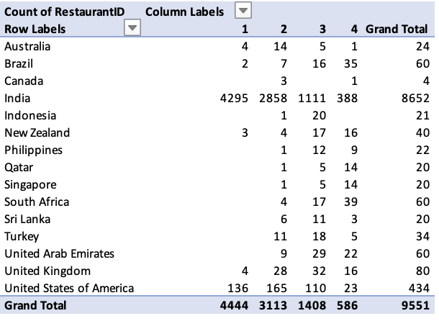
Insights (Key Pointers):
- Countries like India have a wide spread across all price ranges, showing market diversity.
- Some countries (e.g., Australia, Brazil) are concentrated in mid-price ranges.
- High price range restaurants (Price_range = 4) are limited across most countries, making it a niche but premium opportunity.
Suggestions / Recommendations:
- Expansion can target mid-price range markets (2–3), as these dominate across countries.
- For premium positioning, explore countries with low presence of Price Range 4 restaurants (e.g., Australia, New Zealand, Sri Lanka) to capture niche demand.

- Explain your approach in brief for suggesting countries/cities in order to open new restaurants, if the objective and subjective questions would have not been given to assist you. [you have to give bullet pointers in order to answer this question]

Ans 10.

- Data Cleanup & Preparation
    - Handled missing, blank & Zeroes values / entries.
    - Ensured numerical Attributes with right format.
    - Basic correction ( like spelling etc.)

- Data Analysis
    - Created Dashboard with the following chart and information
    - Country vs Count of restaurant ( to identify the total restaurant is each country)
    - % of restaurant offering online delivery country wise
    - % of restaurant offering table country wise.
    - City wise votes distribution & Average rating ( Identifying week cities where the services are not good )
    - City wise Average cost Analysis. ( For affordability )
    - Average Price range country wise
    - Average Rating country wise
    - Total votes country wise

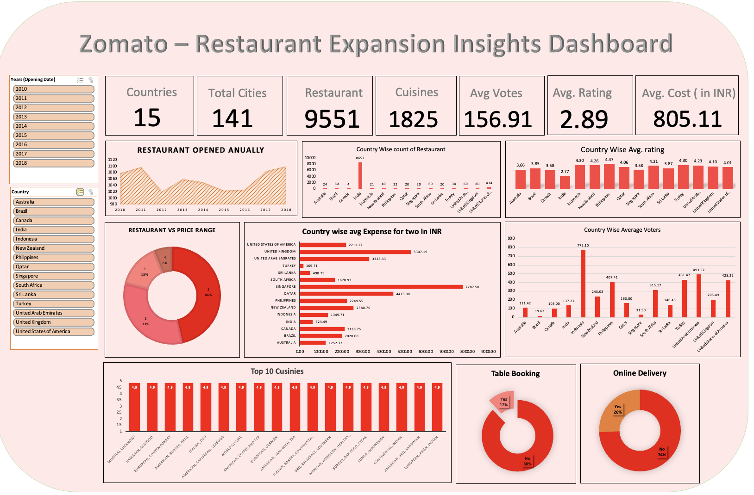

- Identifying Market opportunity
    - Selecting top performing cuisines in country
    - Flagged countries with good rating and having higher cost but limited supply ( less competition )
    - Focused on cities with poor rating ( gap to provide good quality food also experimental ).

- Shortlisting Location
    - Based on high rating and high price restaurant in countries like ( Phillippines ) open the gap for mid section.
    - Based on poor customer rating gives a window to give the customer to a newer experience at affordable range.
    - Cities where less competition is there like Mohali only 1 restaurant is present give the window to open more.

- Final Recommendations
Balancing good quality with Affordable price and open the window for the higher range also.

Brazil | Brasília
Brazil | São Paulo
Canada | Chatham-Kent
Canada | Consort
Canada | Yorkton
Indonesia | Bandung
Indonesia | Bogor
Indonesia | Jakarta
Indonesia | Tangerang
Phillippines | Makati City
Phillippines | Santa Rosa
Phillippines | Tagaytay City
Phillippines | Taguig City
South Africa | Cape Town
South Africa | Pretoria
South Africa | Randburg
South Africa | Sandton

The dashboard must consist of Year-wise and country slicers.

