CloudSentinel CSPM Functional Business Requirements Document
Functional BRD - CSPM capabilities, technical architecture, and SaaS UI reference
Document control | Value
Product | CloudSentinel CSPM
UI reference project | cloudsentinel-saas
Document type | Functional Business Requirements Document
Version | 2.2
Date | 27 August 2026
Status | Functional draft for product and engineering approval
Scope | Cloud Security Posture Management only
Initial cloud | AWS
Planned clouds | Microsoft Azure and Google Cloud
Primary owners | Product, Cloud Security, Engineering, GRC

1. Executive summary
CloudSentinel CSPM is a functional cloud-control-plane security product. It connects customer cloud accounts, discovers resources, evaluates configuration, correlates risky relationships, prioritizes findings, supports remediation decisions, scans Infrastructure as Code, and reports technical compliance posture.
Cloud providers already supply strong security controls and native posture products. Customers still struggle with fragmented account coverage, inconsistent policies, unclear ownership, excessive findings, weak evidence, configuration drift, and different remediation processes across clouds. CloudSentinel will address these operating problems through one evidence-backed CSPM workflow.
CloudSentinel will not compete by offering another list of configuration failures. It will compete through:
- Transparent coverage across accounts, regions, and supported clouds.
- Evidence-backed findings with observed configuration, source, freshness, and confidence.
- Contextual risk prioritization using exposure, privilege, resource relationships, environment, and business criticality.
- Prevention through Infrastructure as Code scanning and policy gates.
- Governed remediation with ownership, approval, verification, exceptions, and audit history.
- Unified compliance evidence without claiming that technical checks prove certification.
This document defines how each CSPM function must behave from user input through processing, output, error handling, authorization, and acceptance. Release 1 remains AWS-first. Azure and GCP remain preview until their inventory, policy, onboarding, evidence, and acceptance requirements meet the same product standard.

2. Purpose
This BRD defines functional business requirements for CloudSentinel as a CSPM product. It covers actors, product screens, inputs, processing rules, outputs, validations, permissions, workflows, acceptance conditions, non-functional requirements, delivery gates, and success measures.
It also records the logical CSPM reference architecture and current repository-backed technical baseline needed to make the functional requirements testable. It is not a substitute for detailed API schemas, database schemas, threat models, test plans, or implementation tasks; those documents must trace back to approved requirements in this BRD.

3. CSPM product definition
CloudSentinel CSPM is a cloud control-plane security product. It uses cloud configuration metadata, policies, relationships, tags, logs of configuration changes, and Infrastructure as Code to answer five questions:
- What cloud resources exist?
- Which resources violate required security policy?
- Which violations create material risk in their current context?
- Who owns the risk and what safe change will reduce it?
- Has the risk been fixed, and has it returned?

3.1 CSPM capability boundary
Included in CSPM | Excluded from this BRD
Cloud account and organization onboarding | Endpoint detection and response
Cloud asset inventory and relationships | Host and container CVE scanning
Configuration and policy assessment | Runtime eBPF detection
Internet exposure and control-plane reachability | Malware detection and sandboxing
Baseline identity configuration posture | Full Cloud Infrastructure Entitlement Management
Posture-based attack paths | Sensitive-content discovery and DSPM
Compliance control mapping and evidence | Data loss prevention
Configuration drift and posture history | SIEM, SOAR, or incident response replacement
IaC scanning and deployment prevention | Offensive exploitation or penetration testing
Finding workflow, exceptions, remediation, and verification | Application source-code SAST or DAST
Reporting, APIs, and operational integrations | Cloud workload protection platform features

Baseline identity posture includes configuration checks such as missing MFA, dangerous public trust, wildcard administrative access, stale privileged credentials, and unsafe workload roles. Advanced effective-permission analysis, rightsizing, identity behavior analytics, and entitlement lifecycle management belong to CIEM and remain outside this BRD.
Posture attack paths may correlate cloud configuration, network exposure, identity trust, and resource access relationships. They must not depend on runtime, vulnerability, or sensitive-content products to produce a valid CSPM result.

4. Product vision and principles

4.1 Vision
CloudSentinel gives every cloud risk an owner, evidence, business context, safe remediation path, and verified closure.

4.2 Product principles
- Evidence before assertion: Every finding shows observed values, data source, collection time, policy logic, and affected scope.
- Coverage before score: Missing permissions, unsupported services, failed regions, and stale scans reduce reported coverage. They never appear as passing controls.
- Context before severity: Priority reflects exposure, privilege, relationships, business criticality, environment, confidence, and compensating controls.
- Read-only by default: Cloud onboarding and assessment use least-privilege read access.
- Human-controlled change: Remediation requires approval unless a tenant administrator explicitly enables a bounded automation policy.
- Code-first durability: When IaC manages a resource, remediation should update source configuration before or with the live-resource change.
- No compliance theater: A technical control result supports assurance but does not prove legal or regulatory compliance.
- Provider complement: Native AWS, Azure, and GCP findings may be ingested and enriched. CloudSentinel need not duplicate every provider control.
- Explainable decisions: Users can understand why an issue exists, why it has its priority, and what evidence closes it.
- Tenant isolation: Customer data, policy, evidence, findings, and integrations remain isolated by tenant.

5. Business problem
Target customers face these problems:
- Cloud resources are distributed across many accounts, subscriptions, projects, and regions.
- Asset inventories become stale and often omit newly created or short-lived resources.
- Native cloud posture tools use different policy models, severity schemes, workflows, and reports.
- Security teams receive many isolated findings without enough context to identify material risk.
- A failed collection or missing permission can look like a secure environment.
- Remediation guidance often changes a live resource without correcting the IaC source, causing recurrence.
- Finding ownership is unclear across central security, platform, and application teams.
- Exceptions are stored in tickets or spreadsheets without expiry and revalidation.
- GRC teams manually collect screenshots and cannot easily prove continuous control operation.
- Leaders cannot measure whether posture programs reduce risk or only close alerts.

6. Business objectives
ID | Objective | Initial target
BO-01 | Establish trusted cloud visibility | Discover at least 95% of supported, permitted assets within freshness SLA
BO-02 | Expose collection gaps | Show 100% of known permission, region, API, and freshness gaps
BO-03 | Reduce posture noise | Consolidate raw findings into at least 60% fewer actionable issues during pilots
BO-04 | Improve prioritization | Rank all Critical and High issues using exposure, privilege, business context, and confidence
BO-05 | Accelerate ownership | Assign or route at least 90% of Critical and High issues to an owner or queue
BO-06 | Reduce remediation time | Reduce median time to remediate Critical and High issues by 50% from pilot baseline
BO-07 | Prevent insecure deployment | Evaluate integrated IaC changes before deployment and block approved policy violations
BO-08 | Prevent recurrence | Revalidate 100% of closed Critical issues after relevant change or scheduled reassessment
BO-09 | Reduce audit effort | Generate at least 70% of supported technical evidence automatically
BO-10 | Support multicloud governance | Apply one normalized policy and workflow model across GA-supported clouds

Targets must be baselined with design partners before becoming contractual service commitments.

7. Target customers

7.1 Ideal customer profile
- Uses 20 or more cloud accounts, subscriptions, or projects.
- Has an AWS-led environment or an active multicloud program.
- Operates decentralized engineering teams under centralized security or GRC governance.
- Has regulated, audit-sensitive, internet-facing, or business-critical workloads.
- Experiences alert overload, ownership gaps, recurring misconfiguration, or high audit effort.
- Uses Infrastructure as Code and ticketing or source-control workflows.

7.2 Buyer and user personas
Persona | Business need | Required CSPM experience
CISO or security leader | Understand material cloud risk and trend | Executive risk view, coverage, recurring risks, SLA, and risk acceptance
Cloud security engineer | Find, prioritize, and resolve posture risk | Evidence, relationships, queries, policy, suppression, and verification
Cloud or platform engineer | Fix configuration safely | Exact resource, observed state, required state, IaC guidance, impact, and rollback
Application owner | Understand and own issues affecting a service | Business context, due date, remediation steps, and status
GRC analyst or auditor | Evaluate continuous technical controls | Framework mapping, evidence provenance, scope, exceptions, and history
Product administrator | Configure tenant, users, clouds, policies, and integrations | RBAC, SSO, onboarding health, policy assignment, and audit logs
MSP operator | Manage multiple customer tenants | Strong isolation, delegated administration, customer-level reporting, and fleet health

8. Business assumptions
- Customers authorize read-only cloud access for discovery and assessment.
- Customers remain responsible for approving and implementing changes in their environments.
- Cloud provider APIs, quotas, regional availability, and eventual consistency affect collection time.
- Supported control coverage varies by cloud, service, region, and permission scope.
- Technical control checks contribute evidence but do not certify compliance.
- AWS reaches GA before Azure and GCP.
- Production remediation automation requires separate security review and customer opt-in.
- Customer tags, account hierarchy, CMDB data, or repository metadata provide business ownership context when available.

9. CSPM capability model
Capability | Business outcome
1. Secure cloud onboarding | Fast connection without storing long-lived cloud credentials
2. Asset inventory and normalization | Complete, searchable view of supported cloud resources
3. Configuration policy assessment | Continuous detection of insecure cloud configurations
4. Exposure and relationship analysis | Distinguish theoretical configuration weakness from reachable risk
5. Contextual risk prioritization | Focus teams on issues with greatest likely business impact
6. Compliance posture and evidence | Continuous technical-control visibility with defensible evidence
7. Drift and posture history | Identify new, recurring, and long-standing configuration risk
8. Shift-left IaC security | Prevent approved policy violations before deployment
9. Governed remediation | Move each issue from discovery to verified closure
10. Reporting and integrations | Embed CSPM results into customer operating workflows
11. Policy administration | Manage built-in, custom, versioned, and scoped policies
12. Platform administration | Operate a secure multitenant enterprise service

10. Functional product specification

10.1 Product snapshot notice
Screenshots in this document were captured from the dedicated cloudsentinel-saas user interface project and its embedded CSPM demonstration dataset on 26 August 2026. The screens represent the intended product experience; they do not prove that every displayed action is connected to a production backend. Resource names, account identifiers, findings, counts, dates, and scores are illustrative test data. They are not customer security results or production service-level evidence.
Only CSPM screens and CSPM functions are specified by this document. Navigation entries for runtime, vulnerability, DSPM, or other CNAPP modules visible in the current interface remain outside this BRD.

10.2 Functional navigation map
Product area | UI page or module | Primary actor | Core function | CSPM status
Dashboard | Dashboard - Security posture | Security leader, analyst | Summarize posture, material risk, workflow, coverage, and next actions | In scope
Cloud accounts | Settings - Onboarding and Cloud accounts | Administrator | Connect, verify, scan, and offboard cloud accounts | In scope
Inventory | Inventory - All assets and scoped views | Analyst, engineer | Search assets and inspect exposure, ownership, configuration, and posture | In scope
Asset detail | Inventory - Selected asset detail | Analyst, engineer | Investigate one asset, evidence, relationships, configuration, and activity history | In scope
Findings | Findings - All findings and Misconfigurations | Analyst, engineer | Triage, filter, export, re-evaluate, and remediate configuration findings | In scope
Attack paths | Attack paths - Critical, internet, lateral, and resolved | Analyst | Review correlated posture paths, confidence, hops, and remediation priority | In scope
IaC security | Planned shift-left CSPM module | Developer, platform engineer | Scan Terraform plan JSON or CloudFormation before deployment | In scope; UI not represented in current prototype
Compliance | Compliance - Overview, controls, exceptions, and evidence | GRC, auditor, security leader | Review framework controls, score technical posture, and capture snapshots | In scope
Policy settings | Settings - Risk policy and Scan settings | Administrator, policy owner | Configure policy, framework, thresholds, and product behavior | In scope where related to CSPM

10.3 Actor and permission matrix
Function | Administrator | Security analyst | Cloud engineer | GRC or auditor | Read-only executive
View dashboard and coverage | Yes | Yes | Yes | Yes | Yes
Connect or offboard account | Yes | No | Optional delegated | No | No
Trigger inventory scan | Yes | Yes | Optional delegated | No | No
Search inventory and asset detail | Yes | Yes | Yes | Yes | Yes
Re-evaluate findings | Yes | Yes | Optional delegated | No | No
Assign or change finding state | Yes | Yes | Assigned scope | No | No
Request exception | Yes | Yes | Assigned scope | No | No
Approve exception | Yes, when authorized | Optional separate role | No | Optional separate role | No
Scan IaC | Yes | Yes | Yes | No | No
Change policy configuration | Yes | Policy owner only | No | Framework mapping only | No
Capture compliance snapshot | Yes | Yes | No | Yes | No
Export findings or evidence | Yes | Yes | Assigned scope | Yes | Summary only
Approve cloud mutation | Separate privileged permission | No | Separate privileged permission | No | No

No role may approve its own exception or high-impact remediation when tenant separation-of-duty policy requires a second approver.

10.4 End-to-end functional flow
Stage | User input | System processing | User-visible output | Failure behavior
1. Connect | Provider, account scope, region, deployment option | Generate onboarding package, verify trust and temporary access | Connection status and permission coverage | Show exact failed trust, permission, or provider operation
2. Discover | Manual scan or configured schedule | Collect supported resource metadata and normalize assets | Inventory, counts, relationships, freshness | Preserve previous valid state and mark failed scope degraded
3. Evaluate | Enabled policy packs and parameters | Apply versioned checks to fresh evidence | Pass, fail, unknown, error, not-applicable | Never convert missing evidence into pass
4. Correlate | Asset, identity, network, and access relationships | Build supported posture paths and group related findings | Material-risk issues and attack paths | Mark incomplete paths unknown with missing evidence
5. Prioritize | Business criticality, environment, exposure, privilege, confidence | Calculate contextual priority | Ranked findings and issues with explanation | Retain provider severity if context calculation fails
6. Act | Assignment, remediation choice, exception, or ticket | Enforce permission, approval, scope, and audit rules | Guidance, action status, ticket, or approved exception | Reject unauthorized or unsafe mutation without changing cloud state
7. Verify | Rescan or relevant configuration event | Collect fresh evidence and re-evaluate affected policies and paths | Verified resolved, reopened, still open, or unknown | Never close from manual status alone
8. Report | Scope, framework, date, filters, format | Aggregate current or historical evidence | Dashboard, CSV, JSON, compliance report | Show freshness and coverage limitations in every report

10.4.1 CSPM technical reference architecture
The CSPM architecture is AWS-first and agentless. A customer deploys a customer-owned, read-only AWS IAM role with a tenant-specific ExternalId. The platform assumes that role only for the registered account, collects supported configuration metadata, normalizes it, and persists evidence in the relational data store. That relational store is the system of record: it holds assets, policy results, issues, graph edges, compliance snapshots, scan state, and audit-relevant timestamps.
The platform builds an in-memory AssetGraph from persisted graph edges to analyse supported posture paths. A Neo4j projection may be enabled for ad-hoc query and exploration, but it is not a serving dependency and does not replace the relational source of truth. The architecture below intentionally excludes runtime telemetry, host or container vulnerability scanning, sensitive-content discovery, and full effective-permission CIEM.
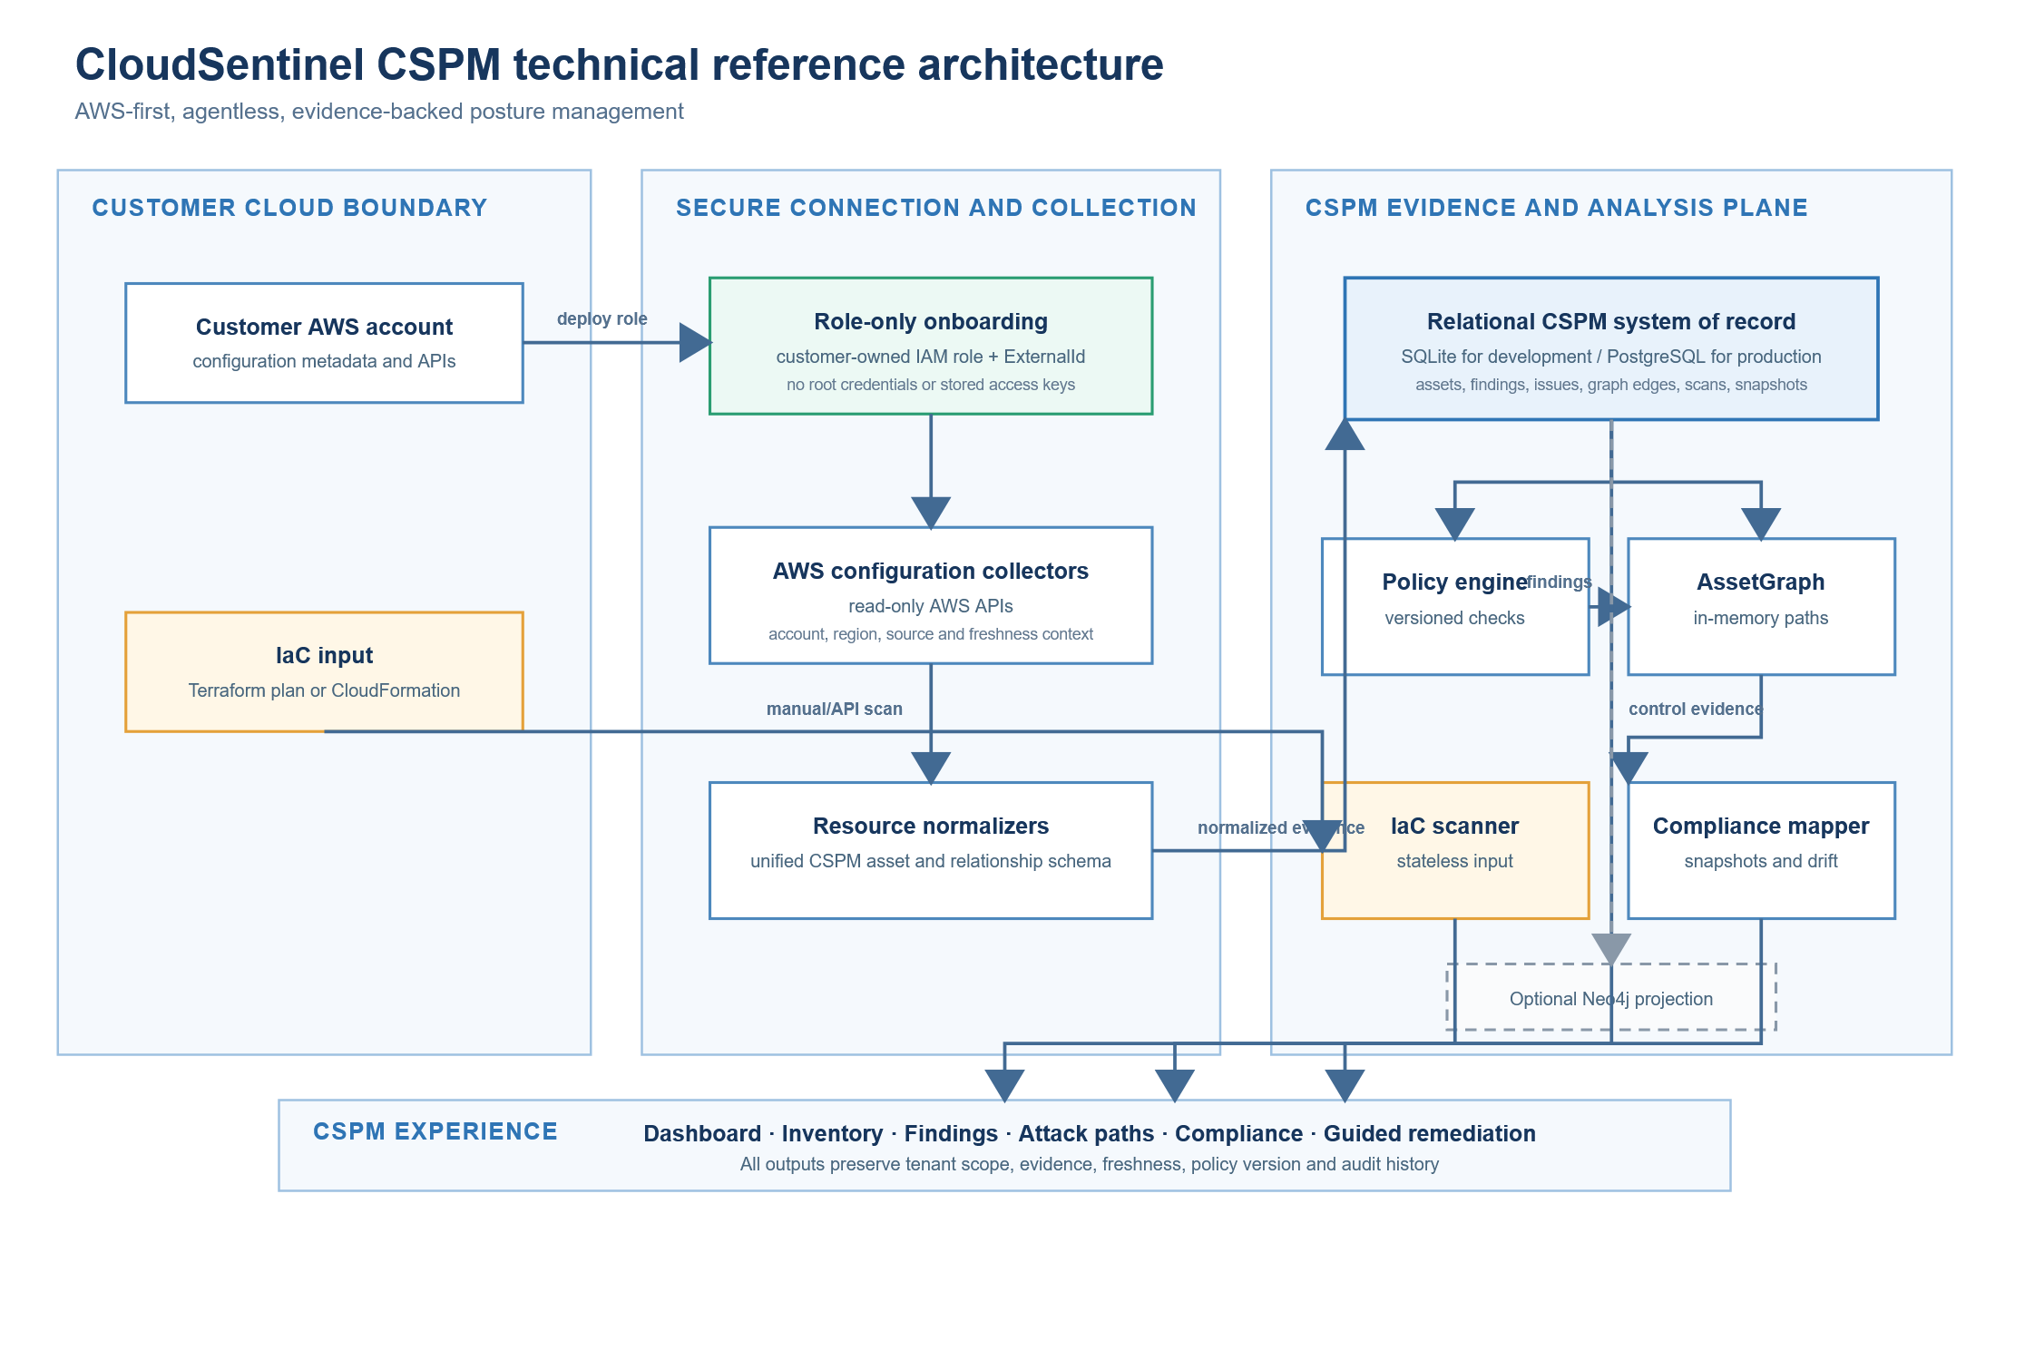
Figure 1. CSPM technical reference architecture rendered from the Mermaid definition: secure AWS onboarding, collection and normalization, SQL evidence, policy and graph analysis, IaC scanning, compliance evidence, and user workflows
Architecture processing rules:
- The platform shall operate CSPM collection through the registered cross-account role. It shall not use customer root credentials, stored access keys, or credentials from a different AWS account.
- Each collected record shall carry tenant, account, region, source, collection time, scan run, and evidence-freshness context before it is eligible for policy evaluation.
- The relational store shall remain the authoritative record for CSPM state. Optional graph exports must be reconstructable from the relational records and must not become required to return posture results.
- The graph engine shall label a relationship as observed or inferred, retain evidence references for every reported path hop, and lower confidence when required evidence is absent.
- The system shall treat failed collection, unsupported service, missing permission, stale evidence, and evaluation error as explicit coverage states. None may be represented as a passed control.
- IaC scans shall be isolated from customer account collection: template or plan input is evaluated statelessly, sensitive values are redacted, and source content is not retained unless a separately approved retention policy applies.
- Azure and GCP adapters may be developed behind the same normalized model, but their current shallow collector coverage is preview only and is not equivalent to AWS CSPM GA.

10.4.2 CSPM technical functions and evidence flow
Technical function | Current logical component | Input | Processing and evidence | CSPM output | Scope status
Secure onboarding | Onboarding template and account-registration service | AWS account selection, role ARN, ExternalId | Generates CloudFormation or Terraform package; validates trust and assumes only the registered role | Connection health, account record, permission coverage, last-verified time | AWS functional baseline
Discovery and normalization | AWS collector and resource normalizers | Read-only AWS configuration APIs | Collects supported resource metadata; converts provider records to a unified asset model; persists source and freshness metadata | Searchable assets, relationships, coverage and scan status | AWS functional baseline
Policy evaluation | Versioned CSPM rule engine | Normalized assets, relationships, policy parameters | Evaluates configuration and combination rules against versioned evidence | Pass, fail, unknown, error, not-applicable, and finding rationale | AWS functional baseline
Relationship correlation | AssetGraph built from persisted graph edges | Asset, identity, network, and access relationships | Enumerates supported paths in memory with bounded traversal; preserves path-hop evidence and confidence | Correlated issues, attack paths, blast-radius context | AWS functional baseline for supported patterns
Contextual prioritization | Issues and priority logic | Findings, exposure, privilege, environment, ownership, confidence | Groups related findings and calculates explainable priority | Ranked issue with risk factors and remediation order | Functional baseline; calibration required
Compliance evidence | Compliance mapper and snapshot records | Active findings, framework mapping, scope and date | Maps technical controls, stores immutable snapshot metadata, and compares snapshots for drift | Framework score, control state, evidence list, drift trend | Functional baseline; GRC validation required
IaC assessment | Terraform and CloudFormation scan service | Terraform plan JSON or CloudFormation JSON/YAML | Parses supported input, evaluates supported policies, redacts secrets, and returns normalized results | IaC findings, severity, resource identifier, rationale, remediation | Manual or API invocation; automated PR gating is roadmap
Presentation and action | CSPM API and UI | Authorized tenant scope, user filters, reporting request | Enforces scope, presents evidence and freshness, records workflow actions | Dashboard, inventory, findings, attack paths, reports, exceptions, exports | Functional baseline

10.4.3 Current CSPM technical limits and roadmap boundary
Capability | Current CSPM position | Product treatment in this BRD
AWS configuration collection | Deepest current implementation, with multiple resource operations, normalizers, and rule types | Release 1 implementation baseline; production readiness still requires coverage, performance, and security validation
Azure and GCP collection | Shallow storage-focused collectors | Preview only; not marketed as multicloud CSPM coverage or used for GA score parity
Event-driven reassessment | Listener module exists but is not wired into the active scan workflow | Roadmap; scheduled and manual reassessment remain the supported functional path
Optional Neo4j projection | Write-through or export option where configured | Optional exploration capability only; SQL remains the system of record
IaC CI or pull-request gating | Scanner accepts direct input or manual CI invocation | Roadmap; do not claim GitHub App, PR comments, automated blocking, or source-line mapping
Runtime, vulnerability, DSPM, and full CIEM | Separate CNAPP capabilities | Excluded from CSPM scoring, functionality, screenshots, and acceptance gates

10.5 Dashboard function
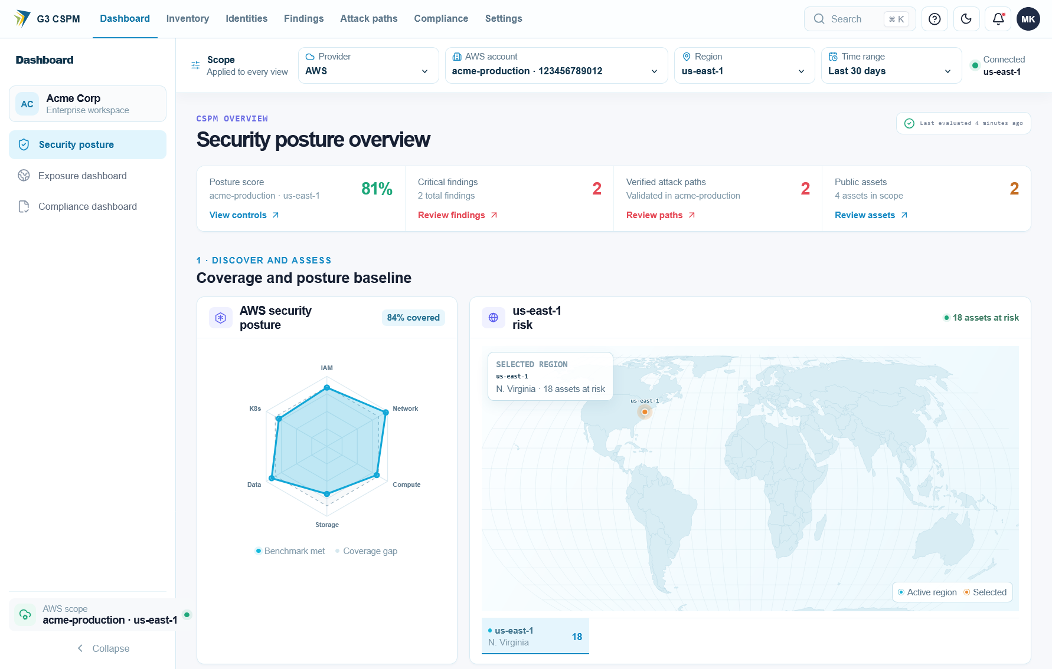
Figure 2. CloudSentinel SaaS CSPM dashboard showing posture score, critical findings, verified attack paths, public assets, service coverage, and regional risk
The dashboard is the CSPM decision workspace. It must summarize current posture without requiring users to interpret every raw finding.
Element | Input or source | Functional behavior | Output or action
Account scope | Global scope selector | Re-query every dashboard widget within authorized account scope | All accounts or selected account posture
Security brief | Open contextual findings | Select highest-priority unresolved decision signal | Critical count and triage action
Operating workflow | Account, inventory, issues, verification state | Determine furthest completed CSPM lifecycle stage | Connect, Discover, Prioritize, Act, Verify status
Assets | Active inventory | Count active assets in selected scope | Click-through to filtered inventory
Public assets | Exposure evaluation | Count assets with verified public exposure | Click-through to public inventory
Active threats | Active configuration findings | Count active posture findings, excluding suppressed hygiene | Click-through to findings
Critical | Open highest-severity issues | Count unresolved Critical items | Start triage action
Source coverage | Collection coverage | Show healthy, degraded, absent, stale, and unsupported sources | Coverage details and corrective action
Next actions | Role and current posture | Rank permitted actions for active persona | Triage, inspect path, scan, or report

Dashboard acceptance rules:
- Every count must use same selected account scope.
- Loading, empty, stale, degraded, and error states must be visually distinct.
- Zero findings with degraded collection must not be displayed as secure.
- Clicking a metric must preserve scope and filter context on destination screen.
- Dashboard must state data freshness when latest supporting evidence exceeds configured SLA.

10.6 Cloud account onboarding function
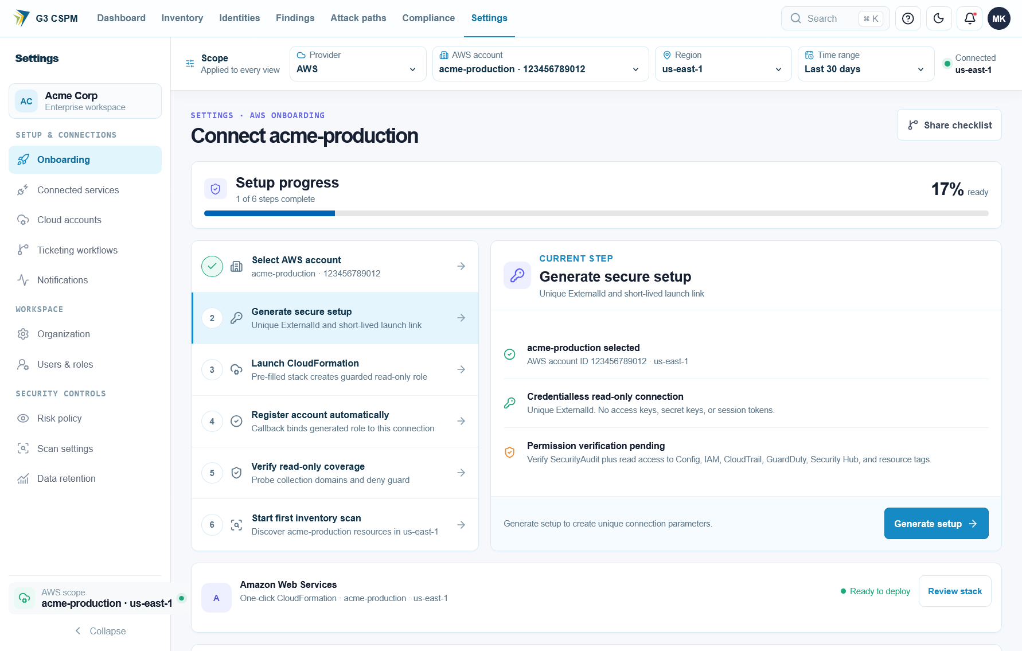
Figure 3. CloudSentinel SaaS onboarding screen showing account selection, secure setup generation, CloudFormation deployment, connection registration, permission verification, and first inventory scan
Cloud account onboarding establishes read-only CSPM access. AWS Release 1 supports CloudFormation or Terraform deployment, temporary role assumption, tenant-specific ExternalId validation, account registration, permission verification, manual scan, and offboarding.
Step | User action | Validation | Stored output
Select provider | Choose AWS and desired account model | Provider enabled for tenant | Draft onboarding session
Generate package | Choose CloudFormation or Terraform | Template version approved and hosting available | Session ID, expiry, template version, ExternalId hash or reference
Deploy customer role | Customer reviews and deploys package | Role trust includes approved platform principal and correct ExternalId | Role ARN and account identifier
Register callback or manual role | Customer stack reports role ARN or administrator registers it | Account ID matches role ARN; session active; duplicate handling defined | Cloud connection record
Verify access | Administrator selects Verify | AssumeRole succeeds and required read APIs are tested | Health, permission results, last verified time
Initial scan | Administrator starts scan | Connection healthy; no conflicting scan | Scan job and progress
Offboard | Administrator requests disconnect | Confirmation, authorization, retention policy | Inactive connection and revocation instructions

Onboarding must not state that nothing is deployed in the customer environment when the selected method creates an IAM role, policies, callback resources, event rules, or telemetry components. UI text must accurately describe every resource created by each onboarding mode.

10.7 Inventory function
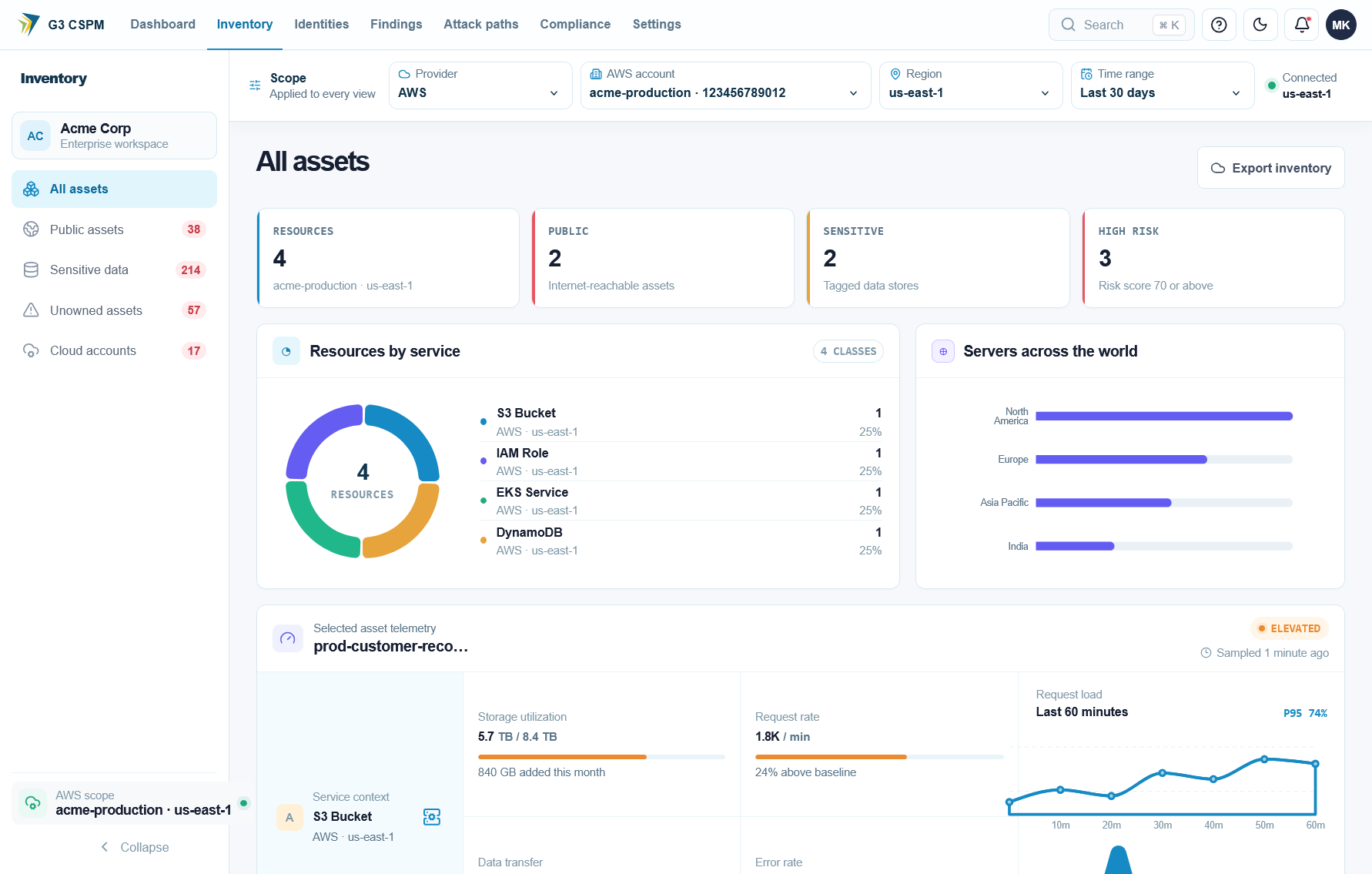
Figure 4. CloudSentinel SaaS inventory showing resource totals, public and sensitive assets, high-risk assets, service distribution, regional context, and asset telemetry
Inventory is the searchable system of record for supported cloud resources and CSPM relationships.
User control | Functional requirement
Category tabs | Filter by All, Network, Data, Compute, Identity, Security, Management, or Other
Search | Match authorized resource name, ARN or native ID, normalized ID, and type
Service filter | Limit results to selected provider service
Region filter | Limit results to selected region or global scope
Exposure filter | Limit results to public, private, unknown, or not-applicable exposure
Risk filter | Limit results by contextual risk severity
Sort | Support risk, name, type, last seen, and exposure where available
Resource row | Show name, native identifier, service, normalized type, region, exposure, and owner
Resource selection | Open summary panel without losing list filters
Full asset action | Open asset detail page with selected asset ID

Inventory processing rules:
- Asset identity must remain stable across scans.
- Failed collection cannot deactivate an asset.
- Public exposure must distinguish verified reachability from a permissive but blocked rule.
- Unknown owner, region, or exposure must display as unknown, not blank or secure.
- Asset detail must expose configuration evidence, related findings, relationships, and freshness.
- Current and historical asset state must remain distinguishable.

10.8 Findings function
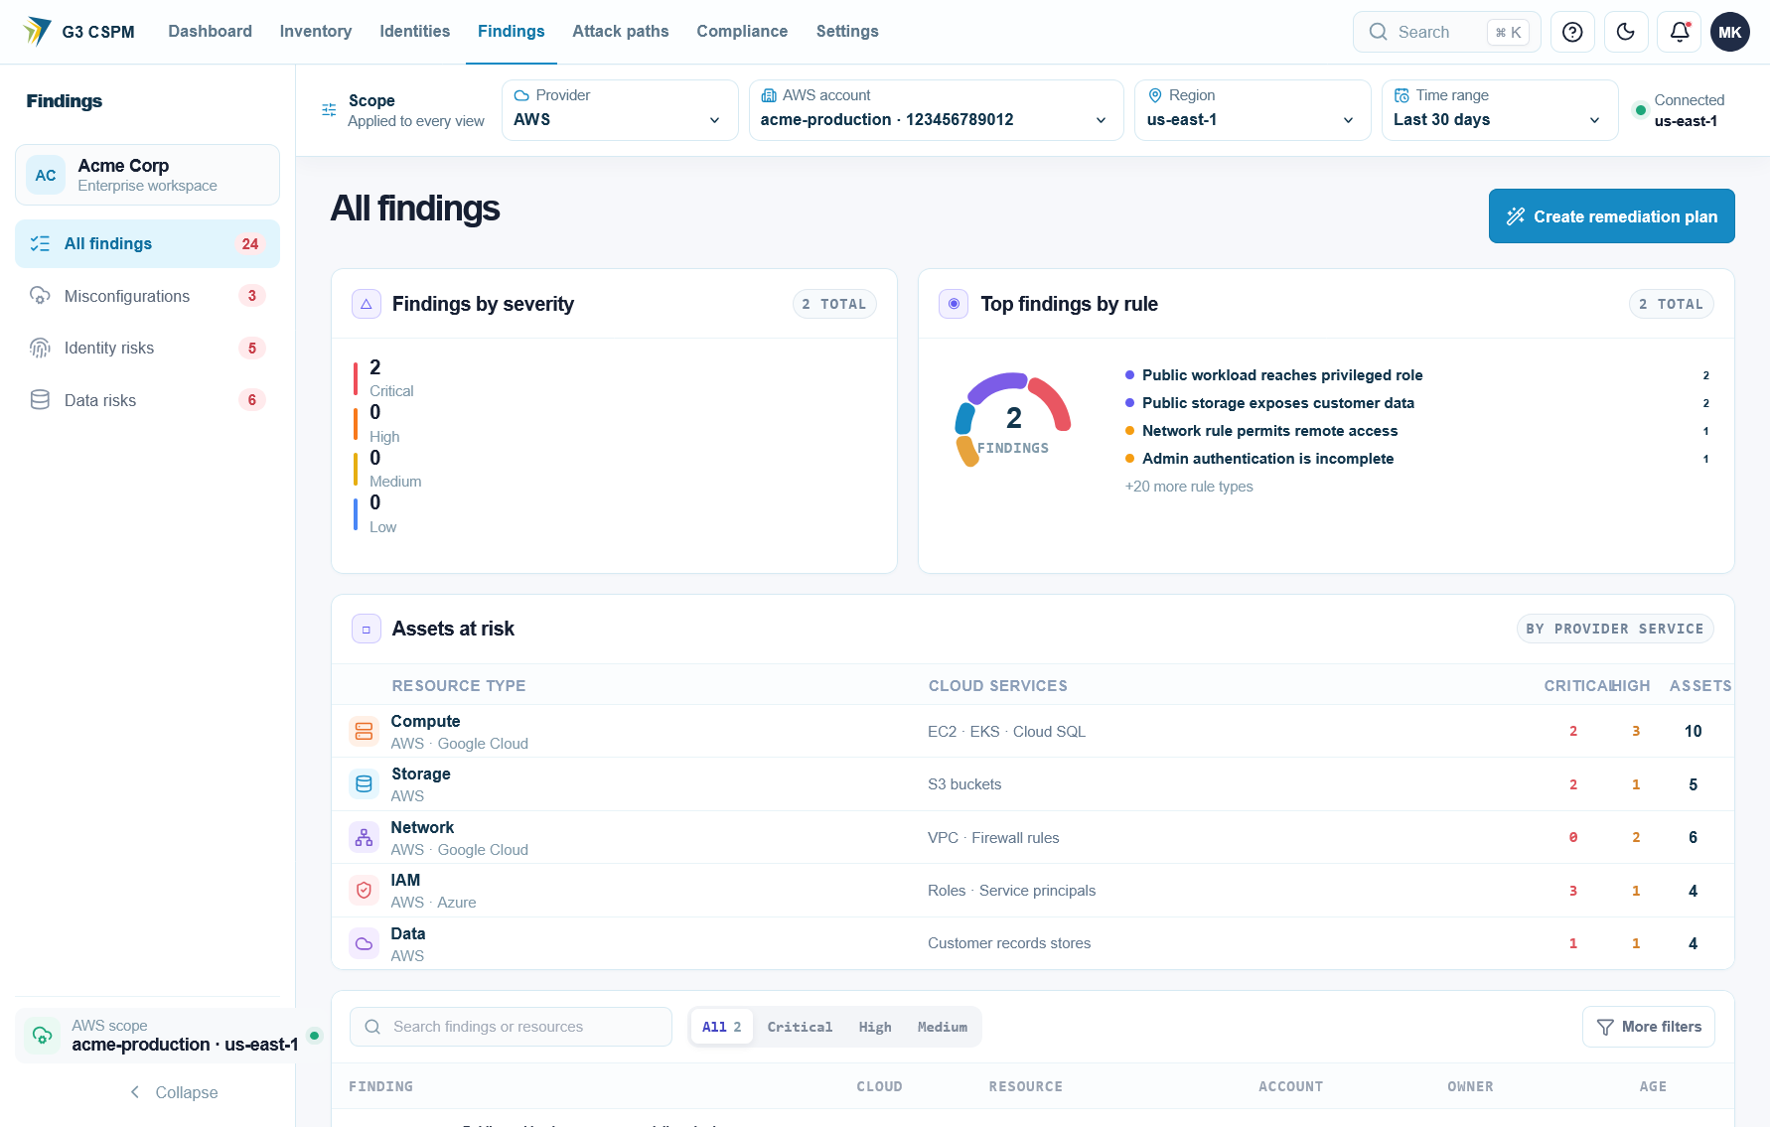
Figure 5. CloudSentinel SaaS findings screen showing severity distribution, top rules, affected asset classes, filtering, and remediation-plan action
Findings converts policy evaluations into actionable CSPM work.
Function | Required behavior
Summary cards | Count active findings by signal class, severity, context, suppression, and resolution
Signal tabs | Separate active threats, network hygiene, and all signals
Status tabs | Filter open, suppressed, and resolved findings
Category tabs | Filter network, compute, data, identity, security, or other posture category
Search | Match verdict, policy ID, resource, native ID, service, or type
Filters | Filter severity, rule, service, account, region, owner, and contextual priority
Freshness warning | Show last confirmed time when active result exceeds freshness SLA
Finding detail | Show title, policy ID and version, resource, observed state, required state, evidence, context, remediation, compliance mapping, timestamps, and status history
Re-evaluate | Run policy evaluation against latest stored evidence or trigger configured refresh workflow
Export | Export only authorized filtered results with freshness and coverage metadata

Finding state logic:
State | Entry condition | Exit condition
Open | Current evidence fails enabled policy | Assignment, exception, false-positive decision, or verified pass
Assigned | Authorized user or routing rule sets owner | Work starts, reassignment, exception, or verified resolution
In progress | Owner accepts remediation work | Pending verification, exception, or reassignment
Pending verification | Fix reported or approved action completed | Fresh evaluation passes, fails, errors, or becomes unknown
Resolved | Fresh evidence passes or risky path is broken | Condition recurs or policy logic changes with valid evidence
Suppressed | Governed suppression rule applies | Rule expires, scope changes, or suppression is revoked
Accepted risk | Approved exception is active | Exception expires, is revoked, or underlying condition resolves
False positive | Authorized reviewer proves evaluation invalid | New evidence or policy version requires revalidation
Reopened | Previously resolved condition fails again | Normal remediation lifecycle

10.9 Attack-path function
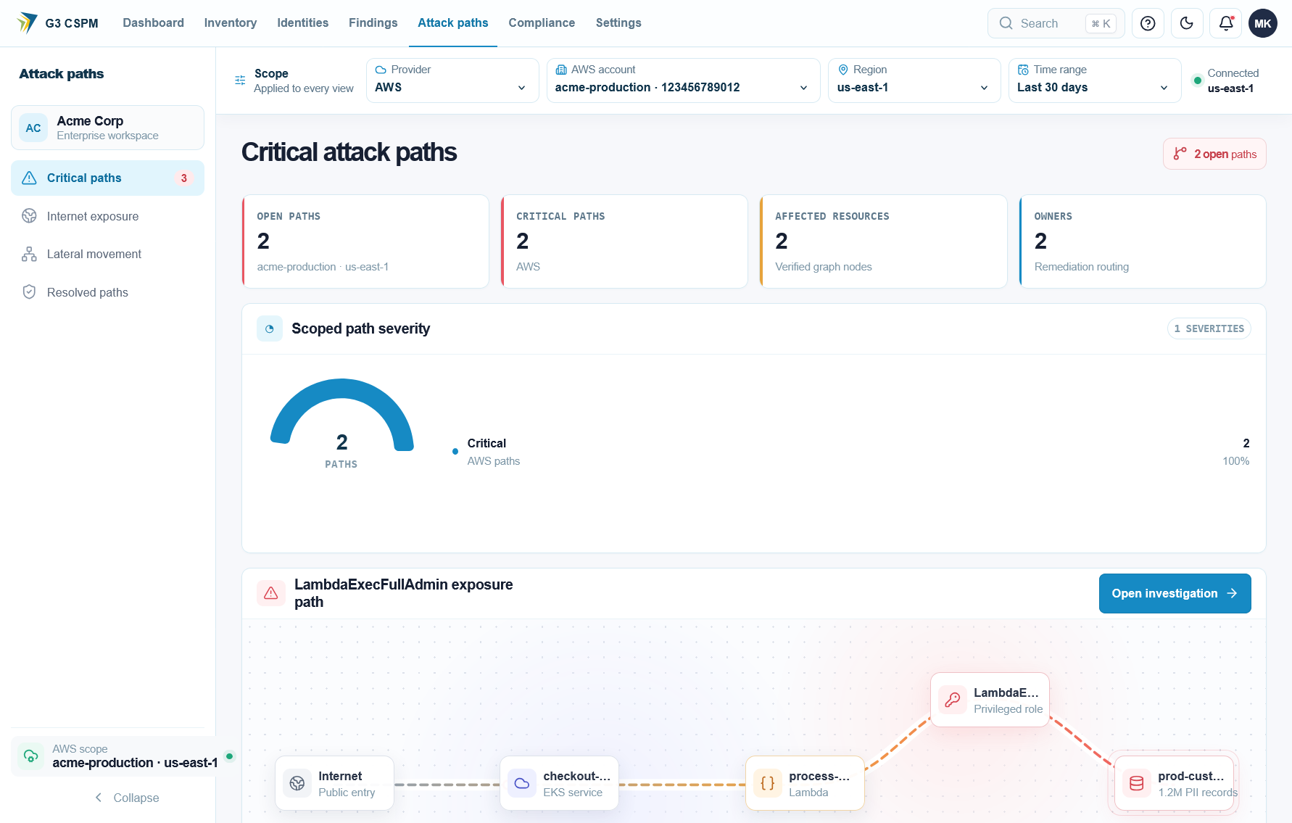
Figure 6. CloudSentinel SaaS attack paths screen showing open critical paths, affected resources, owners, severity, graph hops, and investigation action
Attack paths correlate configuration and relationship evidence to show how exposure may lead to privileged access or cloud-resource impact.
Function | Required behavior
Analyze | Rebuild supported paths from current authorized asset graph
Confidence banner | State whether path evidence is complete, partial, stale, or missing
Evidence counters | Show inventory, identity, data-resource metadata, relationships, and entry-point coverage used by analysis
List view | Show risk score, title, confidence, ordered hops, observed date, and severity
Graph view | Visualize same path without changing underlying path result
Status filter | Filter open and resolved paths
Severity filter | Filter Critical, High, Medium, and Low paths
Path detail | Show hop evidence, assumptions, missing permissions, related findings, compliance mappings, and break-point remediation

Path acceptance rules:
- Every hop must reference stored evidence or be labeled inferred.
- Incomplete IAM, network, or resource-policy evidence must reduce confidence.
- System must never declare a scope clean when required relationship evidence is missing.
- Resolved path requires fresh evidence showing at least one required hop is broken.
- Risk score must remain explainable and versioned.
- Duplicate paths with same entry, decisive relationships, and target should consolidate without losing evidence.

10.10 Infrastructure as Code function
IaC security prevents approved CSPM violations before cloud deployment.
Input | Processing | Output
Terraform plan JSON | Parse planned resources, normalize supported properties, run single-resource and combination checks | Format, resource count, findings, severity, resource address, rationale, remediation
CloudFormation JSON or YAML | Parse resource definitions and intrinsic-function-safe values, then run supported checks | Template format, resource count, findings, logical ID, rationale, remediation
Repository or pipeline directory through approved engine | Run configured scanner using tenant policy and baseline | Pipeline status, SARIF or normalized results, audit artifact

IaC validation and error rules:
- Empty input disables or rejects scan with clear message.
- Invalid JSON or YAML returns location-aware parse error without logging full source.
- Unsupported format returns explicit supported-format list.
- Scanner absence or engine failure returns error, not zero findings.
- Findings identify policy, severity, resource, source location where available, and corrective action.
- Pipeline policy supports pass, warn, or block.
- Existing baseline can be separated from newly introduced violations.
- Secrets and sensitive values must be redacted from UI, logs, API, and exports.

10.11 Compliance function
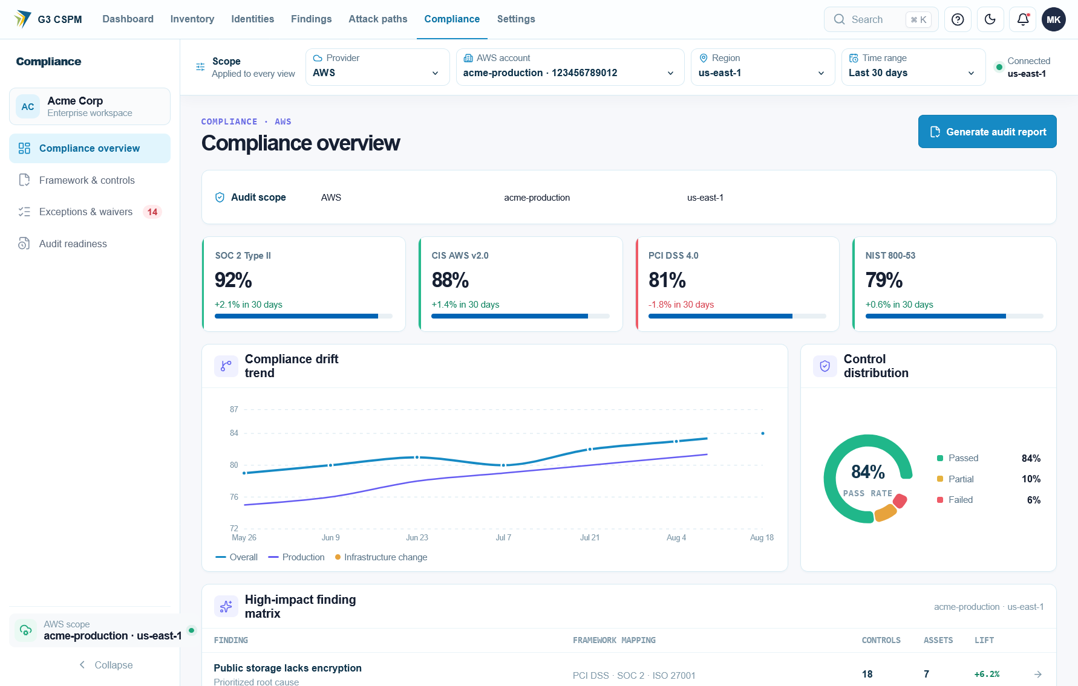
Figure 7. CloudSentinel SaaS compliance screen showing audit scope, framework scores, drift trend, control distribution, high-impact findings, and audit-report action
Compliance translates current CSPM findings into technical-control evidence. It does not certify the customer.
Function | Required behavior
Framework cards | Show framework name and version, technical score, passed controls, and total covered controls
Framework selection | Display controls for selected framework without changing selected account scope
Control filter | Filter failing or all controls; future states include pass, unknown, error, not-applicable, and uncovered
Control row | Show control ID, title, section, state, related policies, evidence count, freshness, and exception status
Snapshot now | Persist point-in-time framework result with scope, policy versions, evidence timestamps, and coverage
History | Display score and control-state changes across snapshots
Drift | Show newly failed, newly passed, recurring, changed, and unevaluable controls
Export | Produce human-readable and machine-readable evidence package

Compliance score rules:
- Unknown, error, and uncovered controls must not count as pass.
- Framework and control version must appear in UI and export.
- Score must disclose denominator and coverage limitations.
- Snapshot must be immutable after creation.
- Exception changes control disposition but does not erase technical failure evidence.
- Reports must state that technical checks do not prove certification or legal compliance.

10.12 Policy and configuration administration
The CSPM portion of Settings must support:
- Built-in policy-pack enablement.
- Framework selection and version visibility.
- Policy parameter values.
- Tenant severity overrides.
- Scope assignment by provider, account, region, environment, tag, and resource type.
- Draft, test, approval, publication, deprecation, and retirement states for custom policy.
- Preview of policy change against current or historical assets.
- Scan cadence and freshness SLA.
- Exception maximum duration and approval rules.
- Finding-routing defaults.
- Export, webhook, ticketing, and source-control integration health.
- Audit history for every configuration change.

10.13 Functional status and empty-state rules
Status | Meaning | Required UI treatment
Loading | Request still active | Progress indicator without false zero
Healthy | Fresh supported evidence available | Normal result plus freshness time
Empty | Valid authoritative collection returned no matching data | Explain scope and next action
Unknown | Evidence insufficient for decision | Show missing evidence and corrective action
Degraded | Some required sources failed or are stale | Warning and affected scope
Error | Operation failed | Error reason, correlation ID, retry path, and retained previous valid state
Unsupported | Product does not cover resource, service, region, or format | Explicit unsupported label
Not applicable | Policy or function does not apply to selected scope | Explain applicability rule

10.14 Functional interface requirements
Interface | Direction | CSPM purpose | Required controls
AWS APIs | Inbound metadata | Asset, configuration, trust, logging, and relationship collection | Temporary credentials, retry, throttling, permission evidence
Azure APIs | Inbound metadata | Future Azure inventory and configuration collection | Tenant-scoped identity, permission health, service coverage
GCP APIs | Inbound metadata | Future GCP inventory and configuration collection | Federation or approved identity, project scope, permission health
Source-control and CI | Bidirectional metadata | IaC scan, annotation, owner mapping, and status gate | App authentication, scoped repositories, signed callbacks
Ticketing | Bidirectional | Create and synchronize remediation work | Idempotency, owner mapping, conflict rules
Webhooks | Outbound | Finding, issue, coverage, and exception events | Signing, retry, idempotency, dead-letter handling
REST API | Bidirectional | Inventory, findings, issues, compliance, administration, and export | Versioning, RBAC, tenant scope, pagination, rate limit, audit
CSV and JSON export | Outbound | Authorized reporting and evidence portability | Scope, redaction, freshness, provenance

11. Functional business requirements
Priority uses MoSCoW: Must, Should, Could, or Won't for the defined release.

11.1 Secure cloud onboarding and coverage
ID | Requirement | Priority | Acceptance condition
FR-ONB-001 | Platform shall onboard AWS accounts through a customer-deployed role using a tenant-specific ExternalId | Must | Trust validation rejects missing, incorrect, reused, or expired onboarding context
FR-ONB-002 | Platform shall provide reviewable CloudFormation and Terraform onboarding options | Must | Customer can inspect all created permissions and resources before deployment
FR-ONB-003 | Platform shall not require storage of long-lived AWS access keys | Must | Production onboarding and scans use temporary role credentials
FR-ONB-004 | Platform shall support AWS Organizations onboarding and delegated rollout | Should | Administrator can connect selected organization accounts with inherited policy
FR-ONB-005 | Platform shall support explicit account and region inclusion or exclusion | Must | Scan scope matches saved configuration and appears in coverage report
FR-ONB-006 | Platform shall validate required permissions before declaring onboarding complete | Must | Validation reports passed, missing, denied, and untested permissions
FR-ONB-007 | Platform shall record account connection health and last successful authentication | Must | Account view shows status, failure reason, and last verified time
FR-ONB-008 | Platform shall support secure Azure subscription onboarding before Azure GA | Must for Azure GA | Connection uses tenant-approved application or managed identity and scoped permissions
FR-ONB-009 | Platform shall support secure GCP project and organization onboarding before GCP GA | Must for GCP GA | Connection uses approved federation or service identity without embedded static keys
FR-ONB-010 | Platform shall support safe offboarding | Must | Access can be revoked and tenant data follows configured retention policy

11.2 Asset inventory and normalization
ID | Requirement | Priority | Acceptance condition
FR-AST-001 | Platform shall discover supported resources across all enabled accounts and regions | Must | Coverage tests compare supported API inventory with persisted inventory
FR-AST-002 | Platform shall preserve cloud-native identifiers and provider metadata | Must | Each asset includes provider, account, region, native ID, type, and collection time
FR-AST-003 | Platform shall normalize equivalent resource concepts across clouds | Must for multicloud GA | Users can query common fields without losing provider-specific evidence
FR-AST-004 | Platform shall capture tags, labels, environment, owner, and business criticality when available | Must | Asset detail shows source and timestamp for each context field
FR-AST-005 | Platform shall model relationships needed for CSPM analysis | Must | Supported links include attachment, trust, access, network, logging, and encryption relationships
FR-AST-006 | Platform shall mark assets inactive only after authoritative collection confirms absence | Must | Partial or failed collection never deletes or resolves valid inventory
FR-AST-007 | Platform shall retain first-seen, last-seen, and last-scanned timestamps | Must | Asset history supports age and drift analysis
FR-AST-008 | Platform shall support search and filtering by provider, account, region, type, tag, owner, environment, and status | Must | Filters return correct results through UI and API
FR-AST-009 | Platform shall show unsupported services and uncollected scopes | Must | Coverage view distinguishes unsupported, denied, failed, stale, and empty
FR-AST-010 | Platform shall export inventory through documented APIs and structured files | Should | JSON and CSV exports preserve stable IDs and timestamps

11.3 Configuration policy assessment
ID | Requirement | Priority | Acceptance condition
FR-POL-001 | Platform shall continuously evaluate assets against enabled posture policies | Must | Scan or relevant change produces deterministic pass, fail, error, or not-applicable result
FR-POL-002 | Each policy shall define provider, supported resource type, rationale, severity, evaluation logic, evidence fields, and remediation guidance | Must | Published policies fail validation when required metadata is missing
FR-POL-003 | Each finding shall contain observed state and required state | Must | Analyst can reproduce result from stored evidence and policy version
FR-POL-004 | Platform shall support built-in security baselines | Must | AWS GA includes approved AWS best-practice and CIS-aligned control set
FR-POL-005 | Platform shall support customer-defined policy | Should | Authorized user can create, test, version, scope, publish, and retire a policy
FR-POL-006 | Platform shall support policy assignment by tenant, cloud, account, region, business unit, environment, resource type, and tag | Must | Assignment test proves only intended resources are evaluated
FR-POL-007 | Platform shall support policy parameters | Should | Customer can set values such as permitted ports, retention days, or approved regions
FR-POL-008 | Platform shall support policy severity override without changing vendor policy logic | Should | Override retains original severity and records approver and reason
FR-POL-009 | Platform shall identify duplicate or equivalent findings from native cloud services | Should | Duplicates group under one issue while preserving all sources
FR-POL-010 | Platform shall never treat evaluation error or missing evidence as pass | Must | Error and unknown states appear separately in UI, API, score, and export
FR-POL-011 | Platform shall support policy suppression only through governed rule or exception | Must | Suppression includes scope, owner, reason, approval, and expiry
FR-POL-012 | Platform shall retain policy version used for every result | Must | Historical result remains reproducible after policy update

11.4 Exposure and relationship analysis
ID | Requirement | Priority | Acceptance condition
FR-EXP-001 | Platform shall evaluate whether a resource has a complete internet path, a blocked path, or insufficient evidence | Must | Result includes evaluated hops and reason for each status
FR-EXP-002 | Platform shall correlate public addressing, gateways, routes, subnets, network controls, resource endpoints, and attachments where supported | Must | Test environments produce expected reachable and unreachable outcomes
FR-EXP-003 | Platform shall distinguish an open network rule from a verified reachable workload | Must | Unattached or blocked rules do not receive same priority as proven exposure
FR-EXP-004 | Platform shall model identity trust and resource-access relationships needed for posture paths | Must | Path shows principal, trust condition, permission evidence, and target resource
FR-EXP-005 | Platform shall detect posture combinations with greater risk than isolated controls | Must | Supported combinations produce one issue linked to underlying findings
FR-EXP-006 | Platform shall explain every path in plain language | Must | User can see entry point, hops, target, assumptions, blockers, and remediation options
FR-EXP-007 | Platform shall attach confidence to inferred or incomplete relationships | Must | Inferred path cannot be displayed as verified without supporting evidence
FR-EXP-008 | Platform shall recalculate affected paths after relevant configuration change | Must | Changed edge or asset triggers reassessment within freshness SLA

11.5 Risk prioritization
ID | Requirement | Priority | Acceptance condition
FR-RSK-001 | Platform shall calculate risk using configuration severity, exposure, privilege, business criticality, environment, relationship context, age, and confidence | Must | Risk explanation shows contribution of each available factor
FR-RSK-002 | Platform shall separate vendor severity from contextual priority | Must | Finding retains original severity and displays computed priority independently
FR-RSK-003 | Platform shall group related symptoms into an actionable issue | Must | One material issue links all contributing findings and assets without hiding evidence
FR-RSK-004 | Platform shall support customer-defined critical assets and environments | Must | Crown-jewel or production context changes priority according to approved model
FR-RSK-005 | Platform shall reduce priority when a verified compensating control breaks the path | Should | Reduced priority records control evidence and expiry or freshness
FR-RSK-006 | Platform shall recalculate priority when context changes | Must | Owner, exposure, policy, tag, path, or exception change updates risk deterministically
FR-RSK-007 | Platform shall provide stable issue identity across rescans | Must | Persistent issue history survives routine evidence refreshes
FR-RSK-008 | Platform shall expose risk-model version | Must | Historical reports identify model version used for each score

11.6 Compliance posture and evidence
ID | Requirement | Priority | Acceptance condition
FR-CMP-001 | Platform shall map technical policies to supported framework controls | Must | Mapping identifies framework, version, control, and mapping rationale
FR-CMP-002 | AWS GA shall support approved mappings for CIS AWS Foundations and selected NIST, PCI DSS, SOC 2, and ISO 27001 controls | Must | Framework catalog passes product and GRC review
FR-CMP-003 | Platform shall distinguish technical-control coverage from full compliance | Must | Reports include scope and limitation statement
FR-CMP-004 | Platform shall calculate pass, fail, unknown, error, not-applicable, and uncovered status | Must | Unknown or uncovered controls do not increase compliance score
FR-CMP-005 | Platform shall preserve evidence provenance | Must | Evidence includes asset, observed value, collector, account, region, time, policy version, and evaluation result
FR-CMP-006 | Platform shall create point-in-time compliance snapshots | Must | User can reproduce framework posture for selected date and scope
FR-CMP-007 | Platform shall show compliance drift | Must | Report shows newly failed, remediated, recurring, and unchanged controls
FR-CMP-008 | Platform shall include approved exceptions and their expiry in reports | Must | Auditor can trace approver, reason, scope, start, expiry, and current status
FR-CMP-009 | Platform shall export audit evidence in machine-readable and human-readable formats | Should | Export includes control summary and evidence detail without screenshots
FR-CMP-010 | Platform shall not market a framework score as certification | Must | Product copy and exports use approved assurance language

11.7 Drift, freshness, and continuous monitoring
ID | Requirement | Priority | Acceptance condition
FR-DRF-001 | Platform shall support scheduled posture assessment | Must | Tenant can configure supported cadence within service limits
FR-DRF-002 | Platform shall support change-triggered reassessment for material AWS configuration events | Should for AWS GA | Supported event updates affected assets and policies without full scan
FR-DRF-003 | Platform shall record first observed, last observed, resolved, reopened, and recurrence count | Must | Finding timeline survives repeated scans and temporary disappearance
FR-DRF-004 | Platform shall detect changes between observed configurations | Must | User can view changed fields and collection times
FR-DRF-005 | Platform shall display freshness SLA by account, region, service, and evidence source | Must | Stale status appears before user interprets posture results
FR-DRF-006 | Platform shall alert on failed or degraded collection | Must | Operational alert contains scope, cause, last success, and affected coverage
FR-DRF-007 | Platform shall protect prior valid state during partial collection failure | Must | Failed scope neither resolves findings nor marks missing assets inactive
FR-DRF-008 | Platform shall support historical posture trend | Should | User can compare risk, findings, coverage, and compliance over selected periods

11.8 Infrastructure as Code security
ID | Requirement | Priority | Acceptance condition
FR-IAC-001 | Platform shall scan Terraform plan JSON and CloudFormation JSON or YAML | Must | Supported insecure fixtures produce expected findings and line or resource references
FR-IAC-002 | Platform shall support broader IaC formats through an approved scanning engine | Should | Format coverage and engine version appear in scan result
FR-IAC-003 | Platform shall evaluate both individual resource checks and supported multi-resource combinations | Must | Test plan detects isolated and relationship-based template risk
FR-IAC-004 | Platform shall integrate with pull-request or pipeline workflows | Must | Scan result can pass, warn, or fail according to tenant policy
FR-IAC-005 | Platform shall annotate the changed resource and explain required correction | Should | Developer receives file, resource, policy, severity, rationale, and remediation
FR-IAC-006 | Platform shall support baseline handling for pre-existing findings | Should | Policy can block newly introduced violations without forcing immediate legacy cleanup
FR-IAC-007 | Platform shall link deployed resources to IaC source when reliable metadata exists | Could | Runtime finding shows repository, file, resource block, revision, and owner
FR-IAC-008 | Platform shall propose code-first remediation when IaC owns the resource | Should | Proposed change is reviewable and does not bypass source-control approval
FR-IAC-009 | Platform shall prevent secrets or sensitive template content from leaking into findings | Must | Redaction tests cover logs, UI, API, and exports
FR-IAC-010 | Platform shall expose scanner version, policy version, and scan time | Must | Pipeline artifact supports later audit and reproduction

11.9 Finding workflow, remediation, and verification
ID | Requirement | Priority | Acceptance condition
FR-REM-001 | Platform shall support states for open, triaged, assigned, in progress, pending verification, resolved, accepted risk, false positive, and reopened | Must | State transition rules and audit events pass workflow tests
FR-REM-002 | Platform shall assign issues to user, team, or integration queue | Must | Assignment records actor, time, owner, due date, and source
FR-REM-003 | Platform shall provide console, CLI, and IaC guidance where supported | Must | Guidance identifies prerequisites, impact, least-change fix, and verification
FR-REM-004 | Platform shall identify whether remediation changes live infrastructure, source code, or both | Must | User sees change target before approval
FR-REM-005 | Platform shall support ticket creation and bidirectional status synchronization | Should | Duplicate ticket prevention and conflict behavior pass integration tests
FR-REM-006 | Platform shall require approval before executing a cloud mutation | Must | Unauthorized or unapproved action is rejected and audited
FR-REM-007 | Platform shall preview affected resources and expected configuration change | Must for automated remediation | Approval view contains exact scope and policy context
FR-REM-008 | Platform shall use least-privilege, time-bounded credentials for approved remediation | Must for automated remediation | Credential scope cannot exceed approved action
FR-REM-009 | Platform shall provide rollback guidance when a safe rollback exists | Should | High-impact actions cannot be labeled one-click without reviewed rollback
FR-REM-010 | Platform shall close a finding only after fresh evidence confirms compliance | Must | Manual status change alone cannot create verified closure
FR-REM-011 | Platform shall reopen a resolved issue when the condition recurs | Must | Recurrence increments counter and retains prior remediation history
FR-REM-012 | Platform shall support bulk action only for homogeneous, previewed, bounded changes | Should | Bulk job shows per-resource result and stops safely on authorization failure

11.10 Exceptions and governance
ID | Requirement | Priority | Acceptance condition
FR-EXC-001 | Platform shall support time-bound risk exceptions | Must | Exception requires owner, reason, scope, start, expiry, and approver
FR-EXC-002 | Platform shall prevent indefinite exception by default | Must | Default policy requires expiry within tenant-defined maximum
FR-EXC-003 | Platform shall support compensating-control evidence | Should | Exception links evidence source, owner, freshness, and review date
FR-EXC-004 | Platform shall notify owners before exception expiry | Must | Notification timing is configurable and auditable
FR-EXC-005 | Platform shall automatically re-evaluate expired exceptions | Must | Expired issue returns to active workflow if condition remains
FR-EXC-006 | Platform shall distinguish accepted risk from false positive | Must | Reports and metrics treat states separately
FR-EXC-007 | Platform shall audit policy, severity, suppression, exception, and remediation changes | Must | Event includes actor, previous value, new value, scope, result, and time

11.11 Reporting, dashboards, and integrations
ID | Requirement | Priority | Acceptance condition
FR-RPT-001 | Platform shall provide executive posture view | Must | View includes material risk, coverage, trend, SLA, recurrence, and accepted risk
FR-RPT-002 | Platform shall provide operational finding and issue views | Must | Users can filter by cloud, account, region, owner, environment, policy, severity, risk, and status
FR-RPT-003 | Platform shall provide asset and coverage views | Must | Empty result always includes coverage and freshness context
FR-RPT-004 | Platform shall provide framework posture and evidence reports | Must | Reports trace summary values to individual evidence records
FR-RPT-005 | Platform shall support CSV and JSON exports | Must | Export respects tenant, role, scope, and redaction rules
FR-RPT-006 | Platform shall provide documented REST APIs | Must | API contract includes pagination, filters, errors, versioning, and rate limits
FR-RPT-007 | Platform shall provide signed, retryable webhooks | Should | Delivery supports authentication, idempotency, backoff, and dead-letter handling
FR-RPT-008 | Platform shall integrate with common ticketing, chat, SIEM, and source-control systems | Should | Each GA integration has health status and auditable configuration
FR-RPT-009 | Platform shall support scheduled reports | Should | Report records scope, generation time, data freshness, and recipient authorization
FR-RPT-010 | Platform shall prevent cross-tenant or unauthorized report access | Must | Negative authorization tests cover UI, API, links, and exports

11.12 Policy administration
ID | Requirement | Priority | Acceptance condition
FR-ADM-001 | Platform shall maintain a versioned policy catalog | Must | User can inspect current and historical policy metadata
FR-ADM-002 | Platform shall support draft, test, approved, active, deprecated, and retired policy states | Should | Only approved active versions affect production posture
FR-ADM-003 | Platform shall test policy changes against selected current or historical assets before publication | Should | Preview shows new, resolved, changed-severity, and error results
FR-ADM-004 | Platform shall record policy owner and review date | Must | Overdue review appears in administrative health view
FR-ADM-005 | Platform shall support policy packs by cloud, framework, and customer baseline | Must | Pack enablement shows included policies and parameters
FR-ADM-006 | Platform shall prevent silent breaking changes to policy semantics | Must | Material logic change creates new version and change log

11.13 Tenant and platform administration
ID | Requirement | Priority | Acceptance condition
FR-TEN-001 | Platform shall isolate every tenant's assets, evidence, findings, policy, integrations, and audit records | Must | Automated cross-tenant tests return no unauthorized data
FR-TEN-002 | Platform shall support SAML 2.0 or OIDC SSO | Must | Tenant can configure and validate one supported protocol
FR-TEN-003 | Platform shall support least-privilege RBAC | Must | Privileged APIs enforce explicit permissions
FR-TEN-004 | Platform shall support administrator, analyst, engineer, auditor, and read-only roles | Must | Role matrix passes positive and negative tests
FR-TEN-005 | Platform shall support scoped access by tenant, business unit, account, and environment | Should | Restricted user cannot query or export outside assigned scope
FR-TEN-006 | Platform shall provide immutable security audit events | Must | Audit search includes actor, action, target, result, time, and correlation ID
FR-TEN-007 | Platform shall expose operational health for collectors, queues, APIs, storage, integrations, and scheduled jobs | Must | Support can identify affected tenants and scope without reading customer content

12. Primary business workflows

12.1 Onboard to trusted coverage
- Administrator chooses cloud, organization, accounts, regions, and policy pack.
- Platform generates a reviewable least-privilege deployment package.
- Customer deploys the package in its cloud environment.
- Platform verifies identity, trust, permissions, account ownership, and supported APIs.
- Initial collection runs.
- Coverage report shows discovered assets, unsupported scope, denied APIs, failures, and freshness.
- Administrator accepts scope or corrects gaps before posture score becomes authoritative.

12.2 Discover to verified closure
- Collector observes resource configuration and relationships.
- Policy engine evaluates evidence using a versioned policy.
- Platform creates or updates a stable finding.
- Correlation engine groups related findings into an issue where applicable.
- Risk engine adds exposure, privilege, business context, age, and confidence.
- Routing assigns owner and SLA.
- Engineer reviews live and IaC remediation options.
- Approved change is implemented through customer workflow.
- Platform collects fresh evidence.
- Issue closes only after successful verification.
- Later recurrence reopens the same issue history.

12.3 IaC prevention
- Developer opens a pull request or pipeline run.
- Platform scans supported IaC and records engine and policy versions.
- Findings are limited to changed code or clearly identified existing baseline.
- Developer receives resource-level rationale and correction guidance.
- Policy determines pass, warning, or block.
- Scan result is stored as audit evidence.
- Where code-to-cloud mapping exists, deployed posture links back to source revision.

12.4 Exception lifecycle
- Owner requests exception with business reason and scope.
- Approver reviews risk, compensating control, and expiry.
- Approved exception changes workflow status but retains underlying evidence.
- Platform monitors compensating-control freshness.
- Notifications occur before expiry.
- At expiry, platform reassesses current configuration.
- Remaining violation re-enters active remediation.

13. Information requirements

13.1 Core business entities
Entity | Required meaning
Tenant | Isolated customer security and administration boundary
Cloud connection | Authorized relationship with provider organization, account, subscription, or project
Collection scope | Cloud, account, region, service, API, and permission boundary evaluated
Asset | Normalized cloud resource with provider-native identity
Relationship | Evidence-backed link between assets or identities
Policy | Versioned rule defining required posture
Evidence | Observed value and provenance used in evaluation
Finding | One policy result for one resource or relationship
Issue | Actionable risk that may group multiple findings and assets
Attack path | Ordered posture relationships connecting entry condition to impact
Exception | Approved, scoped, time-bound risk decision
Remediation action | Proposed or executed change with approval and result
Compliance mapping | Relationship between technical policy and framework control
Snapshot | Point-in-time posture or framework state
Audit event | Immutable record of security-relevant product action

13.2 Mandatory provenance
Every evidence-backed result shall retain:
- Tenant and cloud connection.
- Provider, account or subscription or project, region, service, and resource ID.
- Collector and collector version.
- Collection operation and collection time.
- Observed value and normalized value.
- Policy ID and policy version.
- Evaluation result and evaluation time.
- Confidence and missing evidence.
- First observed, last observed, and resolution history.
- Source finding when imported from a native provider service.
- Risk-model version when contextual score is applied.

13.3 Data retention
Data class | Initial requirement
Current inventory | Retain while connection is active plus tenant-configured offboarding period
Finding and issue history | Minimum 13 months; configurable for enterprise plans
Compliance snapshots | Minimum 13 months
Audit events | Minimum 13 months; longer where contractually required
Raw provider responses | Minimize; retain only required evidence fields where possible
IaC scan artifacts | Retain metadata and findings; source content retention is opt-in and minimized

Final retention values require legal, privacy, security, and customer review.

14. Non-functional requirements
ID | Category | Requirement | Initial target
NFR-001 | Availability | Production service availability | 99.9% monthly, excluding published maintenance
NFR-002 | Freshness | Scheduled AWS posture freshness | 95% of enabled scopes assessed within configured SLA
NFR-003 | Event latency | Supported AWS change reassessment | 95% within 10 minutes of accepted event
NFR-004 | Scale | Account capacity | At least 1,000 accounts per enterprise tenant without architecture change
NFR-005 | Scale | Asset capacity | At least 10 million active assets per tenant with paginated access
NFR-006 | Performance | Common dashboard API | p95 under 2 seconds for indexed tenant-scoped queries
NFR-007 | Performance | Search and filtered list | p95 under 3 seconds at supported scale
NFR-008 | Security | Encryption | TLS in transit and managed encryption at rest
NFR-009 | Security | Tenant isolation | Enforced at authentication, authorization, query, export, job, cache, and storage layers
NFR-010 | Security | Secrets | No cloud secret values collected or stored for CSPM operation
NFR-011 | Security | Cloud access | Temporary, least-privilege credentials with auditable use
NFR-012 | Reliability | Idempotency | Repeated collection or webhook delivery does not duplicate logical assets or issues
NFR-013 | Reliability | Partial failure | One failed account, region, service, or integration does not invalidate healthy scopes
NFR-014 | Explainability | Result reproduction | Stored evidence and versions reproduce policy result
NFR-015 | Privacy | Data minimization | Collect only configuration data required for approved CSPM capability
NFR-016 | Portability | Export | Customer can export assets, findings, evidence, exceptions, and audit history
NFR-017 | Accessibility | Web interface | Target WCAG 2.1 AA for supported user workflows
NFR-018 | Observability | Platform health | Metrics, logs, traces, job status, and correlation IDs support tenant-scoped diagnosis
NFR-019 | Recovery | Recovery point objective | 15 minutes for production metadata
NFR-020 | Recovery | Recovery time objective | 4 hours for production service

NFR targets become contractual only after capacity, resilience, and security validation.

15. Security and privacy requirements
- CSPM collection shall remain read-only unless separately approved remediation is invoked.
- Product shall never read secret values to perform CSPM configuration assessment.
- Cloud trust relationships shall use tenant-specific anti-confusion controls such as AWS ExternalId.
- Onboarding templates and permissions shall be versioned and reviewable.
- Privileged product operations shall require strong authentication and authorization.
- Administrative, export, policy, exception, and remediation actions shall be audited.
- Tenant data shall not be used to train shared models without explicit contractual consent.
- Logs and error messages shall redact credentials, tokens, source content, and sensitive identifiers according to policy.
- Data residency, deletion, backup, and subprocessors shall be documented for enterprise customers.
- Independent security testing shall cover tenant isolation, onboarding trust, authorization, webhook security, and remediation boundaries before GA.

16. Current repository baseline
This section records implementation evidence observed in repository on 26 August 2026. It is not a GA claim and does not replace testing.
CSPM area | Repository evidence | Product interpretation
AWS collection | src/odineyes/inventory/aws_raw_collector.py and 37 AWS normalizers in src/odineyes/inventory/normalizers.py:117 onward | Broad AWS prototype foundation exists
Azure collection | Storage-account-only collector in src/odineyes/inventory/azure_collector.py:25 | Experimental, not Azure CSPM GA
GCP collection | Bucket-only collector in src/odineyes/inventory/gcp_collector.py:27 | Experimental, not GCP CSPM GA
Policy checks | 70 rule_* functions in src/odineyes/inventory/rules.py:536 onward | Useful AWS policy base; requires catalog QA and coverage measurement
Relationship findings | Combination rules begin in src/odineyes/inventory/rules.py:1619 | Evidence-aware grouping exists for selected cases
Posture attack paths | Eight issue types defined in src/odineyes/inventory/issues.py:71 | Selected AWS path patterns exist; full coverage remains roadmap
IaC scanning | 13 single-resource and 3 combination checks in src/odineyes/iac/scanner.py:250 onward | Terraform-plan and CloudFormation prototype exists
Broad IaC engine | Checkov wrapper in src/odineyes/iac/checkov_runner.py:35 | Broad policy option exists when dependency is installed
Compliance | Mapping and reporting endpoints in src/odineyes/inventory/rules.py:43 and src/odineyes/api/inventory_routes.py:1222 | Evidence mapping exists; GRC validation still required
Onboarding | Template generation and account verification in src/odineyes/api/inventory_routes.py:258 and src/odineyes/api/inventory_routes.py:1459 | AWS onboarding workflow exists and needs production security gates
Remediation | CLI guidance in src/odineyes/inventory/rules.py:431 | Guided remediation exists; governed execution is not assumed
Coverage transparency | Coverage endpoint in src/odineyes/api/inventory_routes.py:482 | Coverage foundation exists but must become CSPM-specific across service scopes

16.1 Current-state restrictions
- Only AWS may be positioned as near-term production CSPM.
- Azure and GCP storage collectors do not constitute multicloud CSPM coverage.
- Repository function counts measure implementation surface, not control quality or completeness.
- Runtime, vulnerability, DSPM, CIEM, and other CNAPP modules are outside this CSPM BRD.
- Existing remediation commands are guidance. They must not be represented as universally safe automatic fixes.
- Production claims require test evidence, security review, performance validation, and documented service coverage.

17. Release scope

17.1 Release 1: AWS CSPM GA
Must include:
- Secure single-account and multi-account onboarding.
- Supported-service AWS inventory with transparent regional and permission coverage.
- Versioned policy catalog with evidence-backed findings.
- Exposure and selected posture attack-path analysis.
- Contextual risk and stable issue lifecycle.
- CIS AWS Foundations and approved cross-framework mappings.
- Scheduled scans, drift history, collection-health alerts, and supported event-triggered reassessment.
- Terraform plan and CloudFormation scanning with CI policy gate.
- Assignment, SLA, exceptions, guided remediation, verification, and recurrence.
- Enterprise authentication, RBAC, tenant isolation, audit logs, API, and exports.

17.2 Release 2: AWS workflow depth
- Organization-scale policy assignment.
- Custom policy authoring and historical preview.
- Native AWS Security Hub finding normalization and deduplication.
- Code-to-cloud ownership mapping.
- Pull-request annotations and code-first fix proposals.
- Ticketing and webhook integrations.
- Bounded, approval-based remediation for a reviewed control subset.
- Advanced posture trend and executive program metrics.

17.3 Release 3: Azure CSPM GA
- Production Azure onboarding and tenant validation.
- Required Azure asset and relationship coverage.
- Azure-native posture policy catalog and evidence model.
- Azure exposure, drift, compliance, and remediation workflows.
- Normalized cross-cloud inventory, issues, policy assignment, and reports.
- Azure release gates equal to AWS quality requirements.

17.4 Release 4: GCP CSPM GA
- Production GCP onboarding and organization support.
- Required GCP asset, relationship, policy, exposure, compliance, and remediation coverage.
- Cross-cloud posture paths where evidence is reliable.
- GCP release gates equal to AWS and Azure quality requirements.

18. Release acceptance gates

Gate A: Scope integrity
- Product surfaces only CSPM capabilities described by this BRD.
- Excluded CNAPP modules are not required for CSPM scores or posture paths.
- Marketing claims match validated provider and service coverage.

Gate B: Security and tenancy
- Independent review approves onboarding trust and least-privilege access.
- Cross-tenant authorization tests pass for UI, API, exports, jobs, caches, and integrations.
- No long-lived cloud access keys are required.
- Audit coverage includes all privileged actions.

Gate C: Coverage and evidence
- Supported service matrix is published.
- Missing permissions and failed scopes cannot produce false passes or false resolution.
- Evidence contains mandatory provenance.
- Asset completeness reaches pilot target for supported scope.

Gate D: Policy quality
- Every GA policy has positive, negative, unknown, and error tests.
- Security and GRC owners approve policy metadata and mappings.
- False-positive and false-negative sampling meets approved threshold.
- Breaking policy changes require new version.

Gate E: Risk and workflow
- Contextual score is explainable and reproducible.
- Supported posture paths show verified, blocked, and unknown states correctly.
- Ownership, SLA, exception, verification, reopening, and audit flows pass acceptance tests.

Gate F: Operations
- Scale, availability, recovery, and freshness targets pass production-like tests.
- Collector failure, provider throttling, integration failure, and backlog recovery are tested.
- Customer-facing health and coverage views identify affected scope.

Gate G: Customer value
- Design partners confirm actionable reduction in raw finding volume.
- Pilot measures ownership, remediation time, recurrence, and audit effort.
- At least three design partners complete end-to-end onboarding and remediation workflows.

19. Success metrics

19.1 North-star metric
Verified material posture risks reduced per customer per month.
A risk counts only when CloudSentinel identified it with sufficient evidence, routed it to an owner, and later verified that the risky condition or path no longer exists.

19.2 Product metrics
Metric | Why it matters
Supported asset coverage | Measures visibility within declared scope
Coverage-gap age | Measures time spent blind due to failure or permission loss
Raw findings to actionable issues ratio | Measures noise reduction
Critical and High owner coverage | Measures accountability
Median time to triage | Measures analyst usability
Median time to verified remediation | Measures operational value
Reopen and recurrence rate | Measures remediation durability
IaC predeployment detection rate | Measures prevention
Exception expiry compliance | Measures governance quality
Automated evidence coverage | Measures audit-effort reduction
False-positive rate | Measures policy trust
Unknown and error rate | Measures evidence quality and collection health

19.3 Guardrail metrics
- Unauthorized cloud mutations: zero.
- Cross-tenant data exposures: zero.
- Findings resolved because of partial collection failure: zero.
- Unknown evaluations counted as pass: zero.
- Expired exceptions left suppressed: zero.
- Critical remediation actions without recorded approval: zero.

20. Dependencies
- Cloud provider APIs, identity services, quotas, and event delivery.
- Customer permission approval and organization hierarchy access.
- Security and GRC review of policies and framework mappings.
- Source-control, CI, ticketing, chat, and webhook integration APIs.
- Reliable account, tag, CMDB, or repository ownership data.
- Product security controls for tenancy, credentials, audit, and remediation.
- Legal and privacy decisions for retention, residency, and subprocessors.
- Capacity testing infrastructure and representative design-partner environments.

21. Business and delivery risks
Risk | Impact | Required response
Native cloud tools cover basic checks | Weak differentiation | Focus on evidence, coverage, cross-cloud consistency, workflow, and durable remediation
Broad but shallow service coverage | Customer distrust | Publish exact service matrix and use GA gates per provider
Missing permissions appear secure | False assurance | Treat unknown, denied, failed, and stale as explicit non-pass states
Excessive findings | Low adoption | Correlate issues, use contextual priority, and measure noise reduction
Unsafe automatic remediation | Outage or security regression | Read-only default, approval, preview, bounded permissions, verification, and rollback
Live fix conflicts with IaC | Configuration returns | Identify source ownership and prefer code-first change
Compliance overstatement | Legal and trust risk | Use technical-evidence language and GRC-approved disclaimers
Multicloud normalization hides provider detail | Incorrect assessment | Preserve native evidence beside normalized fields
Provider API throttling | Stale coverage | Rate controls, incremental collection, retries, and health reporting
Policy update changes historical results | Audit inconsistency | Version policies and preserve evaluation provenance
Ownership data is missing | Slow remediation | Support fallback queues, tag policy, CMDB mapping, and owner confidence

22. Governance and decision rights
Decision | Accountable | Responsible | Consulted
Product scope and release | Product leader | Product manager | Engineering, Security, Sales
CSPM policy content | Cloud Security leader | Detection engineering | GRC, Cloud engineering
Compliance mapping | GRC leader | Compliance engineering | Security, Legal
Risk model | Security leader | Product and detection engineering | Customers, GRC
Remediation automation | Product Security leader | Platform engineering | Cloud engineering, Legal, Customer success
Provider GA declaration | Product leader | Engineering and QA | Security, Support, Sales
Availability and recovery targets | Engineering leader | SRE | Product, Security
Data retention and residency | Legal or Privacy leader | Platform engineering | Security, Product

23. Decisions required before implementation commitment
- Exact AWS services and regions included in Release 1 GA.
- Whether AWS Organizations onboarding is mandatory for Release 1 or Release 2.
- Approved compliance framework versions and control coverage.
- Pilot thresholds for coverage, false positives, noise reduction, and freshness.
- Initial ticketing and source-control integrations.
- Whether production remediation remains guidance-only in Release 1.
- Maximum default exception duration.
- Required retention and data-residency options.
- Packaging and entitlement boundaries for custom policy, IaC, and multicloud support.
- Azure and GCP release order based on design-partner demand.

24. Requirement traceability summary
Business objective | Primary capabilities | Requirement groups
BO-01, BO-02 | Onboarding, inventory, coverage | FR-ONB, FR-AST, FR-DRF
BO-03, BO-04 | Policy, relationships, risk | FR-POL, FR-EXP, FR-RSK
BO-05, BO-06 | Workflow and remediation | FR-REM, FR-EXC, FR-RPT
BO-07 | IaC prevention | FR-IAC, FR-POL
BO-08 | Drift and verification | FR-DRF, FR-REM
BO-09 | Compliance evidence | FR-CMP, FR-RPT
BO-10 | Multicloud governance | FR-ONB, FR-AST, FR-POL, FR-TEN

Detailed product requirements, user stories, architecture decisions, tests, and release evidence shall reference these IDs.

25. Glossary
Term | Definition
CSPM | Cloud Security Posture Management
Asset | Cloud resource represented with native and normalized identity
Collection scope | Provider, account, region, service, and permission boundary assessed
Coverage | Degree to which declared scope has fresh and valid evidence
Evidence | Observed configuration and provenance used to evaluate policy
Finding | One policy result associated with resource or relationship
Issue | Actionable risk grouping one or more related findings
Posture attack path | Evidence-backed configuration and access chain connecting exposure to impact
Drift | Difference between earlier and current observed configuration or required state
Exception | Approved, scoped, time-bound acceptance of unresolved risk
Verified closure | Fresh evidence confirms finding condition or risky path no longer exists
IaC | Infrastructure as Code
Unknown | Evaluation lacks enough evidence to determine pass or fail
Native finding | Result produced by AWS, Azure, or GCP security service and imported into CloudSentinel

26. Approval
Role | Name | Decision | Date
Product owner
Cloud Security owner
Engineering owner
GRC owner
Product Security owner

