**Algorithm 2021 Spring HW1**

(Chapter 1 to Chapter 4)

Give asymptotic tight bound($θ$) for question 1-4 by using master theory.

1. (2.5pts) $T\left(n\right)=7T\left(\frac{n}{3}\right)+ n^{2}$

$θ(1)$

$θ(n)$

$θ(n^{2})$

$θ(n^{3})$

Ans: ( C )

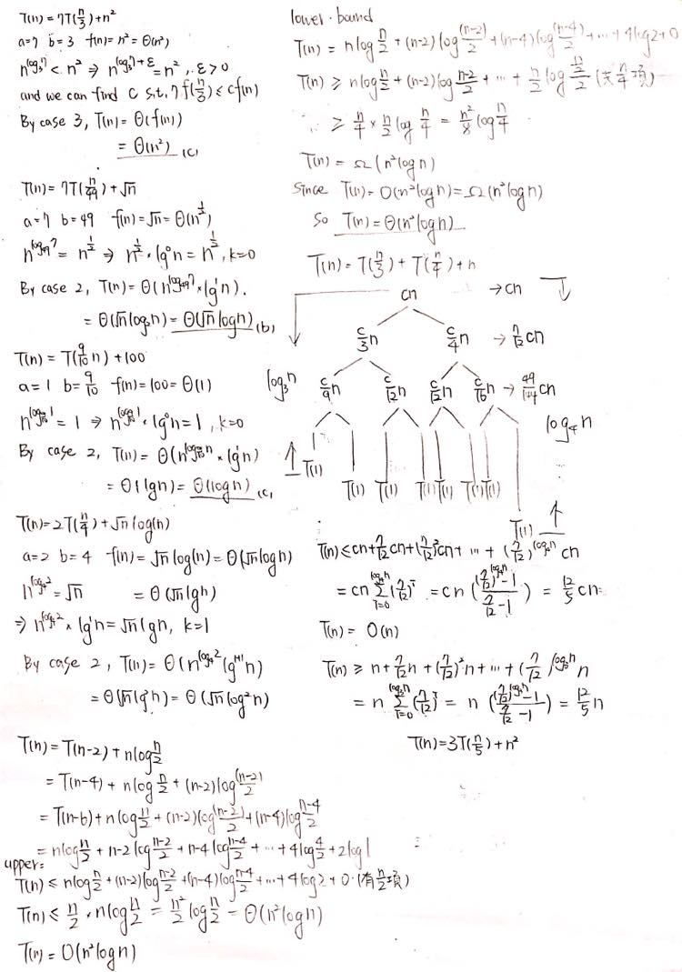

1. (2.5pts) $T\left(n\right)=7T\left(\frac{n}{49}\right)+ \sqrt{n}$

$θ(n)$

$θ(\sqrt{n} log⁡(n))$

$θ(n^{3/2})$

$θ(n^{2})$

Ans: (B )



1. (2.5pts) $T\left(n\right)=T\left(\frac{9}{10}n\right)+100$

$θ\left(1\right)$

$θ(n log⁡(n))$

$θ\left(\log\left(n\right)\right)$

$θ(\log^{2}(n))$

Ans: ( C )



1. (2.5pts) $T\left(n\right)=2T\left(\frac{n}{4}\right)+\sqrt{n} log(n)$

$θ(n^{2})$

$θ(\sqrt{n} log(n))$

$θ(\sqrt{n} \log^{2}(n))$

$θ(n log(n))$

Ans: ( C)



Give asymptotic tight bound($θ$) for question 5-6. (Assume that T(n) is a constant for sufficiently small n.)

1. (15pts) $T\left(n\right)=T\left(n-2\right)+n\log{\frac{n}{2}}$ (Assume $n$ is even.)

Ans: $Θ(n^{2}\log{n)}$

Upper bound



Lower bound

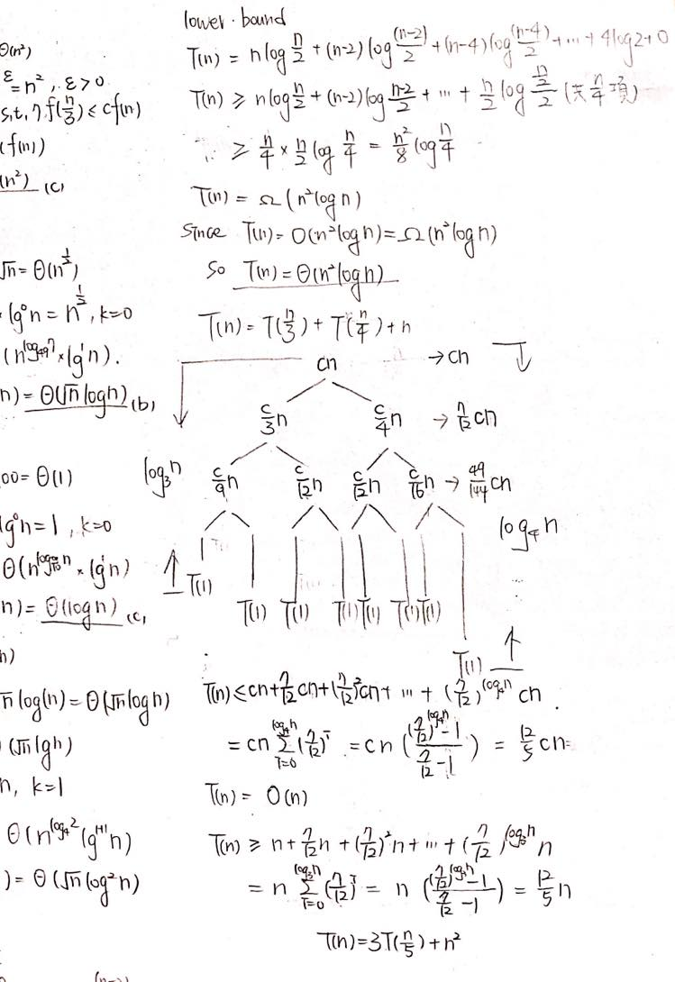

1. (15pts) $T\left(n\right)=3T\left(\frac{n}{3}\right)+\frac{n}{\log^{2}n}$

Ans: $Θ(n）$

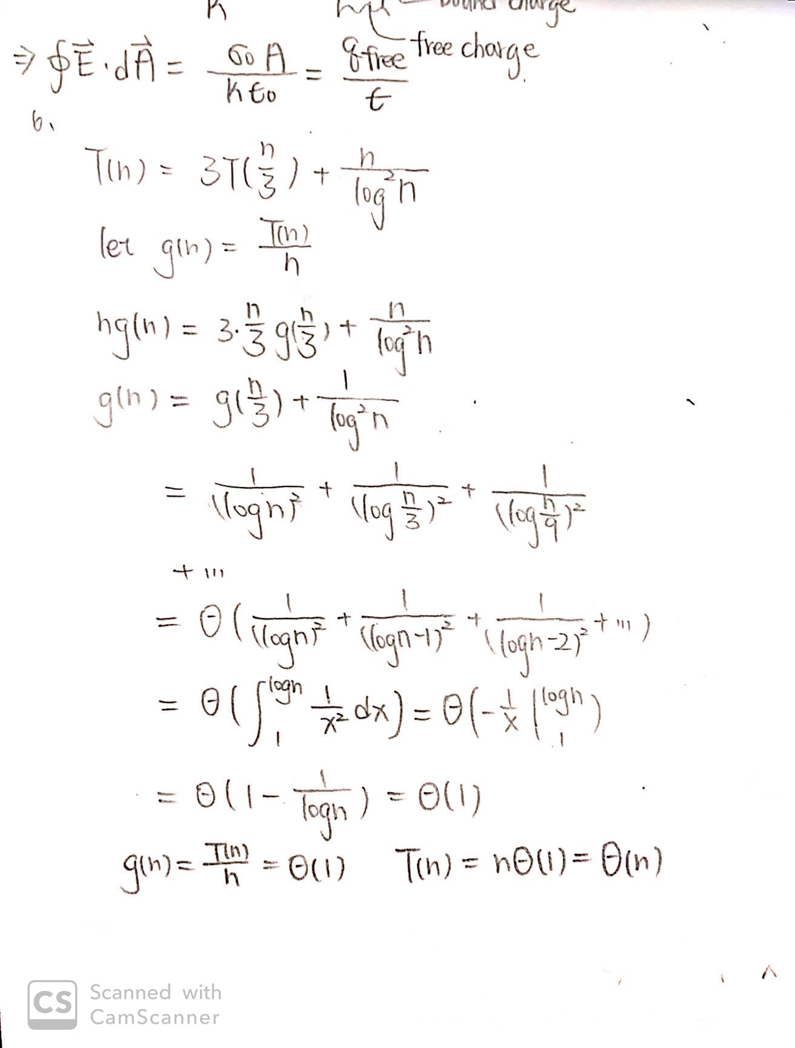

Use the recursion-tree method to give asymptotic tight bound($θ$) for question 7-8, and justify your answer. (Assume that T(n) is a constant for sufficiently small n.) (Please draw the tree.)

1. (15pts) $T\left(n\right)=T\left(\frac{n}{3}\right)+T\left(\frac{n}{4}\right)+n$

Ans: $Θ(n)$

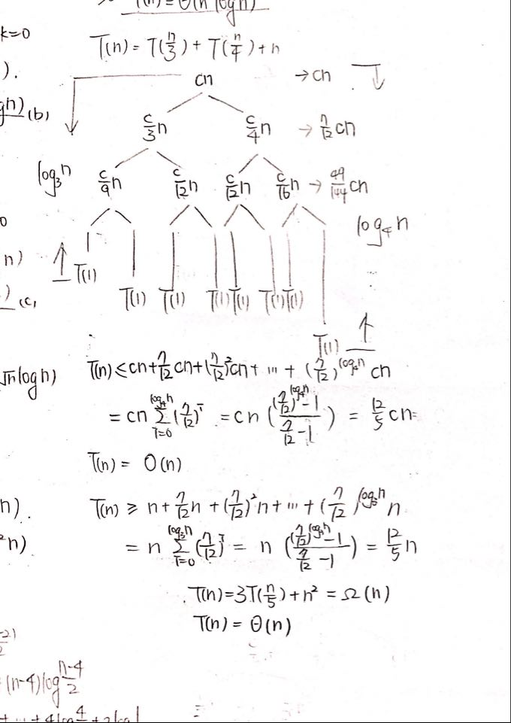

1. (15pts) $T\left(n\right)=3T\left(\frac{n}{5}\right)+n^{2}$

Ans: $Θ(n^{2})$

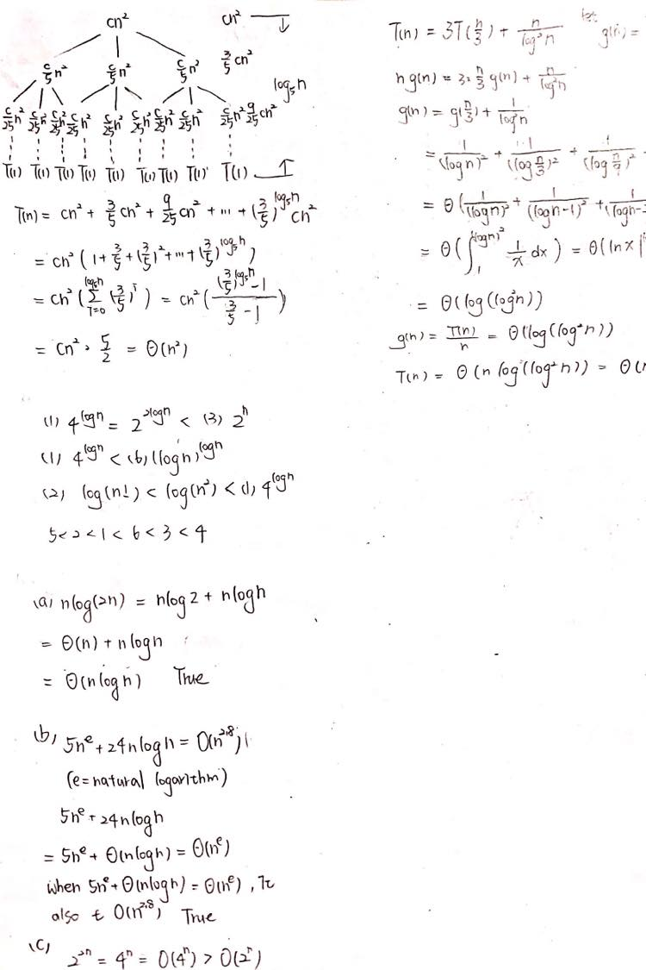

1. (15pts) Compare the following time complexity and arrange them in increasing order.

(1) $4^{\log{n}}$

(2) $\log{(n!)}$

(3) $2^{n}$

(4) $n!$

(5) $n^{\frac{1}{\log{n}}}$

(6) ${(log{n)}}^{\log{n}}$

1. 125634
2. 521634
3. 521364
4. 123465

Ans: ( B )



1. (15pts) True or False

(a) n $\log{(2n)}= O(nlog{n)}$

(b) $5n^{e}+24\operatorname{nlog}{n=O(n^{2.8})}$ (e = natural logarithm)

(c) $2^{2n}=O(2^{n})$

Ans: True/True/False

