**Algorithm 2021 Spring HW2**

(Chapter 6 to Chapter 8)

Given 57, 19, 83, 46, 13, 49, 7, 10 in order to build a max-heap.

1. (12.5pts) Which number is the number 46’s left child？
   1. 10
   2. 19
   3. 13
   4. 49
   5. None of above.

Ans: (b)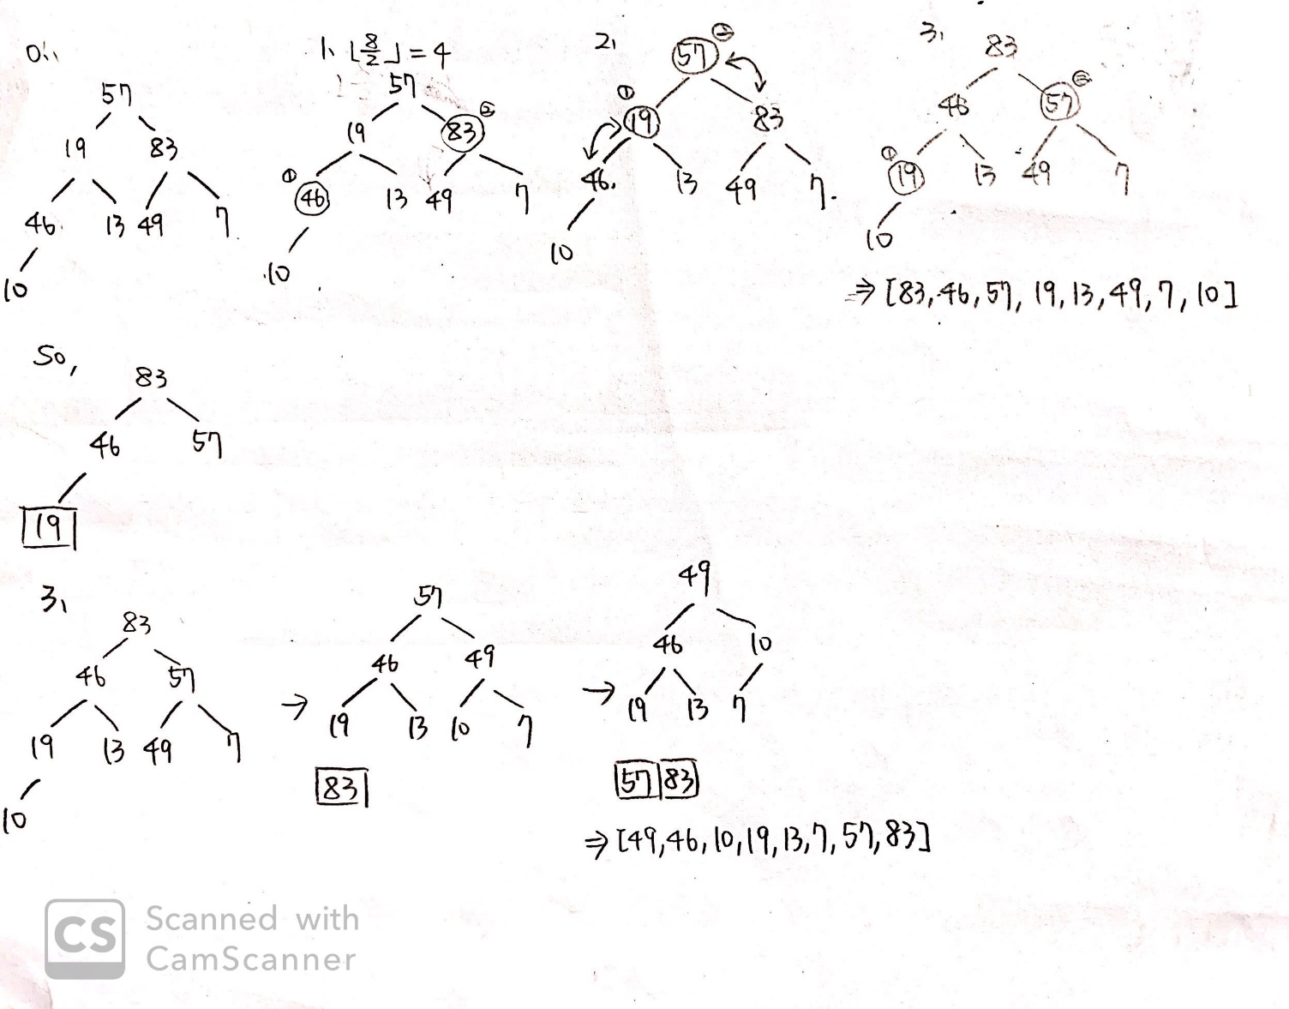

1. (12.5pts) Please choose the right array to represent the Heap in [1].
   1. [57,46,83,19,13,49,7,10]
   2. [57,19,83,46,13,49,7,10]
   3. [83,46,57,19,13,49,7,10]
   4. [83,19,57,46,13,49,7,10]
   5. None of above.

Ans: (c)

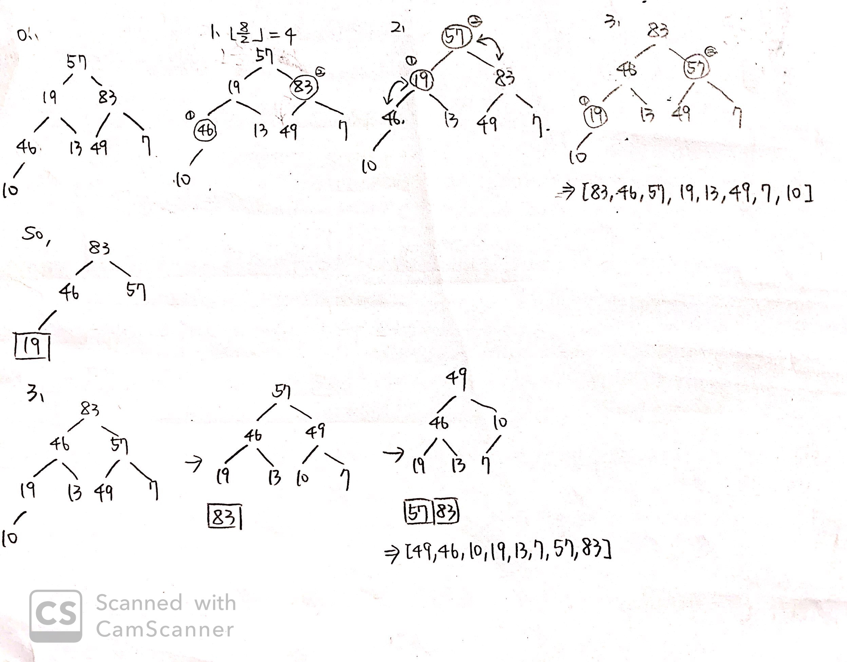

1. (12.5pts) Please choose the right array after 2 step of Heap sort in [1].
   1. [49,46,19,10,13,7,57,83]
   2. [49,46,10,19,7,13,57,83]
   3. [49,46,10,19,13,7,57,83]
   4. [49,19,46,13,10,7,57,83]
   5. None of above.

Ans: (c)



Radix sort

Given 112, 375, 169, 412, 241, 842, 468, 516.

1. (12.5pts) Please choose the right result after finishing the second digit arrange.

(a) 112, 412, 516, 241, 842, 468, 169, 375

(b) 241, 112, 412, 842, 375, 516, 468, 169

(c) 412, 516, 112, 241, 842, 468, 169, 375

(d) 112, 412, 516, 241, 842, 169, 468, 375

Ans: (a)

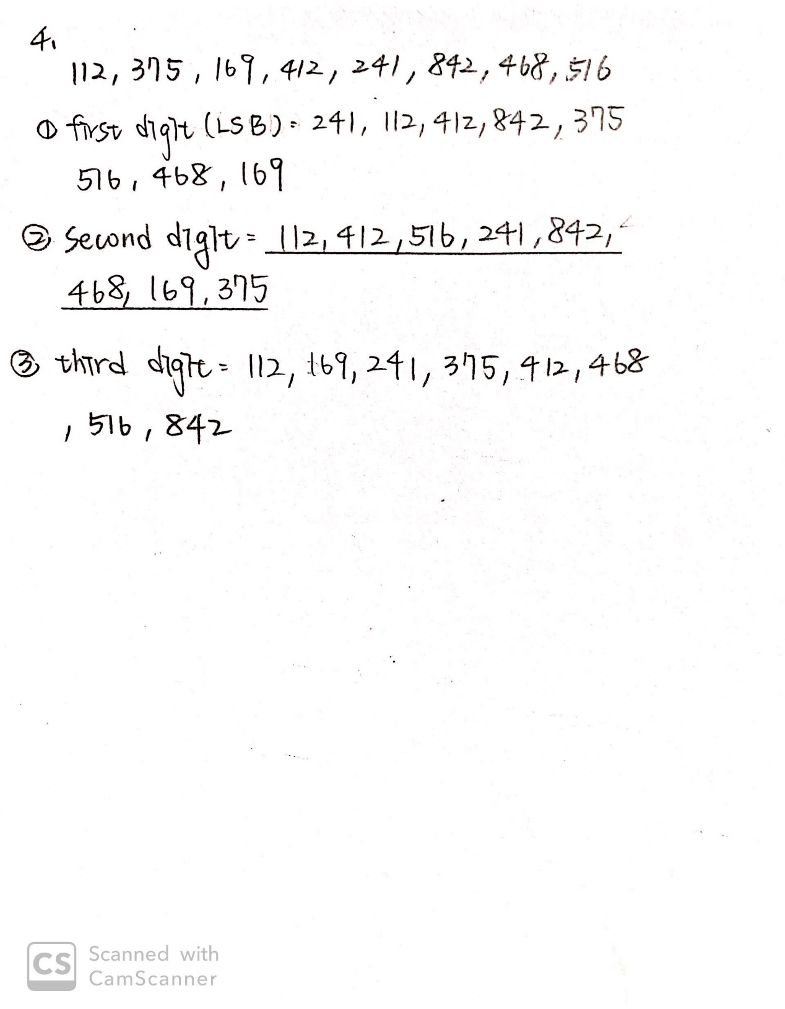

For question 5, 6 and 7, please refer to the following code:

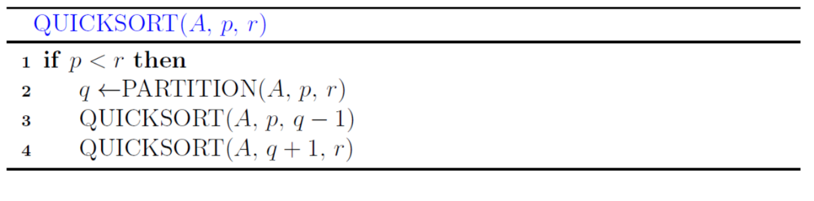

-

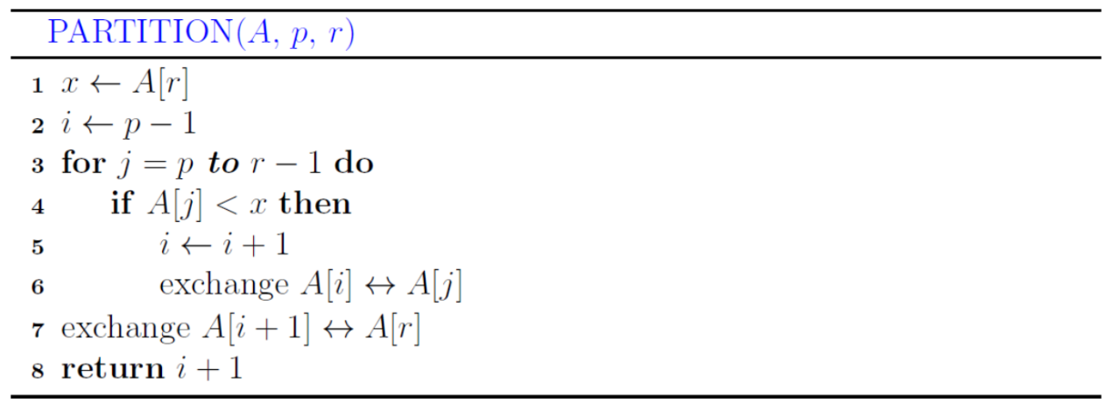

1. (12.5pts) Given a list of numbers A = {5, 2, 10, 3, 7, 11, 6, 3, 12, 7, 15}, how many times are the function “exchange” being called when we call function QUICKSORT(A, 0, 10) ?

Ans: 25 times

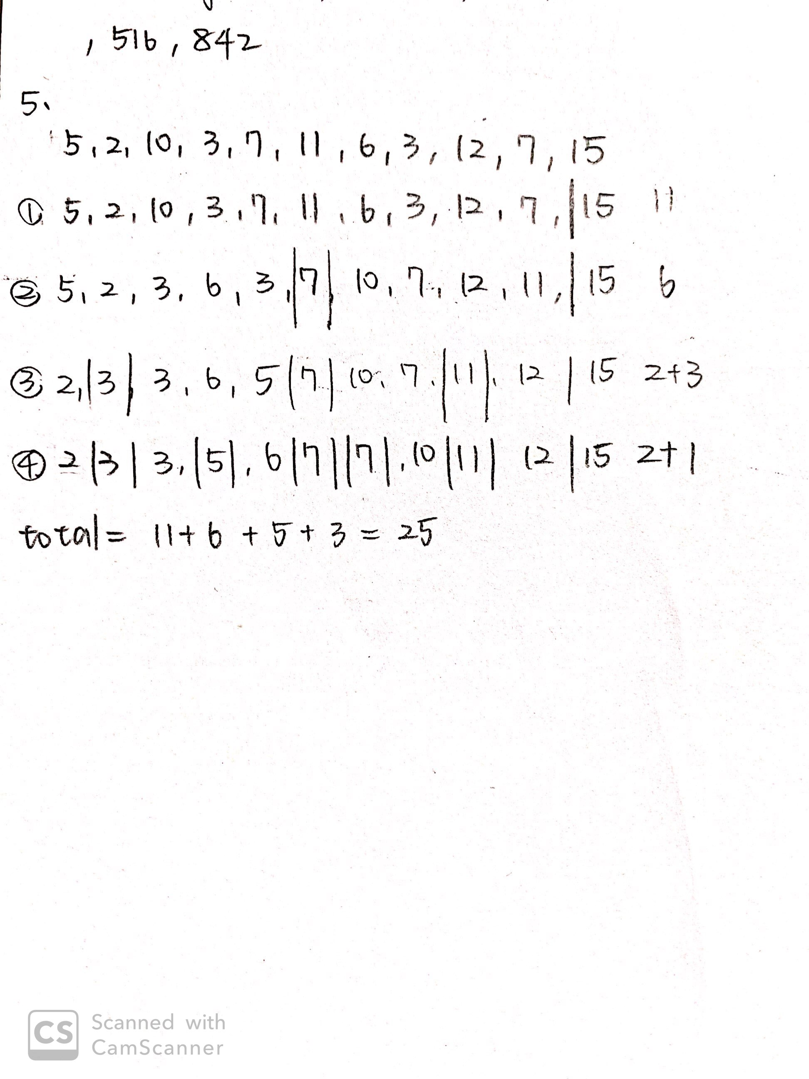

1. (12.5pts) Which list of numbers has the worst case of QUICKSORT?
2. {1, 2, 3, 4, 5, 6, 7, 8, 9}
3. {3, 2, 1, 4, 6, 8, 7, 5, 9}
4. {9, 8, 7, 6, 5, 4, 3, 2, 1}
5. {6, 6, 6, 6, 6, 6, 6, 6, 6}

Ans: (a), (c), (d)

不論是 (a), (c)或 (d)，他每次切的時候都會切在最旁邊，所以如果worse case是單純看PARTITION次數，三者都是最差狀況

1. (12.5pts) Suppose we are implementing quicksort to sort an array. After the first partition step has been completed, the contents of the array are in the following order: 3, 5, 3, 9, 17, 14, 24, 21, 19. What is the pivot of the first partition step?

Ans: 3, 9

1. 最左邊的3，他左邊沒有比他小的數，右邊也都是大於或等於他的數
2. 9，他左邊沒有比他小的數，右邊都是大於（或等於）他的數

其他不符合的原因（舉例）﹕5:A[2](3)<5，右邊的3:A[1]>3，17:A[5]<17，14:A[4]>14，24,21:A[8]<24,21，19:A[6]>19

For question 8, please refer to the following code:

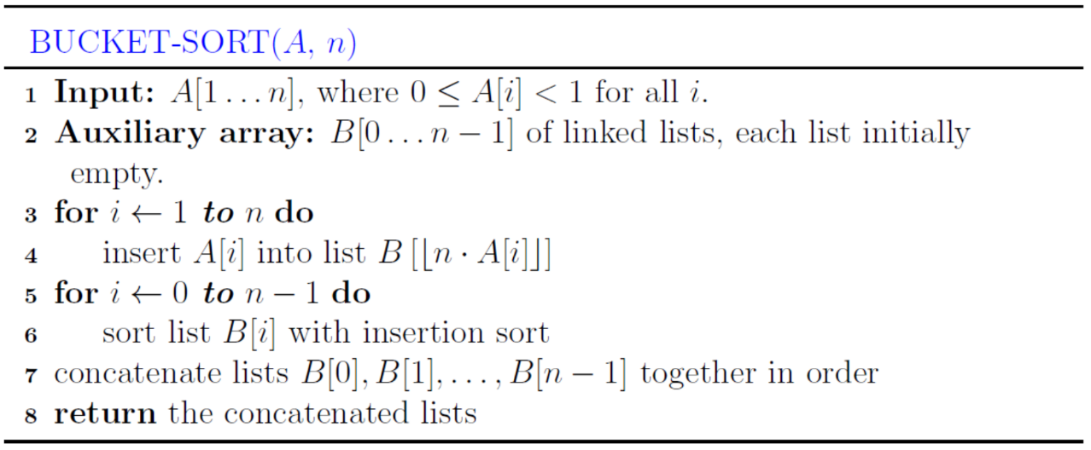

1. (12.5pts) Please answer the output lists(B[0],…, B[n-1]) of BUCKET-SORT on the array=(.69, .57, .99, .15, .27, .59, .61, .76, .87, .98, .01, .79, .23).

Ans: # of bucket: 10

(.01, .15, .23, .27, .57, .59, .61, .69, .76, .79, .87, .98, .99)

