**Algorithm 2021 Spring HW3**

(Chapter 9 and Chapter 15)

1. (25pts) There are two sorted arrays, each containing $n$ numbers. Please give an algorithm to find the median of all $2 n$ elements, and it’s running time should be bounded by $O(\lg{n})$.
2. Compare Median of array 1 and 2.
3. If median 1 = median 2, the median of all 2n element is it.
4. If median 1 > median 2, find median of all 2n element in array1 [ n/2 , n ], array2 [ 0 , n/2 ]
5. Else, find median of all 2n element in array1 [ 0 , n/2 ], array2 [ n/2 , n]
6. Repeat the process above until the subarray remain 2 elements in each array. ( we will let them be array 1[0,1] and array 2[0,1] ).
7. Compare array1 [0] and array2 [0] to get the larger one.

Compare array1 [1] and array2 [1] to get the smaller one.

Add the above two elements and divided by 2, then we get the median.

1. (25pts) Determine the cost of an optimal binary search tree for a set of n = 5 keys with the following probabilities:

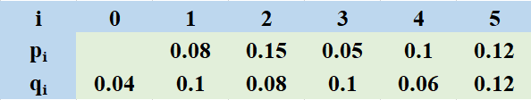

(A) 2.85

(B) 1.98

(C) 2.12

(D) 1.92

(note: level starts at 1.)

(note2: need to construct the tree)

Ans:

qi:直到搜尋leaf還是沒找到的點(參照資結課本第10章)

w[i,j] = qi-1 + $\sum_{k=i}^{j}{(qk+pk)}$

|  |  |  |  |  |  |  |
| --- | --- | --- | --- | --- | --- | --- |
| w (j→) | 0 | 1 | 2 | 3 | 4 | 5 |
| 1 | 0.04 | 0.22 | 0.45 | 0.6 | 0.76 | 1 |
| 2 |  | 0.1 | 0.33 | 0.48 | 0.64 | 0.88 |
| 3 |  |  | 0.08 | 0.23 | 0.39 | 0.63 |
| 4 |  |  |  | 0.1 | 0.26 | 0.5 |
| 5 |  |  |  |  | 0.06 | 0.3 |
| 6 |  |  |  |  |  | 0.12 |

e[i,j] = min(w[i,j] + e[i,k-1] + e[k+1,j])

|  |  |  |  |  |  |  |
| --- | --- | --- | --- | --- | --- | --- |
| e (j→) | 0 | 1 | 2 | 3 | 4 | 5 |
| 1 | 0.04 | 0.36 | 0.89 | 1.37 | 1.98 | 2.85 |
| 2 |  | 0.1 | 0.51 | 0.99 | 1.57 | 2.35 |
| 3 |  |  | 0.08 | 0.41 | 0.86 | 1.52 |
| 4 |  |  |  | 0.1 | 0.42 | 1.04 |
| 5 |  |  |  |  | 0.06 | 0.48 |
| 6 |  |  |  |  |  | 0.12 |

r

|  |  |  |  |  |  |
| --- | --- | --- | --- | --- | --- |
| r (j→) | 1 | 2 | 3 | 4 | 5 |
| 1 | 1 | 2 | 2 | 2 | 4 |
| 2 |  | 2 | 2 | 3 | 4 |
| 3 |  |  | 3 | 4 | 4 |
| 4 |  |  |  | 4 | 5 |
| 5 |  |  |  |  | 5 |

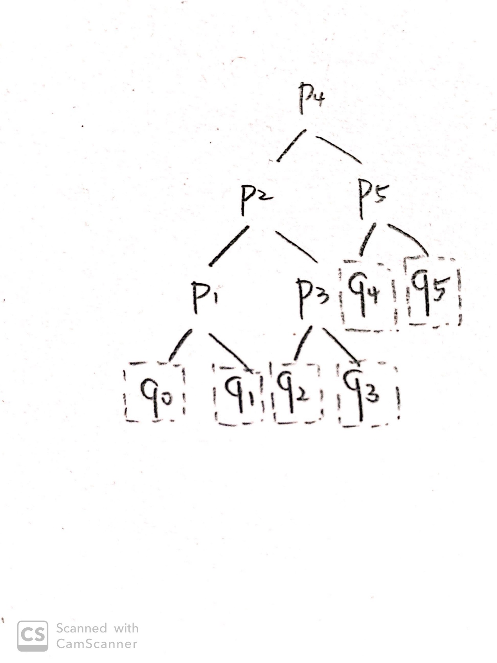

1. (25pts)



Please find the longest common subsequence of string “ACBDSABBE” and “CADDSBEAB” by using the above algorithm. You need to draw the table to show your process.

Let X = “ACBDSABBE”, Y = “CADDSBEAB”

i is the index about with X, j is the index with Y.

below is table of c[i,j]

|  |  |  |  |  |  |  |  |  |  |  |
| --- | --- | --- | --- | --- | --- | --- | --- | --- | --- | --- |
|  |  | A | C | B | D | S | A | B | B | E |
|  | **0↑** | **0←** | 0← | 0← | 0← | 0← | 0← | 0← | 0← | 0← |
| C | 0↑ | 0↑ | **1↖** | **1**← | 1← | 1← | 1← | 1← | 1← | 1← |
| A | 0↑ | 1↖ | 1↑ | **1↑** | 1← | 1← | 2↖ | 2← | 2← | 2← |
| D | 0↑ | 1↑ | 1↑ | 1↑ | **2↖** | 2← | 2↑ | 2↑ | 2↑ | 2↑ |
| D | 0↑ | 1↑ | 1↑ | 1↑ | **2↑** | 2↑ | 2↑ | 2↑ | 2↑ | 2↑ |
| S | 0↑ | 1↑ | 1↑ | 1↑ | 2↑ | **3↖** | **3←** | **3←** | 3← | 3← |
| B | 0↑ | 1↑ | 1↑ | 2↖ | 2↑ | 3↑ | 3↑ | 4↖ | **4↖** | 4← |
| E | 0↑ | 1↑ | 1↑ | 2↑ | 2↑ | 3↑ | 3↑ | 4↑ | 4↑ | **5↖** |
| A | 0↑ | 1↑ | 1↑ | 2↑ | 2↑ | 3↑ | 4↖ | 4↑ | 4↑ | **5↑** |
| B | 0↑ | 1↑ | 1↑ | 2↑ | 2↑ | 3↑ | 4↑ | 5↖ | 5↖ | **5↑** |

The LCS = “CDSBE”

1. (25pts) Matrix-chain

Consider the multiplication of five matrices $A_{1}A_{2}A_{3}A_{4}A_{5}$, and the dimensions are as follows:

|  |  |  |  |  |  |
| --- | --- | --- | --- | --- | --- |
| matrix | A1 | A2 | A3 | A4 | A5 |
| dimension | $$20×25$$ | $$25×15$$ | $$15×10$$ | $$10×20$$ | $$20×30$$ |

Please find the minimum number of scalar multiplications, optimal parenthesization and fill up the two tables.

Table m:

I

1

2

3

4

5

J 1 2 3 4 5

|  |  |  |  |  |
| --- | --- | --- | --- | --- |
| 0 | 7500 | 8750 | 12750 | 20750 |
|  | 0 | 3750 | 8750 | 17250 |
|  |  | 0 | 3000 | 10500 |
|  |  |  | 0 | 6000 |
|  |  |  |  | 0 |

Table s:

I

1

2

3

4

J 2 3 4 5

|  |  |  |  |  |
| --- | --- | --- | --- | --- |
|  | 1 | 1 | 3 | 3 |
|  |  | 2 | 3 | 3 |
|  |  |  | 3 | 3 |
|  |  |  |  | 4 |
|  |  |  |  |  |

Calculate m:

P = <20,25,15,10,20,30>

m[1,2] = P0 P1 P2 = 20*25*15 = 7500

m[2,3] = P1 P2 P3 = 25*15*10 = 3750

m[3,4] = P2 P3 P4 = 15*10*20 = 3000

m[4,5] = P3 P4 P5 = 10*20*30 = 6000

m[1,3] = m[1,1] + m[2,3] + P0 P1 P3 = 0 + 3750 + 20*25*10 = 8750

or = m[1,2] + m[3,3] + P0 P2 P3 = 7500 + 3000 + 20*15*10 = 13500

m[2,4] = m[2,2] + m[3,4] + P1 P2 P4 = 0 + 3000 + 25*15*20 = 10500

or = m[2,3] + m[4,4] + P1 P3 P4 = 3750 + 0 + 25*10*20 = 8750

m[3,5] = m[3,3] + m[4,5] + P2 P3 P5 = 0 + 6000 + 15*10*30 = 10500

or = m[3,4] + m[5,5] + P2 P4 P5 = 3000+ 0 + 15*20*30 = 12000

m[1,4] = m[1,1] + m[2,4] + P0 P1 P4 = 0 + 8750 + 20*25*20 = 18750

or = m[1,2] + m[3,4] + P0 P2 P4 = 7500 + 0 + 20*15*20 = 13500

or = m[1,3] + m[4,4] + P0 P3 P4 = 8750 + 0 + 20*10*20 = 12750

m[2,5] = m[2,2] + m[3,5] + P1 P2 P5 = 0 + 10500 + 25*15*30 = 21750

or = m[2,3] + m[4,5] + P1 P3 P5 = 3750 + 6000 + 25*10*30 = 17250

or = m[2,4] + m[5,5] + P1 P4 P5 = 8750 + 0 + 25*20*30 = 23750

m[1,5] = m[1,1] + m[2,5] + P0 P1 P5 = 0 + 17250 + 20*25*30 = 32250

or = m[1,2] + m[3,5] + P0 P2 P5 = 7500 + 10500 + 20*15*30 = 27000

or = m[1,3] + m[4,5] + P0 P3 P5 = 8750 + 6000 + 20*10*30 = 20750

or = m[1,4] + m[5,5] + P0 P4 P5 = 12750 + 0 + 20*20*30 = 24750