1.(30%)A 16K × 4 memory uses coincident decoding by splitting the internal decoder into X-selection and Y-selection .Determine the X and Y selection lines that are enabled when the input address is the binary equivalent of 6000

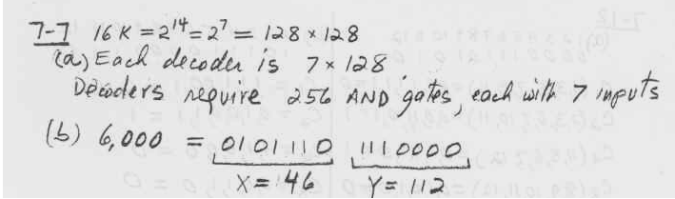

2.(30%)Given a 32 × 8 ROM chip with an enable input ,show the external connections necessary to construct a 128 × 8 ROM with four chips and a decoder

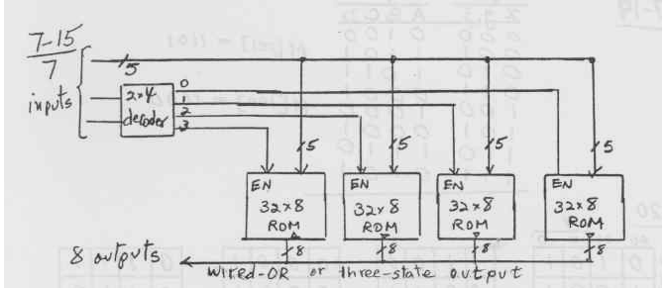

3.(40%)Design a counter with T flip-flops that goes through the following binary repeated sequence :0 , 1, 3 ,7 ,6 ,4 .Show that when binary states 010 and 101 are considered as don’t care conditions ,the counter may not operate properly .find a way to correct the design.
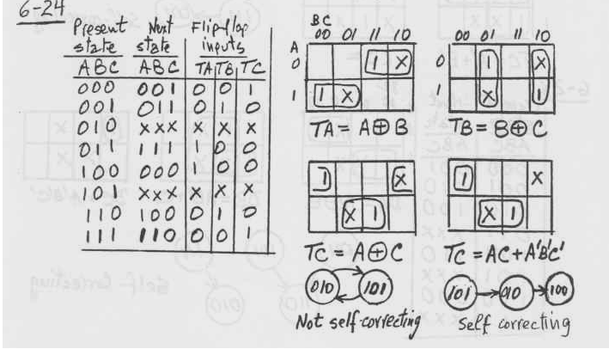
只要有寫出正確的self correcting的方法就給分,如果寫錯,則扣一半,剩下一半由證明not self-correcting的過程完整與否給分

