Discrete Mathematics

HW5

E94086107 張娟鳴

11-1 2.

(a)

Trail: can have repeated vertices but no repeat edges, open.

b-d not a trail: {b,e} {e,f} {e,g} {g,e} {e,b} {b,c} {c,d}

(b)

Path: no repeated vertices and edges, open.

b-d trail and not a path: {b,e} {e,f} {f,g} {g,e} {e,d}

(c )

b-d path: {b,e} {e,d}

(d)

Closed walk: can have repeated vertices and edges, closed.

Circuit: can have repeated vertices but no repeat edges, closed.

b-b closed but not a circuit: {b,e} {e,f} {f,g} {g,e} {e,b}

(e)

Cycle: no repeated edges and circuits, closed.

b-b circuit but not cycle: {b,c} {c,d} {d,e} {e,g} {g,f} {f,e} {e,b}

(f )

b-b cycle: {b,a} {a,c} {c,b}

11-1 5.

(1) path from a to h needs to go through {b,g},

so the answer = # of path a-b * # of path g-h.

a-b path:　　　　　　g-h path:

{a,b}　　　　　　　　{g,h}

{a,c} {c,b}　　　　　　{g,f} {f,h}

{a,c} {c,d} {d,b} 　　　{g,e} {e,f} {f,h}

a-h path: $3*3=9$

(2) length 5: length a-b + length g-h + {b,g} = 5

Length a-b + length g-h = 4 = 1 + 3 = 2 + 2 = 3 + 1

上面三種情況都各只有一種搭配可以符合，所以共三種

a-h and length 5 path: 3 kinds.

11-2 4.

Spanning graph: $V_{1}=V$, no restrict with E

Induced graph: if $U⊆V$, induced subgraph’s edges contain all edges (from G) $\left\{x,y\right\} if both x,y∈U$

因為Spanning graph的點包含了原先G的所有點，如果他要是induced subgraph的話，就需要包含所有點在G裡面構成的邊，也就只有G本身自己可以滿足這個條件。

A: 1種，G本身

11-2 6.

(1) 11種，如下圖

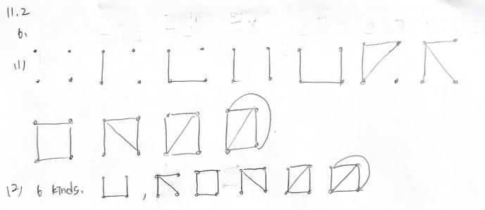

11-3 2.

希望 |V| 越大，則deg(v)應該越小越好，所以可以的話盡量讓 deg(v)=3

And by theorem, we know $Σ_{v∈V}deg\left(v\right)=2|E|$

Then, $Σ_{v∈V}deg\left(v\right)=34≥3|V|$, maximum |V|=11 ( 3*11+1，有10個vertex deg(v)=3，一個deg(v)=4 )

11-3 9.

(a)

# of edges of a cube of dimension n is $n*2^{n-1}$.

So, $n*2^{n-1}=524288$

$n=16$

(b)

# of vertices of n dimension hypercube is $2^{n}$

$n*2^{n-1}=4980736$

$n=19$

# of vertices $=2^{19}=524288$

11-4 8.

(a)

$K_{1,4}$: edge in G {a,b}, $a∈V_{1}, b∈V_{2}$ 且 $V_{1}$ 每個點都有對應到 $V_{2}$

所以在這個case裡面最多可以有4個edge，從 $V_{1}$ 到 $V_{2}$ 的四個點

而最長path可為2，從 $V_{2}$ 出發到 $V_{1}$ 再回到 $V_{2}$

(b)

In this case, 因為比較少點的那一邊有3個點，最好情況是 $V_{1}$ 每個點(假設有 a, b, c)都與 $V_{2}$ 每個點(1,2,3…,7)相連

最長path就可以從 $V_{2}$ 的 $1$ 出發，到 $V_{1}$ 的a，接著連回 ${ V}_{2}$ 的2， $V_{1}$ 的 b， $V_{2}$ 的3， $V_{1}$ 的c， $V_{2}$ 的4，共7個點6條邊

其中a,b,c和1,2,3,4......並非指特定點，只是代表不同集合的不同點

(c )

同理，最長的path應該是從有12個vertices的 $V_{2}$ 出發，然後拜訪 $V_{1}$ 全部共7個，來回總共15個點14條邊（=2*7=14）

(d)

Since m<n, the longest path in $K_{m,n}=2*m=2m$

11-5 7.

(a)

我們可以視為有n個點要排成列，共有n!種排法，但因為要排成圓型，1->2->3->1和2->3->1->2會變成同一種，需除n，且因為沒有方向概念，1->2->3->1和1->3->2->1視為同一種，要再除2，所以共 $\frac{\left(n-1\right)!}{2}$ 種。

(b)

For a $K_{n}$, we have $(_{2}^{n})=\frac{n\left(n-1\right)}{2}$ edges. And each Hamilton cycles has n edges, so we will have $\frac{n\left(n-1\right)}{2}*\frac{1}{n}=\frac{n-1}{2}$ kinds of edge-disjoint Hamilton cycles.

To have a better answer, n should be odd.

When n=21, $\frac{21-1}{2}=10$

(c)

Since they need to hold hands form a cycle, we can think it as edge-disjoint Hamilton cycle, so just like we need to find total number of edge-disjoint Hamilton cycle on a $K_{19}$. when n=19, $\frac{19-1}{2}=9$, we have 9 edge-disjoint Hamilton cycle in $K_{19}$.

所以9天內所有學生旁邊的人都不是重複的。

11-6 2.

Each committees is a vertex. If someone attends two committees, for example $c_{i}, c_{j}.$ Then draw the edge joining the vertices for $c_{i}, c_{j}$, and we will get graph G. Then the least number of meeting times is the chromatic number of this graph (in hours) .